ASSIGNMENT 1 CS204 DATABASE SYSTEMS FALL 2009
Q1: What does the term view means? Give an example [2 points]
Q2: In your opinion, what are the advantages of creating views in SQL, as compared to simply using the tables generated after the execution of an SQL query [2 points]
Q3: In the following, you are given several ER diagrams. You are required to map these diagrams to relations. For each diagram, you should map its entity sets as well as the relationship set (if the latter exists). In order to do so, give the name of the relation, the name of its fields, and any integrity constraints that apply to this relation, i.e., primary key and referential integrity constraints [3+3+2.5+2.5 points]

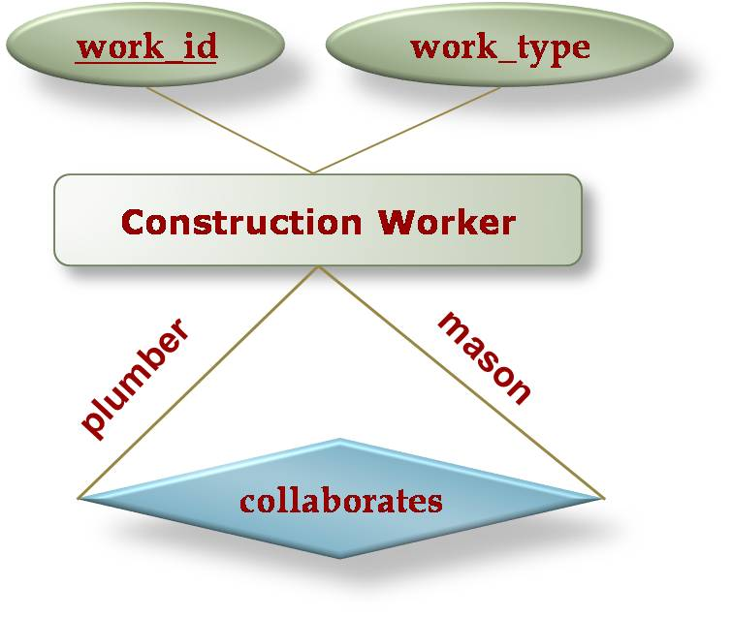

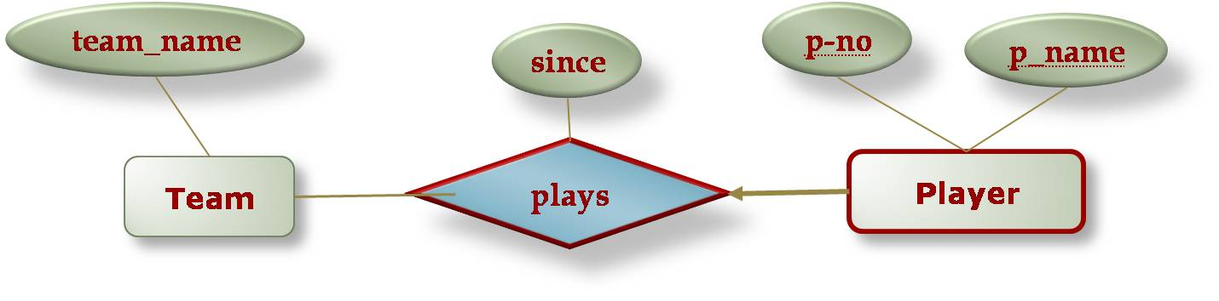

- For the following class hierarchy, there are two possible options for creating the tables. Show the tables with both of these options.
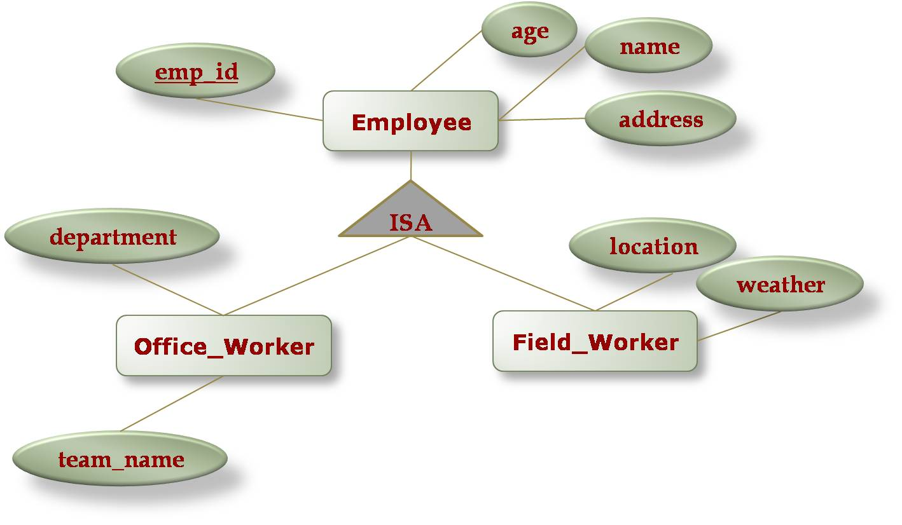
- Map the following diagram to tables, and also tell what is the meaning of the dotted rectangle labeled “work”.
