VIRTUAL CREATIVE STORYTELLING INTERNSHIP
WEEK 2 • STORY WORLD BUILDING AND CHARACTER DESIGN
FROM AUDIENCE TO ENTERPRISE
Original narrative universe: CREATOR → COMPANY
A contemporary entrepreneurial story set in fictional Nivara

1. Week 2 Objective
This week deepens the Week 1 narrative framework by constructing an immersive story world and designing dynamic characters whose choices are shaped by that world. The setting is a fictional contemporary Tier-2 Indian city, Nivara, designed as a bridge between inherited social expectations and emerging digital entrepreneurship. The objective is to make the entrepreneurial conflict feel lived, visual and emotionally credible.

2. Continuity with Week 1
Week 1 established From Audience to Enterprise and the fictional CREATOR → COMPANY concept. Week 2 turns the market gap into lived experience: what kind of city would produce Aarohi, what pressures would she face, who would challenge her, and how would the physical and digital environment shape her decisions?
Current evidence: the July 2026 ISB–HashFame study reports 4.12 million Indian creators in 2025, 66% from non-metro markets, and identifies repeat monetisation and diversified revenue as next-stage challenges.

3. Story World: Nivara
Nivara is a fictional Tier-2 Indian city in 2026. Its identity comes from the coexistence of an old commercial core, an education ecosystem, regional-language culture, creator spaces, family businesses, digital commerce and young people pursuing careers that were unconventional a generation ago.
World-building principle: Nivara is not a decorative backdrop. Every major feature creates a constraint, opportunity, relationship or decision for the characters.
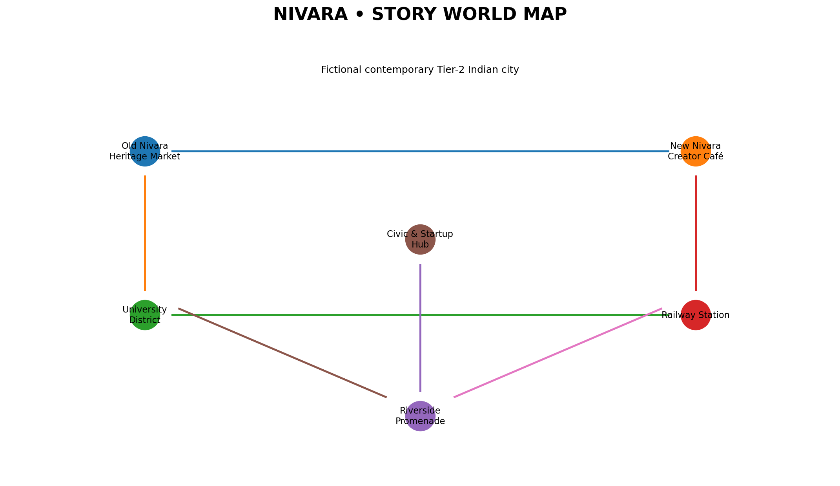

4. Time Period and Socio-Economic Climate

4.1 Time period
2026. Smartphones, short-form video, digital payments, creator platforms, AI tools and social commerce are ordinary parts of working life.

4.2 Economic climate
Nivara contains family-owned shops, services, education, small manufacturers, cafés and emerging digital ventures. It is connected enough for a creator to reach national audiences, yet small enough for reputation and community trust to remain highly visible.

4.3 Digital climate
Technology remains invisible infrastructure. Aarohi does not think in terms of technology features; she thinks in terms of audience behaviour, revenue, trust, customers and time. BCG's 2025 creator-economy research highlights the movement from content toward commerce, including subscriptions, virtual gifting, live commerce and generative AI.

5. Geography and Physical Environment
Location | Narrative Function
Old Nivara / Heritage Market | Dense streets, old storefronts and family businesses. Represents continuity and inherited economic knowledge.
New Nivara / Creator Café | Modern cafés, laptops, cameras and informal creator meetups. Represents emerging creator culture.
University District | Students, libraries and affordable food. Represents aspiration and experimentation.
Civic & Startup Hub | Incubation rooms and workshops. Represents formal entrepreneurial infrastructure.
Riverside Promenade | Quiet reflective space for difficult conversations and decisions.
Railway Station | Symbolic threshold between staying and leaving; recurring motif for opportunity and ambition.

6. Architecture and Ambient Details
- Old neighbourhoods use weathered façades, mixed-use buildings, balconies, shopfronts and hand-painted signs.
- Newer districts contain compact coworking spaces, cafés, coaching centres and flexible workspaces.
- Aarohi's workspace is a converted bedroom with a ring light, phone tripod, microphone, notebooks, packaging samples and a whiteboard of content and revenue experiments.
- Ambient sound alternates between market calls, scooters, community announcements, college traffic, café conversations and notification sounds.
- Visual lighting changes with narrative function: warm routine, harsh screen light during pressure, open daylight during clarity, evening city lights during moments of possibility.

7. Culture and Social Environment

7.1 Traditional expectations
- Stable employment is associated with security and respect.
- Family members worry about unpredictable income and public exposure.
- Success is often measured through salary, job title, property or visible stability.
- Entrepreneurship is admired after success but questioned during uncertainty.

7.2 Emerging youth culture
- Digital careers are increasingly visible.
- Regional language and local identity can become sources of differentiation.
- Young people combine employment, freelancing, content creation and entrepreneurship.
- Community reputation remains important even when audiences are geographically dispersed.
The real-world context supports this design: ISB–HashFame's 2026 research reports non-metro creators as the majority of India's creator base and identifies regional-language ecosystems as central to the market.

8. Main Character: Aarohi Mehta
Attribute | Profile
Age | 24
Occupation | Regional content creator; aspiring creator-entrepreneur
Residence | Nivara; lives with her mother
Content niche | Culture, everyday life, local discovery, practical lifestyle stories and entrepreneurial observations
Primary motivation | Financial independence without surrendering authenticity
External goal | Build a sustainable creator-led business
Internal need | Learn that ownership and value creation matter more than visibility
Strengths | Observation, empathy, communication, consistency, curiosity
Flaws | Impatience, comparison, external validation, difficulty separating identity from business decisions
Core fear | Financial dependence and loss of audience trust
Symbolic object | Notebook with content ideas on one side and business ideas on the other
Character question | Do I want to be seen, or do I want to be free?

8.1 Physical description
Aarohi has a practical contemporary appearance. Her visual identity is work rather than glamour: phone, tripod, microphone, notebooks, packaging samples and unfinished ideas surround her.

8.2 Backstory
Aarohi grew up watching her mother manage a household with careful budgeting. During college she began documenting overlooked local stories. Her simple videos built a loyal regional audience. Brand enquiries followed, and sponsorships initially felt like proof of success. Campaign-based income eventually exposes the weakness beneath the visibility.

9. Supporting Characters
Character | Role / Personality | Narrative Function
Meera Mehta | Mother; values security and social credibility. | Represents stability and inherited expectations; gradually moves from concern to cautious belief.
Kabir Shah | Childhood friend; analytical, practical and skeptical. | Represents feasibility and disciplined execution.
Sana Iyer | Peer creator; experienced in diversified creator income. | Represents the possible future Aarohi could build.
Raghav Malhotra | Brand executive; persuasive and commercially successful. | Represents the established transactional creator-marketing model and short-term incentives.
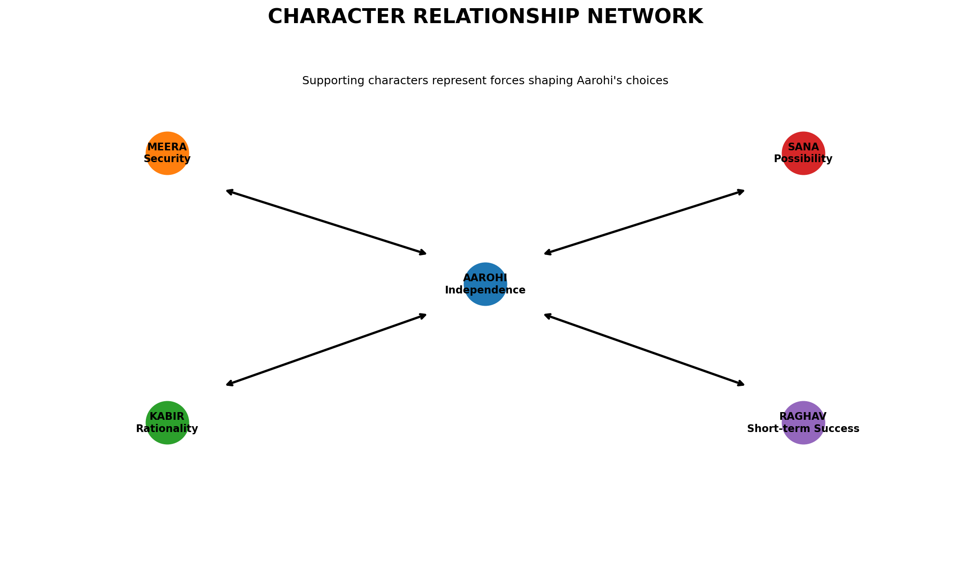

10. Character Motivations and Conflicts
Character | Wants | Fears | Central Conflict
Aarohi | Ownership and independence | Dependence; loss of authenticity | Immediate brand money vs long-term ownership
Meera | Security for her daughter | Financial instability and judgment | Protecting Aarohi vs allowing risk
Kabir | A workable business | Wasted time and money | Creative ambition vs operational discipline
Sana | Durable creator businesses | Creators trapped in attention metrics | Mentoring without imposing her path
Raghav | Effective brand campaigns | Loss of creator control | Transactional efficiency vs creator autonomy

11. Character Evolution
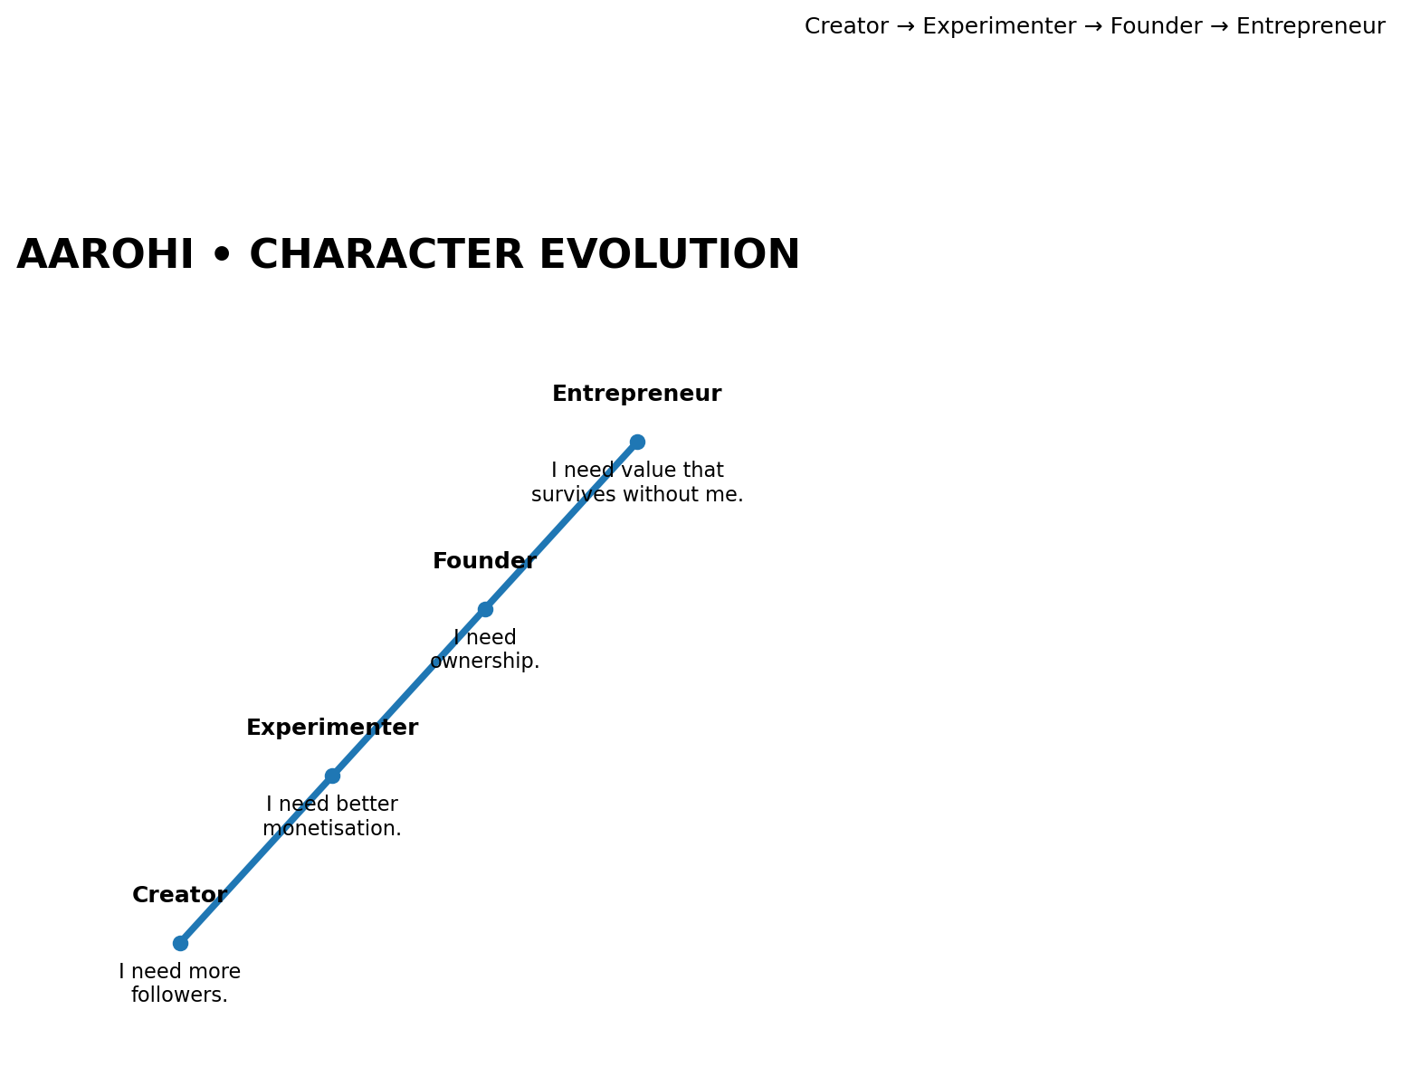
Aarohi's transformation is gradual: she first tries to improve sponsorship income, then experiments with owned products, learns from weak demand, listens to her community and finally recognizes that a creator business must create value beyond daily posting.

12. World ↔ Character Symbiosis
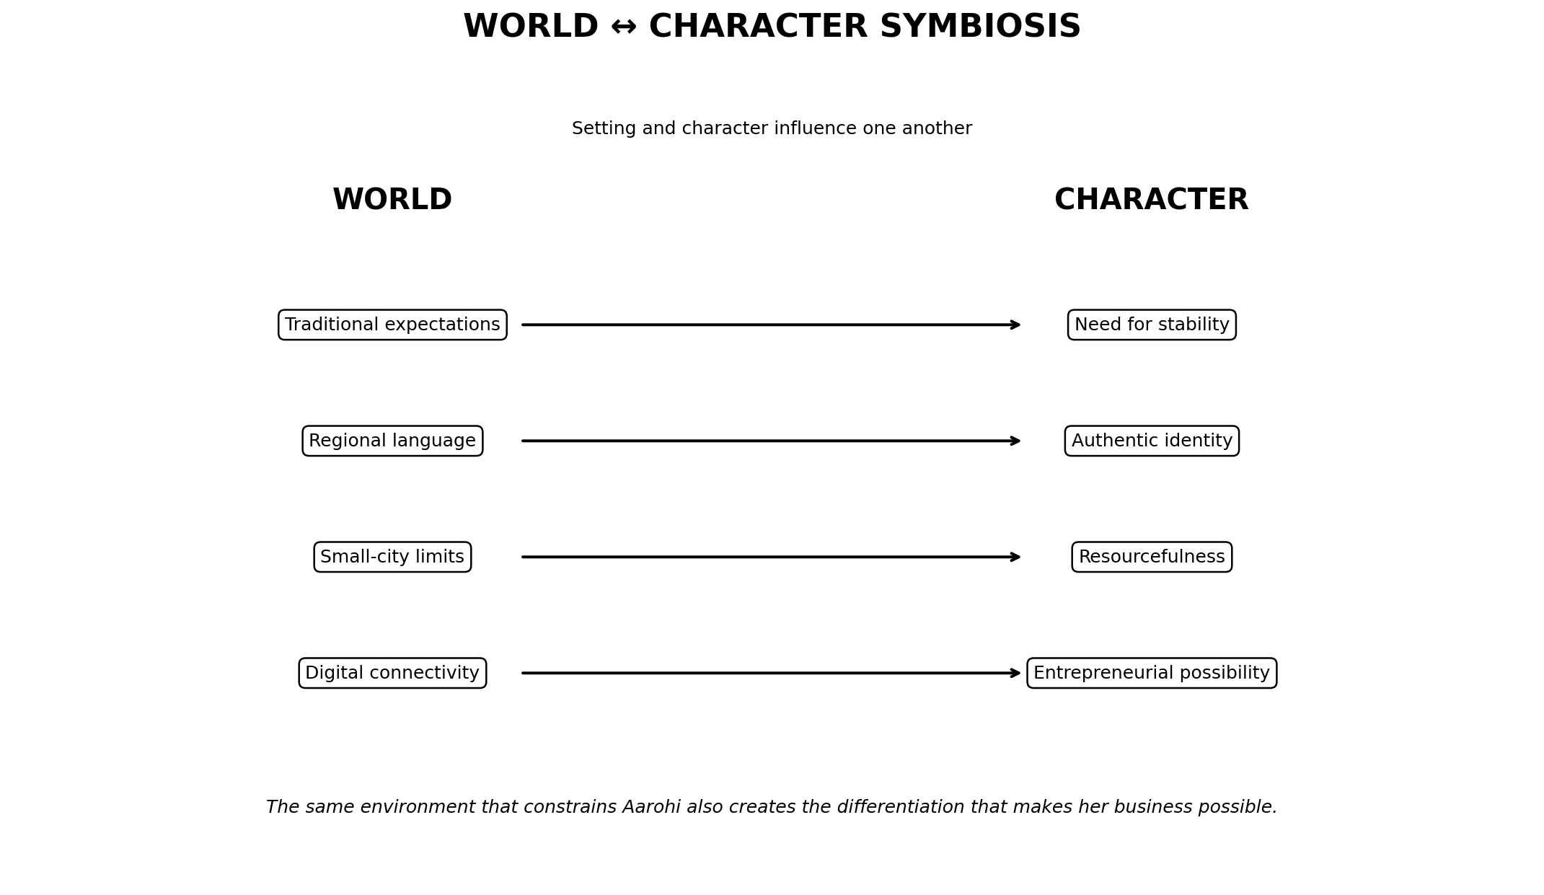
World Element | Influence on Aarohi | Aarohi's Response
Traditional expectations | Creates pressure for stability | Seeks proof that entrepreneurship can be responsible
Regional language culture | Creates differentiation and trust | Builds around local identity
Small-city ecosystem | Limits some networks | Uses digital channels to reach beyond geography
Digital connectivity | Creates national reach | Turns audience access into experiments
Local community | Provides high-trust relationships | Develops an owned community
The same city that limits Aarohi also gives her the differentiation that makes her business possible.

13. Environmental Storytelling
- Aarohi's bedroom gradually changes from a creator corner into a small business studio.
- Her notebook changes from content ideas into a two-column system: audience insight and business experiment.
- The railway station recurs during conversations about leaving Nivara.
- The heritage market supplies early story ideas and local products.
- The creator café acts as a social laboratory for creators to exchange information about algorithms, campaigns and failures.
- The riverside becomes a reflective space for questions about ambition, independence and identity.

14. Daily Life and Story Rhythm
At first Aarohi's routine is repetitive: check analytics, film, edit, post, reply, wait for brand messages, track income and repeat. As the story develops, her day becomes customer-centric: interviewing followers, testing products, checking costs, reviewing feedback, negotiating and making decisions.

15. Narrative Continuity with Week 1
Week 1 Element | Week 2 Expansion | Narrative Benefit
CREATOR → COMPANY | Nivara gives it a social environment | Business idea becomes lived experience
Short-term vs long-term | Raghav embodies short-term incentives | Conflict becomes personal
Audience vs business | Aarohi's routine shows the difference | Market gap becomes human
Entrepreneurial transformation | Character evolution is mapped | Provides a believable arc
Themes | Family, city, peer and brand relationships reinforce themes | Themes become visible through action

16. Creative Design Principles
- Believability before spectacle.
- Specificity before generic description.
- Conflict through relationships rather than cartoon villains.
- Business logic inside the story: choices affect money, time, trust and identity.
- Visual continuity through recurring locations and objects.
- Fiction grounded in fact: real market conditions inform the world; Nivara and its characters remain fictional.

17. Skills Demonstrated
- World-building
- Character design
- Backstory development
- Motivation mapping
- Relationship design
- Environmental storytelling
- Narrative continuity
- Entrepreneurial storytelling
- Research synthesis
- Visual communication

18. Conclusion
Week 2 transforms the Week 1 entrepreneurial premise into a living narrative environment. Nivara provides the social, cultural, physical and digital conditions that make Aarohi's conflict believable, while the characters turn the market gap into a human story. The world and characters are interdependent: the city shapes Aarohi's choices, while Aarohi's journey challenges assumptions within the city.

19. Research References
- Indian School of Business & HashFame (2026), Understanding the Canvas of India's Creator Economy
https://www.isb.edu/news/press-releases/india-s-creator-economy-enters-a-new-phase-as-non-metro-creators-become-the-majority-reveals-isb-hashfame-report
- BCG (2025), From Content to Commerce: Mapping India's Creator Economy
https://www.bcg.com/publications/2025/india-from-content-to-commerce-mapping-indias-creator-economy
- ISB (2026), Inclusive AI for Viksit Bharat
https://www.isb.edu/news/press-releases/isb-and-meity-convene-national-leaders-at-governance-summit-2026-to-chart-indias-course-for-inclusive-ai
Creative project note: Nivara, Aarohi, supporting characters and CREATOR → COMPANY are fictional original-development elements created for this internship project.

