From Audience to Enterprise
Ideation and Narrative Framework Development
Virtual Creative Storytelling Internship | Week 1
Working concept: CREATOR → COMPANY
Turning a regional creator’s audience into a sustainable, diversified business
A research-grounded fictional entrepreneurship concept developed from current Indian creator-economy evidence.

1. Executive Snapshot
Project premise. This Week 1 project develops an original entrepreneurial story concept inspired by a current Indian market gap: creator participation and brand discovery are expanding rapidly, but sustainable, repeat and diversified creator income remains relatively shallow, particularly outside metro markets.
Research signal. A July 2026 ISB–HashFame study reports that India’s creator base increased from approximately 0.96 million in 2020 to 4.12 million in 2025, with 66% of creators in non-metro markets. The same research reports campaign volume rising from about 14,000 to 42,000 and average campaign spending increasing 3.6 times, while most creators still undertake only one paid campaign annually. This creates a useful distinction between participation and productivity. [1]
Core market-gap statement: The creator ecosystem has become better at helping creators get discovered and secure campaigns than at helping them build durable businesses around their audience, expertise, intellectual property and community.

2. Objective Alignment
- Create a robust narrative framework that can support later creative storytelling phases.
- Use current business research to ground the story in a believable entrepreneurial context.
- Develop primary and secondary characters with motivations, conflicts and relationships.
- Define the plot, conflict, themes and resolution before drafting a full story.
- Illustrate the narrative arc using exposition, rising action, climax, falling action and resolution.
- Generate a visually communicable concept that can be extended into a digital storytelling project.

3. Research and Brainstorming

3.1 Why the Creator Economy?
The creator economy was selected because it sits at the intersection of storytelling, entrepreneurship, digital marketing and consumer behaviour. It is also highly relevant to contemporary India. Current ISB research describes a structural transition from a metro-led creator ecosystem to a geographically distributed market in which non-metro creators represent the majority of creator supply. [1]
BCG’s 2025 analysis estimates that India has more than 2–2.5 million monetized creators influencing roughly $350–400 billion in consumer spending, with creator-influenced consumption projected to exceed $1 trillion by 2030. It also identifies emerging monetization avenues such as subscriptions, virtual gifting and live commerce. [2]

3.2 Research Findings
Signal | Evidence | Implication for the story
Creator base | 4.12M creators in 2025, up from 0.96M in 2020. [1] | The protagonist can be one of millions, not an isolated celebrity.
Regional shift | 66% of creators were non-metro by 2025; non-metro supply grew 6.4× from 2020. [1] | A regional creator is a credible protagonist and widens the social setting.
Audience engagement | Average engagement rose from 1.8% to 7.2% between 2020 and 2025. [1] | The problem is not that audiences do not care.
Brand demand | Creator campaigns grew from ~14,000 to ~42,000; average spend rose 3.6×. [1] | There is real commercial demand for creator influence.
Monetisation gap | Most creators still undertake only one paid campaign annually. [1] | The tension is unstable income despite visible influence.
Language opportunity | Regional-language creator ecosystems form a majority collectively and some language markets have creator participation ahead of brand investment. [1] | Language, community and regional identity can become part of the protagonist’s differentiation.

3.3 Case-Study Mining
Case / player | What it demonstrates | Solved layer | Remaining opportunity
Qoruz | Creator discovery, brand collaboration and campaign intelligence. Qoruz describes a large creator database and tools for discovery, outreach and campaign measurement. [3] | Discovery + campaign execution | Help creators build owned, repeatable revenue beyond sponsorship cycles.
HashFame | Verified network connecting brands, agencies and creators; ISB identifies it as part of the ecosystem studied. [1] | Trusted professional network + collaboration | Build deeper creator operating infrastructure around products, community and recurring revenue.
BCG creator-commerce view | Creator monetisation is broadening beyond brand deals toward commerce, subscriptions, gifting and live formats. [2] | Multiple monetisation pathways are emerging | Help creators choose, launch and manage these pathways as an integrated business.
Regional creator ecosystems | ISB finds non-metro growth and language-based communities increasingly important. [1] | Regional participation and audience trust | Build business models designed for regional language, local identity and niche communities.

4. Market Gap and Opportunity
The market gap is framed as a second-order opportunity. The question is not whether creator-brand marketplaces exist. They do. The question is what remains under-served after discovery, campaign matching and performance tracking have become increasingly sophisticated.
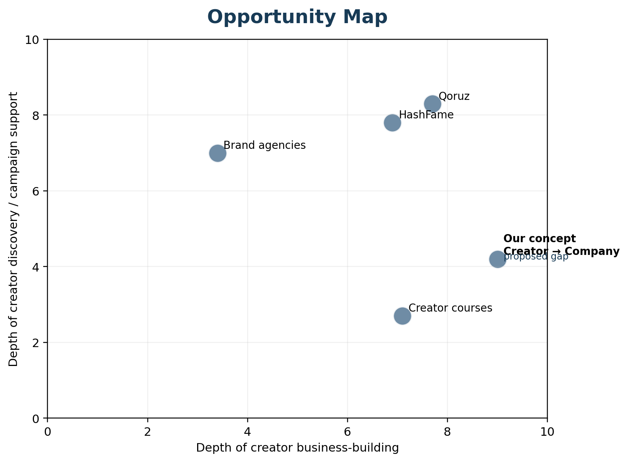
Figure 1. Conceptual opportunity map comparing campaign/discovery support with creator business-building depth. The proposed position is a design hypothesis, not a measured market-share claim.
Opportunity statement: Create an integrated creator-business layer that helps a creator move from audience ownership to products, community, commerce and recurring income, rather than relying predominantly on one-off brand campaigns.

4.1 Design Principles for the Venture
- Owned relationships over rented reach: help creators build direct community relationships rather than depend only on platform algorithms.
- Diversified revenue over single-channel income: combine sponsorships with products, services, memberships, commerce or intellectual property.
- Regional relevance over generic creator tooling: support language, culture and niche community dynamics.
- Business capability over vanity metrics: measure repeat revenue, customer retention, conversion and product traction alongside views and followers.

5. Original Venture Concept: CREATOR → COMPANY
Concept. CREATOR → COMPANY is a fictional digital platform and creator-business operating layer designed to help promising creators transform audience trust into sustainable business assets. It is a creative proposal grounded in the market evidence above, not a claim that this venture currently exists.
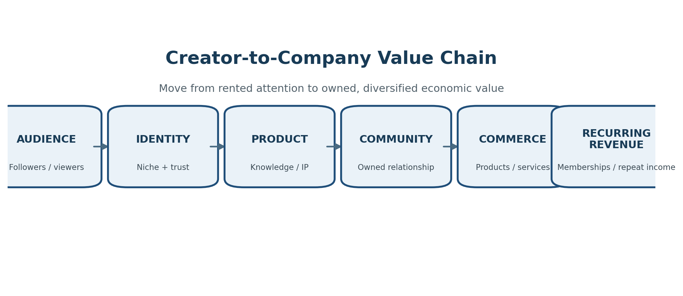
Figure 2. Proposed value chain for the fictional venture.
Module | Purpose | Illustrative output
Business Builder | Translate creator strengths into a business model. | Positioning, niche, customer profile, offer design.
Product Studio | Turn knowledge and creative IP into monetisable products. | Digital guide, course, service, toolkit, physical collaboration.
Community Engine | Convert passive followers into an owned relationship. | Membership, community events, newsletters, private groups.
Commerce Layer | Enable direct purchase and transaction. | Storefront, subscriptions, affiliates, product bundles.
Revenue Intelligence | Show where income comes from and what is repeatable. | Revenue mix, retention, conversion, campaign dependence.
Growth Intelligence | Connect content performance to business outcomes. | Content-to-commerce attribution and audience insights.

5.1 Business Model Hypothesis
- Primary customers: serious emerging creators, especially regional-language and non-metro creators who have demonstrated audience trust but lack diversified monetisation infrastructure.
- Revenue streams: creator subscription, transaction/commerce fee, premium business services and selected enterprise partnerships.
- Core value proposition: move from campaign income to a creator-owned business with multiple revenue channels.
- Key partners: commerce/payment providers, creator platforms, brands, fulfilment partners, educators and digital service providers.
- Key success metrics: creator activation, product launch rate, repeat revenue, revenue diversification, customer retention and creator business survival.

6. Narrative World and Story Premise
Working title: From Audience to Enterprise
Logline: A regional content creator who appears to have achieved digital success discovers that followers and occasional brand deals do not constitute a stable business, forcing her to choose between short-term money and the long-term company she begins building for herself.
Narrative question: Can a creator turn attention into independence without sacrificing the identity and trust that made the audience valuable in the first place?

7. Character Development
Character | Role | Motivation | Conflict | Relationship with protagonist
Aarohi Kulkarni | Protagonist; regional creator | Build an independent career without abandoning her identity. | Income volatility, self-doubt, algorithm dependence, temptation of lucrative brand deals. | Central character; grows from creator to entrepreneur.
Kabir Mehta | Best friend / informal operations partner | Protect Aarohi from reckless business decisions while helping her experiment. | Believes she is risking stable campaign income for an unproven idea. | Confidant and reality check.
Meera Shah | Brand partnership lead | Find creators who can deliver authentic regional trust and measurable outcomes. | Needs performance certainty and short-term campaign results. | Represents the established brand economy.
Dev Patil | Early customer / community member | Wants practical value from Aarohi’s expertise, not just entertainment. | Initially distrusts paid products from creators. | Becomes evidence that the audience can become a community/customer base.
Rohan Sethi | Platform / investor figure | Wants rapid scale and measurable growth. | Pushes for volume and brand deals over long-term creator independence. | External pressure and strategic antagonist.

7.1 Character Interaction Dynamics
- Aarohi ↔ Kabir: trust versus caution. Their conversations externalise the internal debate between stability and experimentation.
- Aarohi ↔ Meera: short-term brand opportunity versus authentic long-term positioning.
- Aarohi ↔ Dev: the transition from audience member to paying customer reveals whether the business actually creates value.
- Aarohi ↔ Rohan: growth pressure tests whether the protagonist will become another campaign-dependent creator or build an independent enterprise.

8. Central Themes
Theme | How it appears | Narrative function
Visibility vs. value | Followers create visibility; products and customer relationships create value. | Drives the protagonist’s transformation.
Independence vs. immediate reward | A large brand deal offers money but conflicts with the venture’s identity. | Creates the climax decision.
Identity as an asset | Regional language and cultural specificity make the creator distinctive. | Explains differentiation and emotional connection.
Ownership | The story asks who owns the audience relationship and economic upside. | Turns the creator economy into an entrepreneurship story.
Failure as information | Early product failure reveals the real customer need. | Makes the narrative growth credible rather than miraculous.

9. Detailed Storyline Outline
Act I — The illusion of success: Aarohi has built a respected regional audience around practical lifestyle and entrepreneurship content. A few brand collaborations create visible success, but income swings sharply from month to month. Her family assumes the problem is solved; Aarohi knows it is not.
Inciting incident: A major brand offers a lucrative campaign. The deal would cover months of expenses but requires Aarohi to promote a product that clashes with the trust she has built with her audience.
Rising Action I: She accepts smaller, safer campaigns while researching what her audience actually wants. A recurring pattern appears: followers repeatedly ask her for structured help, tools and resources rather than more motivational content.
The experiment: Aarohi launches a small paid digital product. The first version performs poorly. Reviews show that the audience does not want a generic course. They want a practical system, local examples and community accountability.
Midpoint revelation: She reframes the business: her audience is not merely an attention pool. It is a community with recurring problems that can be solved with products, services and shared experiences.
Rising Action II: She builds a small membership community, launches a redesigned product and tests one commerce partnership. Revenue remains modest, but the mix becomes more stable. A platform growth adviser pressures her to abandon the slow model in favour of more sponsorships.
Climax: The original major brand returns with an even larger offer. Taking it would immediately solve her cash-flow problem but would conflict with the business she is building. Aarohi chooses the uncertain path and turns the brand proposal down.
Falling Action: The community responds. Early customers renew memberships, a regional partner joins, and the redesigned product begins to generate repeat sales. The business is no longer dependent on one campaign.
Resolution: Aarohi has not become a celebrity billionaire. She has achieved something more meaningful: a creator business whose revenue comes from multiple sources and whose audience relationship has become an owned economic asset.
Closing image: A dashboard shows several small recurring revenue streams replacing one giant but unstable campaign number. Aarohi closes her laptop after checking next month’s confirmed income. The final line: “For the first time, the story was hers to own.”

10. Narrative Arc Illustration
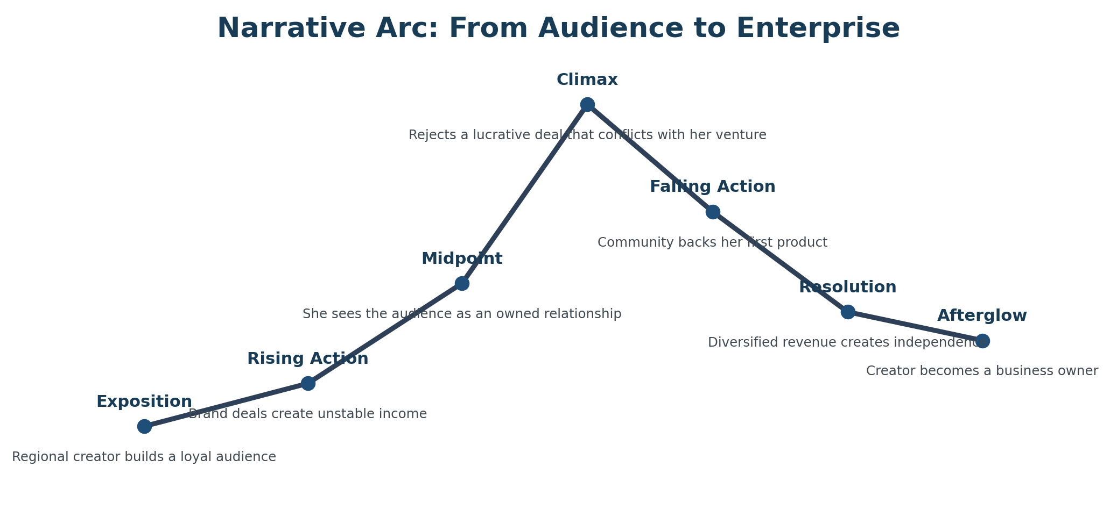
Figure 3. Narrative arc showing the movement from visible success to business independence.
Stage | Story event | Emotional / business purpose
Exposition | Aarohi grows a regional audience and gains occasional brand work. | Establishes the apparent success and the hidden instability.
Rising Action | Income volatility, brand pressure and first failed product experiment. | Raises external and internal stakes.
Climax | A high-value brand deal conflicts with the business she wants to build. | Forces a values-based entrepreneurial decision.
Falling Action | Community adoption and diversified revenue begin to validate her model. | Releases tension and demonstrates consequences.
Resolution | Aarohi becomes a creator-business owner with multiple income channels. | Completes the transformation and reinforces the theme of ownership.

11. Narrative and Business Credibility Checks
- No instant success: the protagonist experiments, fails and iterates before finding product-market fit.
- No billionaire ending: success is defined by sustainable income and strategic independence rather than unrealistic wealth.
- No “technology solves everything” shortcut: the platform supports decisions, but the creator still has to understand customers and make trade-offs.
- No claim that the fictional venture already exists: all venture details are explicitly presented as a creative proposal.
- Use real ecosystem players only as case studies. Do not imply endorsement, partnership or factual association with the fictional concept.

12. Expected Creative Outputs from the Framework
- Full short story or narrative script based on the framework.
- Character profiles and relationship map.
- Visual storyboard for key scenes.
- Creator-business value-chain graphic.
- Opportunity / competitor landscape graphic.
- Narrative arc visualization.
- Optional social or presentation adaptation for digital storytelling.

13. Skills Demonstrated
- Market research and opportunity identification
- Creative ideation and concept development
- Narrative planning and story architecture
- Character creation and conflict design
- Business-model thinking
- Audience and consumer analysis
- Visual communication
- Strategic use of evidence in creative work

14. Conclusion
Week 1 establishes a research-grounded foundation for a complete creative storytelling project. The selected concept uses a verified shift in India’s creator economy as its business context and translates the gap between creator participation and sustainable monetisation into a human conflict. The narrative deliberately avoids a conventional “overnight success” storyline. Instead, it focuses on experimentation, failure, identity, customer discovery and an entrepreneurial choice between short-term revenue and long-term ownership.

15. References and Research Sources
- [1] Indian School of Business (ISB) & Hashfame. “India’s Creator Economy Enters a New Phase as Non-Metro Creators Become the Majority.” 14 July 2026. https://www.isb.edu/news/press-releases/india-s-creator-economy-enters-a-new-phase-as-non-metro-creators-become-the-majority-reveals-isb-hashfame-report
- [2] Boston Consulting Group (BCG). “From Content to Commerce: Mapping India’s Creator Economy.” 3 May 2025. https://www.bcg.com/publications/2025/india-from-content-to-commerce-mapping-indias-creator-economy
- [3] Qoruz. “Qoruz Influencer / Creator Platform.” https://creators.qoruz.com/ and https://qoruz.com/influencer-marketing-services/india
- [4] ISB & Hashfame. “Understanding the Canvas of India’s Creator Economy: From Participation to Productivity.” 2026 interactive research report. https://prodcd.isb.edu/media/ykmjlwaj/india_creator_economy_interactive_report.html
Research note: Market figures and company descriptions are presented as reported by the cited sources. The venture concept, characters, storyline, business model and narrative events are original creative-development material and are not presented as factual events.

