<足迹Footprint>

软件架构文档

版本 <2.0>

修订历史记录

|  |  |  |  |
| --- | --- | --- | --- |
| **日期** | **版本** | **说明** | **作者** |
| <27日/4月/2022年> | <1.0> | <第一版软件架构文档 > | <付秋林 杨成昊> |
| <15日/6月/2022年> | <2.0> | <第二版软件架构文档 > | <杨成昊> |
|  |  |  |  |
|  |  |  |  |

目录

1. 简介 4

1.1 目的 4

1.2 参考资料 4

2. 用例视图 4

3. 逻辑视图 4

3.1 概述 4

3.2 在构架方面具有重要意义的设计包 4

4. 进程视图 4

5. 部署视图 4

6. 实现视图 5

7. 技术视图 5

8. 质量属性的设计 5

软件架构文档

# 简介

## 目的

本文档将从构架方面对系统进行综合概述，其中会使用多种不同的构架视图来描述系统的各个方面。它用于记录并表述已对系统的构架方面作出的重要决策。

## 参考资料

# 用例视图

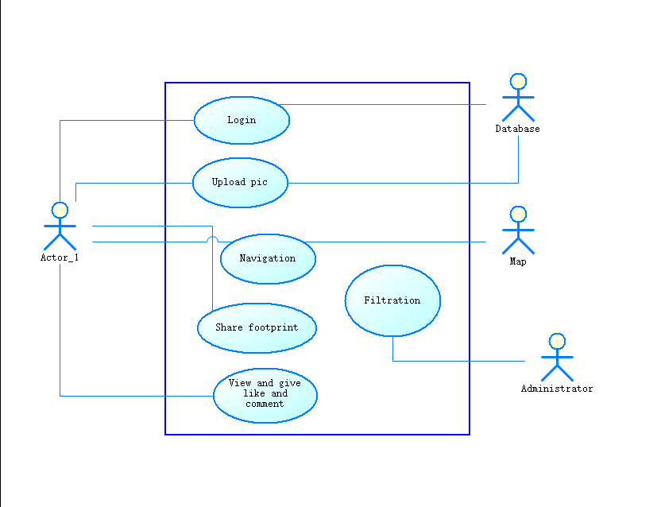

# 逻辑视图

When deploying the architecture of application Footprint, we employed the style of Layered Architecture, which is shown as below.

**3.1. Middleware Layer**

The middleware layer of FootPrint provides underlying libraries, including operation system, hardware interface, device drivers, and so on.

**3.2. Business Specific Layer**

The business-specific layer of FootPrint contains a number of reusable subsystems, including image library, community information library and mapping system.

**3.3. Application Layer**

The application layer of FootPrint includes interface of external system, support to object storage, GUI interface, and so on.

# 进程视图

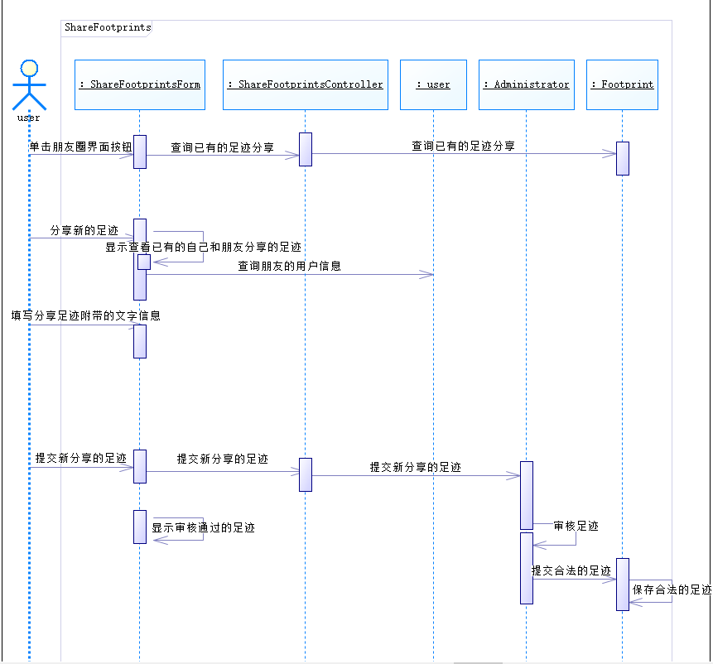

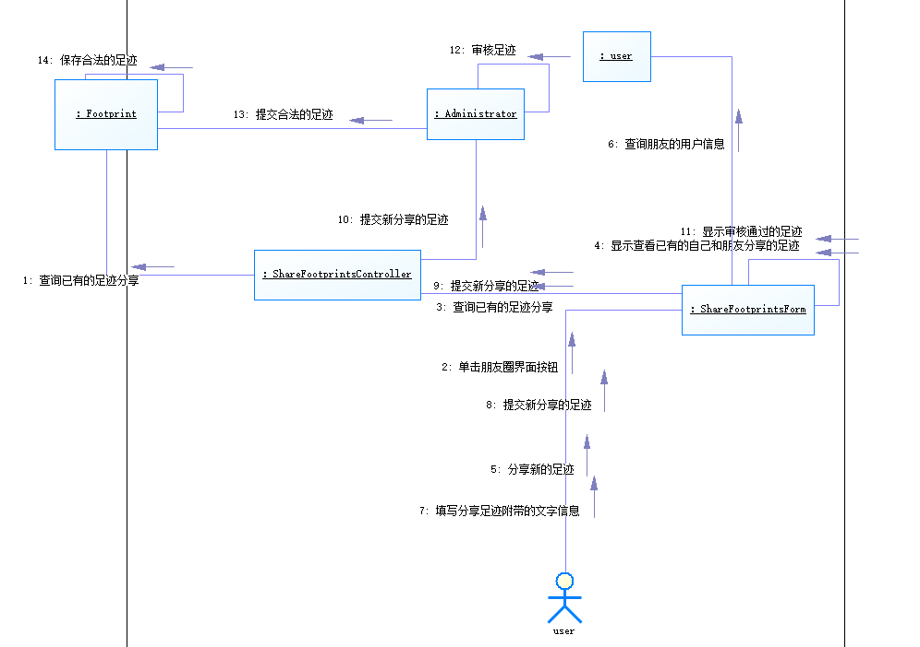

# 部署视图

The deployment view of the architecture describes the various physical nodes for the most typical platform configurations, as well as the allocation of tasks (from the Process View) to the physical nodes.

This section is organized by physical network configuration; each such configuration is illustrated by a deployment diagram, followed by a mapping of processes to each processor.

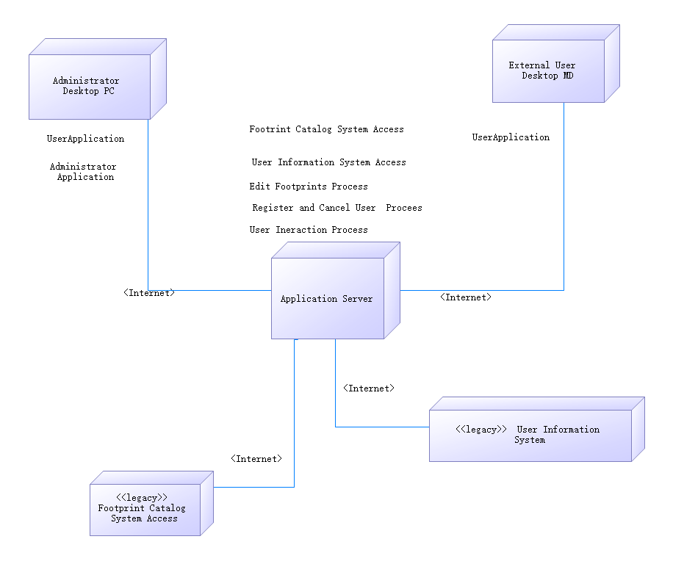

Diagram Name: Deployment View

**5.1****. External User Desktop MD**

People register for or cancel user identity and do edit footprints process by using external desktop MDs which are connected to the Application Server via internet dial up.

**5.2. Administrator Desktop PC**

Administrators manage the footprints’ and users’ catalog by using adminstrator desktop PCs.

**5.3****. Application Server**

The Application Server is the main server. Administrators and users have access to the Server through Internet.

**5.4****. Footprint Catalog System**

The Course Catalog System is a legacy system that contains the complete footprints catalog. Access to it is available via the Application Server and Internet.

**5.5.** **User Information System**

The User Information System is a legacy system that generates the users’information.

# 实现视图

**6.1. Middleware Layer**

The middleware layer of FootPrint provides underlying libraries, including operation system, hardware interface, device drivers, and so on.

**6.2. Business Specific Layer**

The business-specific layer of FootPrint contains a number of reusable subsystems, including image library, community information library and mapping system.

**6.3. Application Layer**

The application layer of FootPrint includes interface of external system, support to object storage, GUI interface, and so on.

# 技术视图

1. 编程语言采用java和javascript语言
2. 开发工具与框架使用 react naïve
3. 数据库使用Mysql

# 核心算法设计（可选）

1、基于关系的推荐

a.社会网络中，三元闭包理论，以及常用推荐算法

b.Facebook中的推荐算法是如何做的

2、基于用户资料的推荐

3、基于兴趣的推荐

# 质量属性的设计

本系统采用的软件架构可以很好的支持软件质量方面的需求：

1. 系统应当方便所有用户的使用，对于有智能手机使用经验的用户的培训时间应不超过2分钟。
2. 系统应该提供在线的支持帮助。
3. 系统必须能够保证每天24小时不间断运行，可用率为99%。
4. 合理的设计系统的结构以保证较高的可维护性，系统的模块应该可替换。
5. 系统应当正确处理发生的异常或者错误，并返回错误信息。