WeSketch

User’s Manual

Team Infinity

# Table of Contents

1.0 GENERAL INFORMATION 2

1.1 System Overview 3

1.2 Organization of the Manual 3

2.0 SYSTEM SUMMARY 4

2.1 System Configuration 5

2.2 User Access Levels 5

2.3 Contingencies 5

3.0 GETTING STARTED 6

3.1 Installation 7

3.2 Access 7

3.2.1 Registration 7

3.2.2 Logging In 7

3.3 Exiting the System 7

4.0 USING THE SYSTEM 8

4.1 Inviting a User to the Board 9

4.2 Joining a Board 9

4.3 Writing on the Board 10

4.4 Changing the Pen Color 10

4.5 Changing the Brush Size 10

4.6 Erasing 11

4.7 Viewing Users Connected to the Board 11

4.7.1 Kick a User off Board 11

# General Information

## 1.0 General Information

General Information section explains in general terms the system and the purpose for which it is intended.

## 1.1 System Overview

The WeSketch application allows office users the ability to collaborate on a shared drawing board from the convenience of their own offices within an organization.

## 1.2 Organization of the Manual

The user’s manual consists of four sections: General Information, System Summary, Getting Started, and Using the System.

General Information section explains in general terms the system and the purpose for which it is intended.

System Summary section provides a general overview of the system. The summary outlines the uses of the system’s hardware and software requirements, system’s configuration, user access and system’s behavior in case of any contingencies.

Getting Started section explains how to get WeSketch and install it on the device.

Using The System section provides a detailed description of system functions.

# System Summary

## 2.0 System Summary

System Summary section provides a general overview of the system. The summary outlines the uses of the system’s hardware and software requirements, system’s configuration, user access and system’s behavior in case of any contingencies.

## 2.1 System Configuration

WeSketch operates on PC’s running the Windows operating system. It is compatible with Windows 7 and higher versions running .NET Framework 4.5 and higher. The application requires connection to the Internet in order to login and view user boards. After installation on the PC, WeSketch can be used immediately without any further configuration.

## 2.2 User Access Levels

Everyone can use application. After logging in a user board is created. The user is considered the owner of the board and can decide who has access to the board. If the user joins another board then the user is considered a board contributor.

## 2.3 Contingencies

Once a board owner signs off or leaves a board the board is deleted. In case of power outage data is not saved in internal memory of the operating device or on the host server. The system will not operate without connection to the host server.

# Getting Started

## 3.0 Getting Started

Getting Started section explains how to get WeSketch and install it on the computer.

## 3.1 Installation

To install WeSketch on your computer run the wesketchinstaller.exe provided at <http://downloads.teaminfinityuis.com/WSDownloads/WeSketchInstaller.zip>.

## 3.2 Access

To access the system you must first run the application and register for an account.

## 3.2.1 Registration

To register for an account click the Register link and then enter your username, email address, password and confirmation password then click Register.

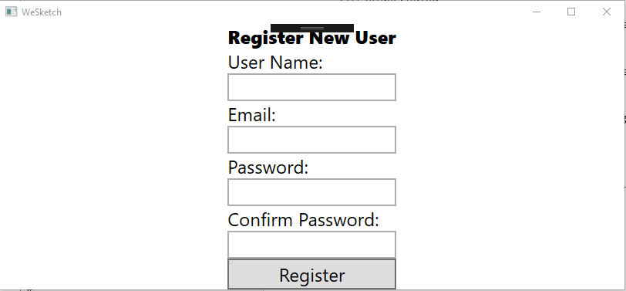

## 3.2.2 Logging In

To login to the application enter your username and password and click Login.

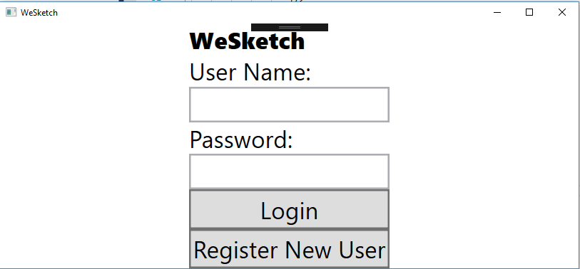

## 3.3 Exiting the System

To exit the system click the close button at the top right of the application window.

# Using the System

## 4.0 Using the System

This section provides a detailed description of system functions.

## 4.1 Inviting a User to the Board

To invite a user to the board click on the Invite button, enter the username or email address of the user you would like to join on the Invite window and then click the Invite button. To cancel this operation click the Cancel button on the Invite window.

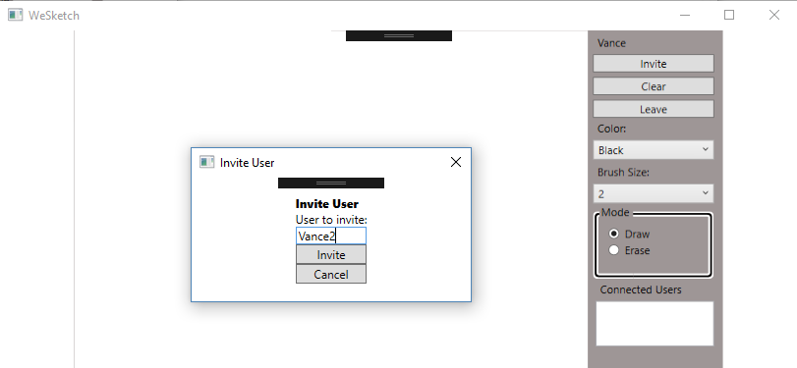

## 4.2 Joining a Board

After a user has logged in and been invited to join a board they will be presented with a notification asking them to join the board. To join the board click the Yes button to join the other user’s board.

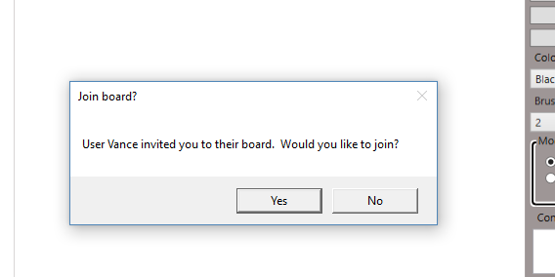

## 4.3 Writing on the Board

To write on the board you will need to use your mouse or a finger or pen on a touch screen device. To use the mouse click the left button to begin drawing and use the mouse to create your drawing. To use a touch screen device simply use your finger or pen on the white board to create your drawing.

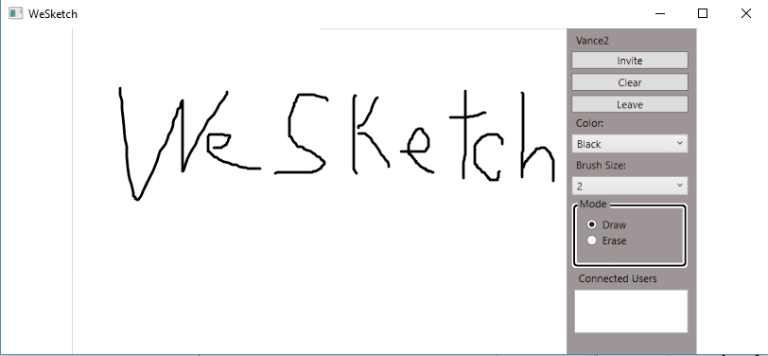

## 4.4 Changing the Pen Color

To change your pen color select the color you would like to use from the Color drop down.

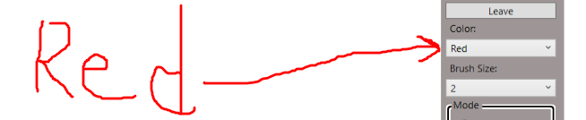

## 4.5 Changing the Brush Size

To change your brush size select the size you would like the brush to be from the Brush Size drop down.

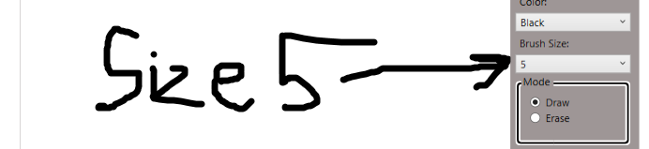

## 4.6 Erasing

To erase select Erase from the Mode box and click on the line that you would like to erase. Erasing will erase the entire line or stroke from the white board.

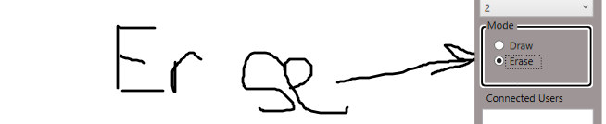

## 4.7 Viewing Users Connected to the Board

To view users connected to the board simply click the user list list to scroll through the list of connected users.

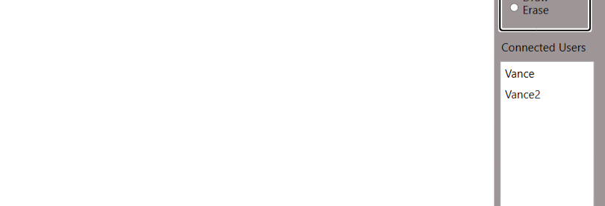

## 4.7.1 Kicking a User off Board

The board owner has the ability to kick a user off of the board. To kick a user off the board select the user name from the list of connected users and click the Kick User button.

