**Tyk On-Premises**

**1.使用docker安装**

**安装tyk-gateway**

下载redis镜像

docker pull redis

**下载**Tyk Gateway镜像

docker pull tykio/tyk-gateway

**运行redis**

docker run -d --name tyk_redis redis

用您的（修改过的）tyk.conf运行一个独立的Tyk Gateway

在当前目录创建tyk.standalone.conf文件

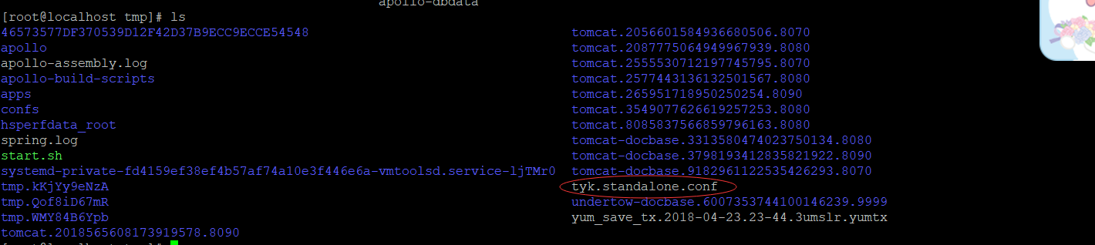

使用vi工具将文件内容改为：

|  |
| --- |
| { |
|  | "listen_address": "", |
|  | "listen_port": 8080, |
|  | "secret": "352d20ee67be67f6340b4c0605b044b7", |
|  | "template_path": "/opt/tyk-gateway/templates", |
|  | "use_db_app_configs": false, |
|  | "app_path": "/opt/tyk-gateway/apps", |
|  | "middleware_path": "/opt/tyk-gateway/middleware", |
|  | "storage": { |
|  | "type": "redis", |
|  | "host": "redis", |
|  | "port": 6379, |
|  | "username": "", |
|  | "password": "", |
|  | "database": 0, |
|  | "optimisation_max_idle": 500 |
|  | }, |
|  | "enable_analytics": false, |
|  | "analytics_config": { |
|  | "type": "", |
|  | "ignored_ips": [] |
|  | }, |
|  | "optimisations_use_async_session_write": true, |
|  | "allow_master_keys": false, |
|  | "policies": { |
|  | "policy_source": "file" |
|  | }, |
|  | "hash_keys": true, |
|  | "suppress_redis_signal_reload": false |
|  | } |

运行：

docker run -d --name tyk_gateway -p 8180:8080 --link tyk_redis:redis -v $(pwd)/tyk.standalone.conf:/opt/tyk-gateway/tyk.conf -v $(pwd)/apps:/opt/tyk-gateway/apps tykio/tyk-gateway

**安装tyk-dashboard**

**安装Mongo**

docker run -d --name tyk_mongo mongo

**安装dashboard**

运行：

docker run -d --name tyk_dashboard -p 3000:3000 --link tyk_redis:redis --link tyk_mongo:mongo --link tyk_gateway:tyk_gateway tykio/tyk-dashboard

**设置DNS**

vi /etc/hosts

添加127.0.0.1 dashboard.tyk.docker

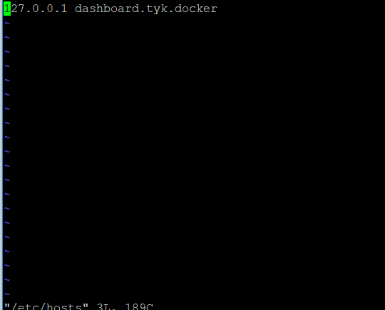

**初始化用户名密码**

**从github下载文件：**

git clone <https://github.com/TykTechnologies/tyk-dashboard-docker.git>

**运行初始化脚本：**

./bootstrap.sh dashboard.tyk.docker

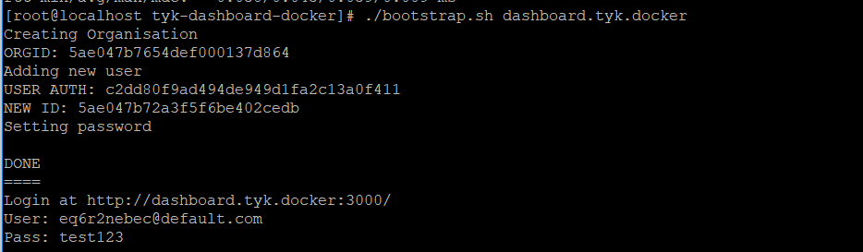

要使用外部配置文件，请使用该-v选项将其挂载/opt/tyk-dashboard/tyk_analytics.conf

**检查是否安装成功**

访问：<http://10.0.4.17:3000> 输入用户名: [eq6r2nebec@default.com](mailto:eq6r2nebec@default.com) 密码：test123

**安装Tyk Pump container**

docker run -d --name tyk_pump --link tyk_redis:redis --link tyk_mongo:mongo tykio/tyk-pump-docker-pub

1. **界面**

