Model Performance Analysis

# 1. Training History and RMSE Analysis

The training history file contains the following key metrics for each iteration (epoch): Training RMSE and Evaluation RMSE. The plot below shows the RMSE values for both the training and evaluation datasets over iterations.

Training and Evaluation RMSE Over Iterations:

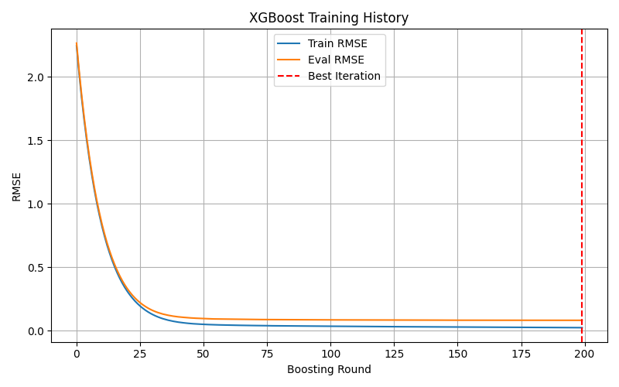

As shown in the plot, the model's training and evaluation RMSE values converge over time, indicating that the model is learning effectively. The training RMSE decreases rapidly during the first few iterations, while the evaluation RMSE stabilizes at a low value, indicating good generalization to the validation set.

# 2. Final RMSE Values

Final Training RMSE: 0.025  
Final Evaluation RMSE: 0.083

# 3. Model Evaluation Metrics

In addition to RMSE, the model's performance was evaluated using other regression metrics: Mean Absolute Error (MAE), Mean Squared Error (MSE), and R-squared (R²). Here are the results of those metrics:

Mean Absolute Error (MAE): 0.042  
Mean Squared Error (MSE): 0.0027  
R-squared (R²): 0.977