Question 1

Answer: 17.72

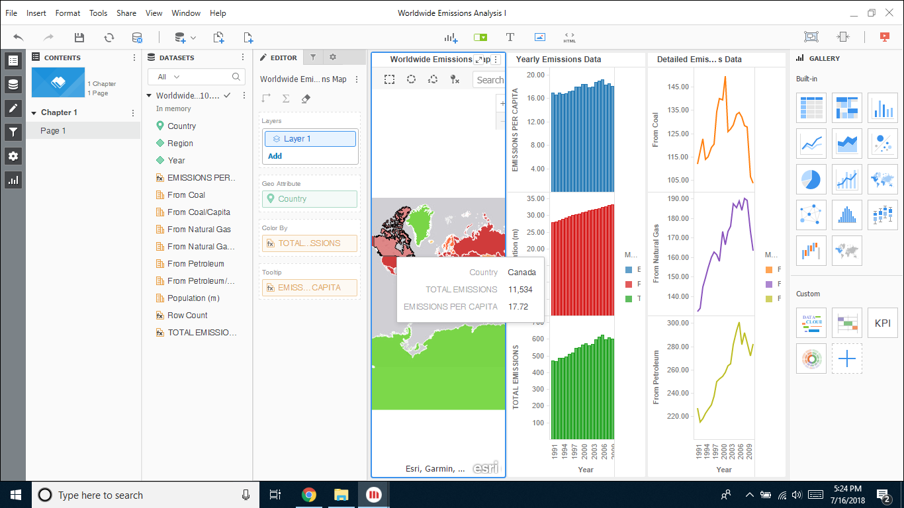

Question 2

Answer: There has been an increment in emission with each year, only a slight dip in the year 2009.

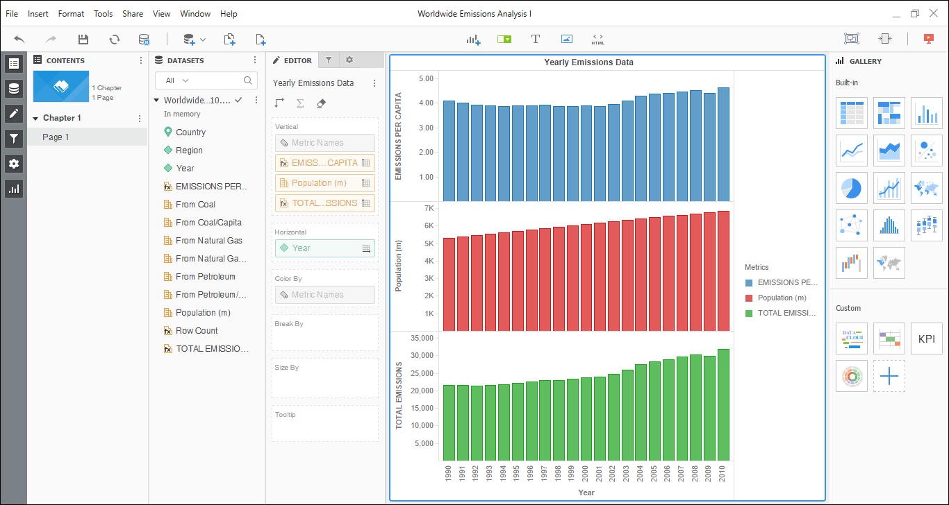

Question 3

Answer:

Emissions decreases in 2009 due to global recession.

For US, the drop was very significant.

