# 东芝TBA-FX8

## 接口说明

| 仪器厂商 | 东芝TBA-FX8 | 仪器型号 | 东芝TBA-FX8 |
| --- | --- | --- | --- |
| 通讯方式 | 单向|双向☑|主动上传 | 仪器类型 | 生化 |
| 医院名称 |  | 程序名称 |  |
| 终端服务器地址 |  | 终端服务器端口号 |  |

## **仪器上接口标示和接口类型**

1. 接口类型：串口☑|网口|监听文件|数据库|其他

1. 连接方式：HL7协议|ASTM协议|监听文件|数据库|其他☑

## 仪器接口说明

* 仪器连接说明 <https://file6d66f4de2a95.vrh5.cn/v3/idea/YnWDdZ8i?suid=7CBF7E3A-ECBC-4D30-8B49-03C69FF065C3&sl=1>

* 仪器回复一定要回复【2】【6】【3】，单纯回复【6】，仪器会识别不到，造成传输结果过慢

* + ​image​

* 仪器设置为双向后无法单向，质控以及定标，本院为仪器厂商到现场固定架子号位置，固定做单向质控

## 串口盒子配置

* **波特率：**9600

* **数据位：8**

* **停止位：**1

* **校验位：**N

## 仪器图片

​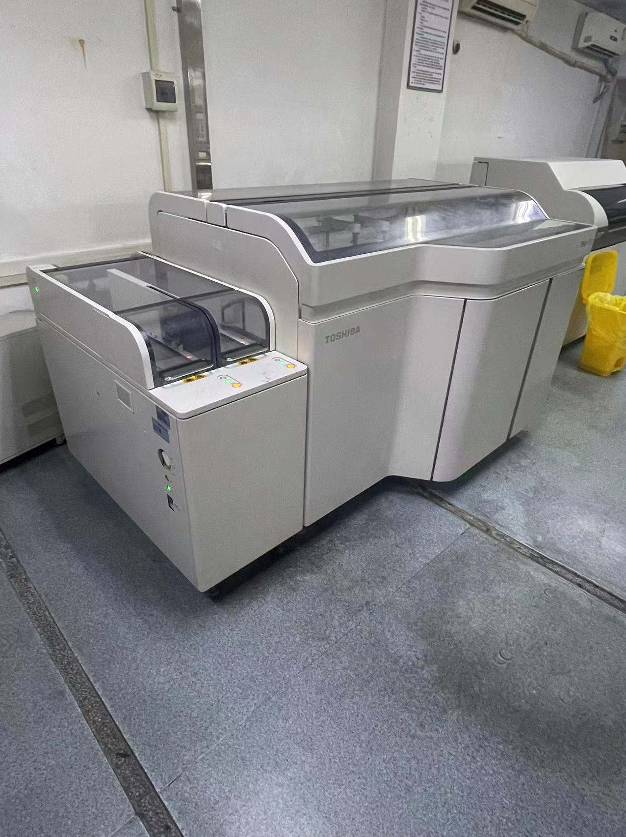​

## 仪器配置

点击下侧中间小电脑，再点击config即可查看配置

​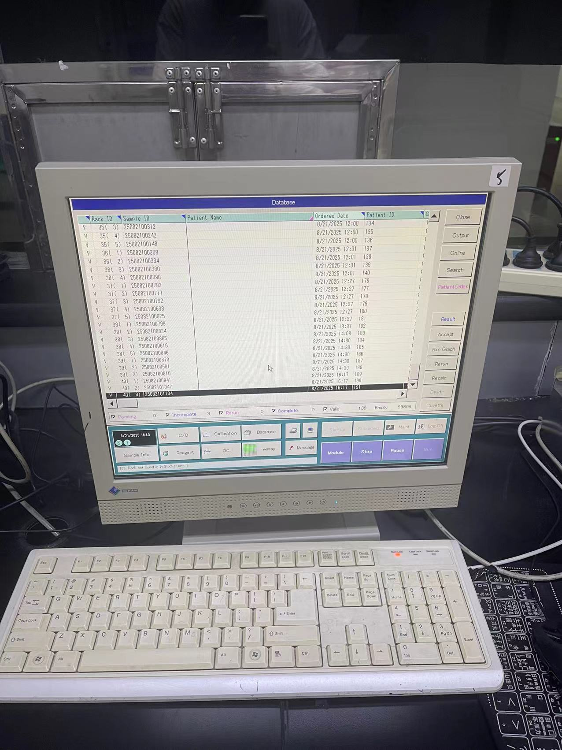​

​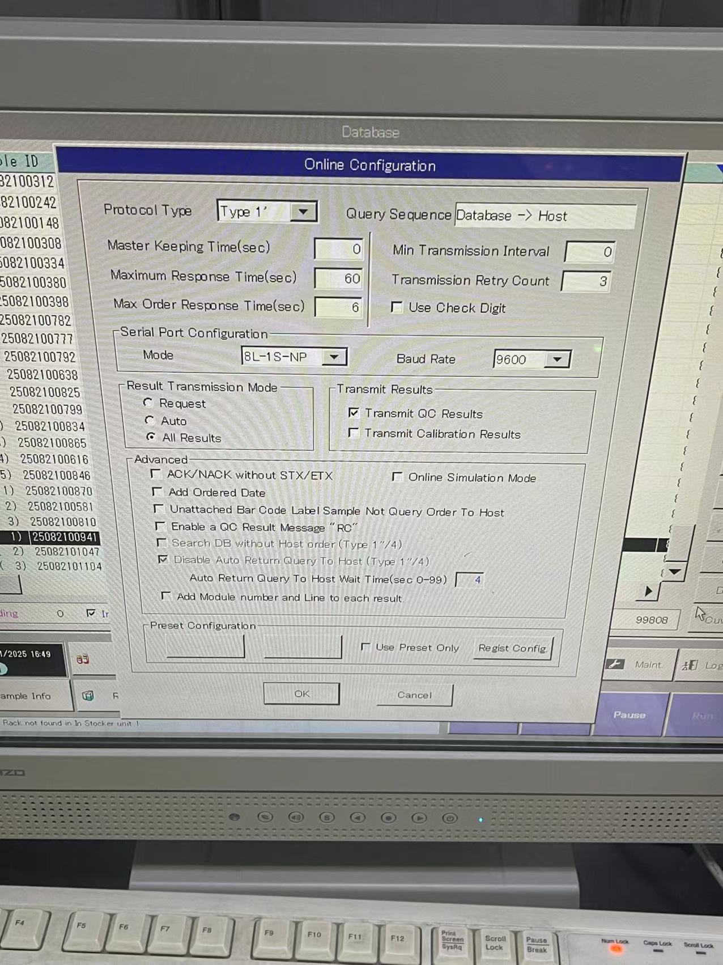​

双向配置切换

初始界面右下角Run按钮，随后点击System

​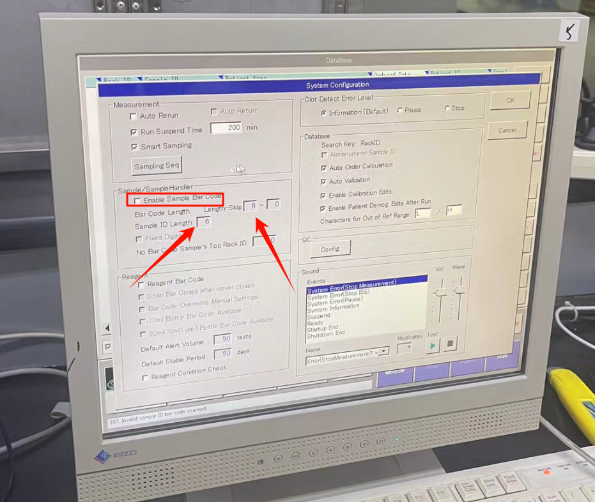​

传结果位置

点击右侧第三个按钮Online，弹窗后点击左侧第三个Send 即可发送

​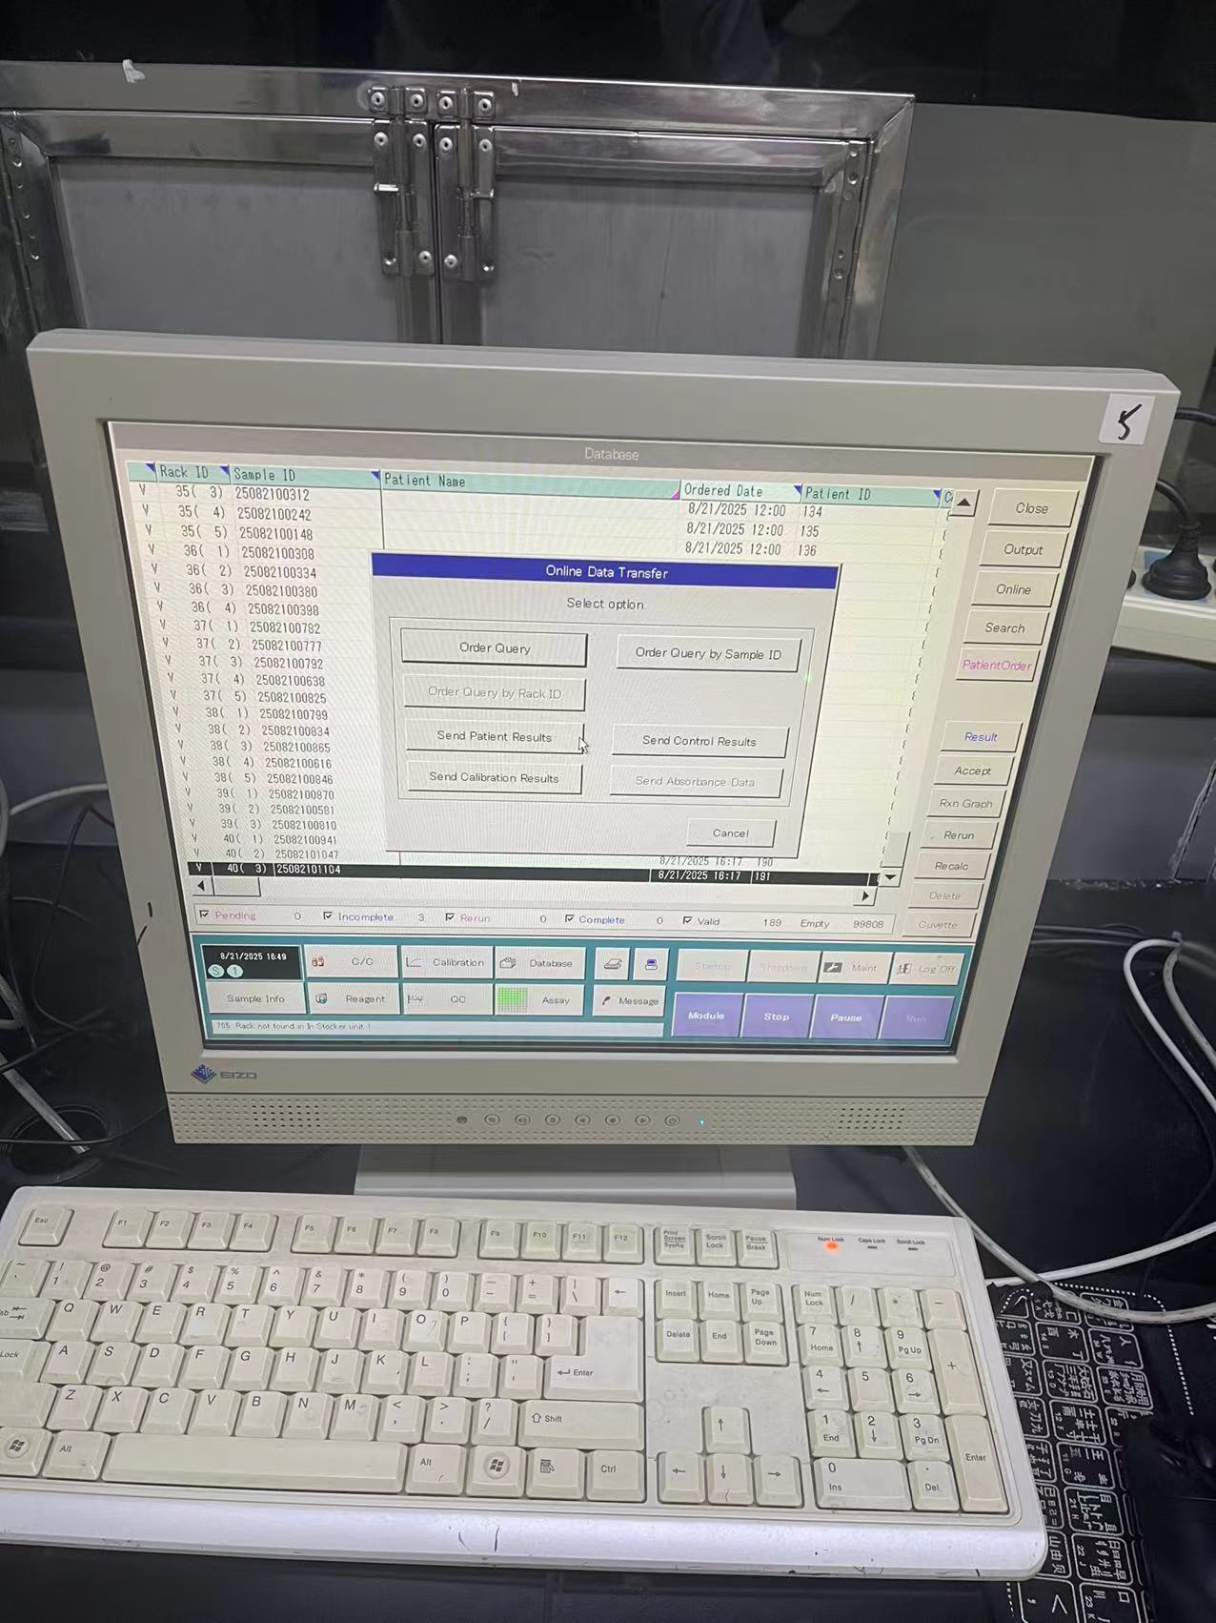​

## **数据格式**

双向请求数据

​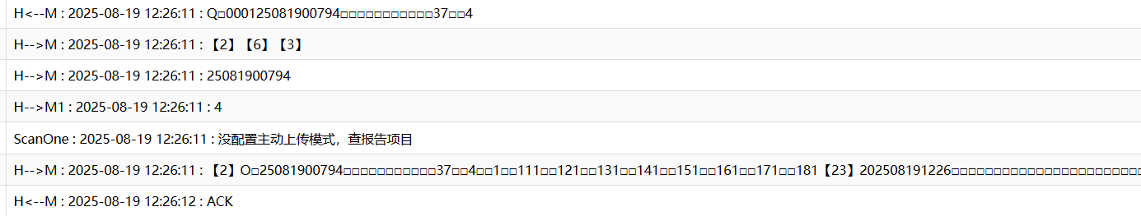​

H<--M : 2025-08-19 12:26:11 : Q□000125081900794□□□□□□□□□□□37□□4  
16  
H-->M : 2025-08-19 12:26:11 : 【2】【6】【3】  
17  
H-->M : 2025-08-19 12:26:11 : 25081900794  
18  
H-->M1 : 2025-08-19 12:26:11 : 4  
19  
ScanOne : 2025-08-19 12:26:11 : 没配置主动上传模式，查报告项目  
20  
H-->M : 2025-08-19 12:26:11 : 【2】O□25081900794□□□□□□□□□□□37□□4□□1□□111□□121□□131□□141□□151□□161□□171□□181【23】202508191226□□□□□□□□□□□□□□□□□□□□□□□□□□□□□□□□□□□□□□□□□□144□□□□□□□□□□□□□□□□□M20231031【23】【3】  
21  
H<--M : 2025-08-19 12:26:12 : ACK

结果格式

H<--M : 2025-08-19 12:39:15 : R□000125081900794□□□□□□□□□□□37□□4202508191238□□1□□11□□□□11□□□1A□□12□□□□15□□□1A□□13□□□□74□□□1A□□14□□42.8□□□1A□□15□□□122□□□1A□□16□□□□12□□□1A□□17□□□6.2□□□1A□□18□□□2.9□□□1A【23】202508191226□□□□□□□□□□□□□□□□□□□□□□□□□□□□□□□□□□□□□□□□□□144□□□□□□□□□□□□□□□□□M20231031【23】  
H-->M : 2025-08-19 12:39:15 : 【2】【6】【3】

## **项目通道号**

​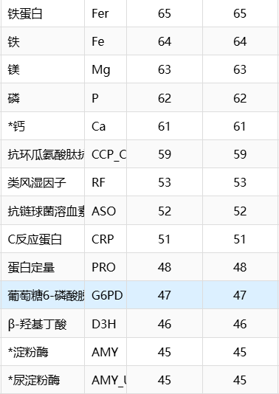​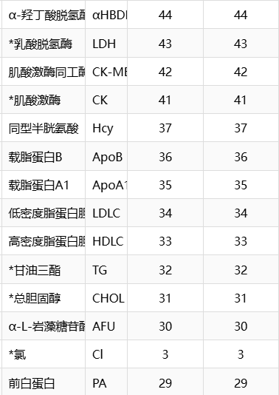​

​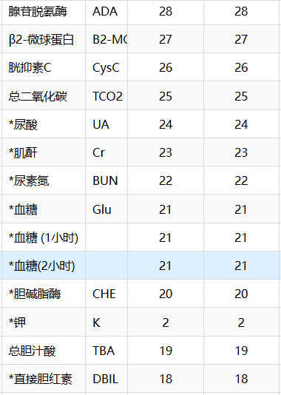​

​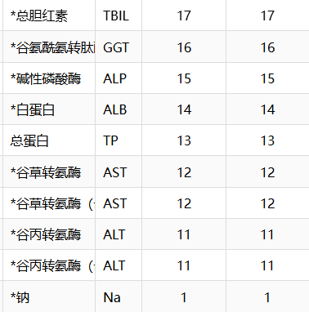​

​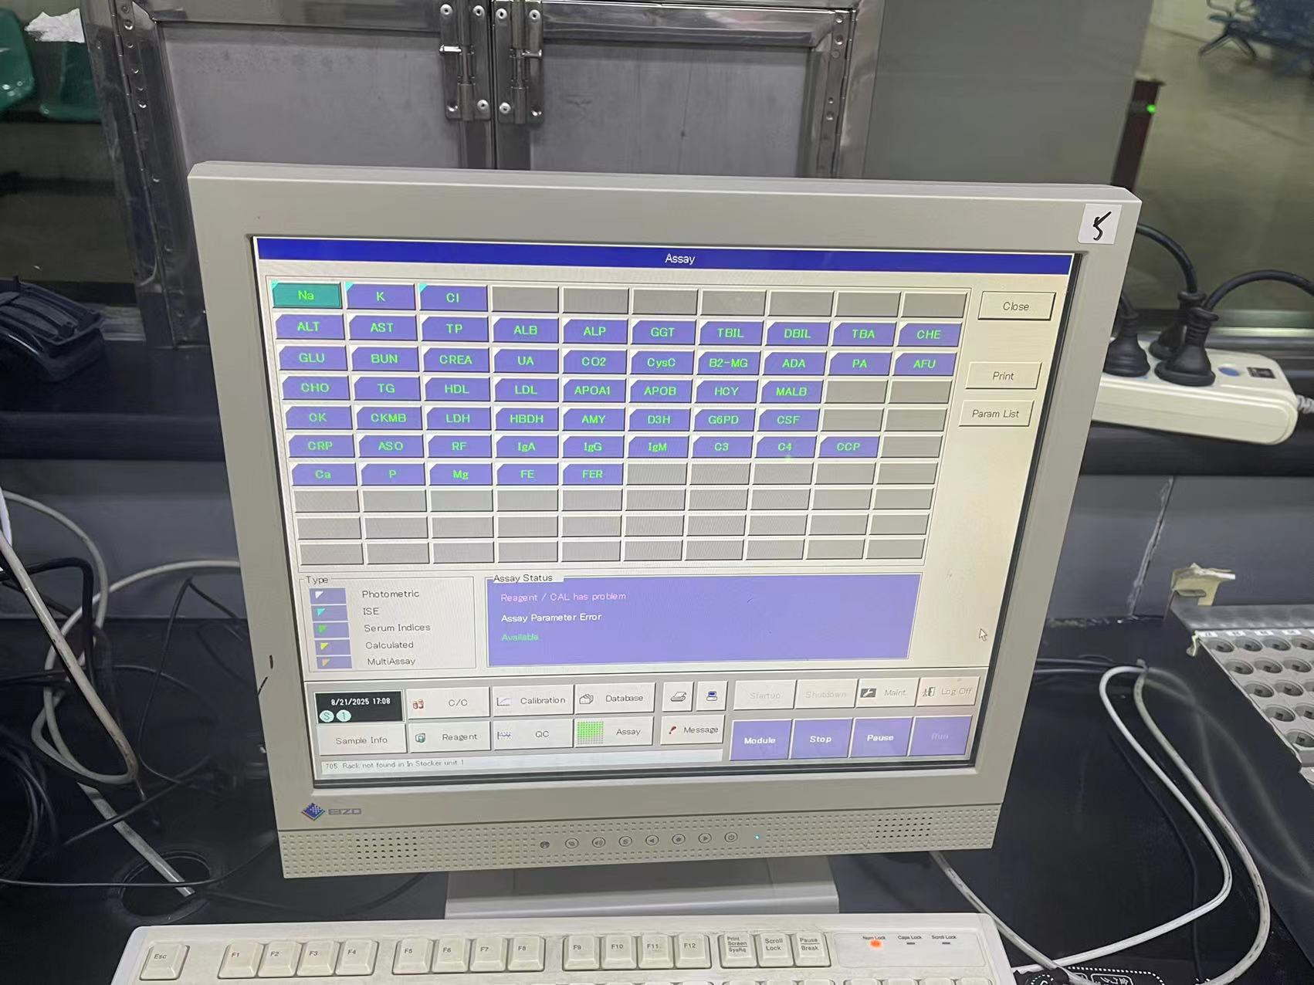​

点进去后AssayID就是通道号

​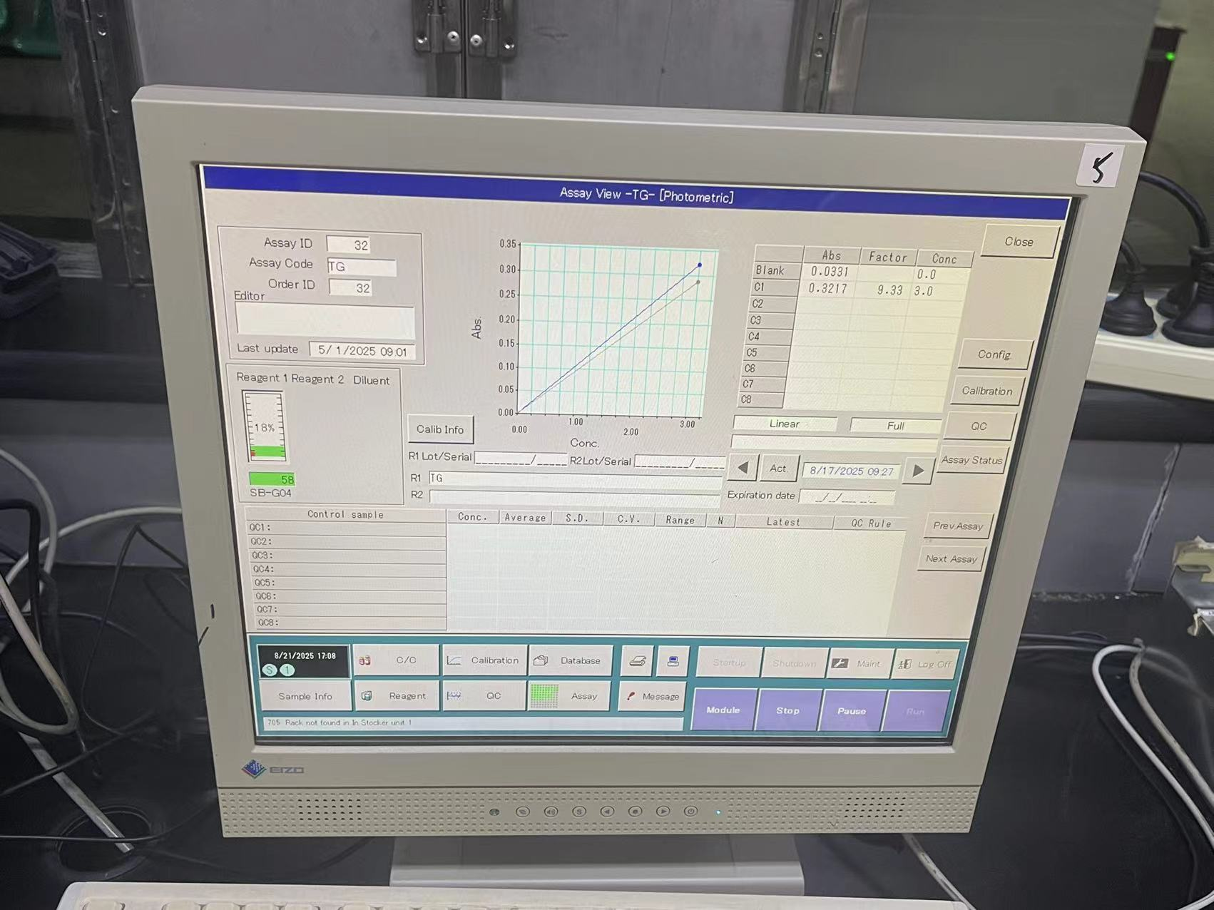​

点击下侧第二行第四个按钮Assay，弹窗后显示可选项目，按照位置为通道号，也可点进去可以查看通道号。

比如Na在第一个位置，就是1，第二行第二个AST，就是12，第四行第二个TG，就是32

## 修改记录

| 序号 | 日期 | 操作人 | 说明 |
| --- | --- | --- | --- |
| 1 | 2025-08-21 16:32:19 | 杨浩然 |  |

## 仪器接口程序

MIFTBABi2(mi)   
 s mi=$g(mi)   
 S ^TMPMACH10(mi,104)=$H  
 i '$l(mi) q  
 s ItemDeli=$li(^dbo.BTMIMachineParameterD(mi),12) //项目分隔符  
 s ResultDeli=$li(^dbo.BTMIMachineParameterD(mi),13) //结果分隔符  
 s AntDeli=$li(^dbo.BTMIMachineParameterD(mi),14) //抗生素分隔符  
 s SenDeli=$li(^dbo.BTMIMachineParameterD(mi),15) //药敏结果分隔符  
 s Port="|TCP|"_$li(^dbo.BTMIMachineParameterD(mi),17) //端口号  
 //控制字符  
 s stx=$c(2),etx=$c(3),ack=$c(6),enq=$c(5),eot=$c(4),etb=$c(23),crlf=$c(13,10)  
 s lf=$c(10),cr=$c(13),nak=$c(21),nak=$c(15),etb=$c(23),sp=$c(32),eot=$c(4),lf=$c(10),cr=$c(13)  
 i $$Start^MI.MIF000(mi) q  
 f d Main i $$Stop^MI.MIF000(mi) q  
 c Port  
 q  
   
   
RuntimeError  
 h 1  
 s iError=+$g(iError)+1  
 d Trace^MI.MIF000(mi,"Error Code:"_$ECODE_",Error:"_$ZERROR,"Runtime Error")  
 i iError>1000 s ret=$$Stop^MI.MIF000(mi)  
 Q   
   
Main   
 //202310111404TEST□□□□□□□□□□□□□□□□□□□□□□□□□□□□□□□□□□□□□□1325□□□□□□□□□□□□□□□□M20131011  
 S $ZT="RuntimeError",$ECODE="",iError=0 //捕获运行时错误,并显示  
 d BUILD  
 s record=$$Read^MI.MIF000(mi,stx,etx,"","",2) q:'$l(record)  
 d Trace^MI.MIF000(mi,record,"H<--M")  
 S i=0  
 s lab=""  
 s i=i+1  
 s type=$p(record," ",1)  
 w stx,ack,etx,*-3 d Trace^MI.MIF000(mi,stx_ack_etx,"H-->M")  
 s (sample,surname,result,date,time,QC,res,counter)=""  
 s type=$TR($E(record,1,2)," ")  
 i type="Q" d  
 .s temlabno=$tr($E(record,7,26)," ")  
 .I $E(temlabno,1)=0 S temlabno=$E(temlabno,2,$L(temlabno))  
 .i '$l(temlabno) q  
 .s racksid=$tr($E(record,18,33)," ")  
 .s rackno=$tr($E(record,33,$l(record))," ")  
 .s IDGroup=$e(record,7,33)  
 .S temlabno=$tr(temlabno," ")  
 .d Trace^MI.MIF000(mi,temlabno,"H-->M")  
 .s positioninfo=$tr($e(record,27,30)," ")_"-"_$tr($e(record,31,33)," ")  
 .try{D ##class(MI.Special.Common).SaveRackNo(temlabno,positioninfo,mi,"上机")}catch{}  
 .d Trace^MI.MIF000(mi,rackno,"H-->M1")  
 .;s WGMEpisNo= ##Class(LIS.Common.DHCVisitNumber).GetMaxMiEpisodeNo(mi,$zd(+$h,8)) ;lyl20241128 取当前工作小组当前号段最大流水号  
 .;s retVal=$$ReceiveLabno^MI.MIF000(mi,temlabno,WGMEpisNo) ///核收标本 ;lyl20241128 尝试自动核收  
 .;i retVal'=1 q  
 .s ^TMP($zn,$j,"ENQ",temlabno)=IDGroup //racksid_"^"_rackno  
 .;s ^TMP(mi,"ENQ",temlabno)=IDGroup  
 .d BUILD  
 i type="R" d  
 .S epis=$tr($e(record,7,20)," ")  
 .i $l(+epis)<5 s epis=+epis  
 .;S QC=$$findQC^MIF000(mi,epis)  
 .I $E(epis,1)=0 S epis=$E(epis,2,$L(epis))  
 .s lab=epis  
 .//00000000082  
 .s positioninfo=$tr($e(record,27,30)," ")_"-"_$tr($e(record,31,33)," ")  
 .try{D ##class(MI.Special.Common).SaveRackNo(epis,positioninfo,mi,"结果")}catch{}  
 .s resstr=$e(record,50,$l(record))  
 .s resstr=$p(resstr,etb,1)  
 .f temi=1:15:$L(resstr) d  
 ..s res1=$e(resstr,temi,temi+14)  
 ..s code=$tr($e(res1,1,3)," ")  
 ..s res=$tr($e(res1,4,9)," ")  
 ..s result=result_code_ResultDeli_res_ItemDeli  
 .d Last  
 if (type="C")!(type="T")!(type="I")!(type="M")!(type="S")!(type="A") d Last q  
 q  
BL(a,b) ; pad field out to correct length  
 q $e(a_bl,1,b)   
Last ; file result if exist  
 s AllRecord=""  
 ;DownLoad TC  
 d BUILD  
 s epis=$tr(epis,"E","")  
 i $l(lab),$l(result) d Save^MI.MIF000(mi,lab,result,date,time,QC)  
 i $l(epis),$l(result) d Save^MI.MIF000(mi,epis,result,date,time,QC) //d Save^MI.MIF000(mi,sample,epis,surname,result,date,time,QC)  
 ;i QC="",$l(epis),$l(result) d Save^MI.MIF000(mi,sample,epis,surname,result,date,time,QC)  
 q  
BUILD  
 i '$d(^TMP($zn)) q  
 i '$d(^TMP($zn,$j)) q   
 m ^aai200(761)=^TMP($zn,$j,"ENQ")  
 s labno="" f s labno=$o(^TMP($zn,$j,"ENQ",labno)) q:labno="" d  
 .;根据预置条码号取得检验条码号  
 .;s ^aai200(763,labno)=""  
 .;s labno1=$$GetLabNo^CHDhcLabDoEpis(labno)  
 .;s ^aai200(764,labno)=labno1_","_labno_","_mi  
 .//----判断日志条码和系统条码是否一样----  
 .;If labno=labno1 Quit  
 .//--------------------------------------  
 .d ScanOne^MI.MIF000(mi,labno) ;^TMP("MIF-SINGLE",208912,"AH7471","A611071030",1)=  
 .;s labno=+labno  
 .;m ^aai200(762,labno)=^TMP("MIFTESTCODE",$j)  
 .;m ^TMP("QQQ")=^TMP("MIFTESTCODE",$j)  
 .s tcx="",count=0  
 .s chl="" f s chl=$o(^TMP("MIFTESTCODE",$j,mi,labno,chl)) q:chl="" d  
 ..s tcx=tcx_$j(chl,4)_1  
 ..s count=count+1  
 .s tcx=tcx_etb  
 .;s xx=$$extdate2^SSUTIL4($h),date=$p(xx,"/",3)_$p(xx,"/",2)_$p(xx,"/",1)  
 .s date=$TR($ZD($P($H,",",1),3),"-")  
 .s time=$TR($ZT($P($H,",",2),2),":")  
 .;s xx=$$exttime^SSUTIL4($p($h,",",2)),time=$p(xx,":",1)_$p(xx,":",2)  
 .s OrderStr=^TMP($zn,$j,"ENQ",labno)  
 .s OrderStr=OrderStr_" 1"_tcx //  
 .//s OrderStr=OrderStr_$j(count,3)_tcx //  
 .;S ordstr=ordstr_tcx_"|R||"_$TR($ZD($P($H,",",1),3),"-")_$TR($ZT($P($H,",",2),1),":")_"||||N||||"_specimenID_"||||||||||O|||||"_cr  
 .s patname=""  
 .//s patid="12"_$j("",18)  
 .//s patid=$$GetEpis^MI.MIFTBABi2(labno,mi)  
 .s id=$$GetEpis(labno,mi)  
 .s patid=id_$j("",20-$l(id))  
 .s PatStr=date_time_" "_patid_"M20231031"  
 .s racksid=$tr($e(^TMP($zn,$j,"ENQ",labno),21,24)," ")  
 .s rackno=$tr($e(^TMP($zn,$j,"ENQ",labno),25,27)," ")  
 .;d SetTSMachine(mi,labno1,racksid,rackno)  
 .;s aa=$c(2)_"O 1604210009 21 5 1 101 111 281 441"_$c(23)_"201604211735"_$c(23,3)  
 .//202310111404TEST□□□□□□□□□□□□□□□□□□□□□□□□□□□□□□□□□□□□□□1325□□□□□□□□□□□□□□□□M20131011【23】  
 .//202310151101TEST□□□□□□□□□□□□□□□□□□□□□□□□□□□□□□□□□□□□□□27□□□□□□□□□□□□□□□□□□M20231015  
 .//202309211517TEST□□□□□□□□□□□□□□□□□□□□□□□□□□□□□□□□□□□□□□944□□□□□□□□□□□□□□□□□M20130921【23】  
 .;s ^huangLL(i)=stx_"O "_OrderStr_PatStr_etb_etx  
 .d SENDSTR(stx_"O "_OrderStr_PatStr_etb_etx)  
 .k ^TMP($zn,$j,"ENQ")  
 q   
  
  
  
SENDSTR(str) ; send string to instrument  
 k ^huangll  
 s ^huangll=str  
 w str,*-3 d Trace^MI.MIF000(mi,str,"H-->M")  
 f j=1:1:6 r *R:1 i ($c(R)=ack)!($c(R)=eot) q  
 i $c(R)=ack d Trace^MI.MIF000(mi,"ACK","H<--M") q 0  
 i $c(R)=eot d Trace^MI.MIF000(mi,"EOT","H<--M") q 0  
 i $c(R)=nak d Trace^MI.MIF000(mi,"NAK","H<--M") q 0  
 i $c(R)=-1 w nak,*-3 d Trace^MI.MIF000(mi,"-1","H<--M") q 0  
 q 1  
  
/// w $$GetEpis^MI.MIFTBALIS("231014000525","121")  
GetEpis(labno,mi)  
 s labno =$g(labno),mi=$g(mi)  
 s epis=""  
 i $l(labno)=0 q ""  
 s VisitNumberDR = $o(^dbo.RPVisitNumberI("IndexVisitNumber",labno,""))  
 i '$l(VisitNumberDR) q ""  
 s WorkGroupMachineDR=$lg(^dbo.BTMIMachineParameterD(mi),6)   
  
 s OrderNo=$o(^dbo.RPVisitNumberReportI("IndexReportID",VisitNumberDR,WorkGroupMachineDR,""))  
 i '$l(OrderNo) q ""  
 s ReportDR=$o(^dbo.RPVisitNumberReportI("IndexReportID",VisitNumberDR,WorkGroupMachineDR,OrderNo,""))  
 i '$l(ReportDR) q ""  
 s ReportData=$g(^dbo.RPVisitNumberReportD(ReportDR))  
 s epis=$lg(ReportData,8)  
 q epis