# 安图凝血Ci310

## 接口说明

| 仪器厂商 | 安图凝血Ci310 | 仪器型号 | 安图凝血Ci310 |
| --- | --- | --- | --- |
| 通讯方式 | 单向|双向☑|主动上传 | 仪器类型 | 临检凝血 |
| 医院名称 |  | 程序名称 |  |
| 终端服务器地址 |  | 终端服务器端口号 |  |

## **仪器上接口标示和接口类型**

1. 接口类型：串口|网口☑|监听文件|数据库|其他

1. 连接方式：HL7协议☑|ASTM协议|监听文件|数据库|其他

## 仪器接口说明

* ‍

## 串口盒子配置

* **波特率：**9600

* **数据位：8**

* **停止位：**1

* **校验位：**N

## 仪器图片

​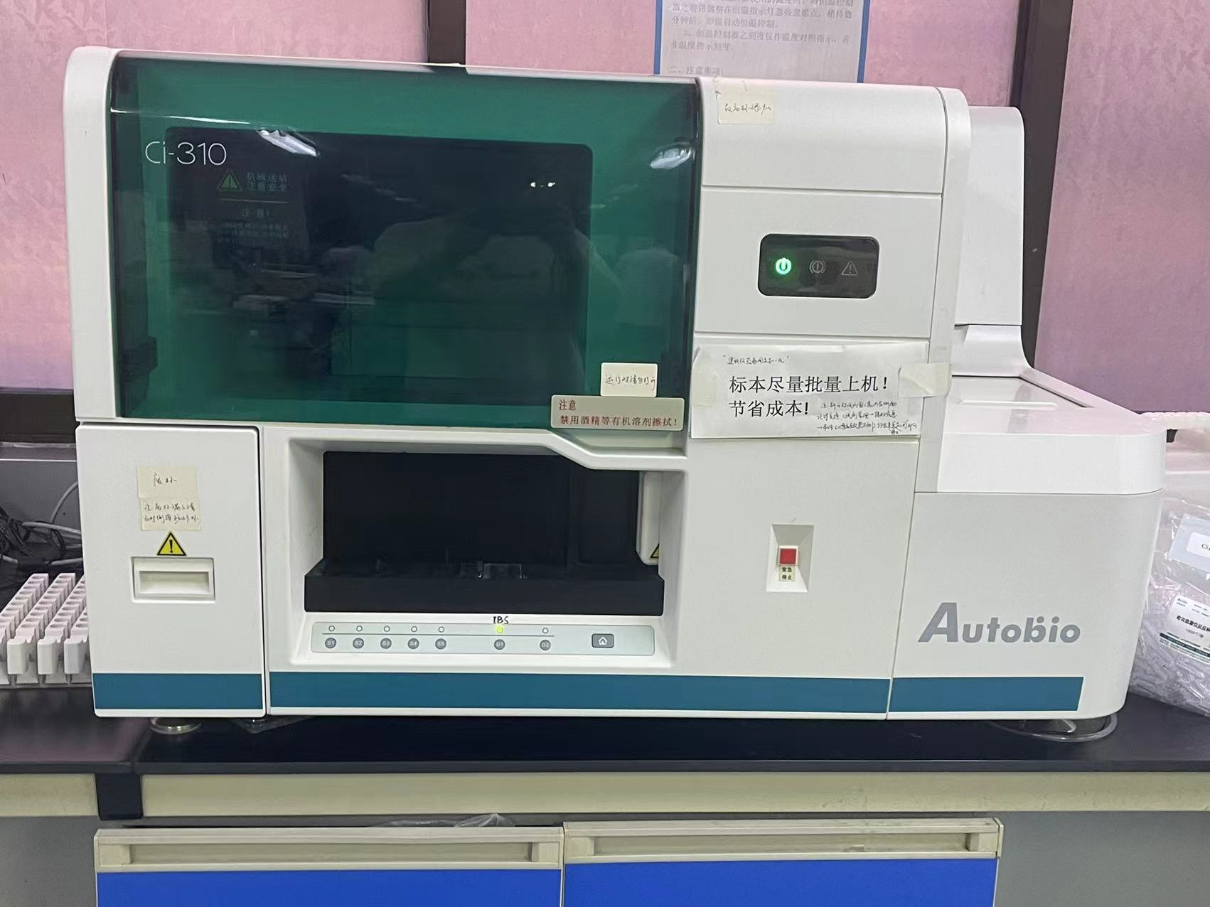​

## 仪器配置

​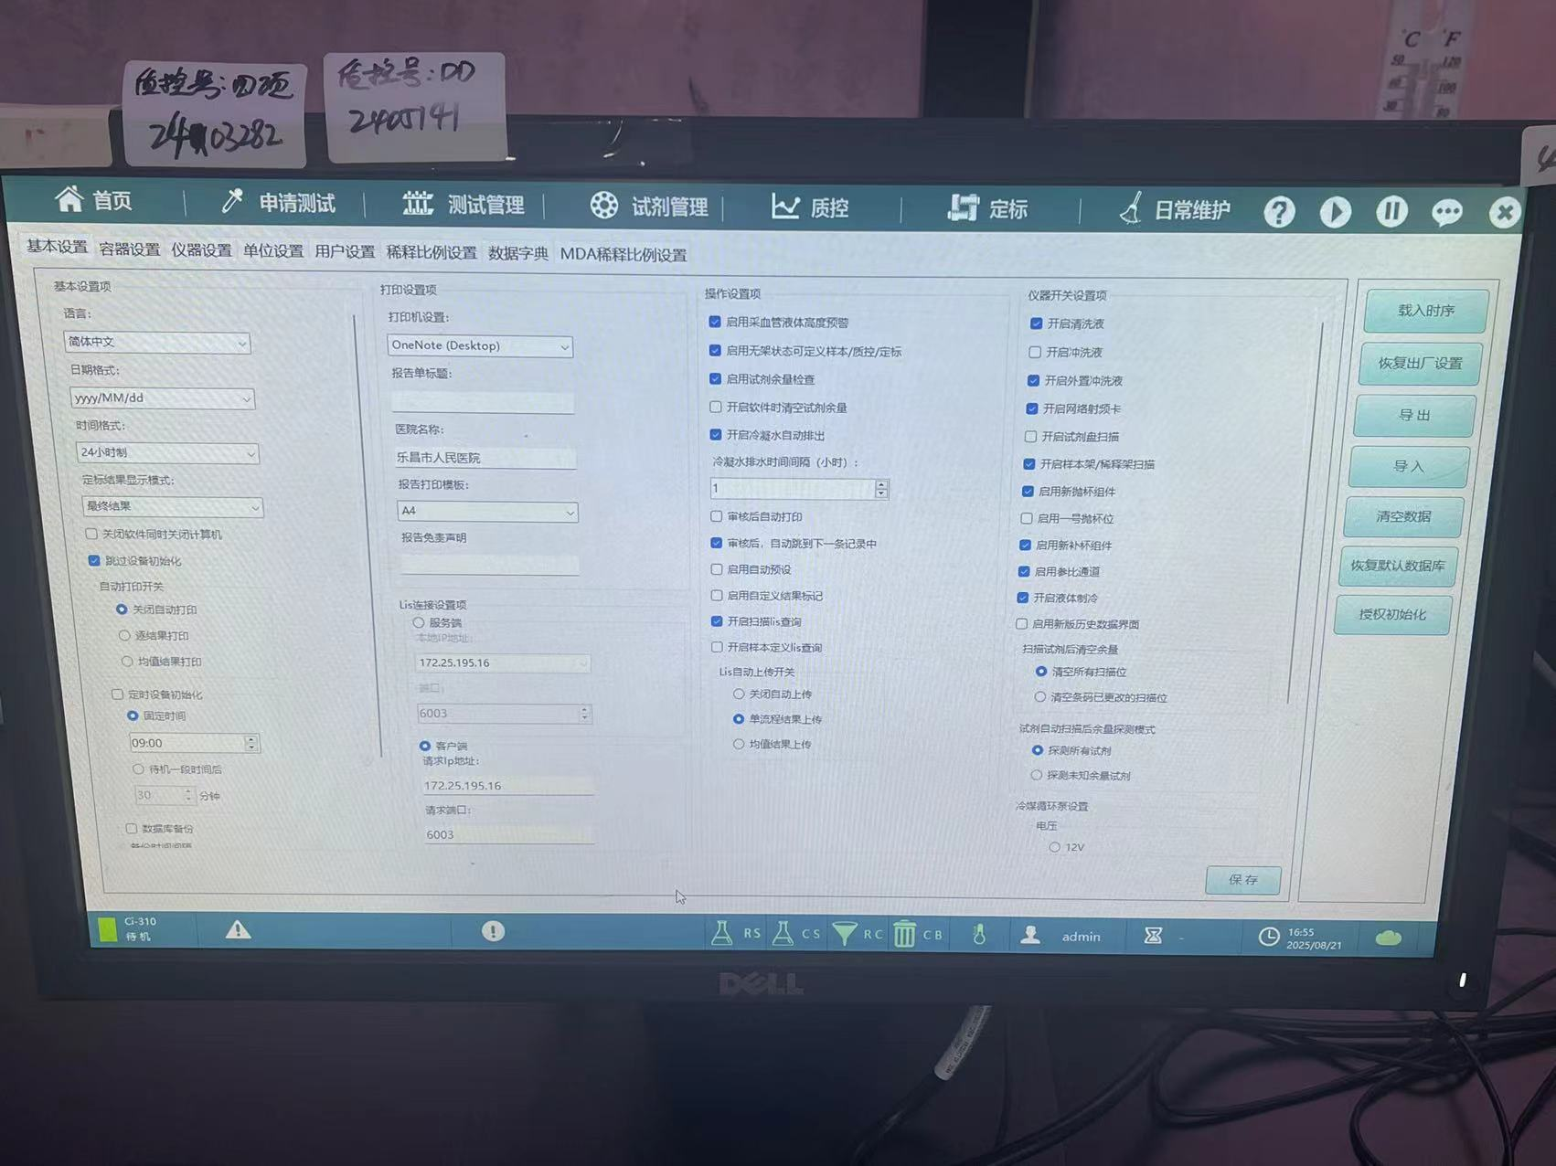​

## **数据格式**

双向请求信息

​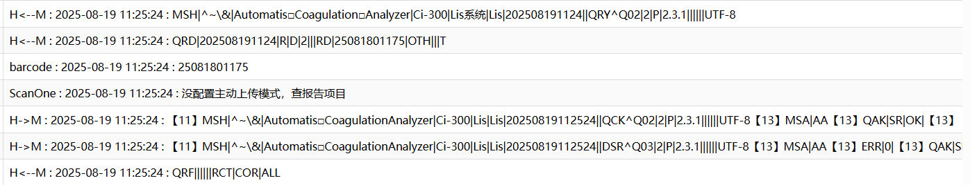​

H<--M : 2025-08-19 11:25:24 : MSH|^~\&|Automatis□Coagulation□Analyzer|Ci-300|Lis系统|Lis|202508191124||QRY^Q02|2|P|2.3.1||||||UTF-8  
116  
H<--M : 2025-08-19 11:25:24 : QRD|202508191124|R|D|2|||RD|25081801175|OTH|||T  
117  
barcode : 2025-08-19 11:25:24 : 25081801175  
118  
ScanOne : 2025-08-19 11:25:24 : 没配置主动上传模式，查报告项目  
119  
H->M : 2025-08-19 11:25:24 : 【11】MSH|^~\&|Automatis□CoagulationAnalyzer|Ci-300|Lis|Lis|20250819112524||QCK^Q02|2|P|2.3.1||||||UTF-8【13】MSA|AA【13】QAK|SR|OK|【13】【28】【13】  
120  
H->M : 2025-08-19 11:25:24 : 【11】MSH|^~\&|Automatis□CoagulationAnalyzer|Ci-300|Lis|Lis|20250819112524||DSR^Q03|2|P|2.3.1||||||UTF-8【13】MSA|AA【13】ERR|0|【13】QAK|SR|OK|||||【13】QRD|20250819112524|R|D|1|||RD|25081801175|OTH|||T【13】QRF||||||RCT|COR|ALL【13】DSP|1||0000070360【13】DSP|2||【13】DSP|3||孙文秀【13】DSP|4||16【13】DSP|5||女【13】DSP|6||【13】DSP|7【13】DSP|8【13】DSP|9【13】DSP|10【13】DSP|11||【13】DSP|12||【13】DSP|13【13】DSP|14【13】DSP|15||【13】DSP|16【13】DSP|17||【13】DSP|18【13】DSP|19【13】DSP|20||【13】DSP|21||25081801175【13】DSP|22||28【13】DSP|23||【13】DSP|24||【13】DSP|25||【13】DSP|26||【13】DSP|27||陈国友【13】DSP|28||皮肤科门诊【13】DSP|29||APTT【13】DSP|30||FIB【13】DSP|31||PT【13】DSP|32||TT【13】DSC|0【13】【28】【13】  
121  
H<--M : 2025-08-19 11:25:24 : QRF||||||RCT|COR|ALL

结果信息

​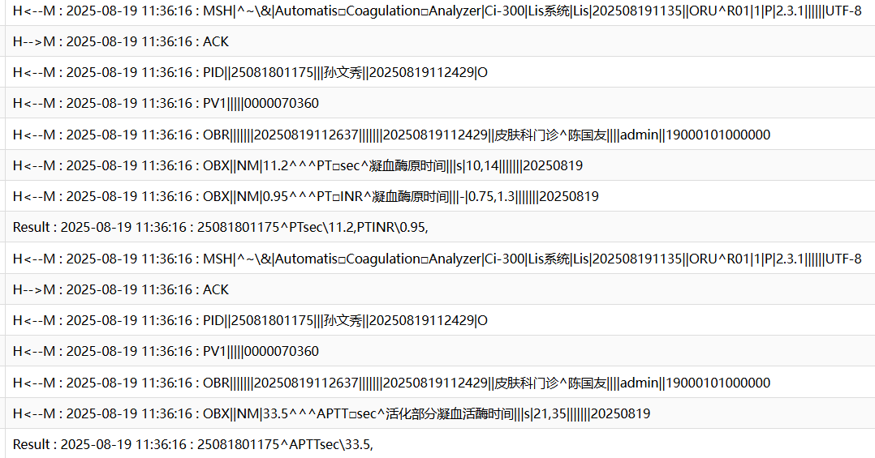​

H<--M : 2025-08-19 11:36:16 : MSH|^~\&|Automatis□Coagulation□Analyzer|Ci-300|Lis系统|Lis|202508191135||ORU^R01|1|P|2.3.1||||||UTF-8  
188  
H-->M : 2025-08-19 11:36:16 : ACK  
189  
H<--M : 2025-08-19 11:36:16 : PID||25081801175|||孙文秀||20250819112429|O  
190  
H<--M : 2025-08-19 11:36:16 : PV1|||||0000070360  
191  
H<--M : 2025-08-19 11:36:16 : OBR|||||||20250819112637|||||||20250819112429||皮肤科门诊^陈国友||||admin||19000101000000  
192  
H<--M : 2025-08-19 11:36:16 : OBX||NM|11.2^^^PT□sec^凝血酶原时间|||s|10,14|||||||20250819  
193  
H<--M : 2025-08-19 11:36:16 : OBX||NM|0.95^^^PT□INR^凝血酶原时间|||-|0.75,1.3|||||||20250819  
194  
Result : 2025-08-19 11:36:16 : 25081801175^PTsec\11.2,PTINR\0.95,  
195  
H<--M : 2025-08-19 11:36:16 : MSH|^~\&|Automatis□Coagulation□Analyzer|Ci-300|Lis系统|Lis|202508191135||ORU^R01|1|P|2.3.1||||||UTF-8  
196  
H-->M : 2025-08-19 11:36:16 : ACK  
197  
H<--M : 2025-08-19 11:36:16 : PID||25081801175|||孙文秀||20250819112429|O  
198  
H<--M : 2025-08-19 11:36:16 : PV1|||||0000070360  
199  
H<--M : 2025-08-19 11:36:16 : OBR|||||||20250819112637|||||||20250819112429||皮肤科门诊^陈国友||||admin||19000101000000  
200  
H<--M : 2025-08-19 11:36:16 : OBX||NM|33.5^^^APTT□sec^活化部分凝血活酶时间|||s|21,35|||||||20250819  
201  
Result : 2025-08-19 11:36:16 : 25081801175^APTTsec\33.5,

## **项目通道号**

​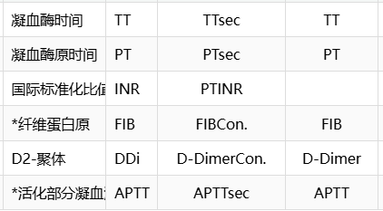​

## 修改记录

| 序号 | 日期 | 操作人 | 说明 |
| --- | --- | --- | --- |
| 1 | 2025-08-21 18:14:46 | 杨浩然 |  |

## 仪器接口程序

MIFCI310(mi)   
 S mi=$G(mi)   
 Q:'$L(mi)  
  
  
 s par11=$li(^dbo.BTMIMachineParameterD(mi),12) //项目分隔符  
 s par10=$li(^dbo.BTMIMachineParameterD(mi),13) //结果分隔符  
 s AntDeli=$li(^dbo.BTMIMachineParameterD(mi),14) //抗生素分隔符  
 s SenDeli=$li(^dbo.BTMIMachineParameterD(mi),15) //药敏结果分隔符  
 s par4="|TCP|"_$li(^dbo.BTMIMachineParameterD(mi),17) //端口号  
  
 S mi1=mi  
 S stx=$C(2),etx=$C(3),ack=$C(6),enq=$C(5),eot=$C(4),etb=$C(23)  
 S sb=$C(11),eb=$C(28),cr=$C(13)  
  
 S lf=$C(10),nak=$C(21),(AllRecord,result,epis)="",kk=1  
   
  
 S (sample,epis,surname,rec,res,result,date,time,QC,errFlag,resultType)=""  
 Q:$$StartUTF8^MI.MIF000(mi)  
 F {  
 D Main  
 Q:$$Stop^MI.MIF000(mi)  
 }  
 C par4  
 Q  
   
  
Main   
 S $ZT="ErrHandler",$EC=""  
 R *R:10  
 Q:'$TEST //如果超时则退出  
 Q:$c(R)'=sb //以sb开头  
 S (sample,epis,surname,rec,res,result,date,time,QC,errFlag,resultType,msgType,barcode,mshStr)=""  
 S startTime=$P($H,",",2)  
 K PLIST  
 S index=1  
 k ^TMIFLIS(mi,"Record")  
 F {  
 S curTime=$P($H,",",2)  
 Q:curTime>(startTime+300) //5分钟内没有处理完则退出循环  
 Q:$$Stop^MI.MIF000(mi)  
 R *R:10  
 Q:'$TEST //如果超时则退出  
   
 ;s indexQ=$o(^TMIFLIS(mi,"Record",""),-1)+1,^TMIFLIS(mi,"Record",indexQ)=$c(R)  
 I $L($G(PLIST(index)))>=32700 { //32767  
 S index=+$O(PLIST(""),-1)+1  
 S PLIST(index)=""  
 }  
 I $C(R)'=eb,$C(R)'=cr {  
 S PLIST(index)=$G(PLIST(index))_$C(R)  
   
 }  
 I ($C(R)=eb)||($c(R)=cr) { //解析一条记录  
 D Record  
 K PLIST  
 S index=1   
 }   
 Q:$C(R)=eb //循环读取,当为eb的时候则退出  
 }  
 i $L(epis),$L(result) D Save  
 Q  
   
Record  
 S index=""  
 S segmentType="",dataTye="",graphType="",base64Stream=""  
 S isImage=0,isBinary=0  
 F {  
 S index=$O(PLIST(index))  
 Q:'$L(index)  
 S record=$TR($G(PLIST(index)),cr)  
 Continue:'$L(record)  
 i record["Connect" /*D Trace^MI.MIF000(mi,"Q","Q<--M")*/ s index="" q  
 D Trace^MI.MIF000(mi,record,"H<--M")   
 I index=1 {  
 S segmentType=$P(record,"|",1)  
 I segmentType="MSH" { //信息头信息  
 S mshStr=record  
 //消息类型  
 S msgType=$P($P(record,"|",9),"^",1) //ORU,ACK,QRY,QCK,DSR   
 S msgReq=$P(record,"|",10)   
 I msgType="ORU" {  
 D SendACK(mi,record,"AA",0,"Message accepted")  
 }  
 I msgType="ORM" {  
 }  
 S resultType=$P(record,"|",11)  
 }  
   
 I segmentType="PID" { //患者信息  
 S epis=$P(record,"|",3)   
 }  
   
 I segmentType="PVI" { //就诊信息  
   
 }  
   
 I segmentType="OBR" { //医嘱信息  
 i '$l(epis) S epis=$P(record,"|",3)   
 i '$l(epis) s epis=$P(record,"|",4)  
 S dateStr=$P(record,"|",8)  
 I dateStr?14N {  
 //S date=$ZDH($E(dateStr,1,4)_"-"_$E(dateStr,5,6)_"-"_$E(dateStr,7,8),3)  
 //S time=$ZTH($E(dateStr,9,10)_":"_$E(dateStr,11,12)_":"_$E(dateStr,13,14),1)   
 }  
 }  
   
 I segmentType="OBX" {  
 S dataTye=$P(record,"|",3) //NM (numeric) 表示数字值，用于定量项目,  
 //ST (string) 表示字符串值，用于定性项目  
 S channel=$P(record,"|",4)  
 S value=$P(channel,"^",1)  
 S channel=$tr($P(channel,"^",4)," ")  
 i $l(channel),$l(value) s result=result_channel_par10_value_par11  
 }  
   
 I segmentType="QRD" { //双向查询  
 S barcode=$P(record,"|",9)  
 I $L(barcode) { //双向  
 D Trace^MI.MIF000(mi,barcode,"barcode")  
 d SendQRD(mi,record_"^"_msgReq,barcode)  
   
 }  
 }   
 }  
 }  
 Q  
  
  
   
Save  
  
 D Trace^MI.MIF000(mi,epis_"^"_result,"Result")   
 I $l(epis),$l(result) {  
 S QC=""  
 D Save^MI.MIF000(mi,epis,result,date,time,QC)  
 }  
 S (sample,epis,surname,rec,res,result,date,time,QC,resultType)=""  
 Q  
  
  
SendACK(mi,mshStr,ackType="AA",errCode=0,errDesc="Message accepted") //send 'ack' to instrument   
 N (mi,mshStr,ackType,errCode,errDesc)  
 S mi=$g(mi),mshStr=$g(mshStr),ackType=$g(ackType),errCode=$g(errCode),errDesc=$g(errDesc)  
 S ret=1,sb=$C(11),eb=$C(28),cr=$C(13)  
 Q:('$l(mi))||('$l(mshStr)) ret  
 S mshStr=$TR(mshStr,cr,"")  
 //Q:$l(mshStr,"|")<21 ret  
 S ret=0  
 S msgRoutine=$P($P(mshStr,"|",9),"^",2)  
 S seq=$P(mshStr,"|",10)  
 S mshStr=$P(mshStr,"|",1,2)_"|LIS|||"_$P(mshStr,"|",6,$l(mshStr))  
   
  
 S $P(mshStr,"|",9)="ACK^"_msgRoutine  
 W sb,mshStr,cr,"MSA|"_ackType_"|"_seq_"|"_errDesc_"|||"_errCode_"|",cr,eb,cr,*-3  
 D Trace^MI.MIF000(mi,$S(ackType="AA":"ACK",ackType="AE":"Error",ackType="AR":"NAK",1:"NULL"),"H-->M")  
 Q ret  
   
  
ErrHandler  
 D Trace^MI.MIF000(mi,$TR($ZERROR,"^","--")_".错误代码:"_$ECODE,"Runtime Error")  
 Q   
  
  
  
SendQRD(mi,record,labno)  
 N (mi,record,AckType,ErrCode,ErrDesc,mshStr,labno)  
 s mi=$g(mi),record=$g(record),AckType=$g(AckType),ErrCode=$g(ErrCode),ErrDesc=$g(ErrDesc),mshStr=$g(mshStr),labno=$g(labno)  
 S ret=1,sb=$C(11),eb=$C(28),cr=$C(13)  
 Q:('$l(mi))||('$l(record))  
 s msgReq=$p(record,"^",2)  
 s record=$p(record,"^",1)  
 d ScanOne^MI.MIF000(mi,labno) ;创建上传化验项目列表  
 S date=$tr($zd(+$h,3),"-")  
 S time=$tr($zt($p($h,",",2)),":")  
 ///无对应样本，则返回消息为  
 s MSH="MSH|^~\&|Automatis CoagulationAnalyzer|Ci-300|Lis|Lis|"_date_time_"||QCK^Q02|"_msgReq_"|P|2.3.1||||||UTF-8"_cr  
 s MSA="MSA|AA"_cr  
 s ERR="ERR|0|"_cr  
 i '$D(^TMP("MIFTESTCODE",$j,mi,labno)) {  
 s QAK="QAK|SR|NF|"_cr  
 s mshStr=MSH_MSA_QAK  
 w sb,mshStr,eb,cr,*-3  
 D Trace^MI.MIF000(mi,sb_mshStr_eb_cr,"H->M-Q02")  
 q  
 }  
   
 //返回QCK^Q02消息作应答  
 s QAK="QAK|SR|OK|"_cr  
 s mshStr=MSH_MSA_QAK  
 w sb,mshStr,eb,cr,*-3  
 D Trace^MI.MIF000(mi,sb_mshStr_eb_cr,"H->M")  
 //h 1 500ms内要发送项目信息  
   
  
 //返回查询应答QCK^Q02消息后,再发送医嘱数据消息DSR^Q03  
 s MSH="MSH|^~\&|Automatis CoagulationAnalyzer|Ci-300|Lis|Lis|"_date_time_"||DSR^Q03|"_msgReq_"|P|2.3.1||||||UTF-8"_cr  
 s MSA="MSA|AA"_cr  
 s QAK="QAK|SR|OK|||||"_cr  
 s QRD="QRD|"_date_time_"|R|D|1|||RD|"_labno_"|OTH|||T"_cr  
 s QRF="QRF||||||RCT|COR|ALL"_cr  
 s VisitNumberDR = $o(^dbo.RPVisitNumberI("IndexVisitNumber",##Class(LIS.Util.Common).IndexData(labno),""))  
 //标本信息  
 s RPVisitNumberData=$g(^dbo.RPVisitNumberD(VisitNumberDR))  
 s RegNo=$lg(RPVisitNumberData,3)  
 s BedNo=$lg(RPVisitNumberData,27)  
 s SurName=$lg(RPVisitNumberData,13)  
 s Age=$lg(RPVisitNumberData,18)  
 s SpeciesDR=$lg(RPVisitNumberData,15),Species=""  
 i $l(SpeciesDR) s Species=$lg($g(^dbo.BTSpeciesD(SpeciesDR)),3)  
 s DoctorDR=$lg(RPVisitNumberData,23),Doctor=""  
 i $l(DoctorDR) s Doctor=$lg($g(^dbo.BTDoctorD(DoctorDR)),3)  
 s LocationDR=$lg(RPVisitNumberData,22),Location=""  
 i $l(LocationDR) s Location=$lg($g(^dbo.BTLocationD(LocationDR)),3)  
 s EpisNo=""  
 s EpisNo=$$GetEpisNo(mi,labno)  
 k DSP  
 s DSP(1)="DSP|1||"_RegNo_cr  
 s DSP(2)="DSP|2||"_BedNo_cr  
 s DSP(3)="DSP|3||"_SurName_cr  
 s DSP(4)="DSP|4||"_Age_cr  
 s DSP(5)="DSP|5||"_Species_cr  
 s DSP(6)="DSP|6||"_cr  
 s DSP(7)="DSP|7"_cr  
 s DSP(8)="DSP|8"_cr  
 s DSP(9)="DSP|9"_cr  
 s DSP(10)="DSP|10"_cr  
 s DSP(11)="DSP|11||"_cr  
 s DSP(12)="DSP|12||"_cr  
 s DSP(13)="DSP|13"_cr  
 s DSP(14)="DSP|14"_cr  
 s DSP(15)="DSP|15||"_cr  
 s DSP(16)="DSP|16"_cr  
 s DSP(17)="DSP|17||"_cr  
 s DSP(18)="DSP|18"_cr  
 s DSP(19)="DSP|19"_cr  
 s DSP(20)="DSP|20||"_cr  
 s DSP(21)="DSP|21||"_labno_cr  
 s DSP(22)="DSP|22||"_EpisNo_cr  
 s DSP(23)="DSP|23||"_cr  
 s DSP(24)="DSP|24||"_cr  
 s DSP(25)="DSP|25||"_cr  
 s DSP(26)="DSP|26||"_cr  
 s DSP(27)="DSP|27||"_Doctor_cr  
 s DSP(28)="DSP|28||"_Location_cr  
 s seq=29  
 S chl="" F S chl=$o(^TMP("MIFTESTCODE",$j,mi,labno,chl)) Q:chl="" D  
 .s DSP(seq)="DSP|"_seq_"||"_chl_cr  
 .s seq=seq+1  
   
 s DSPs=""  
 s seq="" f s seq=$o(DSP(seq)) q:seq="" d  
 .s DSPs=DSPs_DSP(seq)  
 s DSC="DSC|0"_cr  
 s mshStr=MSH_MSA_ERR_QAK_QRD_QRF_DSPs_DSC  
 w sb,mshStr,eb,cr,*-3  
 D Trace^MI.MIF000(mi,sb_mshStr_eb_cr,"H->M")  
 Q  
///zw $$GetEpisNo^MI.MIFKUF40B("38","25062308821")  
GetEpisNo(mi,labno)  
 s ret="",mi=$g(mi),labno=$g(labno)  
 i '$l(mi) q labno  
 s WGMachineID=$lg($g(^dbo.BTMIMachineParameterD(mi)),6)  
 i $d(^dbo.RPVisitNumberI("IndexVisitNumber",labno)) d  
 .s VisitnumberDR=$o(^dbo.RPVisitNumberI("IndexVisitNumber",labno,""))  
 .i $d(^dbo.RPVisitNumberReportI("IndexReportID",VisitnumberDR,WGMachineID,1)) d  
 ..s ReportDR=$o(^dbo.RPVisitNumberReportI("IndexReportID",VisitnumberDR,WGMachineID,1,""))  
 ..s ret=$lg($g(^dbo.RPVisitNumberReportD(ReportDR)),8)  
 q ret