# 迈克F810血球仪

## 接口说明

| 仪器厂商 | 迈克F810血球仪 | 仪器型号 | 迈克F810血球仪 |
| --- | --- | --- | --- |
| 通讯方式 | 单向|双向☑|主动上传 | 仪器类型 | 临检血球仪 |
| 医院名称 |  | 程序名称 |  |
| 终端服务器地址 |  | 终端服务器端口号 |  |

## **仪器上接口标示和接口类型**

1. 接口类型：串口|网口☑|监听文件|数据库|其他

1. 连接方式：HL7协议☑|ASTM协议|监听文件|数据库|其他

## 仪器接口说明

* 仪器图片为压缩图片，新版本有对应的webservice，可以直接调用，为方便接口部署，将保存压缩图片集成在一个接口里，方法为 SaveImage

## 串口盒子配置

* **波特率：**9600

* **数据位：8**

* **停止位：**1

* **校验位：**N

## 仪器图片

​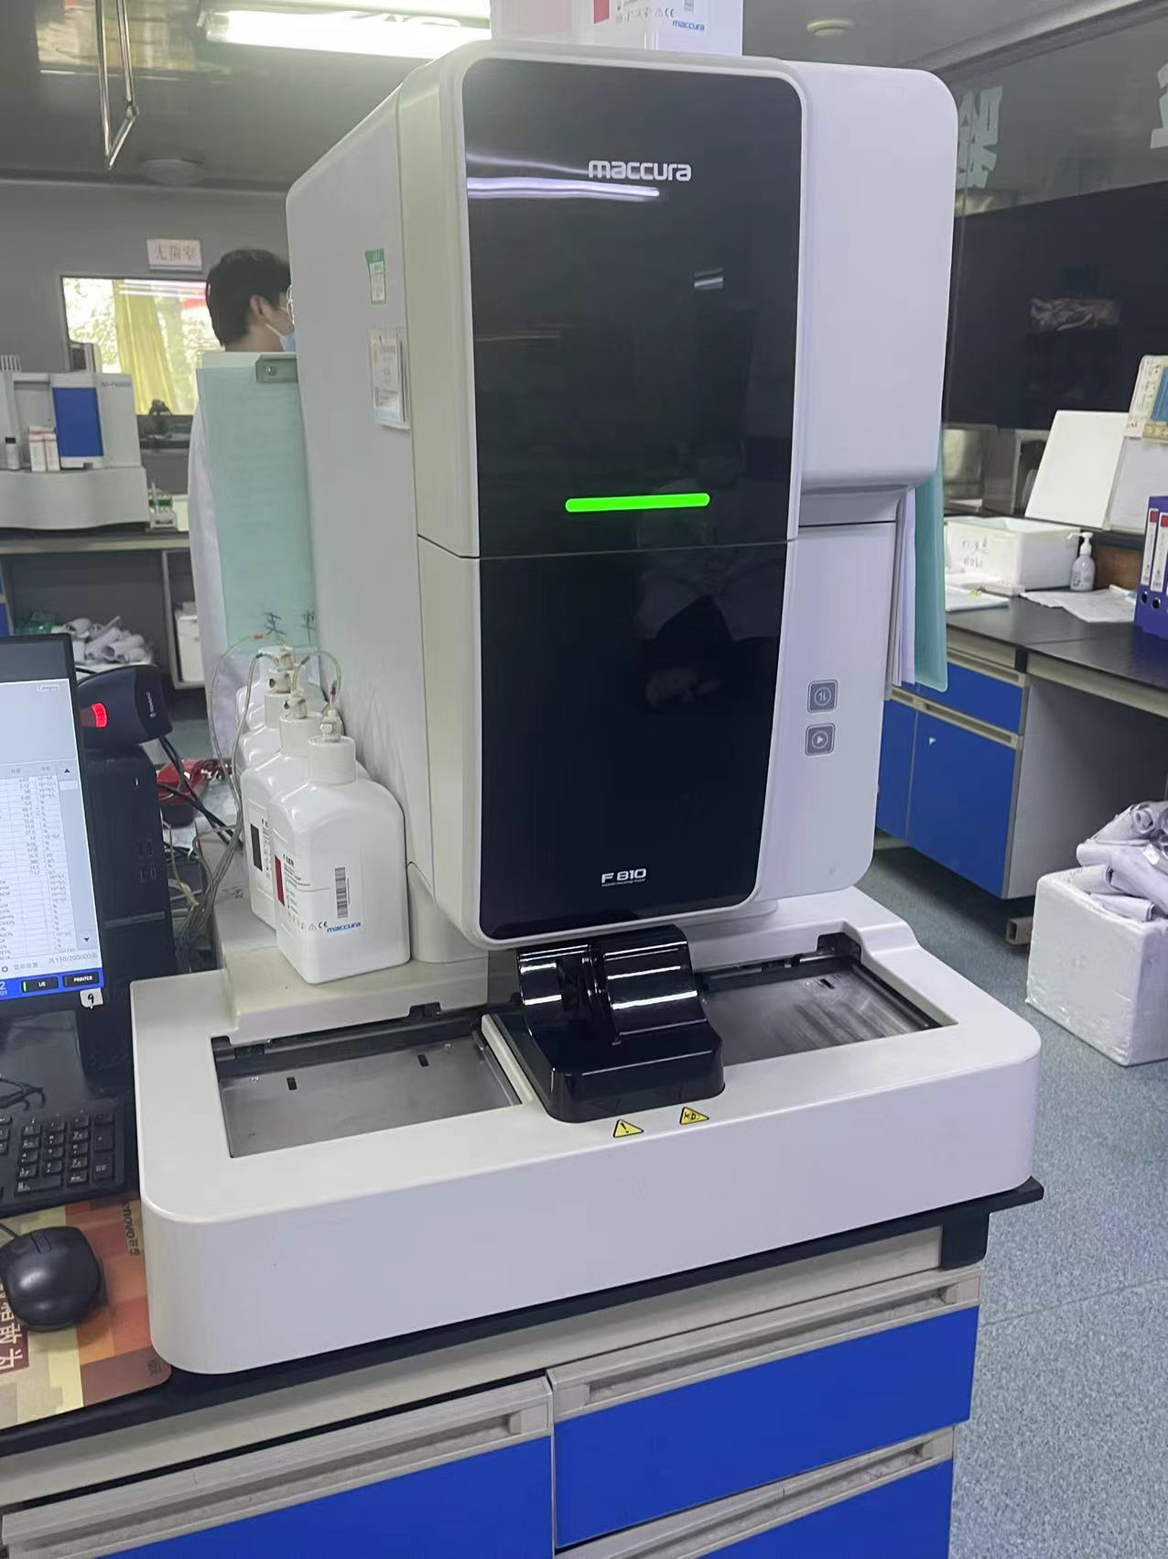​

## 仪器配置

​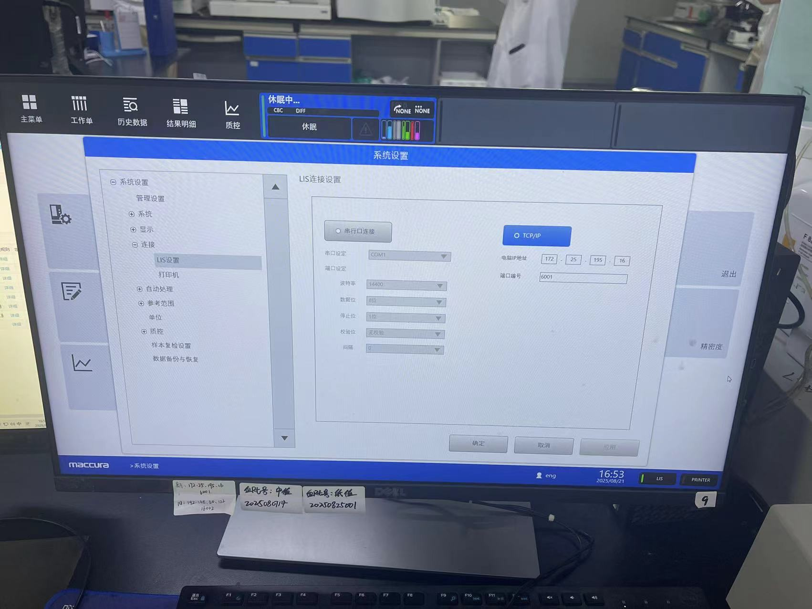​

### 单向改双向配置

​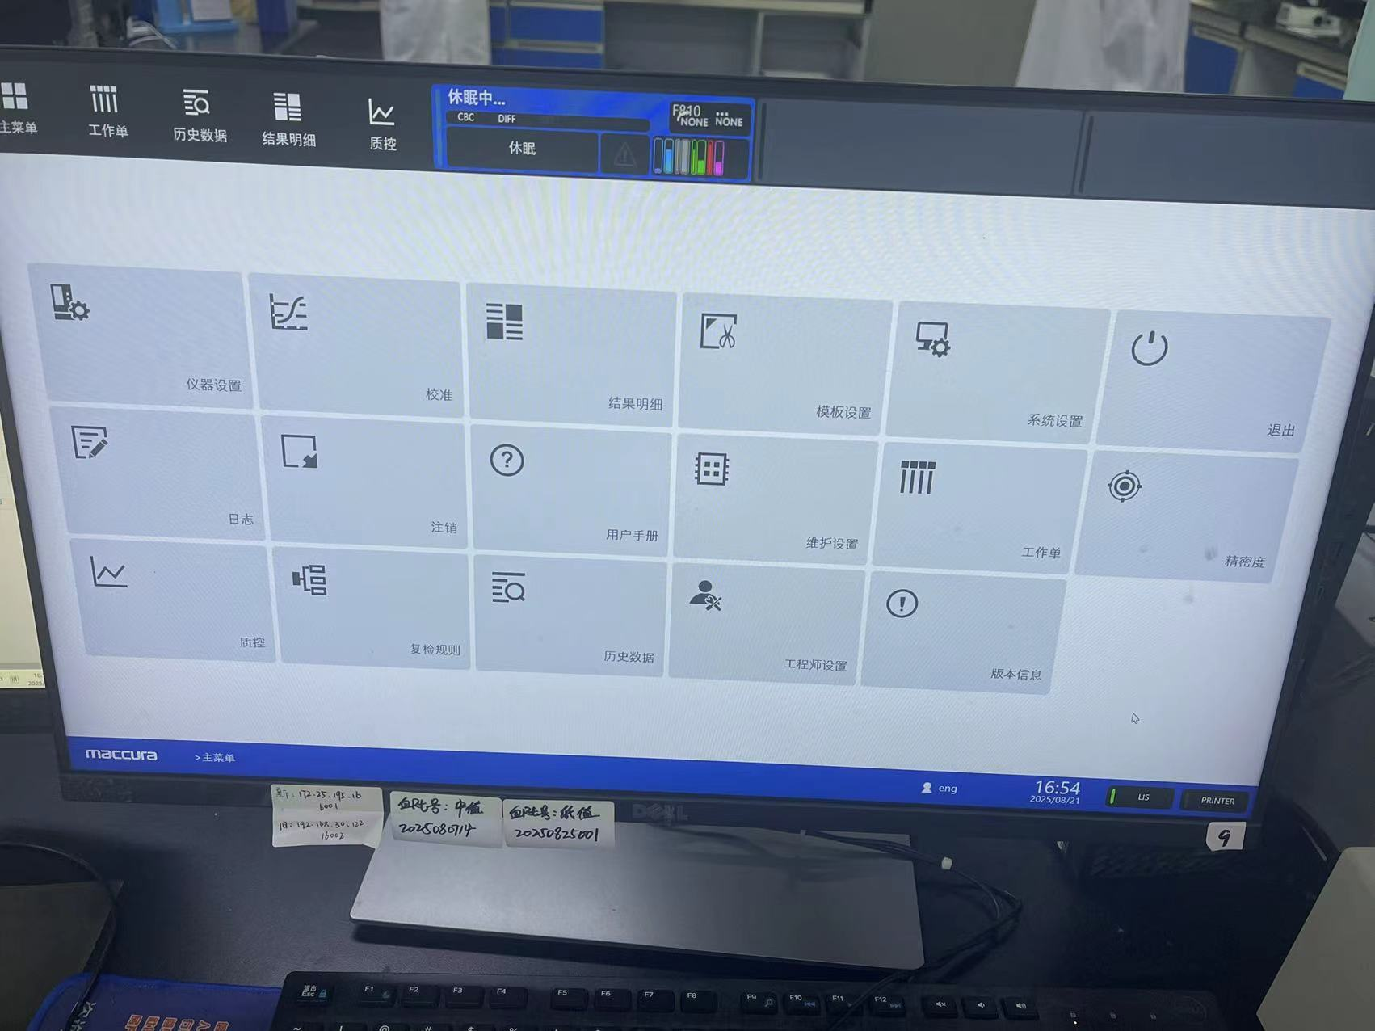​

仪器设置里启用条码

​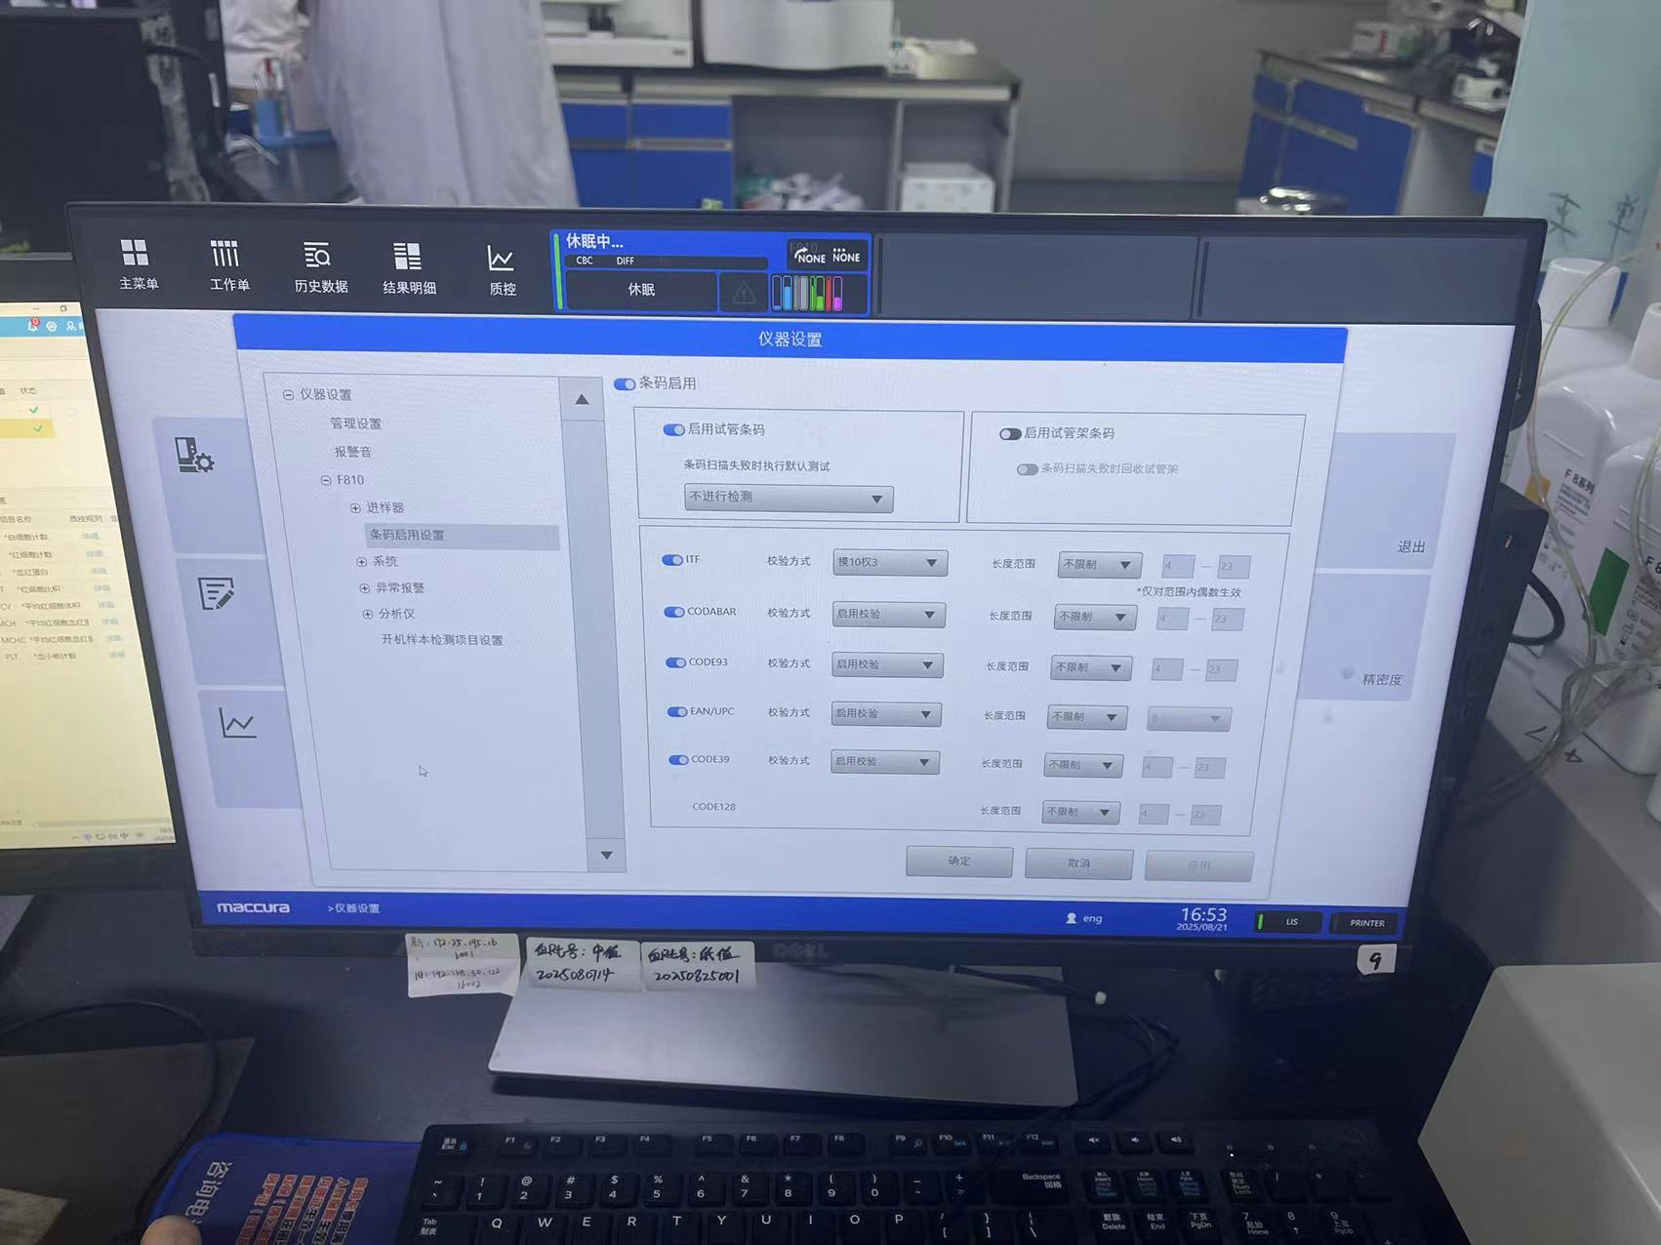​

系统设置里分析预定修改

​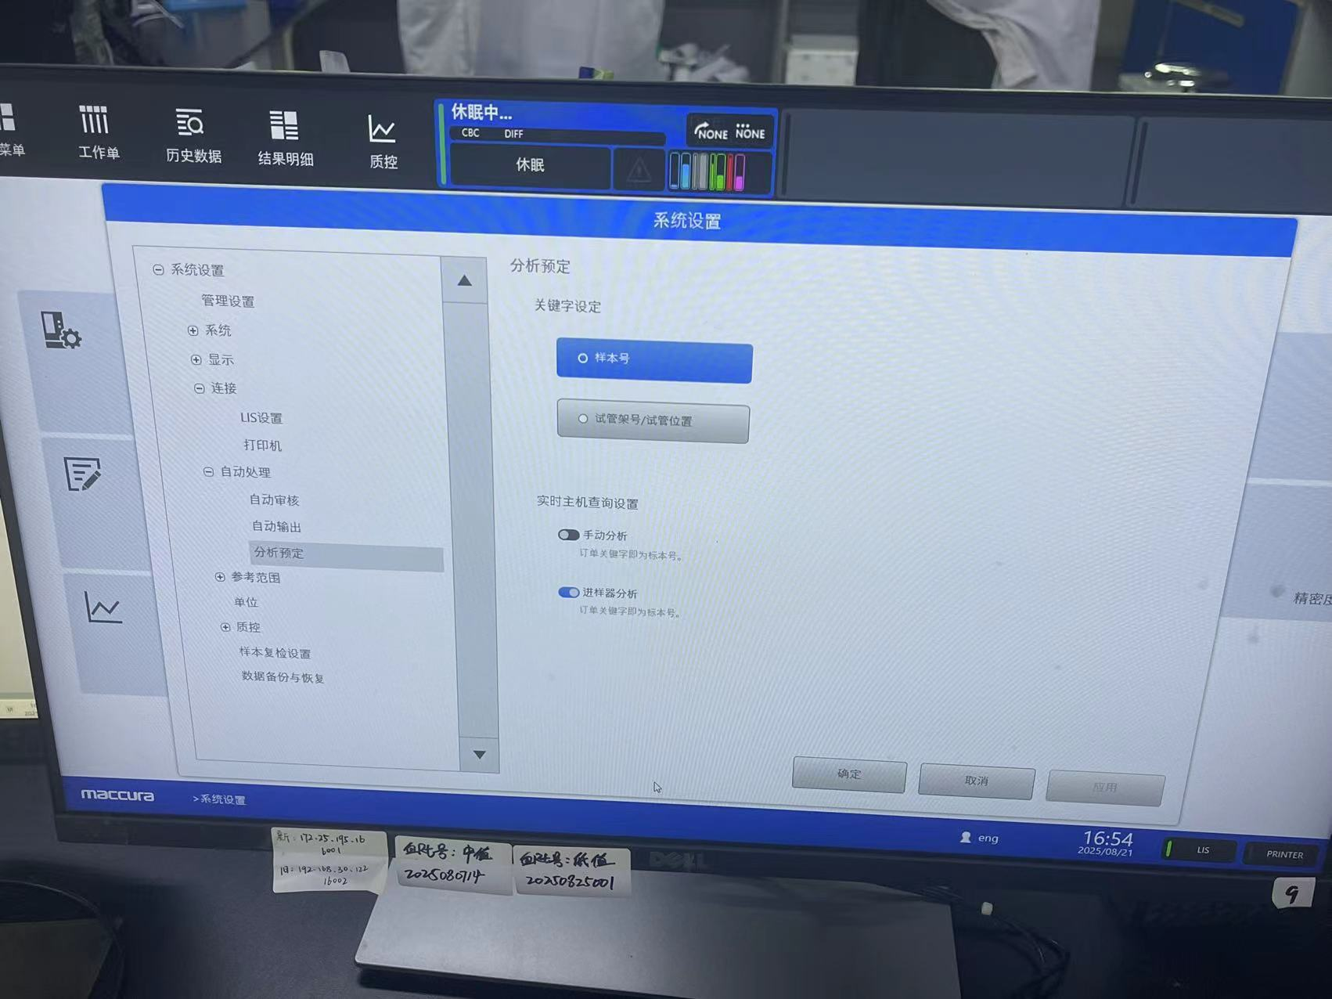​

## **数据格式**

仪器双向请求回复

​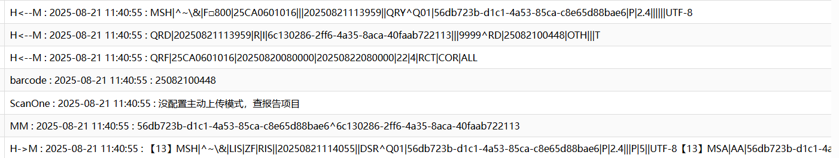​

H<--M : 2025-08-21 11:40:55 : MSH|^~\&|F□800|25CA0601016|||20250821113959||QRY^Q01|56db723b-d1c1-4a53-85ca-c8e65d88bae6|P|2.4||||||UTF-8  
616  
H<--M : 2025-08-21 11:40:55 : QRD|20250821113959|R|I|6c130286-2ff6-4a35-8aca-40faab722113|||9999^RD|25082100448|OTH|||T  
617  
H<--M : 2025-08-21 11:40:55 : QRF|25CA0601016|20250820080000|20250822080000|22|4|RCT|COR|ALL  
618  
barcode : 2025-08-21 11:40:55 : 25082100448  
619  
ScanOne : 2025-08-21 11:40:55 : 没配置主动上传模式，查报告项目  
620  
MM : 2025-08-21 11:40:55 : 56db723b-d1c1-4a53-85ca-c8e65d88bae6^6c130286-2ff6-4a35-8aca-40faab722113  
621  
H->M : 2025-08-21 11:40:55 : 【13】MSH|^~\&|LIS|ZF|RIS||20250821114055||DSR^Q01|56db723b-d1c1-4a53-85ca-c8e65d88bae6|P|2.4|||P|5||UTF-8【13】MSA|AA|56db723b-d1c1-4a53-85ca-c8e65d88bae6【13】QRD|20250821114055|R|I|6c130286-2ff6-4a35-8aca-40faab722113|||RD|25082100448|OTH|||T【13】QRF|RIS|||||RCT|COR|ALL【13】DSP|1||0000071946【13】DSP|2||18【13】DSP|3||李萍【13】DSP|4|||||【13】DSP|5||女【13】DSP|6||O【13】DSP|7||【13】DSP|8||【13】DSP|9||【13】DSP|10||【13】DSP|11||【13】DSP|12||【13】DSP|13||【13】DSP|14||【13】DSP|15||【13】DSP|16||【13】DSP|17||【13】DSP|18||【13】DSP|19||【13】DSP|20||【13】DSP|21||25082100448【13】DSP|22||25082100448【13】DSP|23||20250821114055|||【13】DSP|24||N【13】DSP|25||1【13】DSP|26||serum【13】DSP|27||【13】DSP|28||【13】DSP|29||CBC+DIFF【13】【28】【13】

​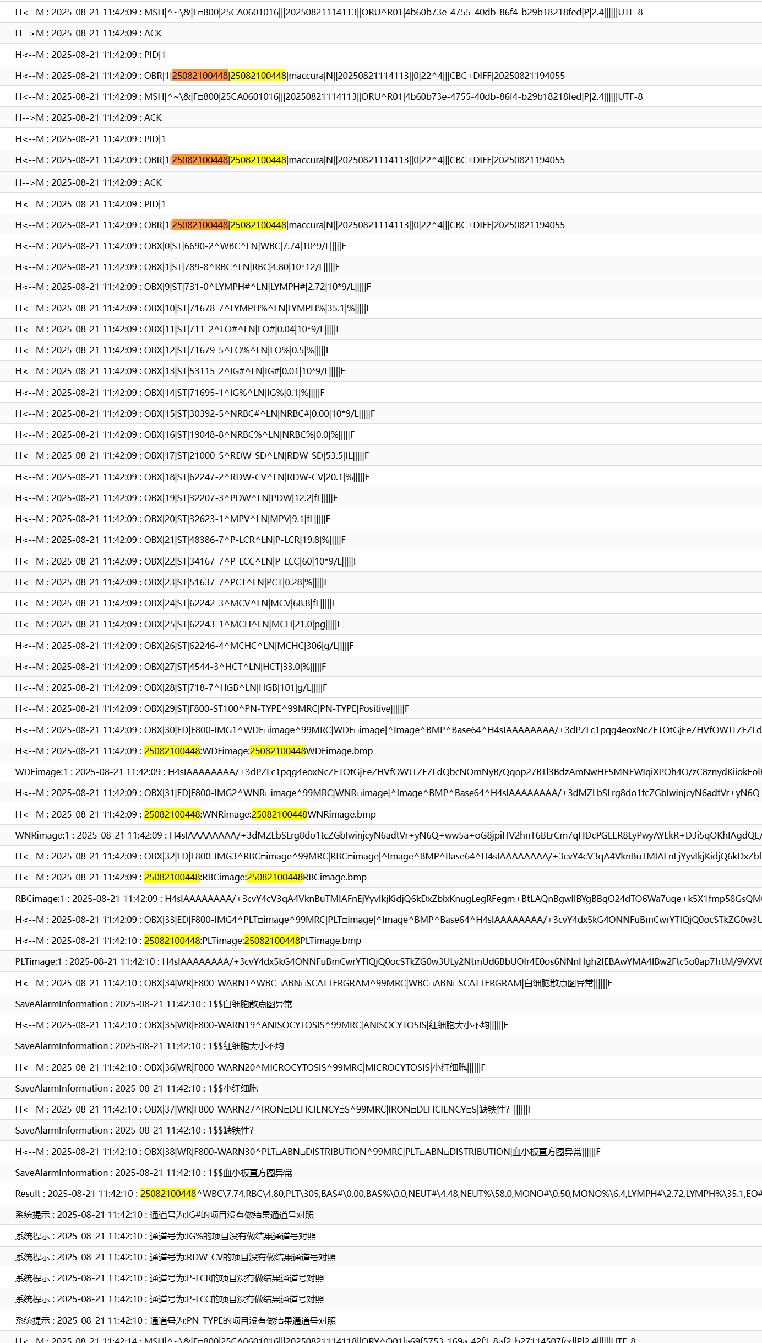​

813  
H<--M : 2025-08-21 11:42:09 : MSH|^~\&|F□800|25CA0601016|||20250821114113||ORU^R01|4b60b73e-4755-40db-86f4-b29b18218fed|P|2.4||||||UTF-8  
814  
H-->M : 2025-08-21 11:42:09 : ACK  
815  
H<--M : 2025-08-21 11:42:09 : PID|1  
816  
H<--M : 2025-08-21 11:42:09 : OBR|1|25082100448|25082100448|maccura|N||20250821114113||0|22^4|||CBC+DIFF|20250821194055  
817  
H<--M : 2025-08-21 11:42:09 : OBX|0|ST|6690-2^WBC^LN|WBC|7.74|10*9/L|||||F  
818  
H<--M : 2025-08-21 11:42:09 : OBX|1|ST|789-8^RBC^LN|RBC|4.80|10*12/L|||||F  
819  
H<--M : 2025-08-21 11:42:09 : OBX|2|ST|777-3^PLT^LN|PLT|305|10*9/L|||||F  
820  
H<--M : 2025-08-21 11:42:09 : OBX|3|ST|704-7^BAS#^LN|BAS#|0.00|10*9/L|||||F  
821  
H<--M : 2025-08-21 11:42:09 : OBX|4|ST|706-2^BAS%^LN|BAS%|0.0|%|||||F  
822  
H<--M : 2025-08-21 11:42:09 : OBX|5|ST|751-8^NEUT#^LN|NEUT#|4.48|10*9/L|||||F  
823  
H<--M : 2025-08-21 11:42:09 : OBX|6|ST|71676-1^NEUT%^LN|NEUT%|58.0|%|||||F  
824  
H<--M : 2025-08-21 11:42:09 : OBX|7|ST|742-7^MONO#^LN|MONO#|0.50|10*9/L|||||F  
825  
H<--M : 2025-08-21 11:42:09 : OBX|8|ST|71677-9^MONO%^LN|MONO%|6.4|%|||||F  
826  
H<--M : 2025-08-21 11:42:09 : OBX|9|ST|731-0^LYMPH#^LN|LYMPH#|2.72|10*9/L|||||F  
827  
H<--M : 2025-08-21 11:42:09 : OBX|10|ST|71678-7^LYMPH%^LN|LYMPH%|35.1|%|||||F  
828  
H<--M : 2025-08-21 11:42:09 : OBX|11|ST|711-2^EO#^LN|EO#|0.04|10*9/L|||||F  
829  
H<--M : 2025-08-21 11:42:09 : OBX|12|ST|71679-5^EO%^LN|EO%|0.5|%|||||F  
830  
H<--M : 2025-08-21 11:42:09 : OBX|13|ST|53115-2^IG#^LN|IG#|0.01|10*9/L|||||F  
831  
H<--M : 2025-08-21 11:42:09 : OBX|14|ST|71695-1^IG%^LN|IG%|0.1|%|||||F  
832  
H<--M : 2025-08-21 11:42:09 : OBX|15|ST|30392-5^NRBC#^LN|NRBC#|0.00|10*9/L|||||F  
833  
H<--M : 2025-08-21 11:42:09 : OBX|16|ST|19048-8^NRBC%^LN|NRBC%|0.0|%|||||F  
834  
H<--M : 2025-08-21 11:42:09 : OBX|17|ST|21000-5^RDW-SD^LN|RDW-SD|53.5|fL|||||F  
835  
H<--M : 2025-08-21 11:42:09 : OBX|18|ST|62247-2^RDW-CV^LN|RDW-CV|20.1|%|||||F  
836  
H<--M : 2025-08-21 11:42:09 : OBX|19|ST|32207-3^PDW^LN|PDW|12.2|fL|||||F  
837  
H<--M : 2025-08-21 11:42:09 : OBX|20|ST|32623-1^MPV^LN|MPV|9.1|fL|||||F  
838  
H<--M : 2025-08-21 11:42:09 : OBX|21|ST|48386-7^P-LCR^LN|P-LCR|19.8|%|||||F  
839  
H<--M : 2025-08-21 11:42:09 : OBX|22|ST|34167-7^P-LCC^LN|P-LCC|60|10*9/L|||||F  
840  
H<--M : 2025-08-21 11:42:09 : OBX|23|ST|51637-7^PCT^LN|PCT|0.28|%|||||F  
841  
H<--M : 2025-08-21 11:42:09 : OBX|24|ST|62242-3^MCV^LN|MCV|68.8|fL|||||F  
842  
H<--M : 2025-08-21 11:42:09 : OBX|25|ST|62243-1^MCH^LN|MCH|21.0|pg|||||F  
843  
H<--M : 2025-08-21 11:42:09 : OBX|26|ST|62246-4^MCHC^LN|MCHC|306|g/L|||||F  
844  
H<--M : 2025-08-21 11:42:09 : OBX|27|ST|4544-3^HCT^LN|HCT|33.0|%|||||F  
845  
H<--M : 2025-08-21 11:42:09 : OBX|28|ST|718-7^HGB^LN|HGB|101|g/L|||||F  
846  
H<--M : 2025-08-21 11:42:09 : OBX|29|ST|F800-ST100^PN-TYPE^99MRC|PN-TYPE|Positive||||||F  
847  
H<--M : 2025-08-21 11:42:09 : OBX|30|ED|F800-IMG1^WDF□image^99MRC|WDF□image|^Image^BMP^Base64^||||||F  
848  
H<--M : 2025-08-21 11:42:09 : 25082100448:WDFimage:25082100448WDFimage.bmp  
849  
WDFimage:1 : 2025-08-21 11:42:09 :   
850  
H<--M : 2025-08-21 11:42:09 : OBX|31|ED|F800-IMG2^WNR□image^99MRC|WNR□image|^Image^BMP^Base64^||||||F  
851  
H<--M : 2025-08-21 11:42:09 : 25082100448:WNRimage:25082100448WNRimage.bmp  
852  
WNRimage:1 : 2025-08-21 11:42:09 :   
853  
H<--M : 2025-08-21 11:42:09 : OBX|32|ED|F800-IMG3^RBC□image^99MRC|RBC□image|^Image^BMP^Base64^||||||F  
854  
H<--M : 2025-08-21 11:42:09 : 25082100448:RBCimage:25082100448RBCimage.bmp  
855  
RBCimage:1 : 2025-08-21 11:42:09 :   
856  
H<--M : 2025-08-21 11:42:09 : OBX|33|ED|F800-IMG4^PLT□image^99MRC|PLT□image|^Image^BMP^Base64^||||||F  
857  
H<--M : 2025-08-21 11:42:10 : 25082100448:PLTimage:25082100448PLTimage.bmp  
858  
PLTimage:1 : 2025-08-21 11:42:10 :   
859  
H<--M : 2025-08-21 11:42:10 : OBX|34|WR|F800-WARN1^WBC□ABN□SCATTERGRAM^99MRC|WBC□ABN□SCATTERGRAM|白细胞散点图异常||||||F  
860  
SaveAlarmInformation : 2025-08-21 11:42:10 : 1$$白细胞散点图异常  
861  
H<--M : 2025-08-21 11:42:10 : OBX|35|WR|F800-WARN19^ANISOCYTOSIS^99MRC|ANISOCYTOSIS|红细胞大小不均||||||F  
862  
SaveAlarmInformation : 2025-08-21 11:42:10 : 1$$红细胞大小不均  
863  
H<--M : 2025-08-21 11:42:10 : OBX|36|WR|F800-WARN20^MICROCYTOSIS^99MRC|MICROCYTOSIS|小红细胞||||||F  
864  
SaveAlarmInformation : 2025-08-21 11:42:10 : 1$$小红细胞  
865  
H<--M : 2025-08-21 11:42:10 : OBX|37|WR|F800-WARN27^IRON□DEFICIENCY□S^99MRC|IRON□DEFICIENCY□S|缺铁性？||||||F  
866  
SaveAlarmInformation : 2025-08-21 11:42:10 : 1$$缺铁性？  
867  
H<--M : 2025-08-21 11:42:10 : OBX|38|WR|F800-WARN30^PLT□ABN□DISTRIBUTION^99MRC|PLT□ABN□DISTRIBUTION|血小板直方图异常||||||F  
868  
SaveAlarmInformation : 2025-08-21 11:42:10 : 1$$血小板直方图异常  
869  
Result : 2025-08-21 11:42:10 : 25082100448^WBC\7.74,RBC\4.80,PLT\305,BAS#\0.00,BAS%\0.0,NEUT#\4.48,NEUT%\58.0,MONO#\0.50,MONO%\6.4,LYMPH#\2.72,LYMPH%\35.1,EO#\0.04,EO%\0.5,IG#\0.01,IG%\0.1,NRBC#\0.00,NRBC%\0.0,RDW-SD\53.5,RDW-CV\20.1,PDW\12.2,MPV\9.1,P-LCR\19.8,P-LCC\60,PCT\0.28,MCV\68.8,MCH\21.0,MCHC\306,HCT\33.0,HGB\101,PN-TYPE\Positive,  
870  
系统提示 : 2025-08-21 11:42:10 : 通道号为:IG#的项目没有做结果通道号对照  
871  
系统提示 : 2025-08-21 11:42:10 : 通道号为:IG%的项目没有做结果通道号对照  
872  
系统提示 : 2025-08-21 11:42:10 : 通道号为:RDW-CV的项目没有做结果通道号对照  
873  
系统提示 : 2025-08-21 11:42:10 : 通道号为:P-LCR的项目没有做结果通道号对照  
874  
系统提示 : 2025-08-21 11:42:10 : 通道号为:P-LCC的项目没有做结果通道号对照  
875  
系统提示 : 2025-08-21 11:42:10 : 通道号为:PN-TYPE的项目没有做结果通道号对照

## **项目通道号**

双向所有通道号 A1C+CBC+DIFF+AWS+CRP

​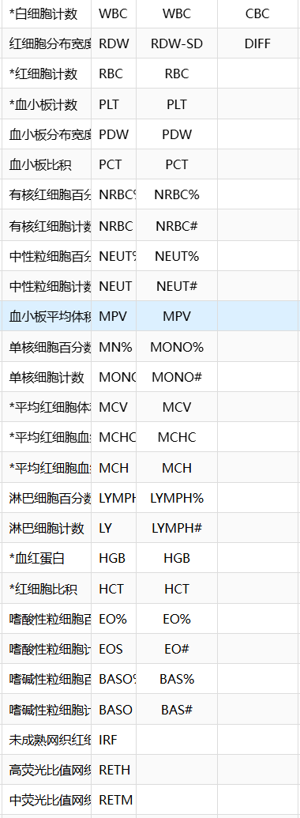​

## 修改记录

| 序号 | 日期 | 操作人 | 说明 |
| --- | --- | --- | --- |
| 1 | 2025-08-21 17:20:27 | 杨浩然 |  |

## 仪器接口程序

MIFKUF10(mi)   
 ///仪器名称: 粪便分析仪  
 ///仪器型号: KU-F10  
 ///仪器厂商: 珠海科域  
 ///通信协议: HL7  
 ///交互方式: 单向  
 ///接 口: TCP/IP,RS232   
 ///编 写 者: liuzf  
 ///编写日期: 2018-01-08  
 ///备 注: 仪器配置:选择HL7协议  
 ///接口版本: V0.0.1  
 ///更新日志:  
 ///-1.更新日期:  
 ///---更 新 者:  
 ///---更新备注: b  
 S mi=$G(mi)   
 Q:'$L(mi)  
  
  
 s par11=$li(^dbo.BTMIMachineParameterD(mi),12) //项目分隔符  
 s par10=$li(^dbo.BTMIMachineParameterD(mi),13) //结果分隔符  
 s AntDeli=$li(^dbo.BTMIMachineParameterD(mi),14) //抗生素分隔符  
 s SenDeli=$li(^dbo.BTMIMachineParameterD(mi),15) //药敏结果分隔符  
 s par4="|TCP|"_$li(^dbo.BTMIMachineParameterD(mi),17) //端口号  
  
 S mi1=mi  
 S stx=$C(2),etx=$C(3),ack=$C(6),enq=$C(5),eot=$C(4),etb=$C(23)  
 S sb=$C(11),eb=$C(28),cr=$C(13)  
  
 S lf=$C(10),nak=$C(21),(AllRecord,result,epis)="",kk=1  
 //S $ZT="ErrHandler",$EC=""  
 S (sample,epis,surname,rec,res,result,date,time,QC,errFlag,resultType)=""  
 Q:$$StartUTF8^MI.MIF000(mi)  
 F {  
 D Main  
 Q:$$Stop^MI.MIF000(mi)  
 }  
 C par4  
 Q  
   
  
Main   
 S $ZT="ErrHandler",$EC=""   
 R *R:10  
 Q:'$TEST //如果超时则退出  
 Q:$c(R)'=sb //以sb开头  
 S (sample,epis,surname,rec,res,result,date,time,QC,errFlag,resultType,msgType,barcode,mshStr)=""  
 S startTime=$P($H,",",2)  
 K PLIST  
 S index=1  
 F {  
 S curTime=$P($H,",",2)  
 Q:curTime>(startTime+300) //5分钟内没有处理完则退出循环  
 Q:$$Stop^MI.MIF000(mi)  
 R *R:10  
 Q:'$TEST //如果超时则退出  
 I $L($G(PLIST(index)))>=32700 { //32767  
 S index=+$O(PLIST(""),-1)+1  
 S PLIST(index)=""  
 }  
 I $C(R)'=eb,$C(R)'=cr {  
 S PLIST(index)=$G(PLIST(index))_$C(R)  
 }  
 I ($C(R)=eb)||($c(R)=cr) { //解析一条记录  
 D Record  
 K PLIST  
 S index=1   
 }   
 Q:$C(R)=eb //循环读取,当为eb的时候则退出  
 }  
 D Save  
 Q  
   
Record  
 S index=""  
 S segmentType="",dataTye="",graphType="",base64Stream=""  
 S isImage=0,isBinary=0  
 F {  
 S index=$O(PLIST(index))  
 Q:'$L(index)  
 S record=$TR($G(PLIST(index)),cr)  
 Continue:'$L(record)  
 D Trace^MI.MIF000(mi,record,"H<--M")  
 I index=1 {  
 S segmentType=$P(record,"|",1)  
 I segmentType="MSH" { //信息头信息  
 S mshStr=record  
 //消息类型MSH|^~\&|RIS||||20221102092643||QRY^Q01|a94d57c6-34ac-4815-bf2d-273d71cacaac|P|2.4||||||UTF-8  
 S msgType=$P($P(record,"|",9),"^",1) //ORU,ACK,QRY,QCK,DSR   
 s MsgCode=$P(record,"|",10)  
 s ^TMPF800("MSH")=MsgCode  
 I msgType="ORU" {  
 D SendACK(mi,record,"AA",0,"Message accepted")  
 }  
 I msgType="ORM" {  
 }  
 S resultType=$P(record,"|",11)  
 }  
   
 I segmentType="PID" { //患者信息  
 ;S epis=$P(record,"|",4)   
 }  
   
 I segmentType="PVI" { //就诊信息  
   
 }  
   
 I segmentType="OBR" { //医嘱信息  
 S epis=$P(record,"|",3)   
 i '$l(epis) s epis=$P(record,"|",4)  
 S dateStr=$P(record,"|",8)  
 I dateStr?14N {  
 //S date=$ZDH($E(dateStr,1,4)_"-"_$E(dateStr,5,6)_"-"_$E(dateStr,7,8),3)  
 //S time=$ZTH($E(dateStr,9,10)_":"_$E(dateStr,11,12)_":"_$E(dateStr,13,14),1)   
 }  
 s positioninfo=$P(record,"|",11)  
 try{D ##class(MI.Special.Common).SaveRackNo(epis,positioninfo,mi,"结果")}catch{}  
   
 }  
   
 I segmentType="OBX" {  
 S dataTye=$P(record,"|",3) //NM (numeric) 表示数字值，用于定量项目,  
 //ST (string) 表示字符串值，用于定性项目  
 S channel=$P(record,"|",4)  
 S channel=$P(channel,"^",2)  
 S value=$P(record,"|",6)  
   
 i dataTye="ST"{  
 i $l(channel),$l(value) s result=result_channel_par10_value_par11  
 }  
 i dataTye="WR"{  
 s expertRules=$P(record,"|",6)  
 try{d ##Class(MI.Special.Common).SaveAlarmInformation(mi,epis,expertRules)}catch{}  
 }  
 i dataTye="ED"{  
 s imagetype=$tr(channel," ")  
 s graphData=$p(value,"^",5)  
 s filename=epis_imagetype_".bmp"  
 try{s ret=$$SaveImage(mi,epis,imagetype,graphData,filename)}catch err{s ret=err.Data}  
 D Trace^MI.MIF000(mi,graphData,imagetype_":"_ret)  
 }  
   
 }  
   
 I segmentType="QRD" { //双向查询  
 // QRD|20221102092049|R|I|f04d46ad-f019-4870-a4e1-9d4c4cf0e86b|||9999^RD|900000054819|OTH|||T  
 S barcode=$P(record,"|",9)  
 s QRDCode=$P(record,"|",5)  
 s ^TMPF800("QRD")=QRDCode  
   
 }  
 I segmentType="QRF" { //就诊信息  
 I $L(barcode) { //双向  
 D Trace^MI.MIF000(mi,barcode,"barcode")  
 i $P(record,"|",6)'="0"{  
 s positioninfo=$P(record,"|",5)_"^"_$P(record,"|",6)  
 try{D ##class(MI.Special.Common).SaveRackNo(barcode,positioninfo,mi,"上机")}catch{}  
 }  
 d SendQRD(mi,record,barcode)  
 }  
 }   
 }  
 }  
 Q  
  
  
   
Save  
  
 D Trace^MI.MIF000(mi,epis_"^"_result,"Result")   
 I $l(epis),$l(result) {  
 S QC=""  
 D Save^MI.MIF000(mi,epis,result,date,time,QC)  
 }  
 S (sample,epis,surname,rec,res,result,date,time,QC,resultType)=""  
 Q  
  
  
SendACK(mi,mshStr,ackType="AA",errCode=0,errDesc="Message accepted") //send 'ack' to instrument   
 N (mi,mshStr,ackType,errCode,errDesc)  
 S mi=$g(mi),mshStr=$g(mshStr),ackType=$g(ackType),errCode=$g(errCode),errDesc=$g(errDesc)  
 S ret=1,sb=$C(11),eb=$C(28),cr=$C(13)  
 Q:('$l(mi))||('$l(mshStr)) ret  
 S mshStr=$TR(mshStr,cr,"")  
 //Q:$l(mshStr,"|")<21 ret  
 S ret=0  
 S msgRoutine=$P($P(mshStr,"|",9),"^",2)  
 S seq=$P(mshStr,"|",10)  
 S mshStr=$P(mshStr,"|",1,2)_"|LIS|||"_$P(mshStr,"|",6,$l(mshStr))  
   
  
 S $P(mshStr,"|",9)="ACK^"_msgRoutine  
 W sb,mshStr,cr,"MSA|"_ackType_"|"_seq_"|"_errDesc_"|||"_errCode_"|",cr,eb,cr,*-3  
 D Trace^MI.MIF000(mi,$S(ackType="AA":"ACK",ackType="AE":"Error",ackType="AR":"NAK",1:"NULL"),"H-->M")  
 Q ret  
   
  
ErrHandler  
 D Trace^MI.MIF000(mi,$TR($ZERROR,"^","--")_".错误代码:"_$ECODE,"Runtime Error")  
 Q   
  
SendQRD(mi,record,labno)  
 N (mi,record,AckType,ErrCode,ErrDesc,mshStr,labno)  
 s mi=$g(mi),record=$g(record),AckType=$g(AckType),ErrCode=$g(ErrCode),ErrDesc=$g(ErrDesc),mshStr=$g(mshStr),labno=$g(labno)  
 S ret=1,sb=$C(11),eb=$C(28),cr=$C(13)  
 Q:('$l(mi))||('$l(record))  
   
   
  
 d ScanOne^MI.MIF000(mi,labno) ;创建上传化验项目列表  
 s MM1=^TMPF800("MSH")  
 s MM2=^TMPF800("QRD")  
 D Trace^MI.MIF000(mi,MM1_"^"_MM2,"MM")   
 S date=$tr($zd(+$h,3),"-")  
 S time=$tr($zt($p($h,",",2)),":")  
 s MSH="MSH|^~\&|LIS|ZF|RIS||"_date_time_"||DSR^Q01|"_MM1_"|P|2.4|||P|5||UTF-8"_cr  
 s MSA="MSA|AA|"_MM1_cr  
 s QRD="QRD|"_date_time_"|R|I|"_MM2_"|||RD|"_labno_"|OTH|||T"_cr  
 s QRF="QRF|RIS|||||RCT|COR|ALL"_cr  
 s VisitNumberDR = $o(^dbo.RPVisitNumberI("IndexVisitNumber",""_labno,""))  
 //标本信息  
 q:'$l(VisitNumberDR)  
 s RPVisitNumberData=$g(^dbo.RPVisitNumberD(VisitNumberDR))  
 s RegNo=$lg(RPVisitNumberData,3)  
 s BedNo=$lg(RPVisitNumberData,27)  
 s SurName=$lg(RPVisitNumberData,13)  
 s Age=$lg(RPVisitNumberData,18)  
 s SpeciesDR=$lg(RPVisitNumberData,15),Species=""  
 i $l(SpeciesDR) s Species=$lg($g(^dbo.BTSpeciesD(SpeciesDR)),3)  
 s DoctorDR=$lg(RPVisitNumberData,23),Doctor=""  
 i $l(DoctorDR) s Doctor=$lg($g(^dbo.BTDoctorD(DoctorDR)),3)  
 s LocationDR=$lg(RPVisitNumberData,22),Location=""  
 i $l(LocationDR) s Location=$lg($g(^dbo.BTLocationD(LocationDR)),3)  
   
 s DSP="DSP|1||"_RegNo_cr_  
 "DSP|2||"_Age_cr_  
 "DSP|3||"_SurName_cr_  
 "DSP|4|||||"_cr_  
 "DSP|5||"_Species_cr_  
 "DSP|6||O"_cr_  
 "DSP|7||"_cr_  
 "DSP|8||"_cr_  
 "DSP|9||"_cr_  
 "DSP|10||"_cr_  
 "DSP|11||"_cr_  
 "DSP|12||"_cr_  
 "DSP|13||"_cr_  
 "DSP|14||"_cr_  
 "DSP|15||"_cr_  
 "DSP|16||"_cr_  
 "DSP|17||"_cr_  
 "DSP|18||"_cr_  
 "DSP|19||"_cr_  
 "DSP|20||"_cr_  
 "DSP|21||"_labno_cr_  
 "DSP|22||"_labno_cr_  
 "DSP|23||"_$tr($zdt($h,3),"-: ")_"|||"_cr_  
 "DSP|24||N"_cr_  
 "DSP|25||1"_cr_  
 "DSP|26||serum"_cr_  
 "DSP|27||"_cr_  
 "DSP|28||"_cr  
 s TCx=""  
 S chl="" F S chl=$o(^TMP("MIFTESTCODE",$j,mi,labno,chl)) Q:chl="" D  
 .s TCx=TCx_"+"_chl  
 s TCx=$e(TCx,2,$l(TCx))  
 s DSP=DSP_"DSP|29||"_TCx_cr  
   
   
   
 s mshStr=MSH_MSA_QRD_QRF_DSP  
 w sb,mshStr,eb,cr,*-3  
 D Trace^MI.MIF000(mi,cr_mshStr_eb_cr,"H->M")  
 Q   
   
   
/// 仪器主键，流水号，图片代码，base64串，图片名称   
SaveImage(mi,epis,imagetype,graphData,filename)  
 S base64Stream=##Class(%GlobalCharacterStream).%New()  
 D base64Stream.Write(graphData)  
 S ftpFfolderName="F810"  
 s ret=$$SaveGZIPBase64ToMachine(mi,epis,imagetype,base64Stream,filename,ftpFfolderName)  
 q ret  
  
  
/// 保存图片Base64串到仪器  
/// mi:仪器主键(*必填)  
/// epis:流水号(*必填)  
/// ImageClass:图片类别(*必填)  
/// base64Stream:图片的Base64流(*必填)  
/// fileName:文件名  
/// ftpFfolderName:文件服务的文件夹名称  
/// w ##Class(MI.Common.DealImage).SaveGZIPBase64ToMachine("1","1","DIFF","","","")  
SaveGZIPBase64ToMachine(mi,epis,ImageClass,base64Stream,fileName,ftpFfolderName)  
 //传入字符串的自动转换流  
 i '$IsObject(base64Stream) d  
 .s base64StreamTmp=##class(%GlobalCharacterStream).%New()  
 .d base64StreamTmp.Write(base64Stream)  
 .s base64Stream=base64StreamTmp  
 s retpath=$$DealGZipBase64Str(base64Stream,fileName,ftpFfolderName)  
 i retpath["-1^" d Trace^MI.MIF000(mi,"路径:"_retpath_"不正常","H<--M")  
 i retpath["-1^" q "-1^可能的非法路径"  
 i $l(retpath)>300 q "-1^可能的非法路径"  
 i retpath=$c(0) q "-1^绘图报错，请查看网站Logs里异常日志"  
 s ret=1  
 i '$d(^dbo.BTMIMachineParameterD(mi)) q "-1^仪器不存在"  
 d Trace^MI.MIF000(mi,epis_":"_ImageClass_":"_fileName,"H<--M")  
 s (ReceiveDate, ImageOrder, Caption, DisplayRatio, Height, Width, Sequence)=""  
 s ret=##Class(MI.Common.MachineResult).SaveImage(ReceiveDate, epis, ImageClass, ImageOrder, retpath, mi, Caption, DisplayRatio, Height, Width, Sequence)  
 i ret=0 s ret=1  
 q ret  
  
/// 通过以GZIP编码的BASE64位串获取文件。如：迈克F810的散点图，把仪器图片串转到仪器目录下或者得到BASE64串  
/// base64Str：文件的base64的字符流  
/// fileName:指定的上传ftp的文件名称，带后缀  
/// ftpFfolderName:返回类型不是BASE64串时指定的上传ftp的文件夹目录名  
/// w ##class(MI.Common.DealImage).DealGZipBase64Str(以GZIP编码的base64串格式的字符流,"","zlz.bmp","zlz")  
DealGZipBase64Str(base64Stream,fileName,ftpFfolderName)  
 s base64Stream=$g(base64Stream)  
 s fileName=$g(fileName)  
 s ftpFfolderName=$g(ftpFfolderName)  
 i '$l(fileName) s fileName="unknown.lis"  
 i '$l(ftpFfolderName) s ftpFfolderName="UnKnown"  
 s otherPara=""_"UNGZ-BASE64GETIMAGE#"_fileName_"#"_ftpFfolderName  
 s retObj=##Class(wbsLisMsgAsyncHandler.LISMsg.wbsLisDealCharStreamAsyncHandler).%New()  
 s ret=retObj.DealStream(base64Stream,otherPara,"wbsLisMsgAsyncHandler.LISMsg.DHCLISImage","LIS.Mach.ImageDeal.ImageDealBase,LIS.Mach.ImageDeal")  
 q ret

## 特殊功能集合

### 保存架子号

/// 保存归档,分类信息,架子号,新增保存类型和参数工作小组ID，针对仪器不在对应的工作小组也可以保存架子号。  
/// D ##class(MI.Special.Common).SaveRackNo(labno, positioninfo, mi, typename, curWorkGroupMachineDR)  
/// D ##class(MI.Special.Common).SaveRackNo("9000000193","50-1","6","上机")  
ClassMethod SaveRackNo(labno, positioninfo, mi, typename, curWorkGroupMachineDR)  
{  
 s labno=$g(labno)  
 s positioninfo=$g(positioninfo)  
 s mi=$g(mi),curWorkGroupMachineDR=$g(curWorkGroupMachineDR),typename=$g(typename)  
 i '$L(curWorkGroupMachineDR) s curWorkGroupMachineDR=$lg($g(^dbo.BTMIMachineParameterD(mi)),6)  
 i $l(typename) s positioninfo=typename_":"_positioninfo  
 s hasFindRep=0  
 i $d(^dbo.RPVisitNumberI("IndexVisitNumber",##Class(LIS.Util.Common).IndexData(labno))) d  
 .s VisitNumberDR=$o(^dbo.RPVisitNumberI("IndexVisitNumber",##Class(LIS.Util.Common).IndexData(labno),""))  
 .i $d(^dbo.RPVisitNumberReportI("IndexReportID",VisitNumberDR)) d  
 ..s WorkGroupMachineDR="" f s WorkGroupMachineDR=$o(^dbo.RPVisitNumberReportI("IndexReportID",VisitNumberDR,WorkGroupMachineDR)) q:WorkGroupMachineDR="" d  
 ...s OrderNo="" f s OrderNo=$o(^dbo.RPVisitNumberReportI("IndexReportID",VisitNumberDR,WorkGroupMachineDR,OrderNo)) q:OrderNo="" d  
 ....s ReportDR="" f s ReportDR=$o(^dbo.RPVisitNumberReportI("IndexReportID",VisitNumberDR,WorkGroupMachineDR,OrderNo,ReportDR)) q:ReportDR="" d  
 .....s WorkGroupMachineDR=$lg($g(^dbo.RPVisitNumberReportD(ReportDR)),4)   
 .....s objrep=##Class(dbo.RPVisitNumberReport).%OpenId(ReportDR)  
 .....i $l(objrep.RackNo),objrep.RackNo'=positioninfo try{j ..SaveRecord(labno,"架子号位置更新:"_objrep.RackNo_"-->"_positioninfo,mi,"101")}catch{} //架子号更新  
 .....s objrep.RackNo=positioninfo  
 .....s sc=objrep.%Save()  
 .....i typename="上机" try{j ..SaveRecord(labno,"仪器上机:"_positioninfo,mi,"6")}catch{}  
 .....s hasFindRep=1  
 .....i ('$SYSTEM.Status.IsOK(sc)) d  
 ......d Trace^MI.MIF000(mi,"-1^存"_typename_"信息失败:"_$SYSTEM.Status.GetErrorText(sc),"H<--M")  
 i hasFindRep=0,$d(^dbo.RPVisitNumberReportI("IndexEpisodeNo",$zd($h,8),curWorkGroupMachineDR,##Class(LIS.Util.Common).IndexData(labno))) d  
 .s ReportDR=$o(^dbo.RPVisitNumberReportI("IndexEpisodeNo",$zd($h,8),curWorkGroupMachineDR,##Class(LIS.Util.Common).IndexData(labno),""))  
 .s objrep=##Class(dbo.RPVisitNumberReport).%OpenId(ReportDR)  
 .i $l(objrep.RackNo),objrep.RackNo'=positioninfo try{j ..SaveRecord(labno,"架子号位置更新:"_objrep.RackNo_"-->"_positioninfo,mi,"101")}catch{} //架子号更新  
 .s objrep.RackNo=positioninfo  
 .s sc=objrep.%Save()  
 .i typename="上机" try{j ..SaveRecord(labno,"仪器上机:"_positioninfo,mi,"6")}catch{}  
 .s hasFindRep=1  
 i hasFindRep=0 d Trace^MI.MIF000(mi,labno_":没有找到报告","H<--M")  
 q hasFindRep  
}  
  
/// 记录标本日志  
/// D ##class(MI.Special.Common).SaveRecord("9000000193","仪器上机:上机:50-1-->上机:50-1","6","100")  
ClassMethod SaveRecord(labno, OperateNotes, mi, OperateTypeCode, curWorkGroupMachineDR)  
{  
 s labno=$g(labno)  
 s OperateNotes=$g(OperateNotes)  
 s mi=$g(mi),curWorkGroupMachineDR=$g(curWorkGroupMachineDR)  
 s OperateTypeCode=$g(OperateTypeCode)  
 i '$l(curWorkGroupMachineDR),$l(mi) s curWorkGroupMachineDR=$lg($g(^dbo.BTMIMachineParameterD(mi)),6)  
 i $d(^dbo.RPVisitNumberI("IndexVisitNumber",##Class(LIS.Util.Common).IndexData(labno))) d  
 .s VisitNumberDR=$o(^dbo.RPVisitNumberI("IndexVisitNumber",##Class(LIS.Util.Common).IndexData(labno),""))  
 .//标本ID,操作时间,操作者,操作说明,操作类型,工作组,标本拒收类型  
 .//BTOperatorType 标本操作类型表  
 .d ##class(HIS.DHCCommon).SaveRecord(VisitNumberDR,$zd($h,8),$p($h,",",2),"",OperateNotes,OperateTypeCode,curWorkGroupMachineDR,"")  
}

### 保存报警信息

/// Creator： yanghaoran  
/// CreatDate： 20240828  
/// Description： 保存报警提示信息  
/// Input： mi 仪器主键,epis 流水号,expertRules 报警信息,expertRulesType 报警信息仪器类型(存在值将报警信息进行转换，不存在则直接保存报警信息)  
/// SaveTypeData (分隔符^)保存类型(1:次评价不打印，2:主评价可打印)，为空默认为1  
/// 是否保存未转换数据(1:保存，0:不保存)，为空默认为0  
/// Output：   
  
/// DeBug: w ##Class(MI.Special.Common).SaveAlarmInformation(57,1200150259127,"CSCSCS")   
/// DeBug: w ##Class(MI.Special.Common).SaveAlarmInformation(2,1892,"Basophilia：嗜碱性粒细胞增加；NRBC?：有核红细胞？；Anisocytosis：红细胞大小不均；Macrocytosis：大红细胞症；Hypochromia：低色素性；WBC_Abn_Scattergram：白细胞异常散点图；IG_Present：幼稚粒细胞存在；PLT_Abn_Distribution：血小板异常直方图；Blasts/Abn_Lympho?：原始细胞/异常淋巴细胞?")   
/// DeBug: w ##Class(MI.Special.Common).SaveAlarmInformation(9,63,"13003","DMD7")   
ClassMethod SaveAlarmInformation(mi, epis, expertRules, expertRulesType, SaveTypeData)  
{  
 s mi=$g(mi)  
 s epis=$g(epis)  
 s expertRules=$g(expertRules)  
 s SaveTypeData=$g(SaveTypeData)  
 s SaveType=$p(SaveTypeData,"^",1)  
 i '$l(SaveType) s SaveType=1 // 保存类型(1:次评价不打印，2:主评价可打印)，为空默认为1  
 s expertRulesIsSave=$p(SaveTypeData,"^",2)  
 i '$l(expertRulesIsSave) s expertRulesIsSave="0" // 是否保存未转换数据(1:保存，0:不保存)，为空默认为0  
 s expertRulesType=$g(expertRulesType)  
  
  
 // 配置信息  
 s Sep="；" // 文本串分隔符  
  
  
 // 转换报警信息  
 i $l(expertRulesType) d  
 .s InputInfo=""  
 .s PoliceInfo=expertRules  
 .i $l(PoliceInfo),$d(^LISPolice(expertRulesType,PoliceInfo)) d  
 ..s InputInfo=$g(^LISPolice(expertRulesType,PoliceInfo))  
 ..d Trace^MI.MIF000(mi,PoliceInfo_"$$"_InputInfo,"报警信息")  
 .i $l(InputInfo) d  
 ..s expertRules=InputInfo  
 .e d  
 ..i expertRulesIsSave=0 d  
 ...s expertRules=""  
 ...d Trace^MI.MIF000(mi,"转换报警信息失败。","报警信息异常")  
 ..e d  
 ...d Trace^MI.MIF000(mi,"保存原始报警信息。","报警信息异常")  
 i '$l(expertRules) q ""  
  
  
 s ReportDR=$$GetReportID(mi,epis)  
 i '$l(ReportDR) q ""  
 s obj=##Class(dbo.RPVisitNumberReport).%OpenId(ReportDR)  
 s TMPstr=obj.MinorConclusion  
 i TMPstr'[expertRules d  
 .i $l(TMPstr) d  
 ..s Str=TMPstr_Sep_expertRules  
 .e d  
 ..s Str=expertRules  
 .s Str=$$DislodgeRepetition(Str,Sep)  
 .i SaveType=1 d  
 ..s obj.MinorConclusion=Str //YHR 20230411 保存在报告次评价 不可打印  
 .i SaveType=2 d  
 ..s obj.MinorConclusion=Str //YHR 20230411 保存在报告主评价 可打印  
 s ret=obj.%Save()  
 D Trace^MI.MIF000(mi,ret_"$$"_expertRules,"SaveAlarmInformation")  
 q ret  
  
  
GetReportID(mi,AssayNo)  
 // 根据仪器试验号获取报告ID  
 s mi=$g(mi),AssayNo=$g(AssayNo)  
 s ReportDR=""  
 i '$l(AssayNo) q ReportDR  
 s WGMachineID=$lg(^dbo.BTMIMachineParameterD(mi),6)  
 i $D(^dbo.RPVisitNumberReportI("IndexMicNo",WGMachineID,AssayNo)) d  
 .s TransmitDate=$zd($p($h,",",1),8)  
 .s ReportDR=$O(^dbo.RPVisitNumberReportI("IndexMicNo",WGMachineID,AssayNo,TransmitDate,""),-1)  
 i $l(ReportDR) q ReportDR  
 i $d(^dbo.RPVisitNumberI("IndexVisitNumber",AssayNo)) d  
 .s VisitnumberDR=$o(^dbo.RPVisitNumberI("IndexVisitNumber",AssayNo,""))  
 .i $d(^dbo.RPVisitNumberReportI("IndexReportID",VisitnumberDR,WGMachineID,1)) d  
 ..s ReportDR=$o(^dbo.RPVisitNumberReportI("IndexReportID",VisitnumberDR,WGMachineID,1,""),-1)  
 q ReportDR  
  
DislodgeRepetition(Str,Sep)  
 // 去除重复信息  
 s Sep=$g(Sep)  
 i '$l(Sep) s Sep="；"  
 k ^LISTMPStr  
 s ret=""  
 f p=1:1:$l(Str,Sep) d  
 .s Strp=$p(Str,Sep,p)  
 .i '$l(Strp) q  
 .s ^LISTMPStr("Data",Strp)=""  
 s GStr="" f s GStr=$o(^LISTMPStr("Data",GStr)) q:GStr="" d  
 .s ret=ret_Sep_GStr  
 s ret=$e(ret,2,*)  
 k ^LISTMPStr  
 q ret  
}

### 迈克F810存图

/// d ##class(MI.TEST.TEST).MK810()  
ClassMethod MK810()  
{  
 s mi="8"  
 s epis="999"  
 s imagetype="WDFimage"  
 s graphData=""  
 s filename=epis_imagetype_".bmp"  
 d SaveImage^MI.MIFMK810(mi,epis,imagetype,graphData,filename)  
 b ;a101  
 q  
 s mi="8"  
 s epis="999"  
 s channel="WDFimage"  
 s graphData=""  
 S base64Stream=##Class(%GlobalCharacterStream).%New()  
 D base64Stream.Write(graphData)  
 s title=channel  
 S ftpFfolderName="F800-1"  
 s graphType="WDF"  
 s ret=..SaveGZIPBase64ToMachine(mi,epis,title,base64Stream,epis_graphType_"-.bmp",ftpFfolderName)  
   
 b ;a101  
}  
  
/// 保存图片Base64串到仪器  
/// mi:仪器主键(*必填)  
/// epis:流水号(*必填)  
/// ImageClass:图片类别(*必填)  
/// base64Stream:图片的Base64流(*必填)  
/// fileName:文件名  
/// ftpFfolderName:文件服务的文件夹名称  
/// w ##Class(MI.Common.DealImage).SaveGZIPBase64ToMachine("1","1","DIFF","","","")  
ClassMethod SaveGZIPBase64ToMachine(mi As %String, epis As %String, ImageClass As %String, base64Stream As %GlobalCharacterStream, fileName As %String, ftpFfolderName As %String) As %String  
{  
 //传入字符串的自动转换流  
 i '$IsObject(base64Stream) d  
 .s base64StreamTmp=##class(%GlobalCharacterStream).%New()  
 .d base64StreamTmp.Write(base64Stream)  
 .s base64Stream=base64StreamTmp  
 s retpath=..DealGZipBase64Str(base64Stream,fileName,ftpFfolderName)  
 i retpath["-1^" d Trace^MI.MIF000(mi,"路径:"_retpath_"不正常","H<--M")  
 i retpath["-1^" q "-1^可能的非法路径"  
 i $l(retpath)>300 q "-1^可能的非法路径"  
 i retpath=$c(0) q "-1^绘图报错，请查看网站Logs里异常日志"  
 s ret=1  
 i '$d(^dbo.BTMIMachineParameterD(mi)) q "-1^仪器不存在"  
 d Trace^MI.MIF000(mi,epis_":"_ImageClass_":"_fileName,"H<--M")  
 s (ReceiveDate, ImageOrder, Caption, DisplayRatio, Height, Width, Sequence)=""  
 s ret=##Class(MI.Common.MachineResult).SaveImage(ReceiveDate, epis, ImageClass, ImageOrder, retpath, mi, Caption, DisplayRatio, Height, Width, Sequence)  
 i ret=0 s ret=1  
 q ret  
}  
  
/// 通过以GZIP编码的BASE64位串获取文件。如：迈克F810的散点图，把仪器图片串转到仪器目录下或者得到BASE64串  
/// base64Str：文件的base64的字符流  
/// fileName:指定的上传ftp的文件名称，带后缀  
/// ftpFfolderName:返回类型不是BASE64串时指定的上传ftp的文件夹目录名  
/// w ##class(MI.Common.DealImage).DealGZipBase64Str(以GZIP编码的base64串格式的字符流,"","zlz.bmp","zlz")  
ClassMethod DealGZipBase64Str(base64Stream As %GlobalCharacterStream, fileName As %String, ftpFfolderName As %String, P3, P4, P5, P6, P7, P8, P9, P10, P11, P12, P13, Sessions, Output RowCount As %String) As %String  
{  
 s base64Stream=$g(base64Stream)  
 s fileName=$g(fileName)  
 s ftpFfolderName=$g(ftpFfolderName)  
 i '$l(fileName) s fileName="unknown.lis"  
 i '$l(ftpFfolderName) s ftpFfolderName="UnKnown"  
 s otherPara=""_"UNGZ-BASE64GETIMAGE#"_fileName_"#"_ftpFfolderName  
 s retObj=##Class(wbsLisMsgAsyncHandler.LISMsg.wbsLisDealCharStreamAsyncHandler).%New()  
 s ret=retObj.DealStream(base64Stream,otherPara,"wbsLisMsgAsyncHandler.LISMsg.DHCLISImage","LIS.Mach.ImageDeal.ImageDealBase,LIS.Mach.ImageDeal")  
 q ret  
}

## 附录

### 仪器文档

[迈克F810通讯文档.docx](assets/迈克F810通讯文档-20250821174710-x8l2bln.docx)