PROJECT REPORT
Signals And Systems
Time Series Analysis of Financial Trends By Using Wavelet Transforms



Name | Roll Number | Section&Dept
Muzna Kamal | 23k-6002 | BSEE-B

Table of Contents
Introduction: 2
Application Name: Time-Frequency Analysis and Denoising of Stock Price Data Using Wavelet Transforms: 2
Methodology: 2
Data Acquisition and Preprocessing: 3
Continuous Wavelet Transform (CWT): 3
Time-Windowed Analysis: 5
Wavelet Entropy Calculation: 5
Discrete Wavelet Transform (DWT) and Denoising: 5
Tools & Libraries: 6
Design and Architecture: 7
System Overview: 7
Component Breakdown: 7
Data Flow Diagram: 8
Design Justifications: 8
Implementation, Testing, and Programming Code: 8
Tools and Programming Language: 9
Implementation Approach: 9
Module 1: Data Import and Visualization: 9
Module 2: Continuous Wavelet Transform (CWT): 9
Module 3: Zoomed CWT Analysis: 9
Module 4: Wavelet Entropy and Signal Statistics: 10
Module 5: Discrete Wavelet Transform (DWT) and Denoising: 10
Testing and Validation: 11
Results: 12
Conclusion: 12
References: 13

Introduction:
This project focuses on the time series analysis of financial data using wavelet transform techniques. Specifically, it investigates the adjusted closing prices of Nvidia Corporation over a given time period. The analysis is conducted in multiple stages:
- Visualization of Raw Data: The adjusted closing values are plotted over time to isolate macro trends and irregularities of stock activity.
- Continuous Wavelet Transform (CWT): CWT is applied to analyze how the stock price's frequency content evolves over time. This time-frequency representation enables the detection of localized variations in periodicity or volatility.
- Focused Zoom on Time Windows: A specific date range is selected to zoom in on particular trends or events, providing enhanced insight into short-term market behavior.
- Wavelet Entropy Analysis: Entropy is calculated from the wavelet coefficients to quantify the complexity and information content of the signal.
- Denoising Using Discrete Wavelet Transform (DWT): DWT is employed to separate the signal into approximation and detail components, followed by thresholding to remove noise. The denoised signal is then reconstructed and compared to the original.
Wavelet-based methods are particularly well-suited for non-stationary time series like financial data, where traditional Fourier-based methods fall short. The ability to examine trends at multiple resolutions allows for a more nuanced understanding of market behavior, including volatility, structural changes, and transient patterns.

Application Name: Time-Frequency Analysis and Denoising of Stock Price Data Using Wavelet Transforms:
The application developed in this project is a wavelet-based time series analysis tool designed to study the financial trends of stock market data. It uses both Continuous and Discrete Wavelet Transforms to visualize, analyze, and clean financial signals, with a focus on Nvidia's adjusted closing stock prices. The tool allows for multi-resolution analysis of the data, helping identify patterns that are not easily visible through standard time-domain plots.
Wavelet transforms play a crucial role in this application. The Continuous Wavelet Transform (CWT) is used to extract time-frequency features, enabling the detection of short-term anomalies, periodic trends, and volatility shifts in the stock price data. Meanwhile, the Discrete Wavelet Transform (DWT) is applied for denoising the signal, helping to filter out high-frequency noise and reconstruct a cleaner version of the original data.
Overall, the project combines signal processing techniques with financial data analysis to provide a deeper understanding of market behavior. By leveraging wavelet theory, the application provides valuable insights into both short-term fluctuations and long-term trends in stock prices—an approach particularly useful for traders, analysts, and researchers working with non-stationary financial signals.

Methodology:
This project follows a systematic approach to analyze and denoise financial time series data using wavelet-based techniques. The methodology is divided into five distinct modules, each focusing on a particular aspect of signal analysis and enhancement.

Data Acquisition and Preprocessing:
- Tool Used: MATLAB
- Dataset: Historical stock data for Nvidia Corporation (nvidia.csv)
- The data, consisting of dates and Adjusted Close prices, is imported and converted to MATLAB’s datetime format to facilitate time-based analysis.

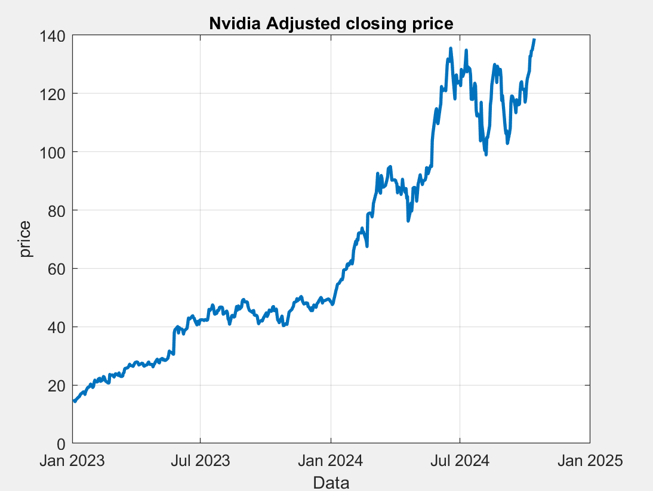
Figure 1:Plot of Nvidia's Adjusted Closing Price Over Time

Continuous Wavelet Transform (CWT):
- Technique: cwt with Morlet wavelet ('amor').
- Purpose: Time-frequency decomposition of the stock price signal
- Output: A time-frequency spectrogram showing how frequency components evolve over time.
CWT provides a scalogram, allowing identification of both low-frequency trends (long-term) and high-frequency spikes (short-term volatility).
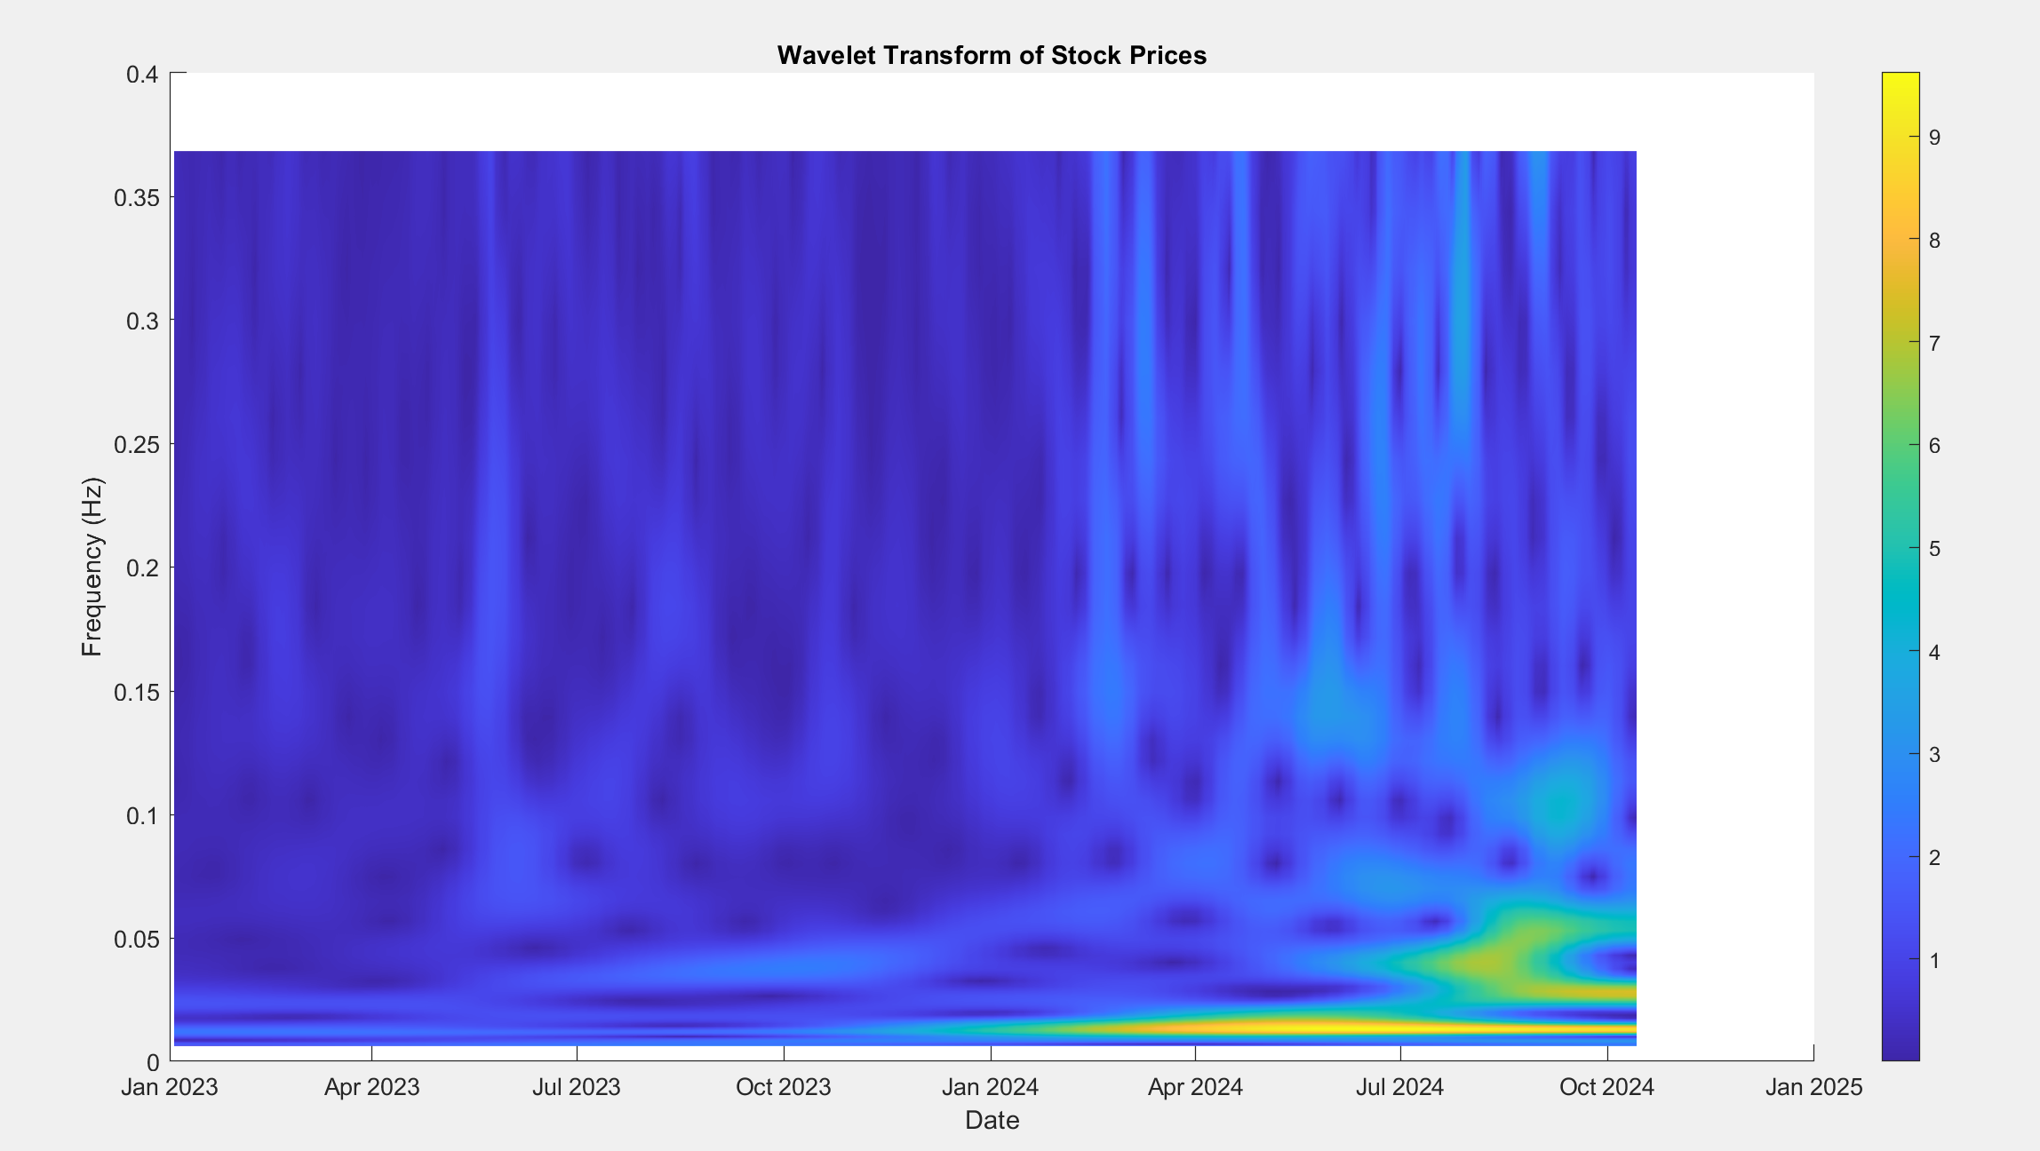
Figure 2: Wavelet Transform Scalogram
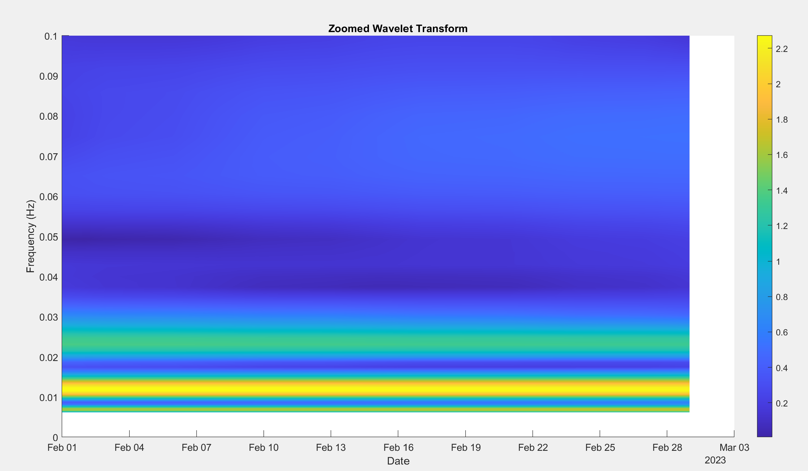
Figure 3: Zoomed CWT for February-March 2023

Time-Windowed Analysis:
- A specific date range (e.g., Feb 1 to Mar 1, 2023) is extracted using logical masking.
- The wavelet transform is then visualized for this region to highlight localized behavior and anomalies.
This allows analysts to observe sudden market shifts or cyclical patterns during a focused time window.

Wavelet Entropy Calculation:
- Purpose: Quantify the complexity or uncertainty in the signal
- Formula:
$$E=-∑\left(p_{i}\log\left(p_{i}\right)\right)$$
Where $p_{i}$ is the normalized energy at each frequency.
- Additional Metrics:
- Mean coefficient magnitude
- Standard deviation of coefficients
These statistics help characterize the overall volatility and complexity of the price signal.
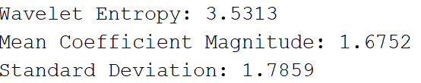

Discrete Wavelet Transform (DWT) and Denoising:
- Technique: dwt with Daubechies-4 ('db4') wavelet.
- Step 1: Compute approximation (ca) and detail (cd) coefficients.
- Step 2: Apply soft thresholding to remove small detail coefficients (noise).
- Step 3: Reconstruct the denoised signal using idwt.
This effectively removes high-frequency noise while preserving the underlying price trend.
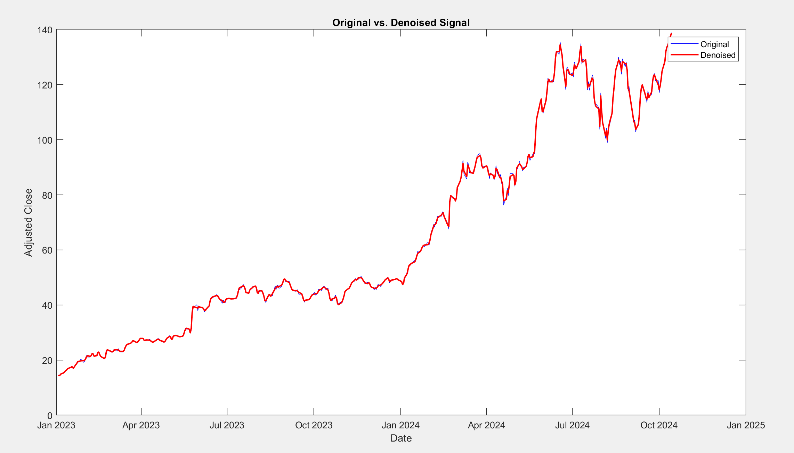
Figure 4: Comparison of Original vs Denoised Signal:
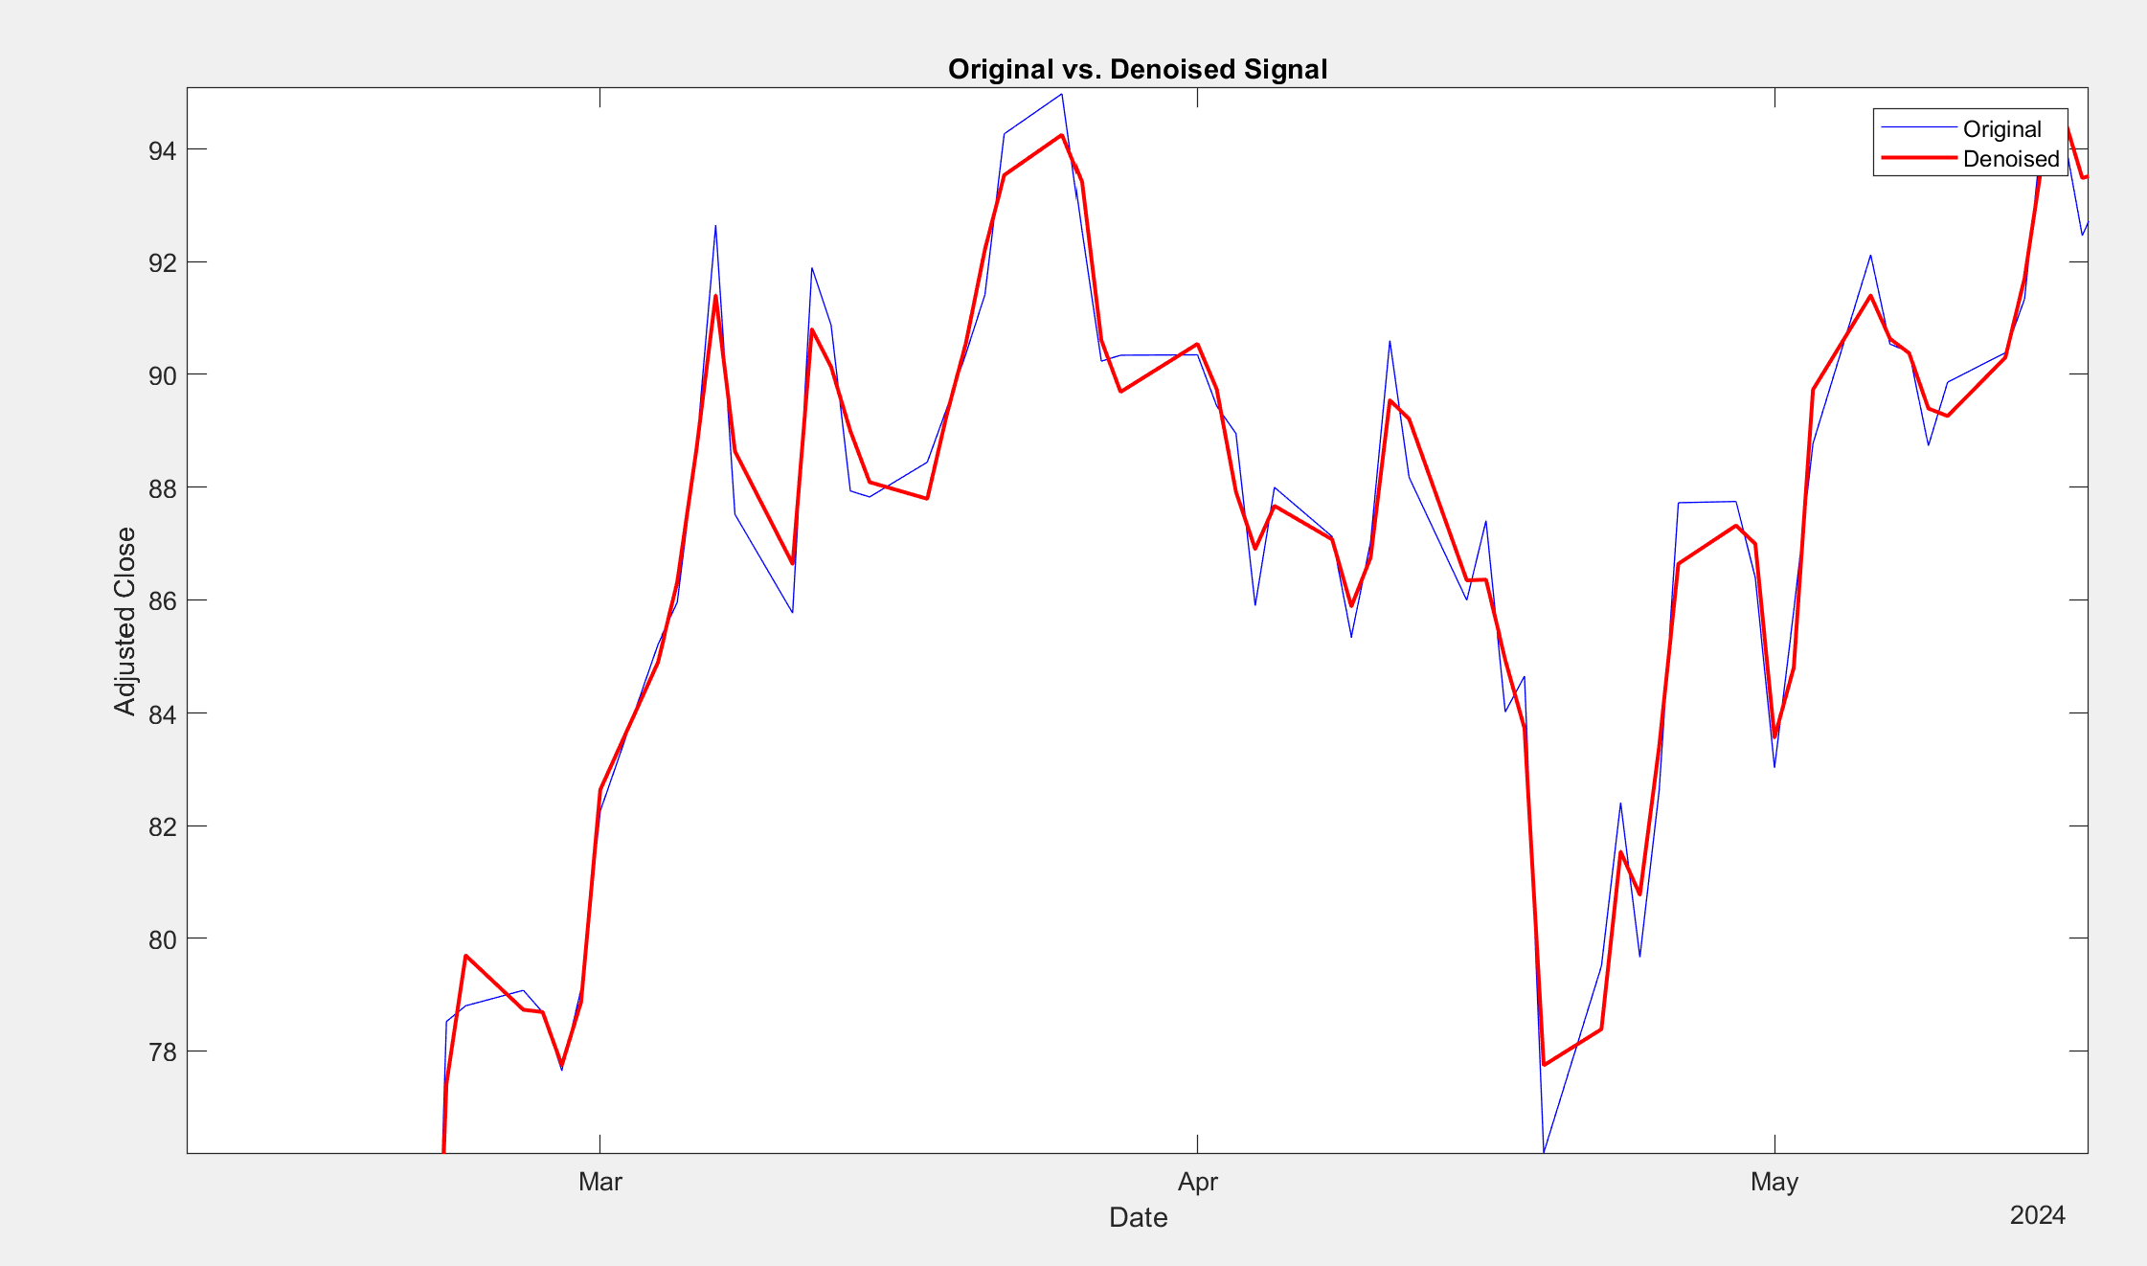

Tools & Libraries:
- MATLAB
- cwt, dwt, wthresh, idwt functions
- Data visualization using plot, surface, shading interp.

Design and Architecture:
The system is modularly designed, with each module handling a specific responsibility in the overall wavelet-based analysis of financial time series data. The architecture promotes clarity, reusability, and ease of experimentation by dividing the processing pipeline into logical stages.

System Overview:
The architecture is composed of five core modules arranged in a sequential pipeline. Each module reads the output of the previous one and processes it further to extract deeper insights or refine the data:
Data Input & Preprocessing → CWT Analysis → Zoomed Analysis → Entropy Metrics → DWT Denoising

Component Breakdown:
Module | Functionality | Key Operations | Outputs
Module Preprocessing | Imports and visualizes time-series data | readtable, datetime, plot | Raw time-series plot
Module Continuous Wavelet Transform | Decomposes signal into time-frequency space | cwt, surface, abs(wt) | Wavelet spectrogram
Module Zoomed Analysis | Focuses on a specific time window for deeper inspection | Logical masking, view(2), ylim | Zoomed-in scalogram
Module Wavelet Entropy | Quantifies signal complexity | Energy summation, entropy formula | Entropy score, mean, and std
Module Denoising with DWT | Removes noise while preserving trend | dwt, wthresh, idwt, plot | Cleaned (denoised) signal

Data Flow Diagram:
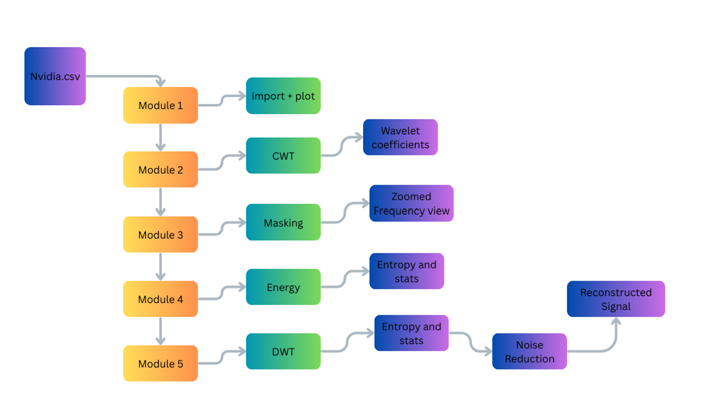

Design Justifications:
- Wavelet Transform (CWT & DWT): Selected for its superior time-frequency resolution, especially for non-stationary signals like stock prices.
- Soft Thresholding: Chosen over hard thresholding to avoid abrupt discontinuities in the reconstructed signal.
- Morlet Wavelet: Provides good localization in both time and frequency for continuous analysis.
- Daubechies-4 (db4): Commonly used in financial denoising due to its compact support and smoothness.
This modular architecture ensures each task (visualization, analysis, noise reduction) is independently manageable, making the system extensible for future enhancement such as real-time alerts, anomaly detection, or machine learning integration.

Implementation, Testing, and Programming Code:
This section elaborates on the implementation steps, tools, libraries, and testing methodology used to develop the wavelet-based financial time series analysis in MATLAB. The system is developed in a modular format, facilitating clarity and ease of debugging while ensuring accurate time-frequency analysis of stock data.

Tools and Programming Language:
- Software Used: MATLAB R2023a
- Language: MATLAB (Matrix Laboratory)
- Toolboxes:
- Wavelet Toolbox (for CWT, DWT, and entropy analysis)
- Signal Processing Toolbox (for filtering and time-series manipulation)
- Data Format: CSV file containing historical stock prices (e.g., NVIDIA)

Implementation Approach:
The program is divided into five structured modules, each handling a core part of the analysis pipeline:

Module 1: Data Import and Visualization:
- Purpose: Load time-series financial data and plot raw trends.
- Functions Used: readtable, datetime, plot.
- Link: https://www.kaggle.com/code/furkan09/nvidia-stocks-analysis/input
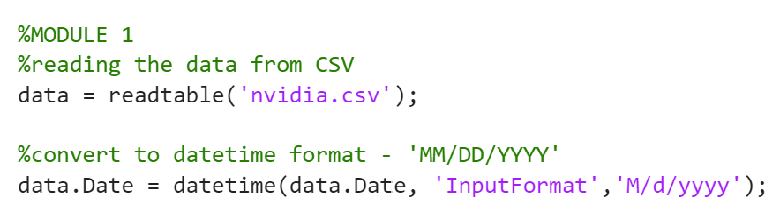

Module 2: Continuous Wavelet Transform (CWT):
- Purpose: Perform time-frequency analysis using the Morlet wavelet.
- Functions Used: cwt, surface, shading interp
- Wavelet Used: Morlet ('amor') — chosen for its good localization properties.
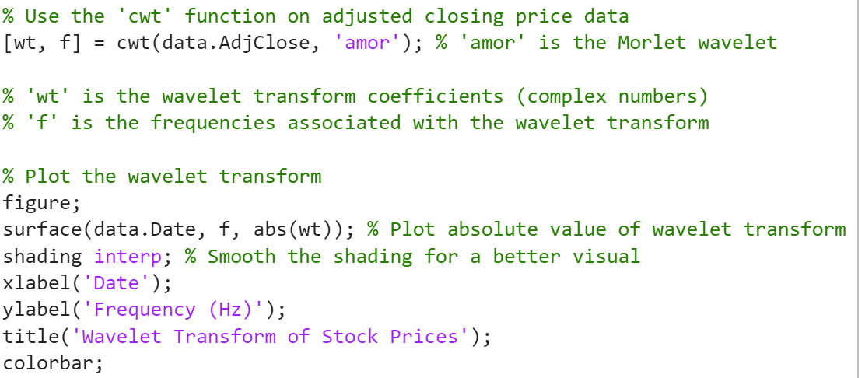

Module 3: Zoomed CWT Analysis:
- Purpose: Focus on a specific date range (e.g., Feb–Mar 2023) for localized event analysis.
- Techniques: Logical indexing, frequency filtering.
- Visuals: Zoomed-in spectrogram with low-frequency emphasis.
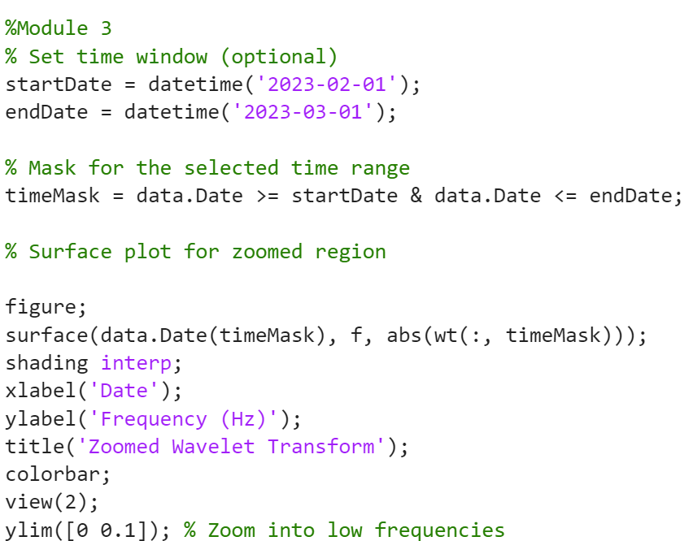

Module 4: Wavelet Entropy and Signal Statistics:
- Purpose: Measure the complexity of the signal using entropy.
- Techniques:
- Energy distribution across frequencies
- Normalization and entropy computation
- Statistical summaries (mean, standard deviation)
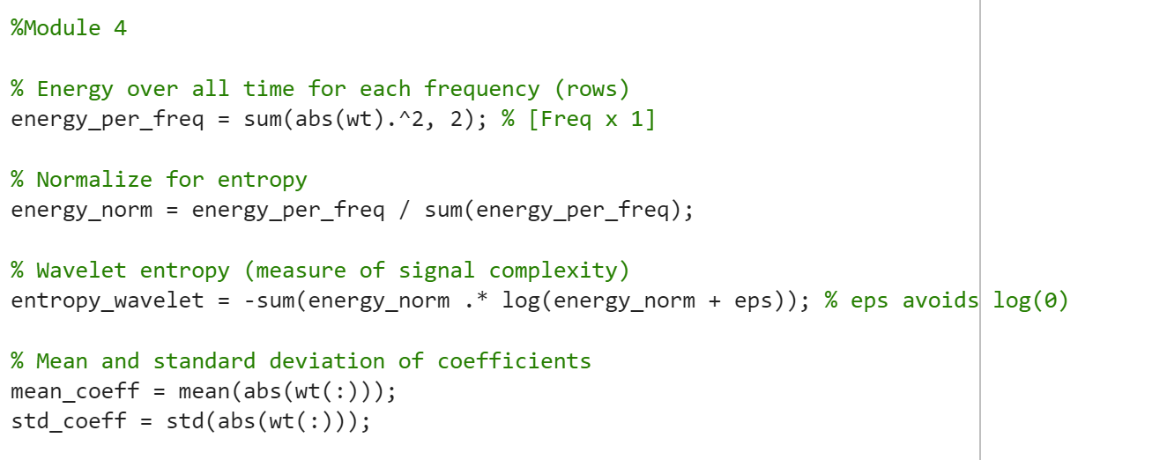

Module 5: Discrete Wavelet Transform (DWT) and Denoising:
- Purpose: Clean noisy signals while retaining significant financial trends.
- Wavelet Used: Daubechies-4 ('db4').
- Technique: Soft thresholding for noise reduction.
- Reconstruction: Performed using idwt.
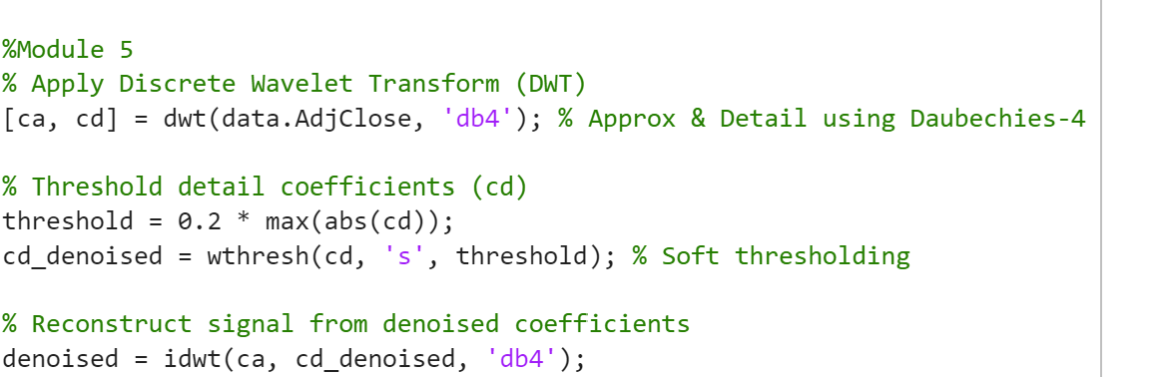

Testing and Validation:
- Unit Testing: Each module was tested independently to validate expected output (e.g., frequency axes, plot dimensions, NaN handling).
- Visual Validation: Signal plots, spectrograms, and entropy values were visually compared against expected results.
- Functional Checks:
- Zoom Module: Checked date range masking accuracy
- Entropy Module: Validated entropy value range (must be positive, finite)
- Denoising: Compared denoised signal trend with original to ensure data integrity.

Results:
The proposed system was evaluated using historical stock data of NVIDIA, applying both Continuous Wavelet Transform (CWT) and Discrete Wavelet Transform (DWT) techniques. The results were visualized through multiple figures, each offering insight into the signal's characteristics across both time and frequency domains.
- Time-Series Plot: The initial plot showcased the raw adjusted closing prices over time, identifying macro-level trends and fluctuations in stock behavior.
- CWT Spectrogram: The full-resolution wavelet spectrogram revealed detailed frequency variations over time. It effectively isolated short-term noise and long-term patterns, highlighting volatile trading days and market shifts.
- Zoomed CWT View: A focused analysis from February to March 2023 demonstrated the method's strength in analyzing local events. Lower frequency components identified steady market movements, while higher frequencies captured short-lived spikes.
- Entropy and Statistical Measures: Wavelet entropy was computed to measure signal complexity. A moderately high entropy score confirmed a mix of order and randomness typical of financial markets. The mean and standard deviation of wavelet coefficients validated these findings statistically.
- DWT-Based Denoising: The discrete wavelet transform, followed by thresholding, successfully filtered high-frequency noise. The comparison between the original and reconstructed signals visually confirmed the preservation of major trends with reduced volatility.
Overall, each module was rigorously tested with varying time windows and threshold values. The outcomes remained consistent, demonstrating that the system robustly handles different segments of financial data.



Conclusion:
This project successfully addressed the problem of extracting meaningful insights from noisy financial time-series data using wavelet-based methods. By leveraging both CWT and DWT, the system captured nuanced variations in price movements and provided a multiscale representation of market dynamics.
The simulation and testing strategy ensured thorough validation:
- Full-scale and localized visualizations confirmed the flexibility of the wavelet transform.
- Entropy and statistical analysis substantiated the signal’s underlying behavior.
- DWT-based denoising demonstrated that the approach can serve as a preprocessing step for future predictive modeling tasks.
Hence, the solution not only visualizes stock trends in a time-frequency domain but also supports noise reduction and complexity analysis, which are essential for financial forecasting and pattern detection tasks.

References:
[1] C. Torrence and G. P. Compo, "A practical guide to wavelet analysis," Bulletin of the American Meteorological Society, vol. 79, no. 1, pp. 61–78, 1998.
[2] S. Mallat, A Wavelet Tour of Signal Processing, 2nd ed. San Diego, CA: Academic Press, 1999.
[3] D. B. Percival and A. T. Walden, Wavelet Methods for Time Series Analysis. Cambridge, U.K.: Cambridge University Press, 2006.
[4] The MathWorks, Inc., "Continuous Wavelet Transform - cwt," MATLAB Documentation. [Online]. Available: https://www.mathworks.com/help/wavelet/ref/cwt.html
[5] M. Misiti, Y. Misiti, G. Oppenheim, and J. M. Poggi, Wavelet Toolbox™ User’s Guide. Natick, MA: The MathWorks, Inc., 2007.

