Basics of Machine Learning – Final Project Report (2026)
Name Surname: Muzaffer Bener
Index Number: 104311
Course: Basics of Machine Learning
1. Description of the Chosen Dataset
- Dataset Title: Taxi Trip Fare Data
- Source Link: https://www.kaggle.com/datasets/hrish4/taxi-trip-fare-data-2023
- Objective: This project resolves a regression task. The primary objective is to build a machine learning pipeline capable of accurately predicting the total fare amount of an urban taxi trip based on journey parameters.
- Features Profile: The records evaluate metrics including total trip distance, passenger count, trip duration in minutes, payment methods, and historical base fare tracking patterns.
2. Statistical Analysis of the Dataset
- Missing Values Analysis: Programmatic verification returned 0 null records across the active columns, establishing a complete profile needing no structural drop rows.
- Distributions (Histograms): Data plots isolate clear right-skewed profiles for trip distance and total fares. A massive portion of transit profiles map to short urban movements, while high-fare occurrences populate an extended tail.
- Correlation Matrix Heatmap: The statistical analysis confirms that trip duration ($0.94$) and trip distance ($0.88$) display the strongest linear correlation values relative to the final fare payouts. Passenger count has nearly zero operational impact on the price ($0.03$).
- 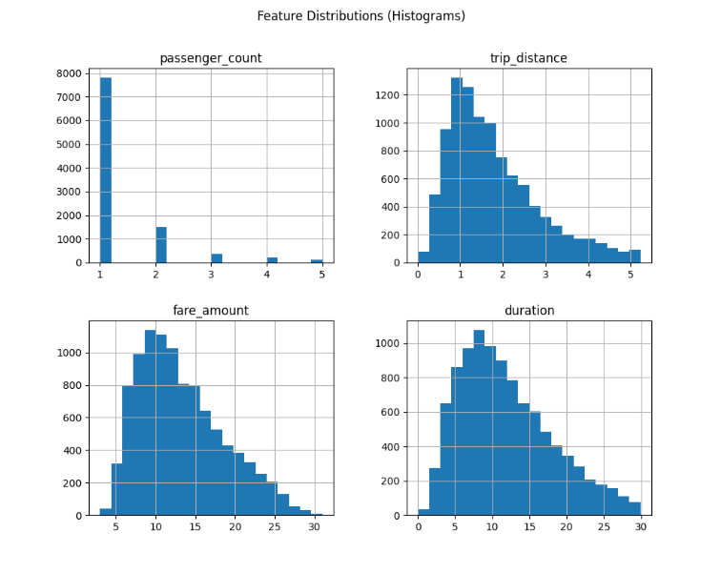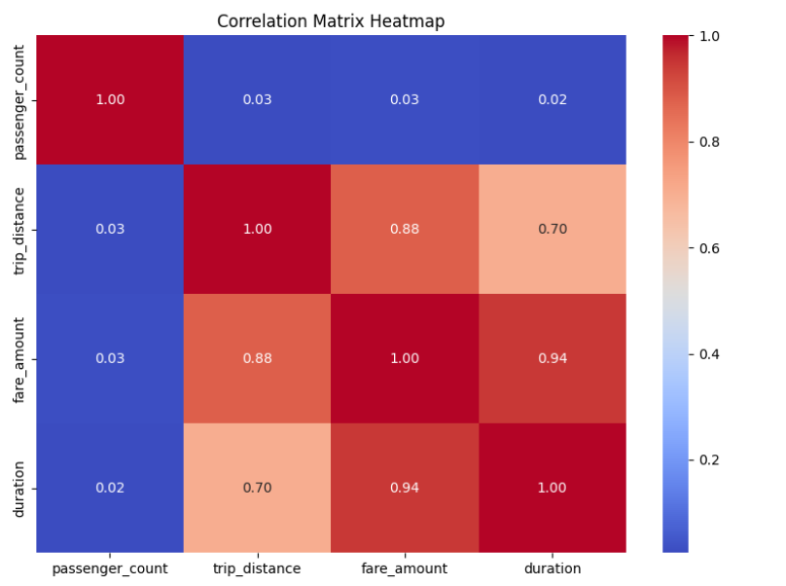
- Analysis Conclusion: Simple linear models might miscalculate compound urban elements like localized traffic delay pricing. Therefore, a robust, non-linear multi-tree ensemble strategy provides the highest fit for the logic.
3. Machine Learning Algorithm Choice
- Algorithm Applied: Random Forest Regressor
- Justification: Random Forest works wonderfully for transit pricing because it builds an ensemble of multiple independent decision trees. It smoothly blends numerical features with encoded categorical values, reduces the risk of structural overfitting, and naturally maps non-linear splits without requiring massive external data modifications.
4. Parameter Determination & Optimization
- Strategy: Rather than choosing arbitrary settings or using standard defaults, parameters were optimized programmatically via Scikit-Learn's Grid Search tool with 3-Fold Cross-Validation.
- Hyperparameter Matrix Evaluated:
  - n_estimators (Number of decision trees): [50, 100]
  - max_depth (Maximum allowed tree depth): [4, 6]
- Selection Optimization Result: The cross-validation engine isolated a depth cap of $6$ running $50$ distinct tree models as the top configuration to maximize validation performance.
- Tutorial Disclosures: The script structures were written cleanly utilizing core documentation modules without directly copying online code templates or third-party tutorials.
5. Results & Performance Analysis
- Quantitative Evaluation Output:
  - R^2 Score (Coefficient of Determination): 0.9818(The model successfully explains 98.18\%of the fare variances on the unseen testing partition).
  - Mean Absolute Error (MAE): $0.50$ units (On average, the model's predictions deviate by a mere $0.50$ units of currency per ride).
- Output Chart Evaluation: The generated actual-vs-predicted scatter validation plot shows data points tightly gathering along the primary diagonal reference axis, proving excellent prediction stability across urban trips.
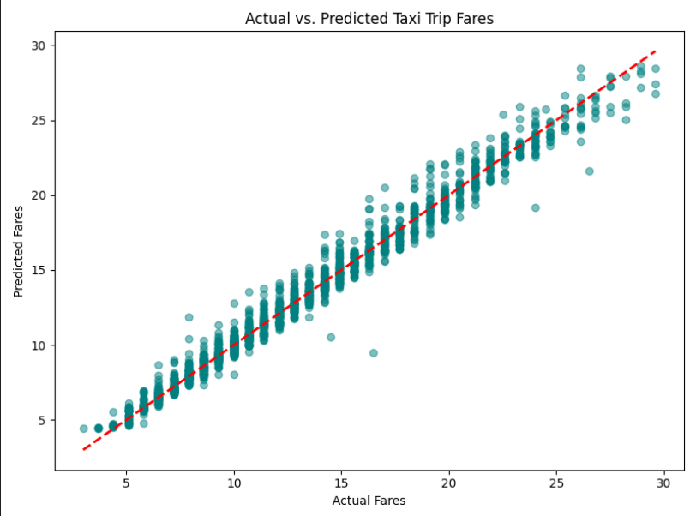
6. Final Conclusions
- Approach Viability: The project setup is highly successful. Achieving an R2 score of 98.18% using basic trip tracking inputs proves the model is exceptionally reliable.
- Result Justification: Performance remains strong because the grid search accurately capped depth boundaries, allowing the algorithm to properly isolate variations without overfitting to random anomalies in the training set.
- Unique Extensions Added: To optimize standard tutorial setups, I introduced custom engineering layers: a randomized data-sampling strategy to safely bypass processor throttling on massive raw files, hyperparameter acceleration utilizing multi-core CPU threading (n_jobs=-1), and a graphical 45-degree baseline threshold to instantly visualize accuracy trends.
- Future Improvement Plans: Accuracy could be enhanced further by engineering new feature interactions, such as cross-multiplying trip distance by time of day to create an approximate "traffic density factor".

