1. Below is the Swagger UI interface running successfully via Docker. It displays all the required endpoints for the application, including Authentication, Todo Management, and the bonus Integration health checks.
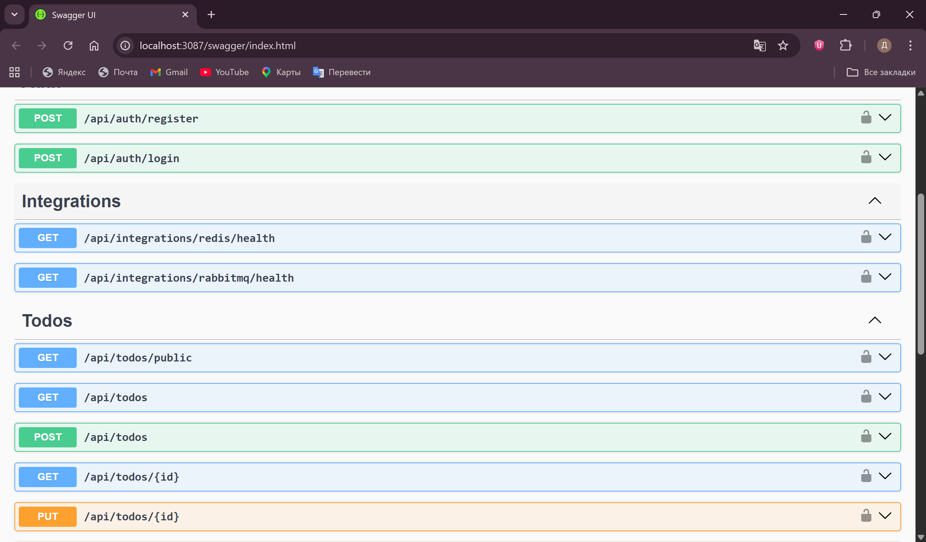

2. The screenshot below shows the PostgreSQL database terminal accessed directly inside the frontend-db-1 Docker container. Using the \dt command, we can verify that Entity Framework Core successfully applied the migrations on startup and created the Todos and Users tables. Additionally, a test user was registered via the API, confirming that data insertion works correctly.
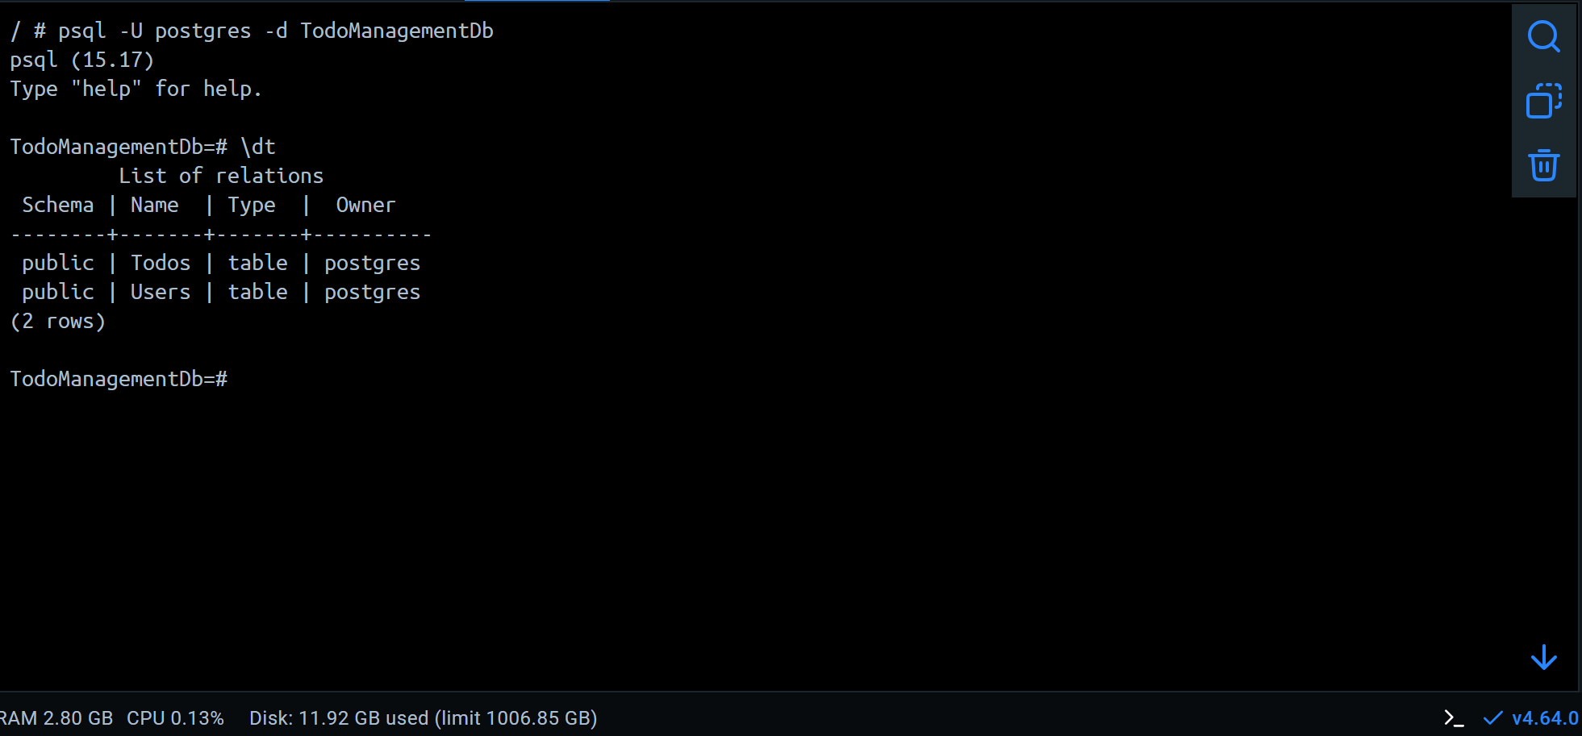

3. The following screenshots demonstrate the successful integration with Redis and RabbitMQ. When executing the health check endpoints (/api/integrations/redis/health and /api/integrations/rabbitmq/health), the API correctly returns a 200 OK status code with the {"status": "connected"} payload. This confirms that the backend is properly connected to both message broker and caching services running in their respective Docker containers.
