RecipeApp – Full-Stack Application Documentation
1. Project Overview
This project is a full-stack web application called "RecipeApp". The main goal was to build a complete ecosystem using Next.js, integrating a custom JWT-based authentication system and a PostgreSQL database managed via Prisma ORM.
2. Project Structure
The application follows a modular Next.js App Router structure, implementing the separation of concerns principle:
- src/app/api/ – Contains the backend REST API route handlers:
  - /auth/... – Registration, login, logout, and current user session verification.
  - /recipes/... – CRUD operations for recipes with strict backend ownership validation.
  - /seed/ – A custom endpoint to quickly populate or clean up the database with mock data.
- src/app/ – The main frontend views (Home, About, Login, Register, Recipe Details, Create Recipe, and Edit Recipe).
- src/components/ – Reusable UI elements, including the dynamic Navbar.tsx which adapts based on the user's authentication state, and basic UI building blocks (Buttons, Inputs).
- src/lib/ – Contains prisma.ts for initializing a global singleton instance of the Prisma Client to prevent connection exhaustion during development.
- prisma/ – Contains the schema.prisma file defining the User and Recipe data models and their relational constraints.
3. Features & Role Authorization
Public Access (Unauthenticated Users)
- Browse the visually appealing Home and About pages.
- Look for specific meals using the real-time Search bar (by title or description) and narrow down results using the Difficulty filter (Easy, Medium, Hard).
- Click on any recipe card to view its full details, including cooking time and author information.
- Create a new account with secure form validation (unique Email, Password hashing).
- Sign in to an existing account with proper error handling for invalid credentials.
Authenticated Users & The "Ownership Rule"
- Create Recipes: Access the protected "Add Recipe" route to publish new culinary creations to the database.
- Manage Own Recipes (Ownership Rule): A strict ownership rule is enforced both on the frontend and backend. Users can only see the "Edit" and "Delete" action buttons on recipes they personally authored. If a user attempts to bypass the UI and send a PUT or DELETE request to another user's recipe, the backend JWT verification intercepts it and returns a 403 Forbidden error.
4. Going Beyond the Specification
To ensure the application is not only functional but also highly polished and developer-friendly, the following additional features were implemented:
- Database Seeding Engine: An internal API route (/api/seed) was built from scratch. It allows developers or evaluators to instantly populate the database with realistic mock users and formatted recipes, and includes a DELETE method to safely clean up the seed data without affecting genuine user records.
- Real-Time Client-Side Filtering: Instead of constantly querying the database, the Home page fetches recipes server-side and then uses React hooks (useState, useEffect) to perform instant, zero-latency text searching and difficulty filtering on the client side.
5. Screenshots
Figure 1: Home page featuring the hero section, real-time recipe search interface, difficulty filter, and dynamic recipe cards.
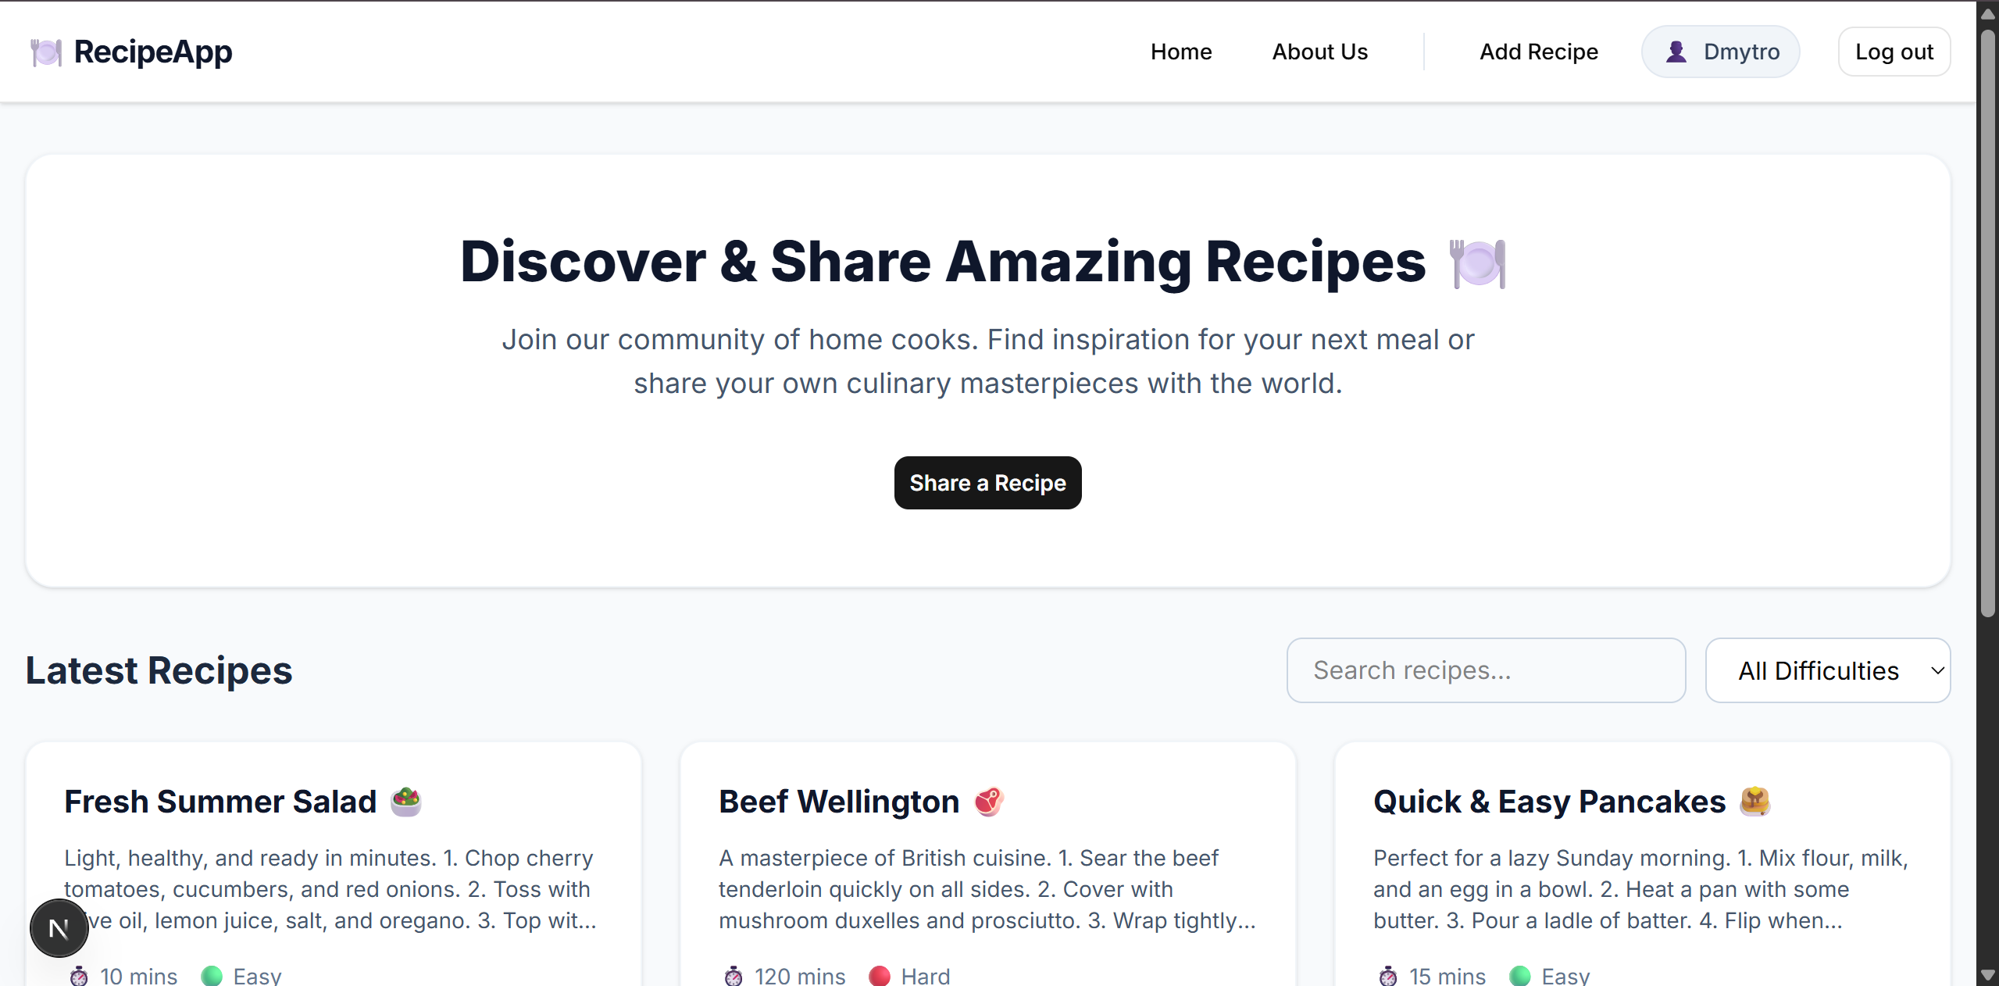
Figure 2: User Authentication (Register) view featuring clean UI and form validation.
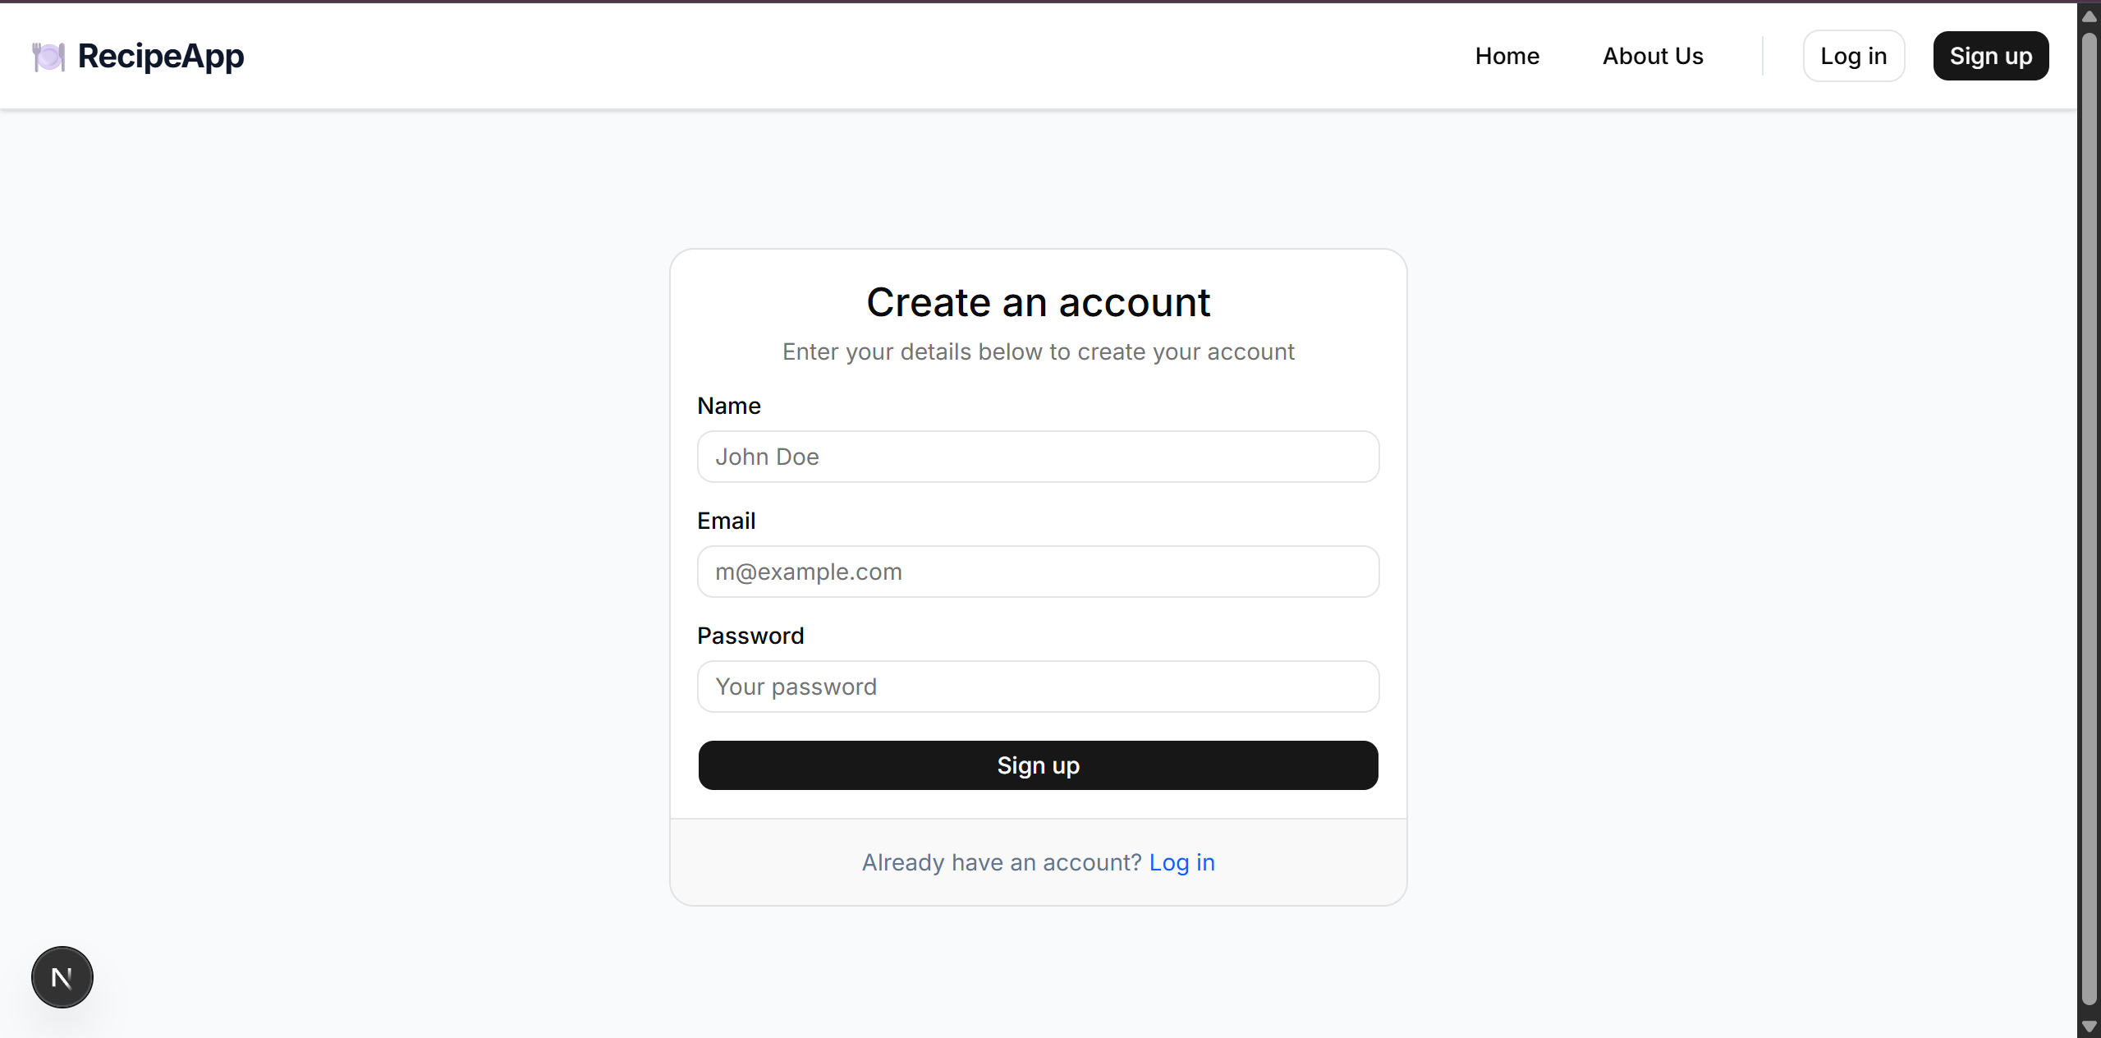
Figure 3: "Create Recipe" form allowing authenticated users to publish their meals.
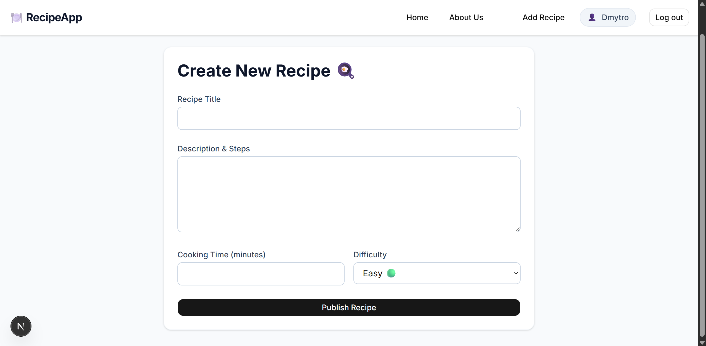
Figure 4: Detailed Recipe view. Since the logged-in user is the author of this recipe, the "Edit" and "Delete" action buttons are visible.
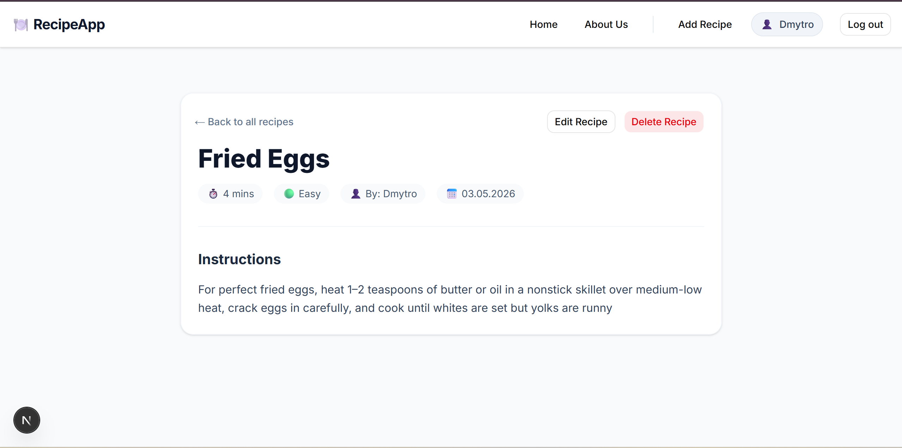
Figure 5: "Edit Recipe" view demonstrating the form pre-populated with existing database values for quick modifications.
