Paradise Hotel – Frontend Application Documentation
1. Project Overview
This project is a React frontend application for a fictional hotel brand called "Paradise Hotel". The main goal was to consume the REST API backend that was provided without changing the backend contract. The app delivers a smooth, visually appealing, and luxurious user experience for three types of users: Guests (unauthenticated), Registered Users, and Administrators.
Note: You can find detailed instructions on how to run the frontend and backend locally or through Docker in the README.md file located at the root of the repository.
2. Technologies Used
- Framework: React (bootstrapped with Vite for fast and modern building).
- Routing: React Router DOM (v6) for seamless Single Page Application (SPA) navigation and protected routes.
- HTTP Client: Axios (configured with interceptors for automatic JWT token injection).
- UI & Styling: Material-UI (MUI) for a responsive, modern, and accessible interface.
- Forms & Validation: React Hook Form for efficient form state management and robust input validation.
- Data Visualization: Recharts for rendering the Admin Dashboard metrics and charts.
- Date Handling: Day.js alongside MUI DatePickers.
3. Project Structure
The application follows a modular and scalable folder structure, implementing the separation of concerns principle:
- src/api/ – Contains the Axios configuration (axios.js). It exports an axiosPublic instance for standard requests and an axiosPrivate instance that automatically attaches the Bearer <token> to the headers.
- src/context/ – Contains AuthContext.jsx, which globally manages the user's authentication state, role, and login/logout logic.
- src/components/ – Reusable UI components:
  - Navbar.jsx – Responsive navigation bar that adapts based on the user's role.
  - ProtectedRoute.jsx – Wrapper component that restricts access to user-only and admin-only routes.
  - RoomCard.jsx & RoomSearchForm.jsx – Modular components used in the search page.
  - ReservationModal.jsx – Pop-up form for booking rooms.
- src/pages/ – The main views of the application (Home, About, Login, Register, RoomSearch, MyReservations, and Admin views).
4. Features & Role Authorization
Public Access (Guests)
- See the strong brand representation on the Home and About pages.
- Create a new account with very strict form validation (Name, unique Email, Password > 6 characters).
- Sign into an existing account with detailed error handling (e.g., catching 401 Invalid login credentials).
- Look for and narrow down the selection of rooms by destination, dates, number of guests, rating, and amenities through a live search interface.
Authenticated Users
- Book a Room: After searching for the desired dates, you can make reservation at the same time by selecting the room you wish to book.
- My Reservations : A personal calendar showing all the bookings past and present.
- Cancel Reservation: Only allow oneself to safely cancel the active bookings.
Administrators
- Admin Dashboard: A variety of crucial business metrics are displayed, among which are a monthly reservation Bar Chart and a location distribution Donut Chart.
- All Reservations: Admins are able to view and manage reservations across the whole system. In addition, Admins have the authority to cancel any active reservation.
- Manage Locations & Rooms: Utilize the MUI DataGrids to perform CRUD (Create, Read, Update, Delete) operations in a concise and user-friendly manner and the modal forms with a strong Flexbox foundation.

5. Going Beyond the Specification
During the process of making the app, a very detailed study of the backend source code that was given showed that there are many backend functions that were not part of the official requirements of the project. Hence, to provide a fully complete administration experience, the following additional feature was implemented successfully:
- Admin Rooms Management (CRUD): Although the specification only required an Admin Locations page, the backend included endpoints for managing individual rooms (/api/admin/rooms). A complete Manage Rooms page was built from scratch. It features a responsive MUI DataGrid and a complex modal form with Flexbox layout, allowing administrators to seamlessly create, edit, delete, and assign rooms to specific hotel locations.
6. Screenshots
Figure 1: Home page featuring the hero section and hotel amenities.
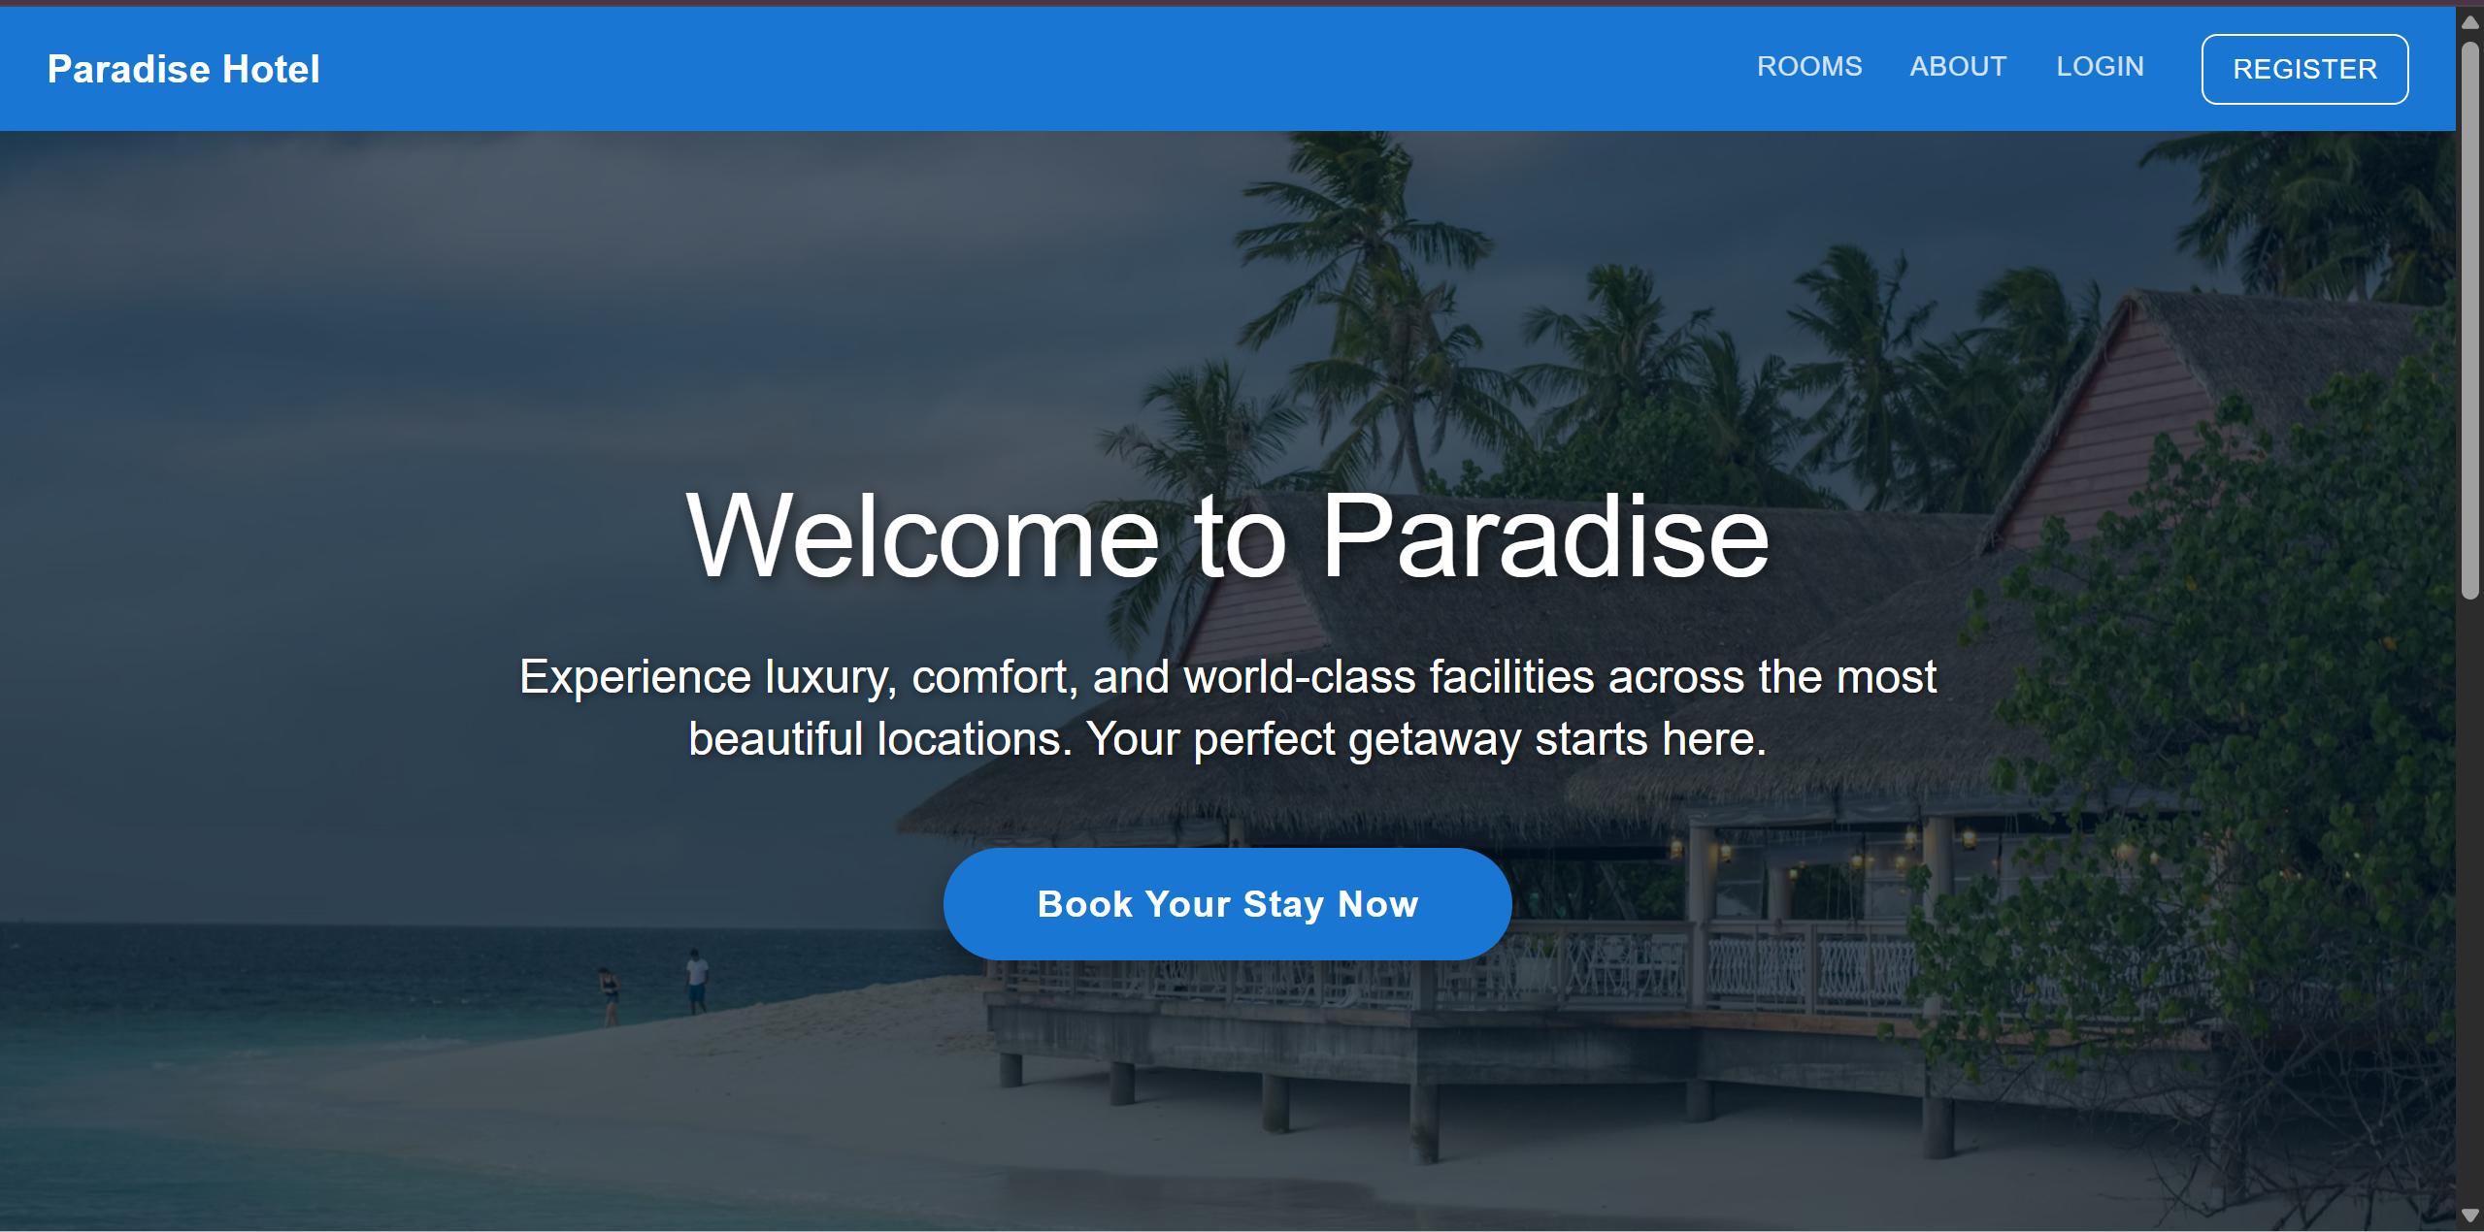
Figure 2: Room search interface with advanced filtering and dynamic room cards.
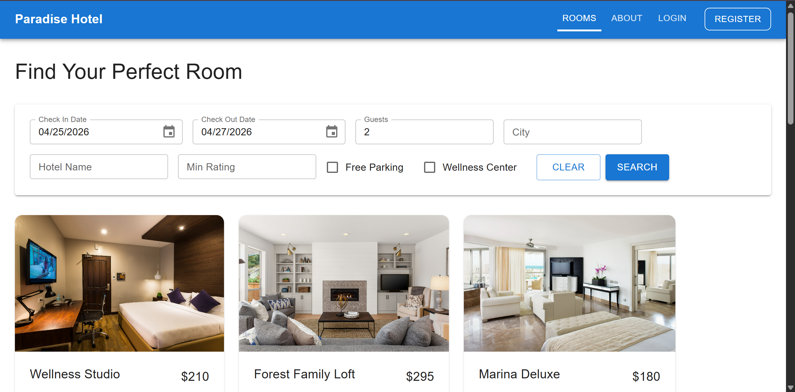
Figure 3: Administrator dashboard displaying dynamic charts and summary statistics.
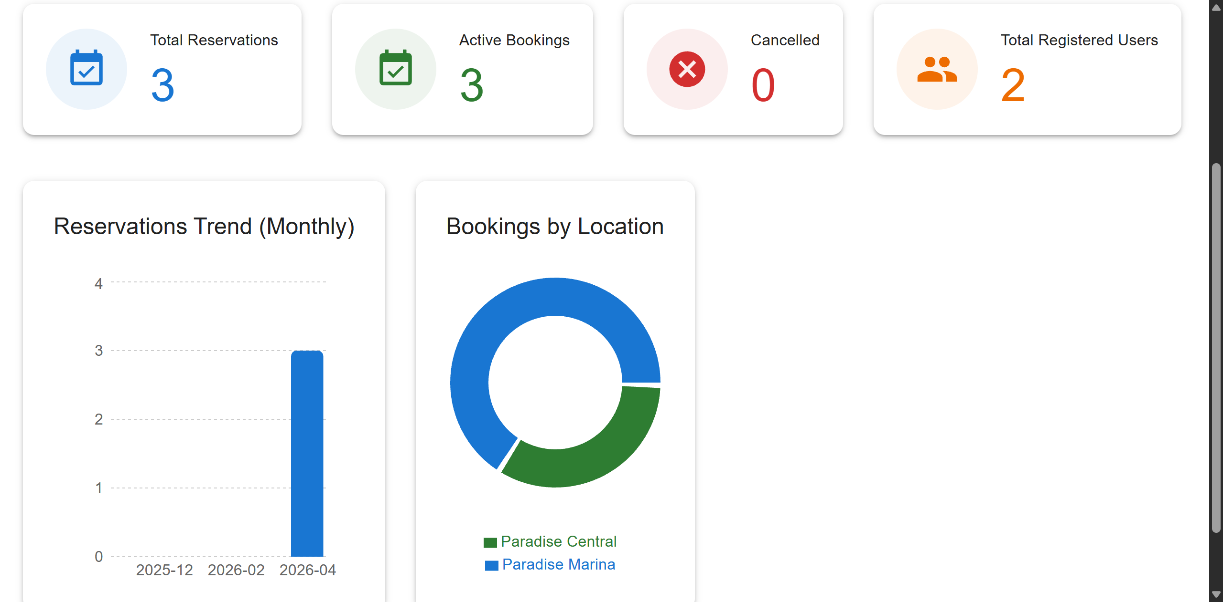
Figure 4: Admin view for managing rooms using MUI DataGrid and custom modal forms.
