KHAJA MUZAMIL MOHIUDDIN

1795609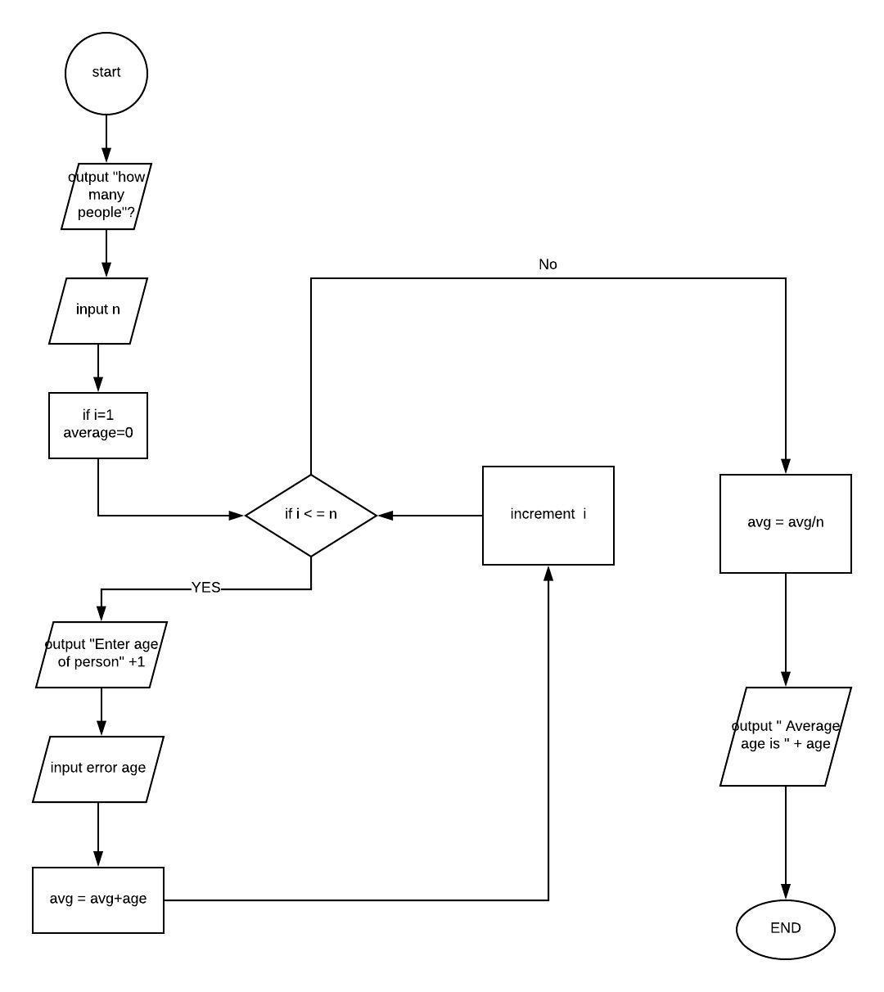

Pseudocode

1. Declare int n
2. Declare int i
3. Declare float average
4. Declare int average
5. Output : “ how many people ?”
6. Input n
7. Set I = 1
8. Set avg = 0
9. For 1 to n
10. Output : “enter age of person “ + i
11. Input age
12. Avg = Avg + Age
13. ENFOR I
14. Avg = Avg / n
15. Output : “average age is “ + avg
16. END

Trace

|  |  |  |  |  |  |  |
| --- | --- | --- | --- | --- | --- | --- |
| Line no. | Input buffer | n | i | Avg | age | Output buffer |
| 1. | - | - | x | x | x | - |
| 2. | - | - | - | x | x | - |
| 3. | - | - | - | - | x | - |
| 4. | - | - | - | - | - | - |
| 5. | - | - | - | - | - | “How many people” |
| 6. | 4 | 4 | - | - | - | - |
| 7. | - | 4 | 1 | - | - | - |
| 8. | - | 4 | 1 | 0 | - | - |
| 9. | - | 4 | 1 | 0 | - | - |
| 10. | - | 4 | 1 | 0 | - | “Enter age of person 1 “ |
| 11. | - | 4 | 1 | 0 | 24 | - |
| 12. | - | 4 | 1 | 24 | 24 | - |
| 13. | - | 4 | 2 | 24 | 24 | - |
| 9. | - | 4 | 2 | 24 | - | - |
| 10. | - | 4 | 2 | 24 | - | “Enter age of person 2 “ |
| 11. | - | 4 | 2 | 24 | 26 | - |
| 12. | - | 4 | 2 | 50 | 26 | - |
| 13. | - | 4 | 3 | 50 | 26 | - |
| 9. | - | 4 | 3 | 50 | - | - |
| 10. | - | 4 | 3 | 50 | - | “Enter age of person 3 “ |
| 11. | - | 4 | 3 | 50 | 25 | - |
| 12. | - | 4 | 3 | 75 | 25 | - |
| 13. | - | 4 | 4 | 75 | 25 | - |
| 9. | - | 4 | 4 | 75 | - | - |
| 10. | - | 4 | 4 | 75 | - | “Enter age of person 4 “ |
| 11. | - | 4 | 4 | 100 | 25 | - |
| 12. | - | 4 | 4 | 100 | 25 | - |
| 13. | - | 4 | 5 | 100 | 25 | - |
| 14. | - | 4 | 5 | 100 | 25 | - |
| 15. | - | 4 | 5 | 25 | 25 | - |
| 16. | - | 4 | 5 | 25 | 25 | “Average age is” + avg |
| 17. | - | 4 | 5 | 25 | 25 | “Average age is” + avg |