

**ASSIGNMENT**

**SUBJECT: DESIGN PATTERN**

**ROLL NO: SP18-MSCS-0026**

**SUBMITTED TO : SIR ARSLAN QURESHI**

**SINGLETON PATTERN DIAGRAM**

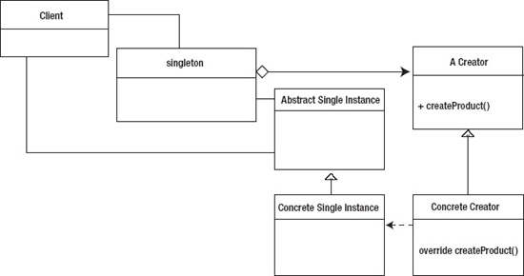

**FACTORY PATTERN DIAGRAM**

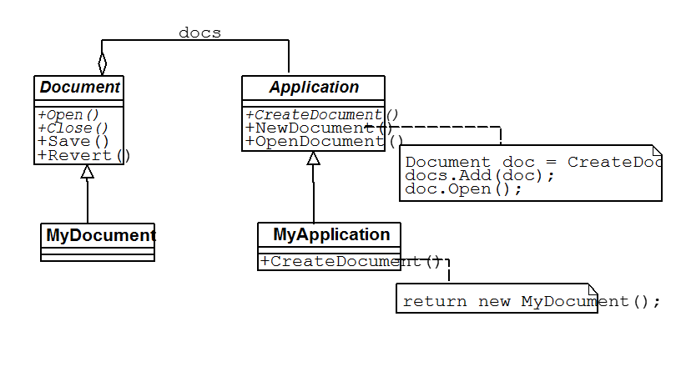

**ADAPTER PATTERN DIAGRAM**

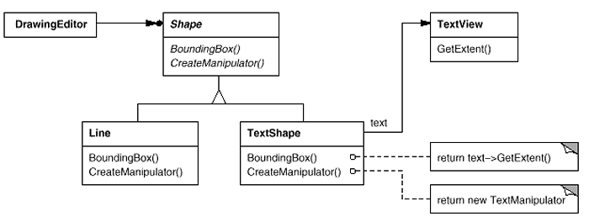

**DECORATOR PATTERN DIAGRAM**

