|  |  |  |  |
| --- | --- | --- | --- |
|  | **COLLEGE OF COMPUTING AND INFORMATION SCIENCES** | | |
| **Final Assessment of Lab Exam (Summer 2021**  **Semester)** | | |
| **Class Id** | 107242 | **Course Title** | Operating System lab |
| **Program** | BSCS | **Campus / Shift** | Main/ Morning |
| **Date** | July 15, 2021 | **Total Marks** | 20 |
| **Duration** | 02.5 hours | **Faculty Name** | Kazim Ali |
| **Student Id** | 11070 | **Student Name** | Kamisha Salim |
| **Code** | **A** |  |  |

**Instructions:**

* Fill out your Student ID and Student Name in above header. •Do not remove or change any part question paper. •Write down your answers with title “Answer for Question# 00”.
* Handwritten text or image should be on A4 size page with clear visibility of contents.
* In case of CHEATING, COPIED material or any unfair means would result in negative marking or ZERO.
* Viva can be taken with prior notice, where deemed necessary.
* **Caution:** Duration to perform Final Assessment is **02 hours only and 30 min** is given to cater all kinds of odds in submission of Answer-sheet. **Therefore, if you failed to upload answer sheet on LMS (in PDF format) within 2.5 hours’ limit, you would be considered as ABSENT/FAILED.**

**Note: Question 1 to 3 is for those students who last number of student ID is odd number and**

**Q4 to Q6 is for those students who have even number at last in Student ID**

**QUESTION – 4**

Write a multithreaded program that outputs Odd and even. This Program should work as follows: The user will run the program and will enter a number on the command line. The program will then create a separate thread that outputs all the Odd or even the number entered by the user.

**CODE:**

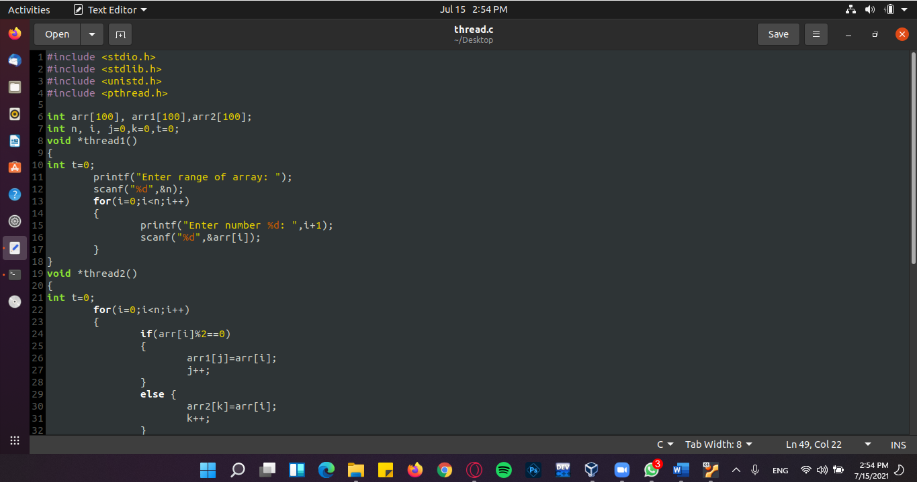

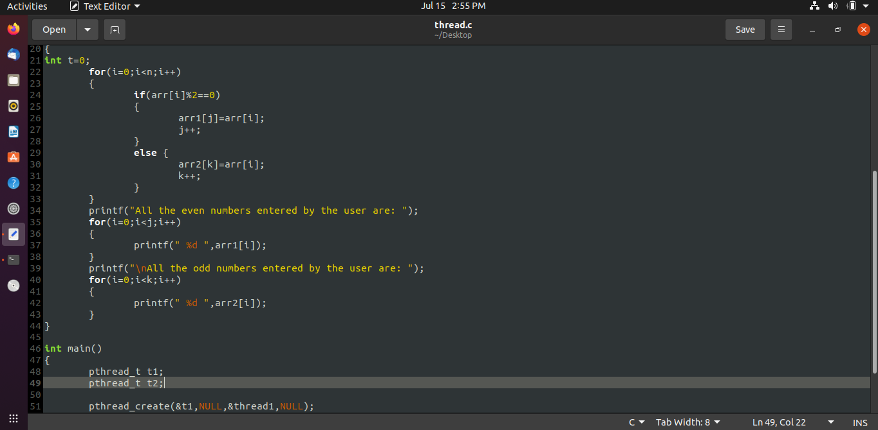

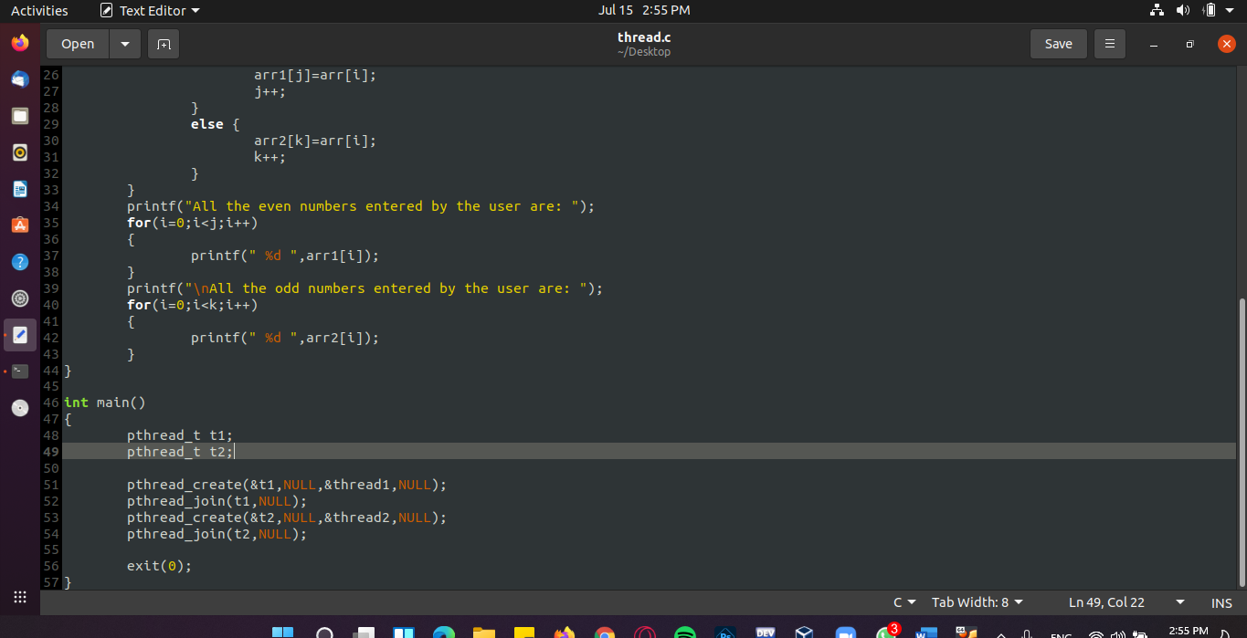

**OUTPUT:**

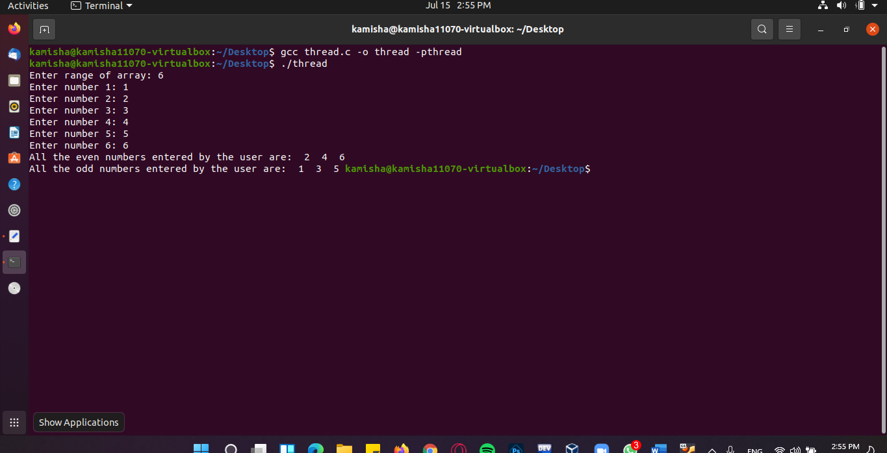

**QUESTION – 5**

Find the sum of n numbers entered by user using dynamically allocated memory using C programming.

**CODE:**

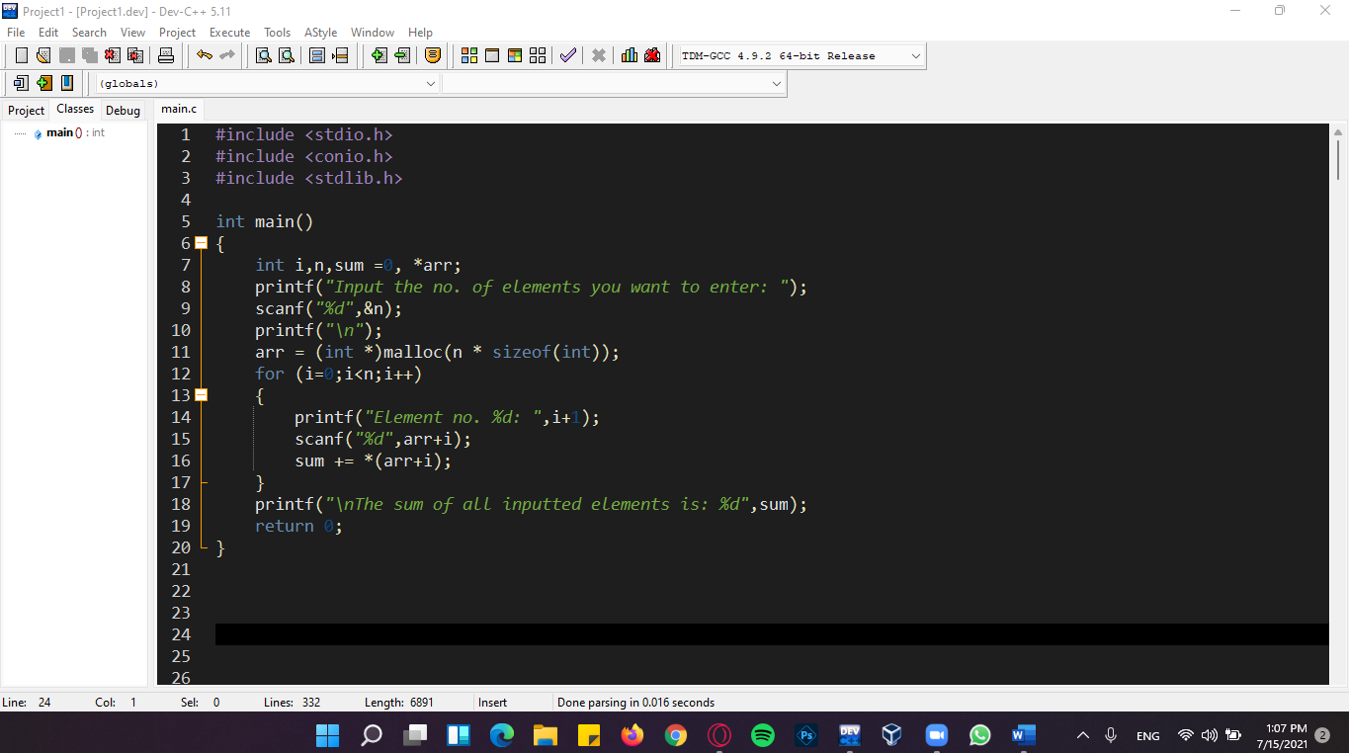

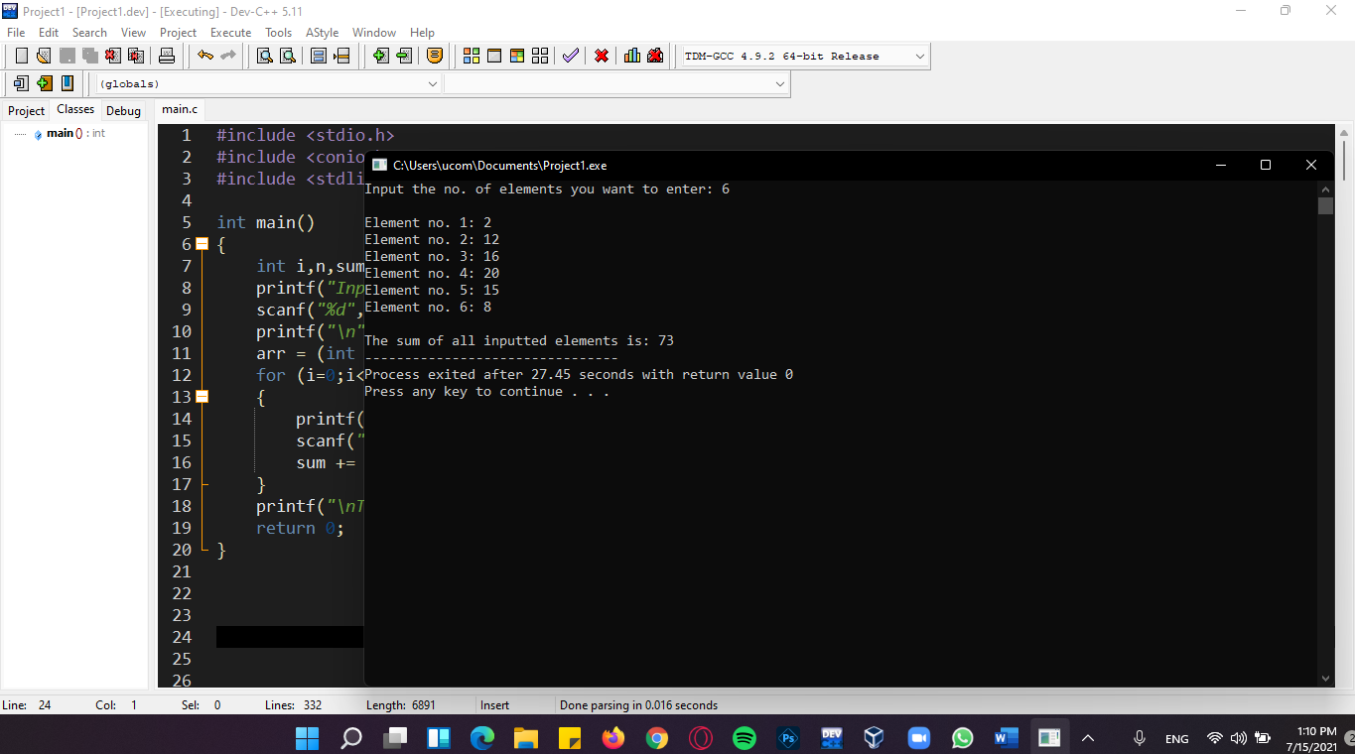**OUTPUT:**

**QUESTION – 6**

Create a function that takes a base number and an exponent number and returns the calculation.

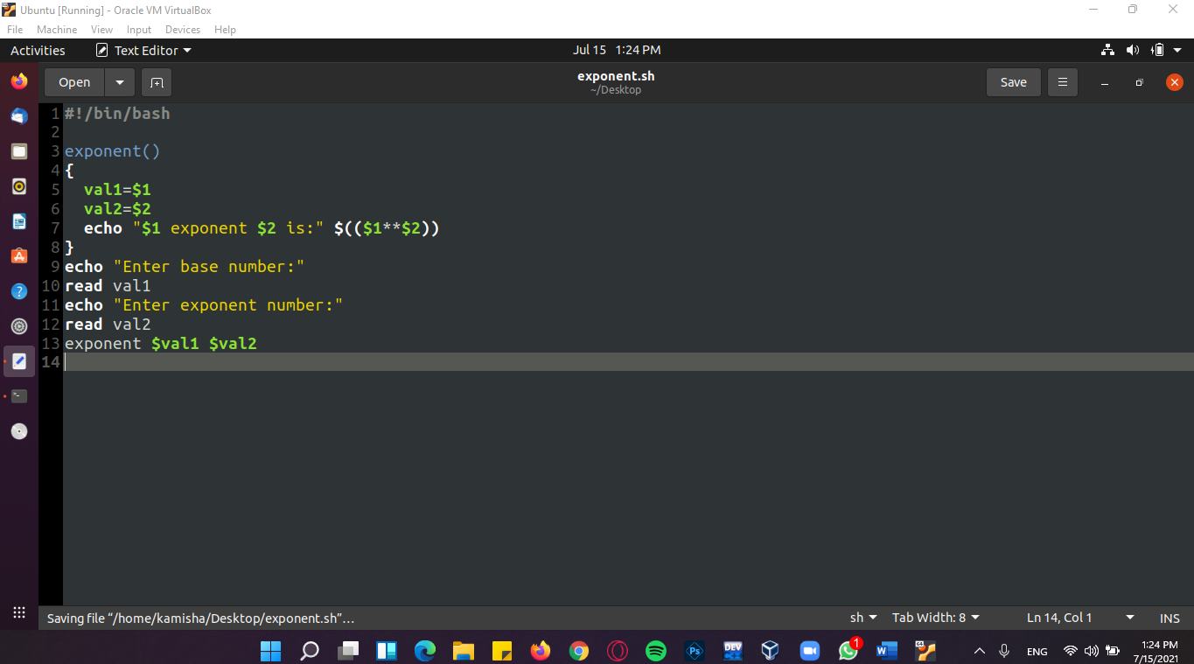**CODE:**

**OUTPUT:**

