**OPERATING SYSTEMS**

**ASSIGNMENT – 01**

**Name:** Kamisha Salim

**S.ID:** 11070

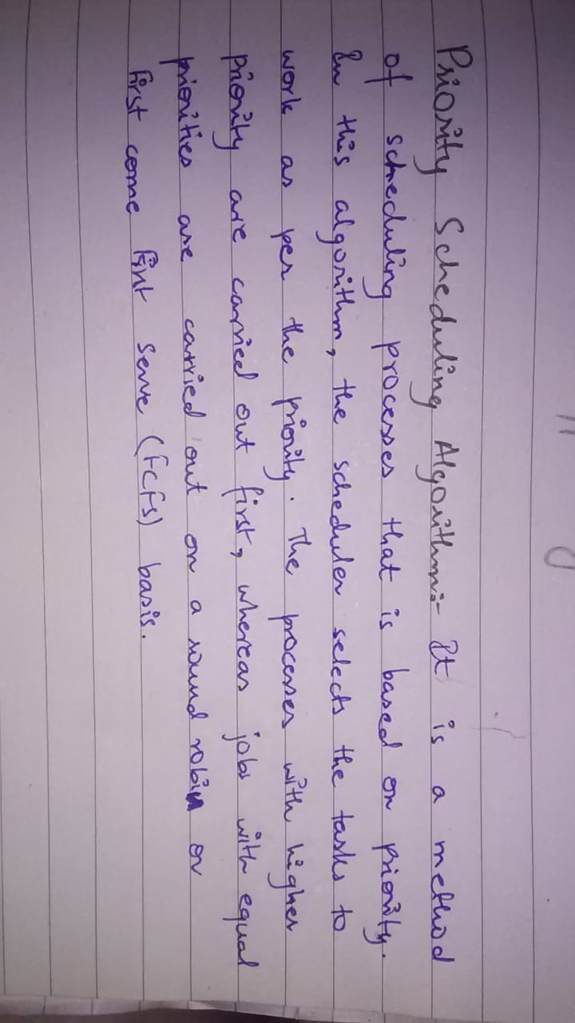**QUESTION – 1**

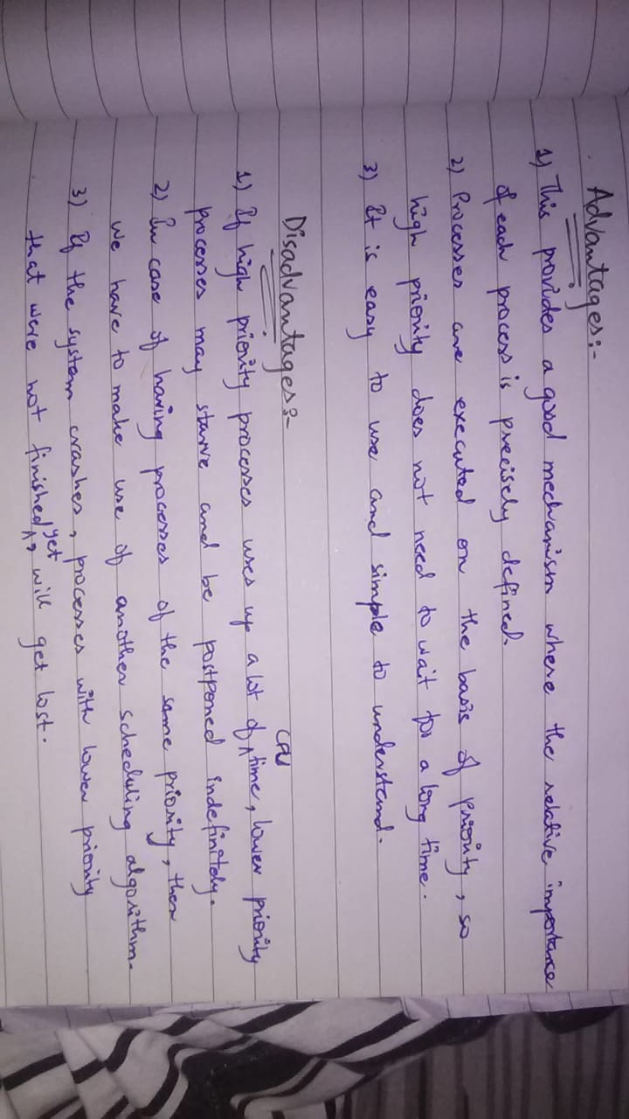**Part – a: Define priority scheduling algorithm and also its advantages and disadvantages.**

**Part – b: Write a program of the given algorithm. Apply priority scheduling algorithm using C/C++.**

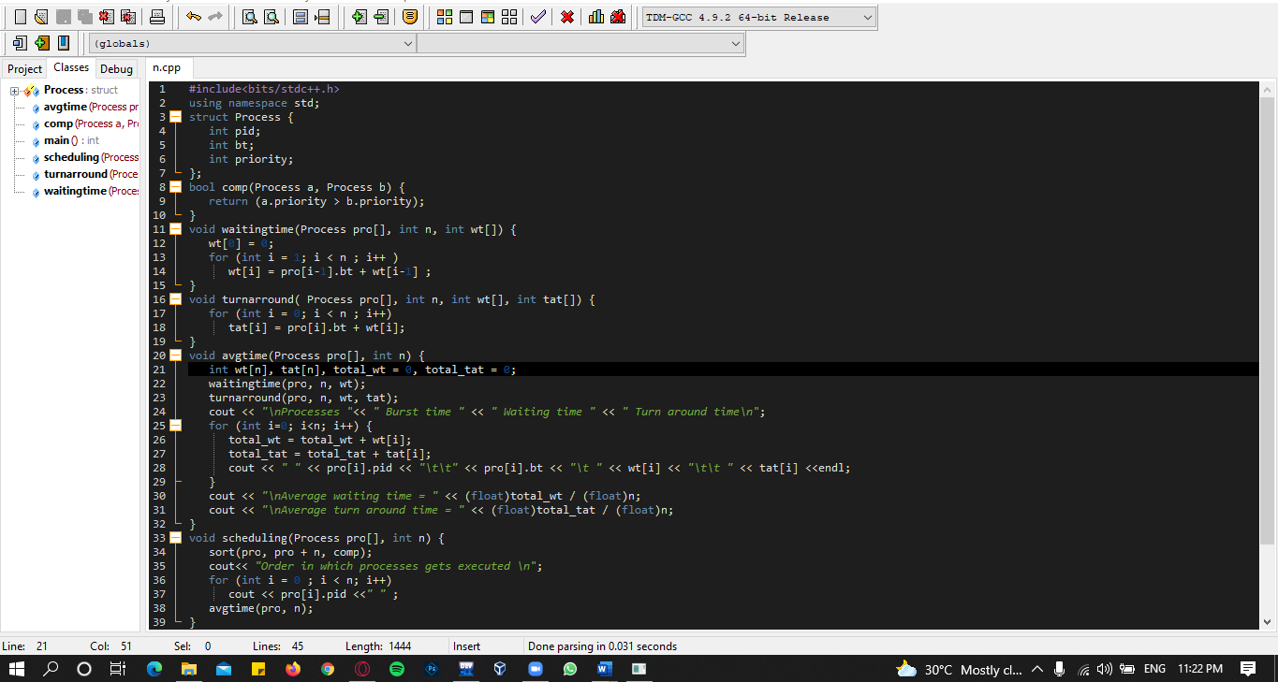**CODE:**

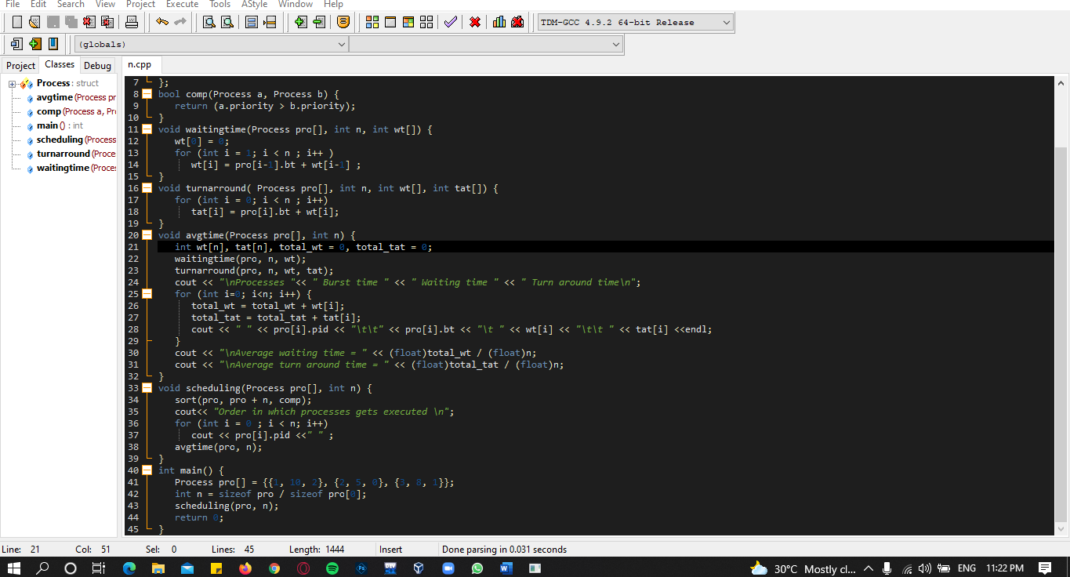

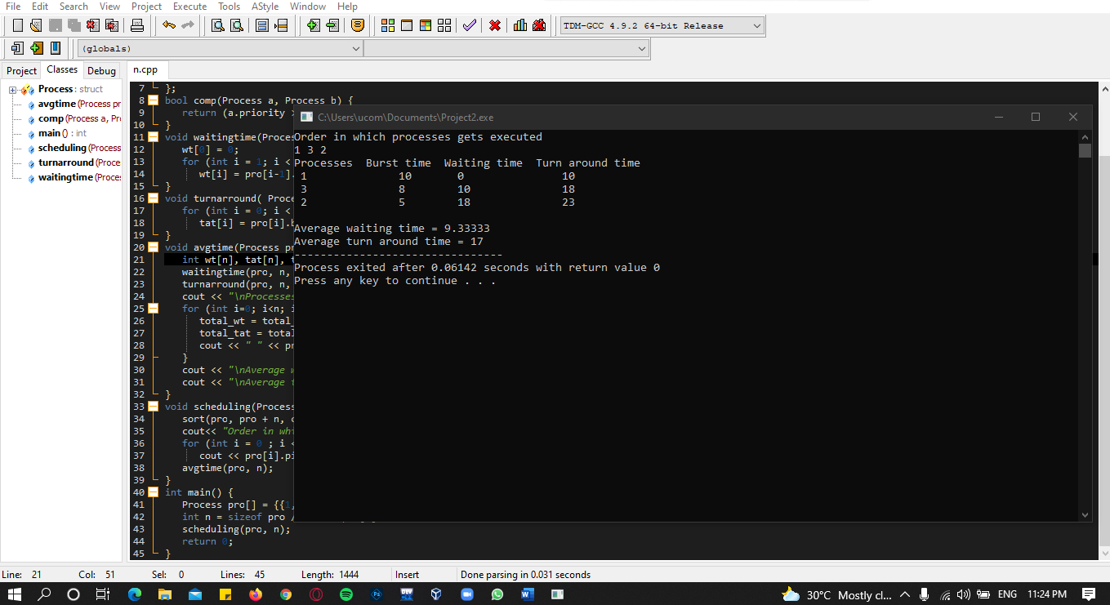**OUTPUT:**

**QUESTION – 2**

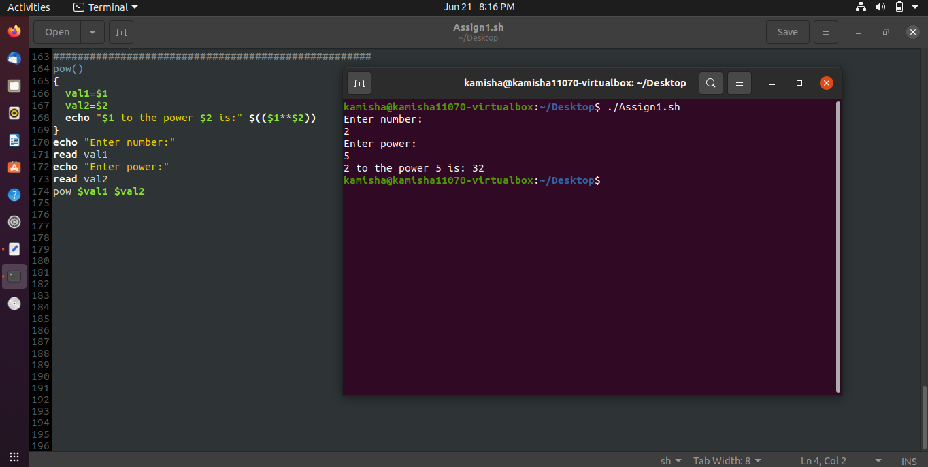**Part – a: Print a power b**

**Part – b: Calculate area of triangle**

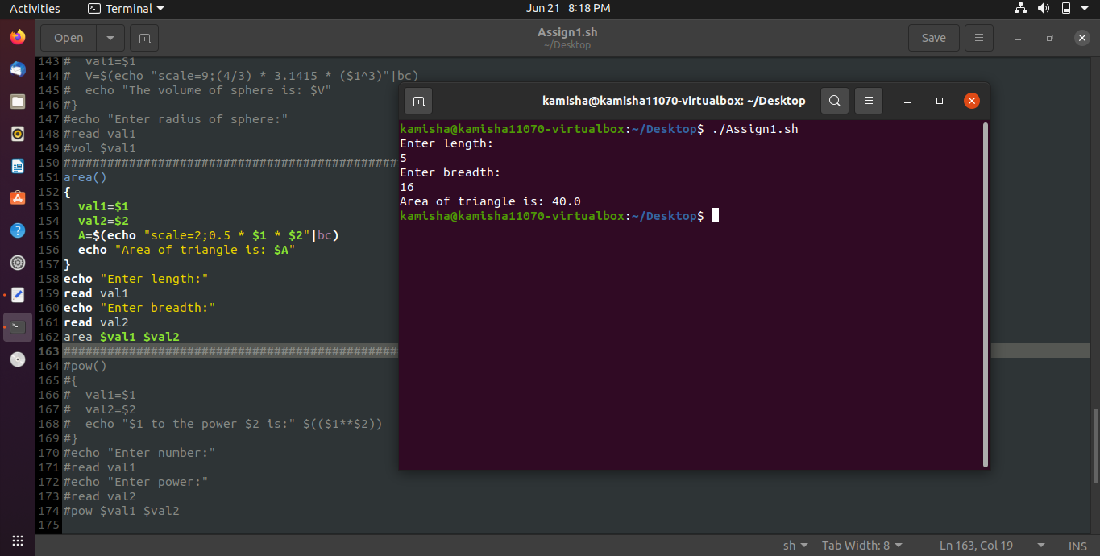

**Part – c: Calculate volume of sphere**

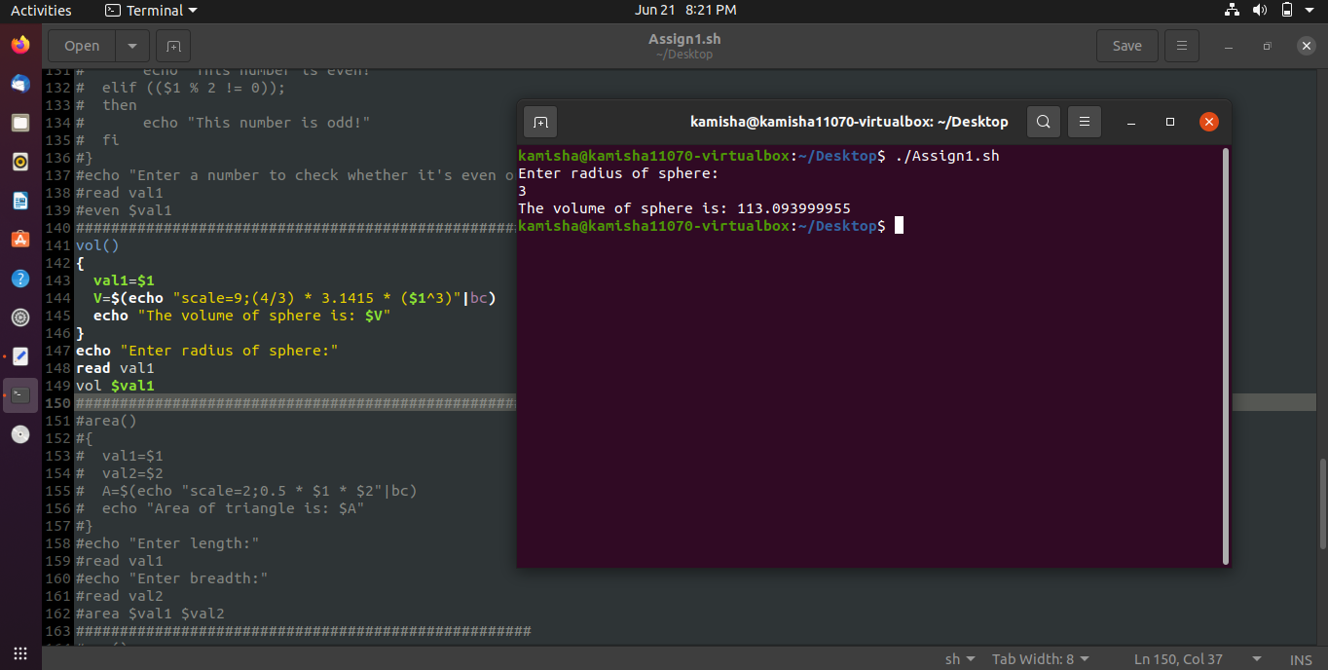

**Part – d: Check if a number is odd or even**

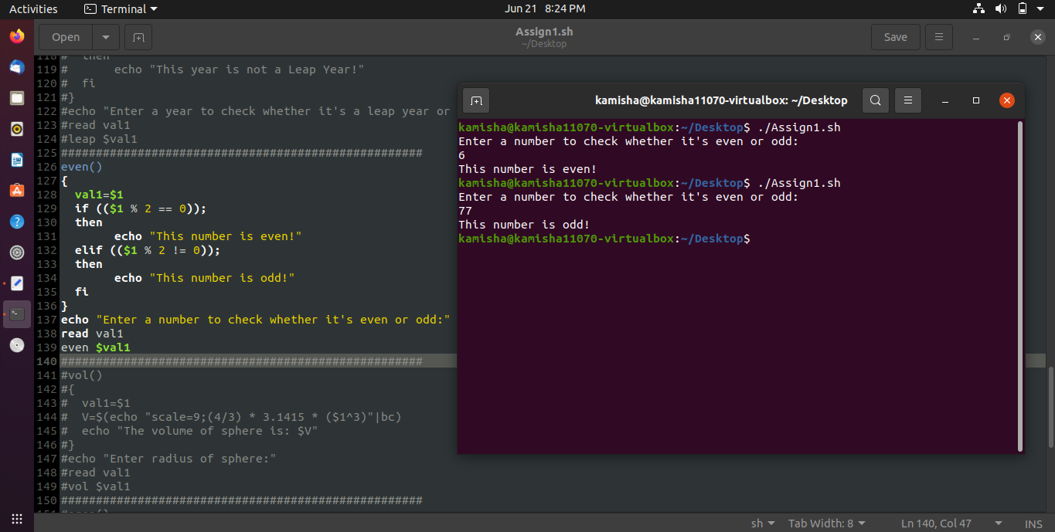

**Part – e: Check if a year is leap year or not**

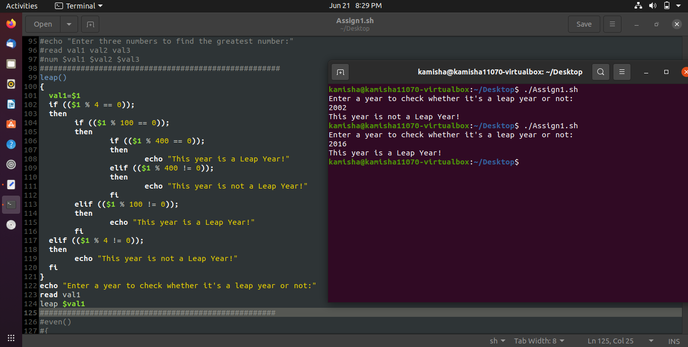

**Part – f: Find the largest number among three numbers**

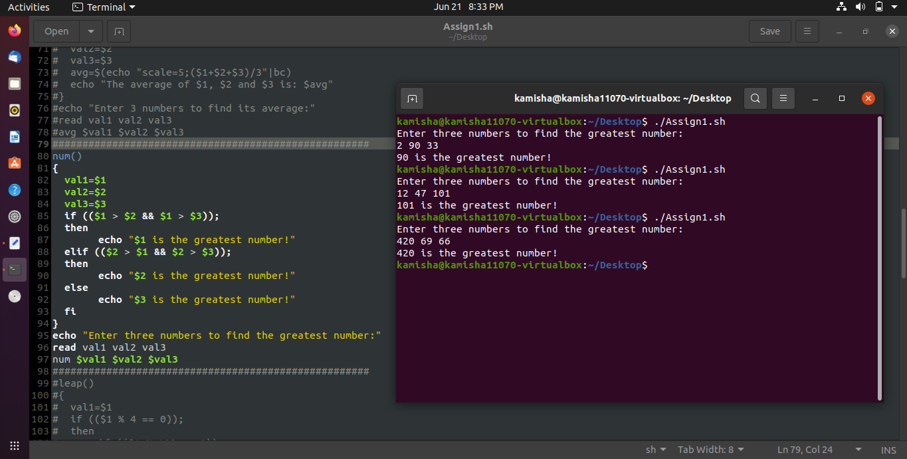

**Part – g: Check if a number is an Armstrong number or not**

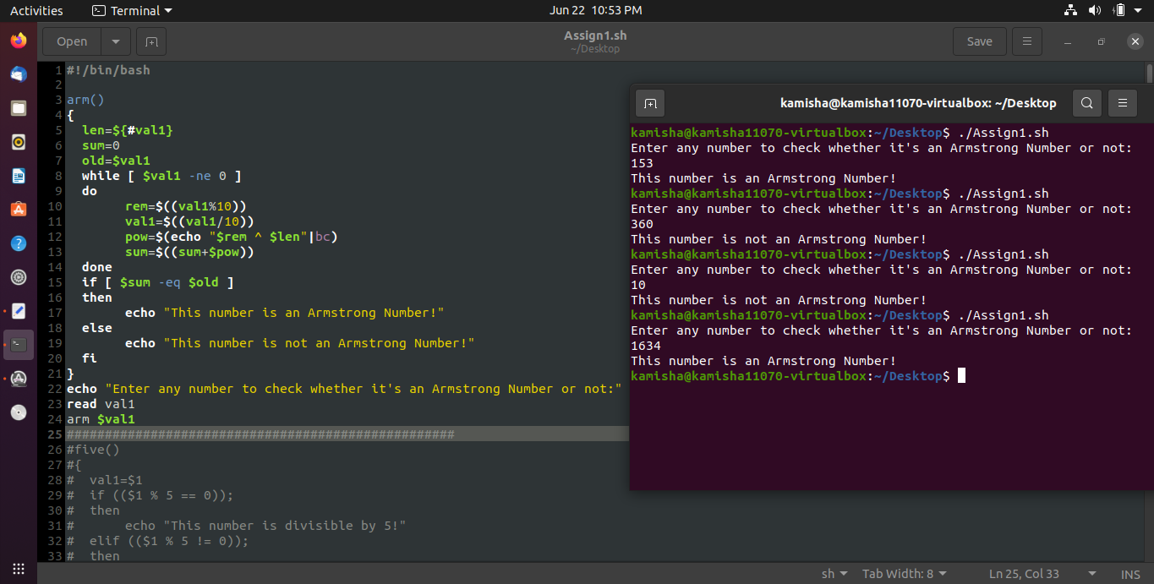

**Part – h: Find the average of three values**

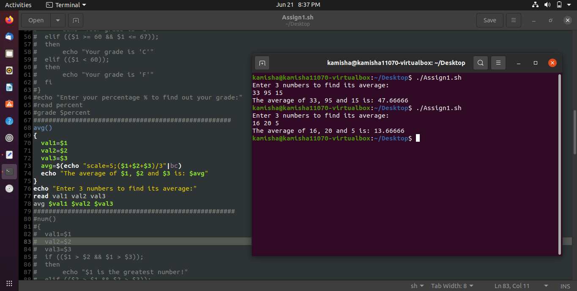

**Part – i: Calculate grade ‘A’ to ‘F’ after inputting percentage**

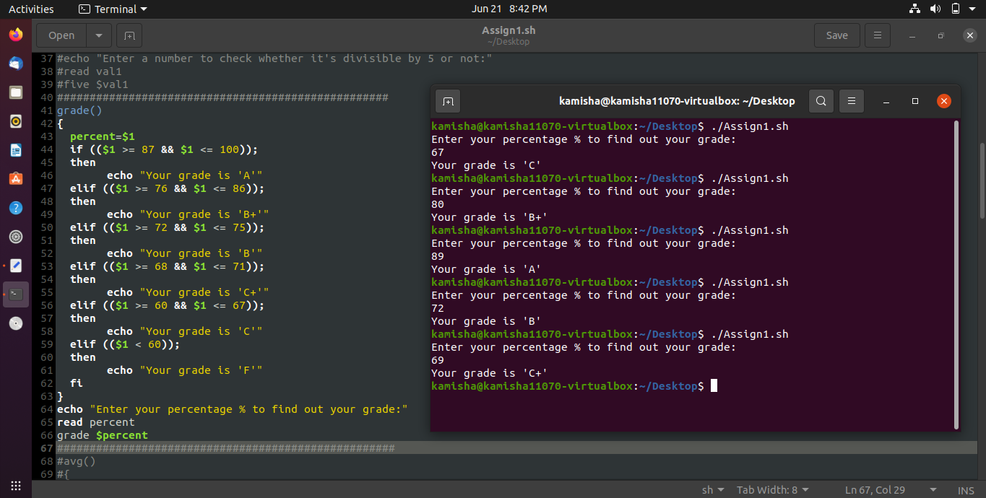

**Part – j: Check if a value is divisible by 5 or not**

