**OPERATING SYSTEMS**

**ASSIGNMENT – 02**

**Name:** Kamisha Salim

**S.ID:** 11070

**QUESTION – 1**

**Provide two programming examples in which multithreading provides better performance than a single-threaded solution.**

**Example – 1:** Here we have divided our program into 4 threads. 1st thread asking the user to input numbers in an array and the 2nd, 3rd and 4th threads are different programs that will be implemented on the user given array. If we were to block any of the last 3 threads except the 1st thread, i.e.: thread no. 2, 3 or 4, the program will automatically jump to the next available thread without any interruptions. For e.g.: if we blocked thread no. 2, the program will jump to thread no. 3 and will display the output without running thread no. 2. This is the advantage of multithreading because if we used single-threading, the program would have executed the entire process in a single sequence and we would not be able to block any processes according to our need in comparison to multithreading.

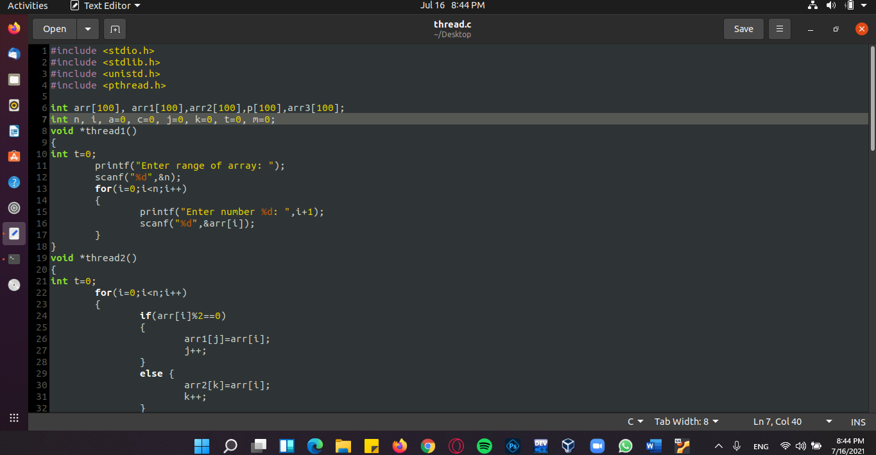

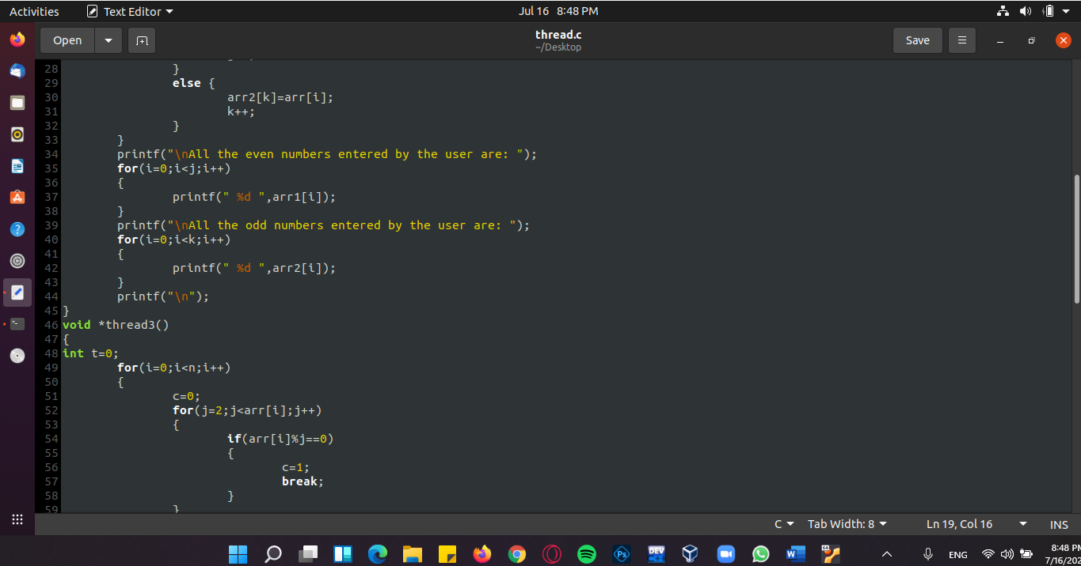

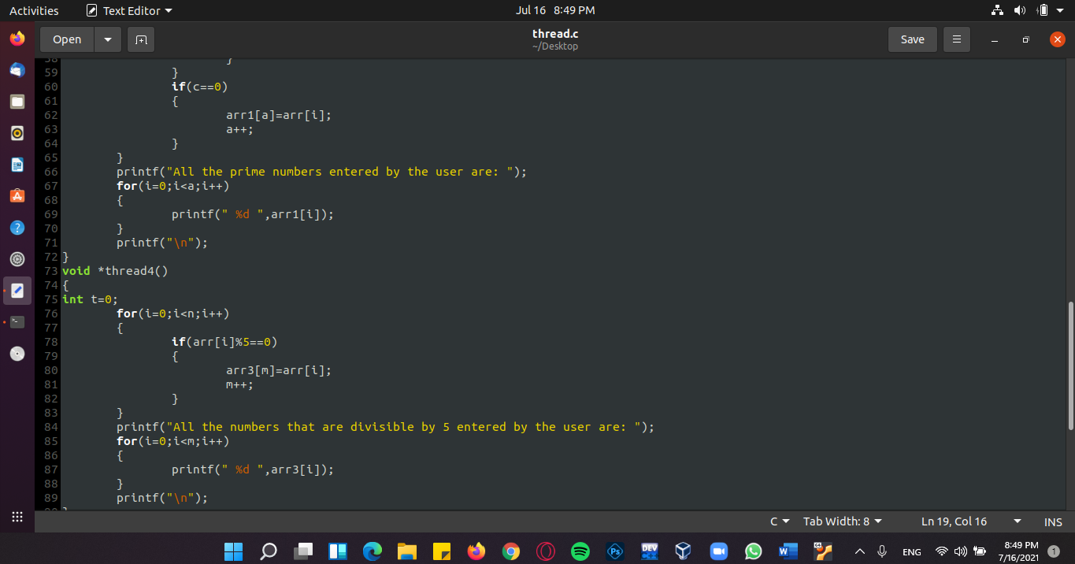

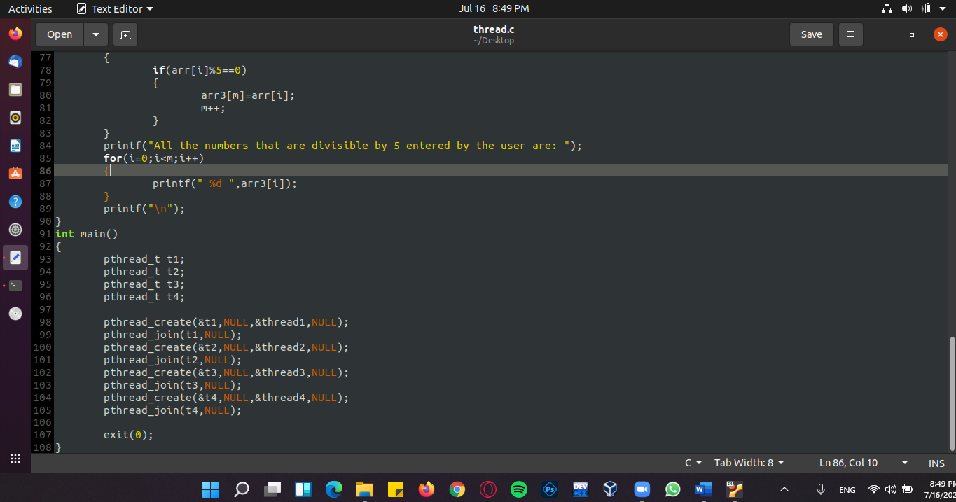

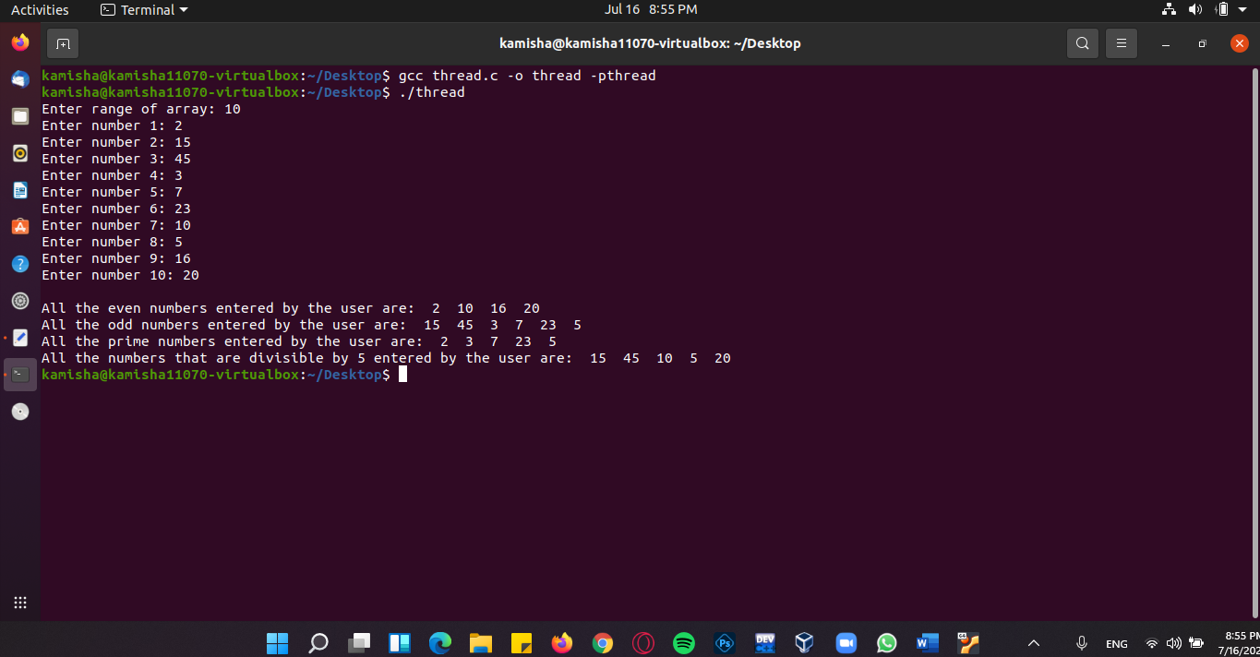**OUTPUT:**

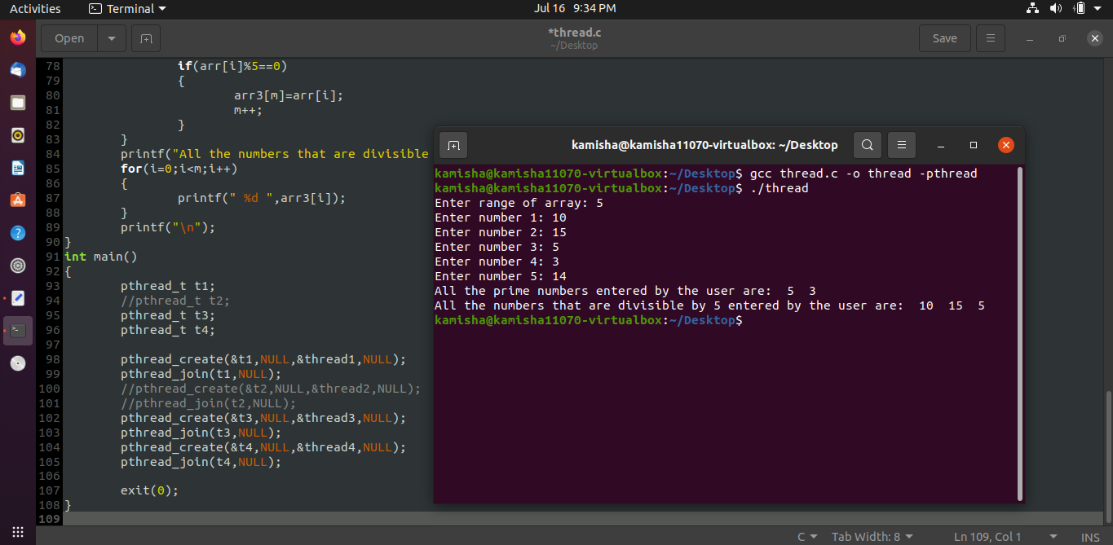**Output if we blocked thread no. 2:**

**Example – 2:** This example is similar to the first example. Here we are searching in the array five times and likewise the first example, if we blocked a thread here, then we will be searching through the array one time less, i.e.: 4 times w.r.t. to our example and can vary. But if we used single-threading here, we would’ve not been able to block any processes unless deleted by the user itself.

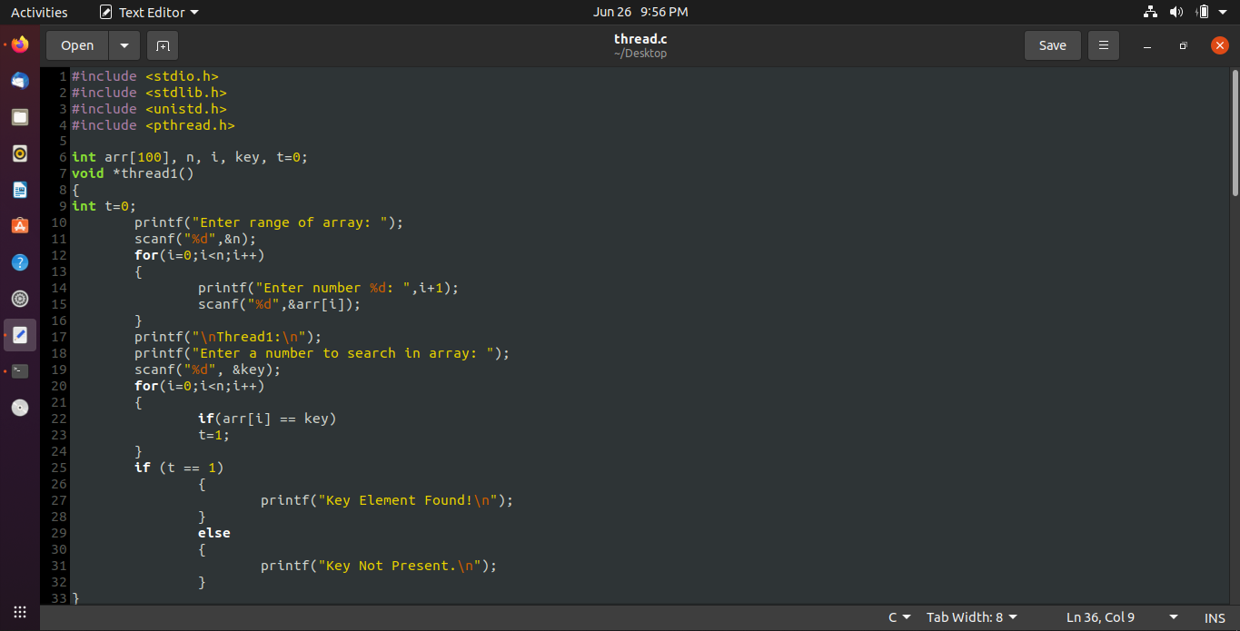

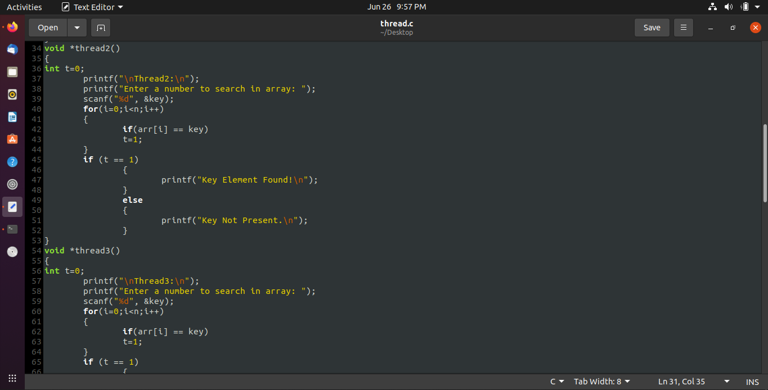

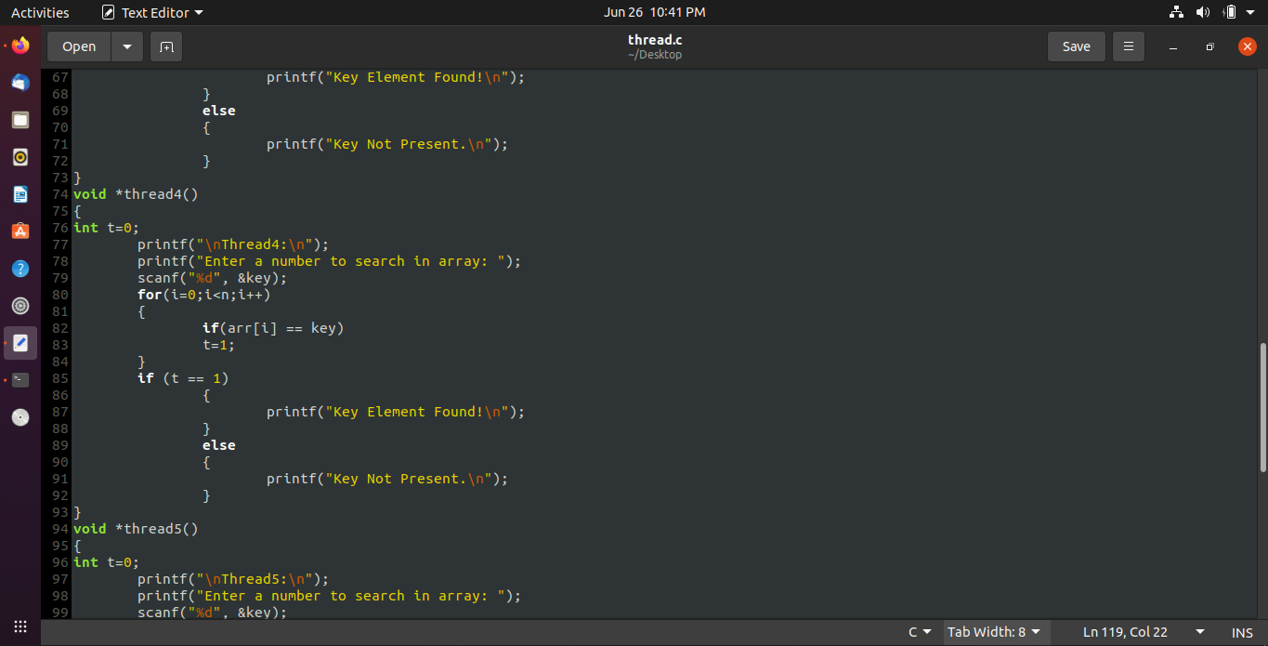

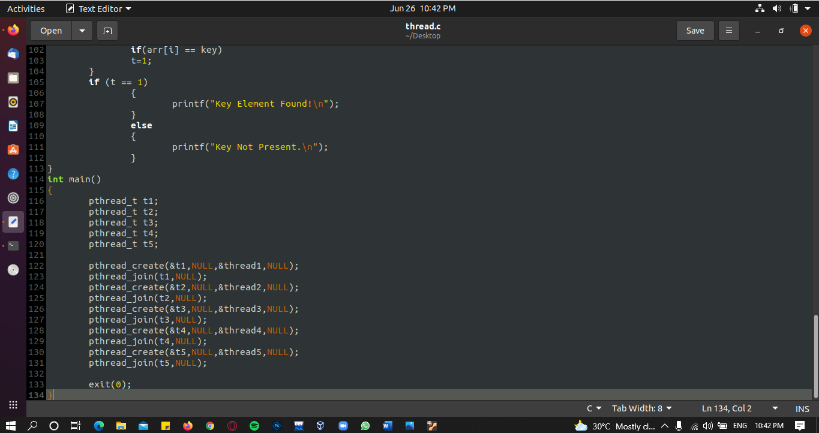

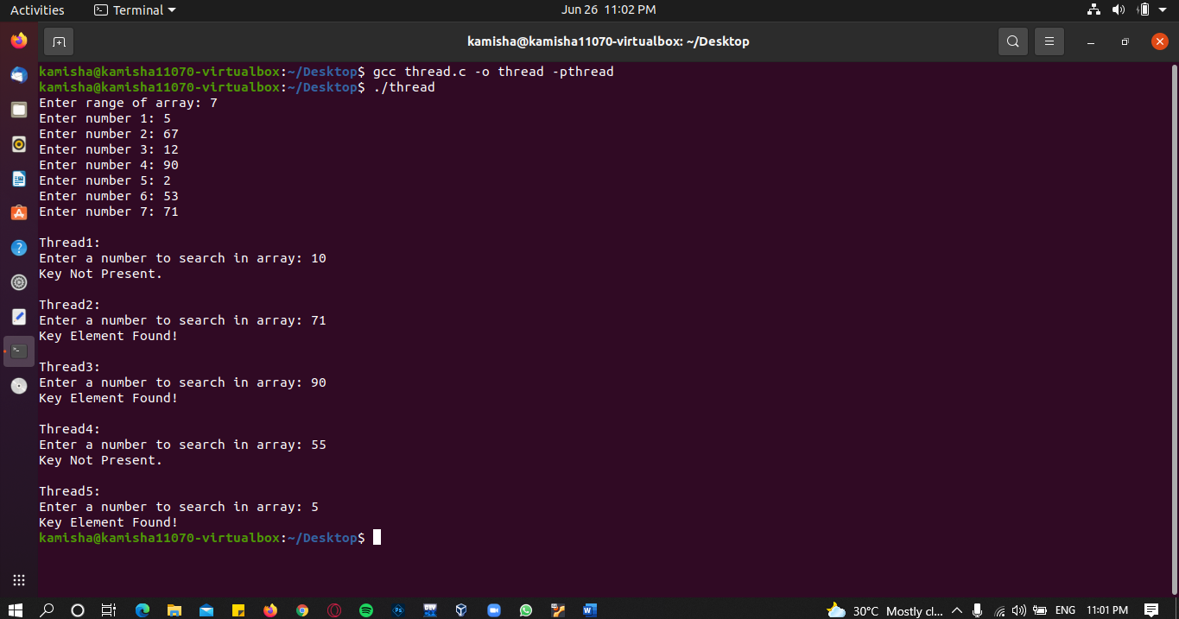**OUTPUT:**

**QUESTION – 2**

**Give an example of a situation in which ordinary pipes are more suitable than named pipes and an example of a situation in which named pipes are more suitable than ordinary pipes.**

**Example – 1:** Unnamed pipes are only used for communication between a child and its parent process. It can either be a one-way or a two-way communication. So, for such communications, ordinary pipes or unnamed pipes are more suitable than named pipes.

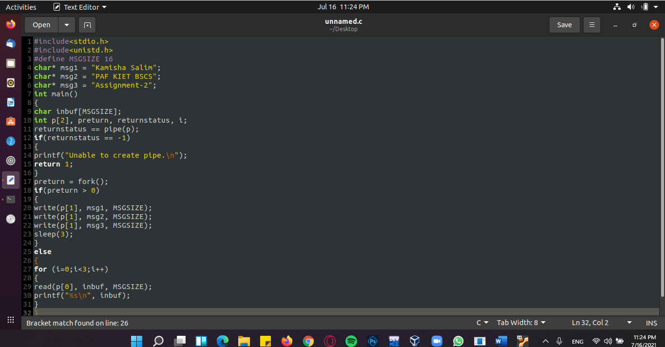

**OUTPUT:**

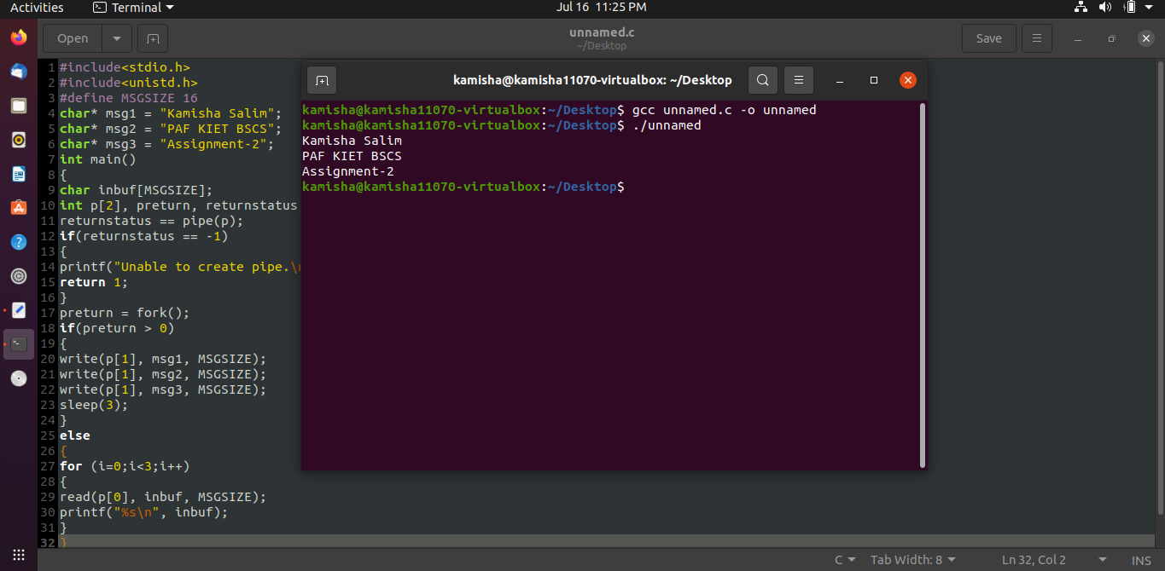**One-way communication between a child and its parent process.**

**Example – 2:** Named pipes are meant for communication between two or more unrelated or unnamed processes and can also have bi-directional communication. So, for such communications, named pipes are more suitable than ordinary pipes.

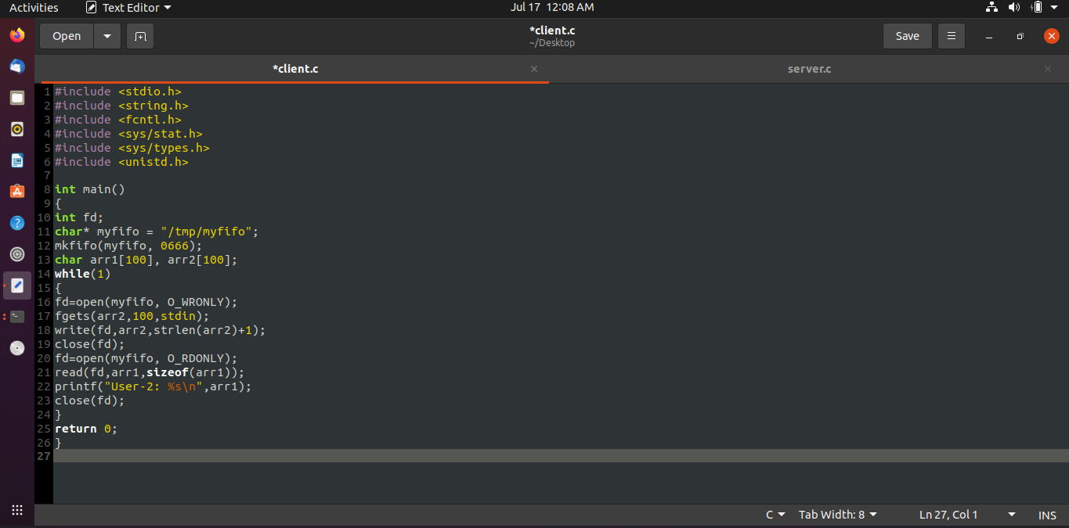

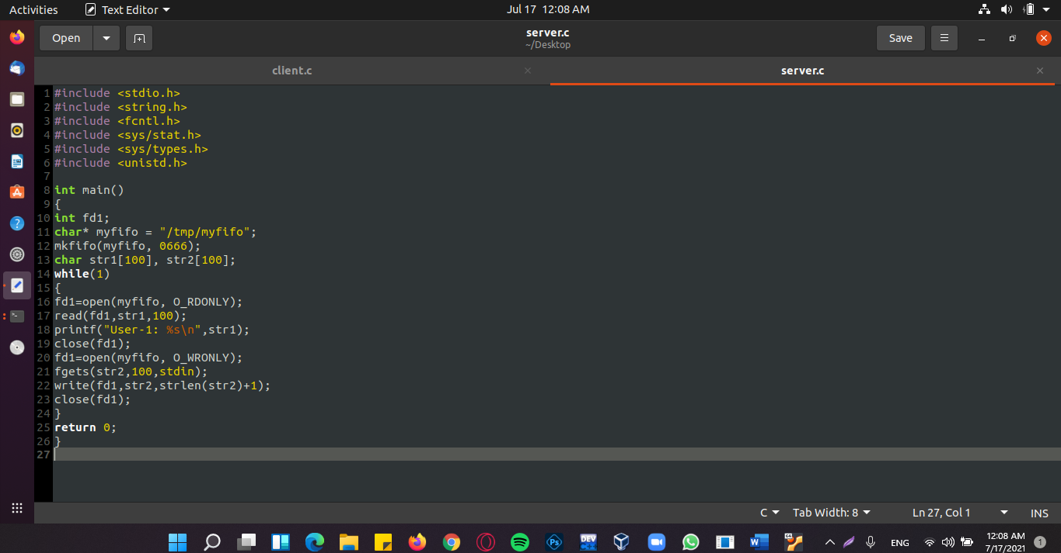

**OUTPUT:**

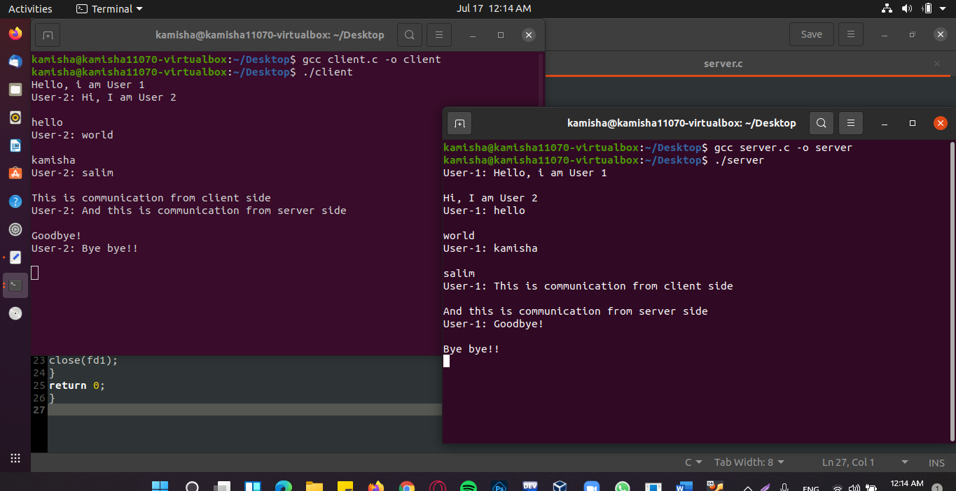**A chat app like communication (two-way communication) is established through named pipes.**

**QUESTION – 3**

**Implement The Longest Remaining Time First (LRTF) scheduling.**

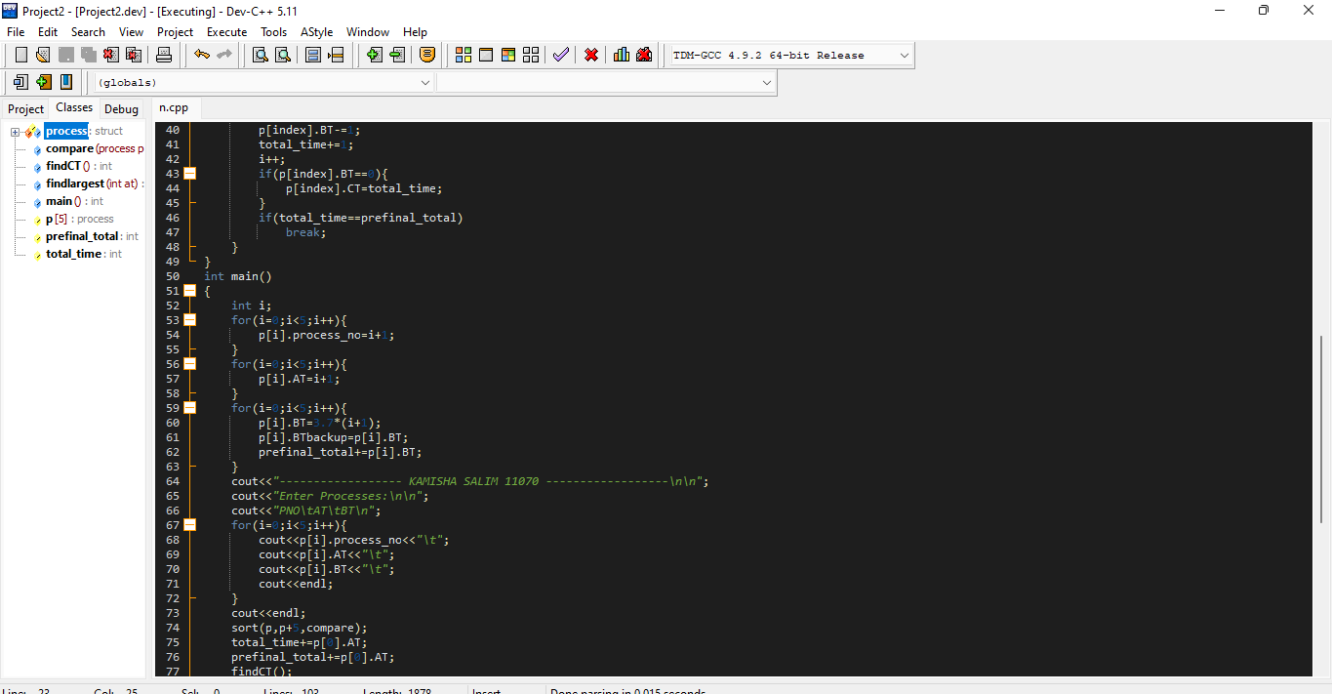





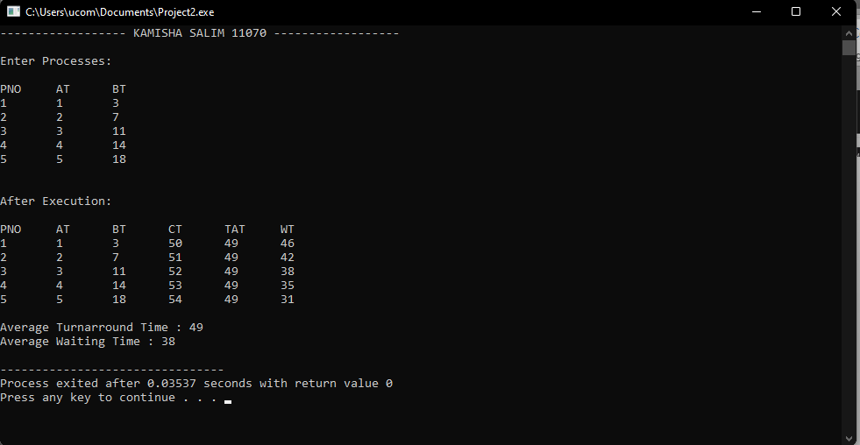**OUTPUT:**