**OPERATING SYSTEM LAB TASK – 03**

**Name:** Kamisha Salim

**S.ID:** 11070

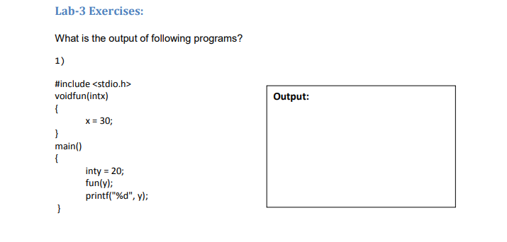**QUESTION – 1**

**OUTPUT (if code is wrong):**

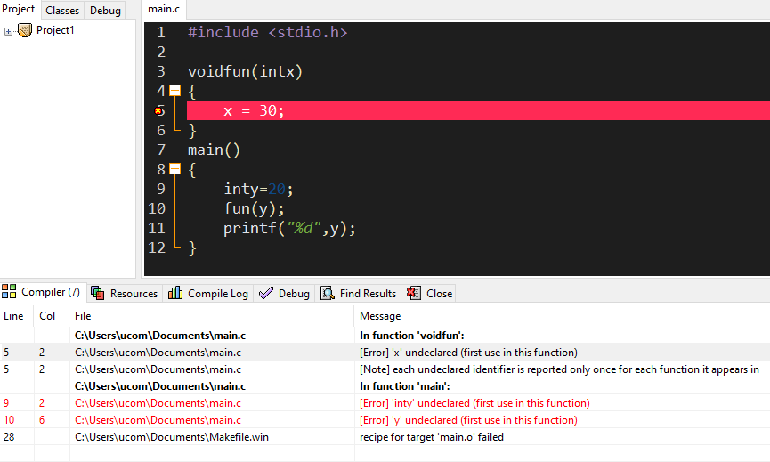

**OUTPUT (if code is corrected):**

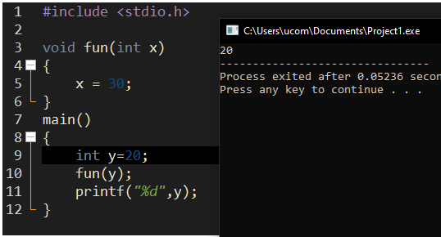

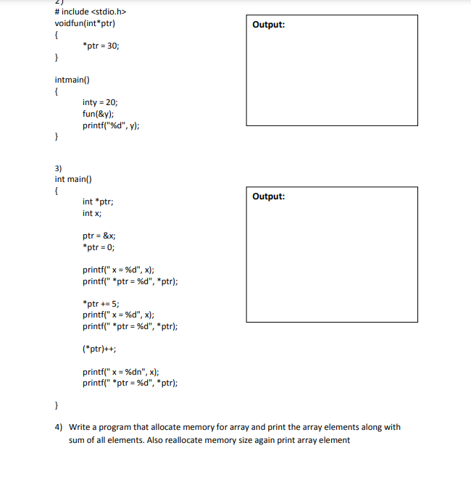**QUESTION – 2**

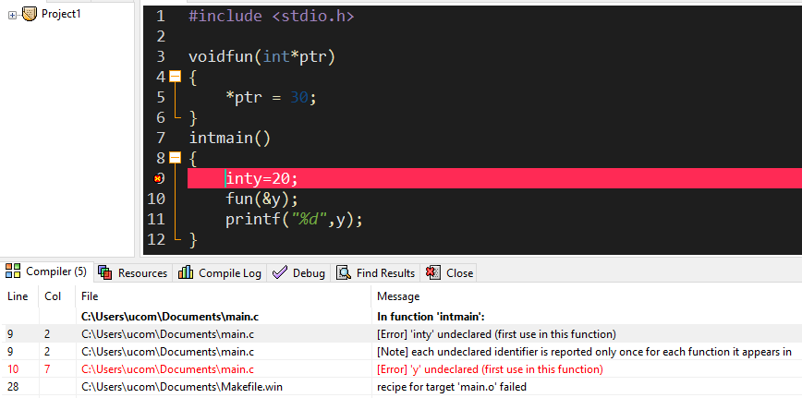**OUTPUT (if code is wrong):**

**OUTPUT (if code is corrected):**

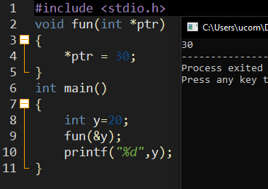

**QUESTION – 3**



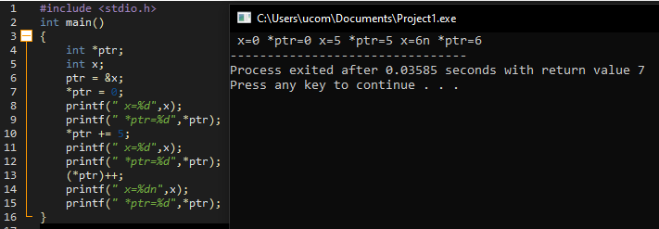**OUTPUT:**

**QUESTION – 4:**

**CODE:**

#include<stdio.h>

#include<stdlib.h>

int main()

{

int *ptr, arr, i, sum = 0;

printf("Allocate memory of array: ");

scanf("%d",&arr);

ptr=(int*)malloc(arr*sizeof(int));

printf("Enter elements: ");

for(i=0;i<arr;i++)

{

scanf("%d",(ptr+i));

}

printf("\nAll elements of array: \n");

for(i=0;i<arr;i++)

{

printf("%d\n",*(ptr+i));

}

for(i=0;i<arr;i++)

{

sum+=*(ptr+i);

}

printf("\nSum of all elements is: %d\n",sum);

free(ptr);

printf("\nReallocate memory of array: ");

scanf("%d",&arr);

ptr=(int*)malloc(arr*sizeof(int));

printf("Enter elements: ");

for(i=0;i<arr;i++)

{

scanf("%d",(ptr+i));

}

printf("\nAll elements of array: \n");

for(i=0;i<arr;i++)

{

printf("%d\n",*(ptr+i));

}

return 0;

}

**OUTPUT:**

