**OPERATING SYSTEM LAB TASK – 04**

**Name:** Kamisha Salim

**S.ID:** 11070

**QUESTION – 1**

**CODE:**

#include<stdio.h>

Int main()

{

int bt[20],wt[20],tat[20],n,i,k,temp,p[20],at[20];

float wtavg, tatavg;

printf("Enter the number of processes: ");

scanf("%d",&n);

printf("\n");

for(i=0;i<n;i++){

p[i]=i;

printf("Enter burst time and arrival time for process %d: ",i);

scanf("%d %d",&bt[i],&at[i]);

}

wt[0] = wtavg=0;

tat[0] = tatavg= bt[0];

for(i=1;i<n;i++)

{

wt[i] = wt[i-1]+bt[i-1];

tat[i] = tat[i-1]+bt[i];

wtavg=wtavg+wt[i];

tatavg=tatavg+tat[i];

}

printf("\n\tPROCESS \tARRIVAL TIME \tBURST TIME \tWAITING TIME \t TURNAROUND TIME");

for(i=0;i<n;i++)

printf("\n\t P%d \t\t %d \t\t %d \t\t %d \t\t %d",i,at[i],bt[i],wt[i],tat[i]);

printf("\n\nAverage Waiting Time: %f",wtavg/n);

printf("\nAverage Turnaround Time: %f",tatavg/n);

}

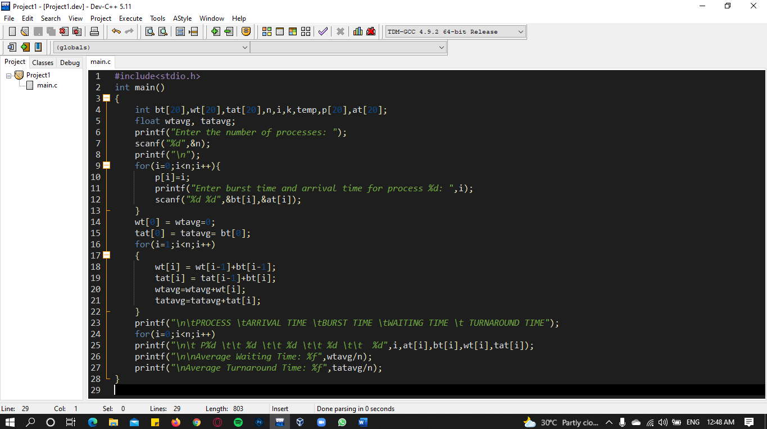**OUTPUT:**

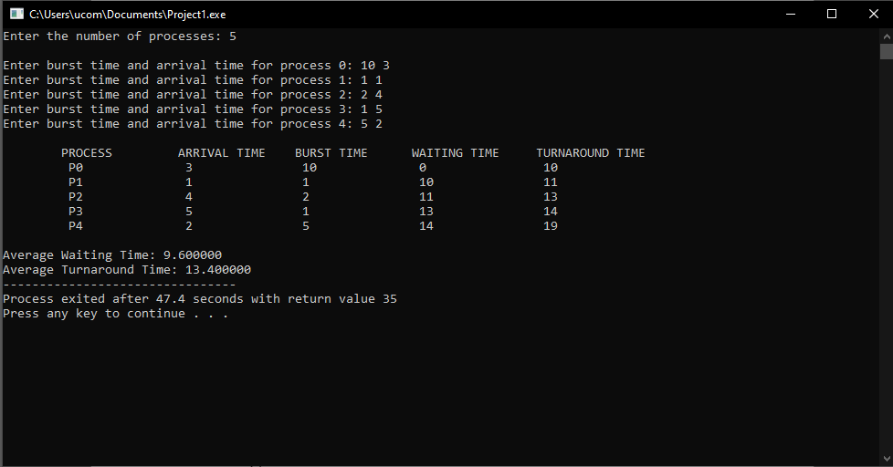

**QUESTION – 2**

**ANSWER:** b) 2