**OPERATING SYSTEM LAB TASK – 06**

**Name:** Kamisha Salim

**S.ID:** 11070

**QUESTION – 1**

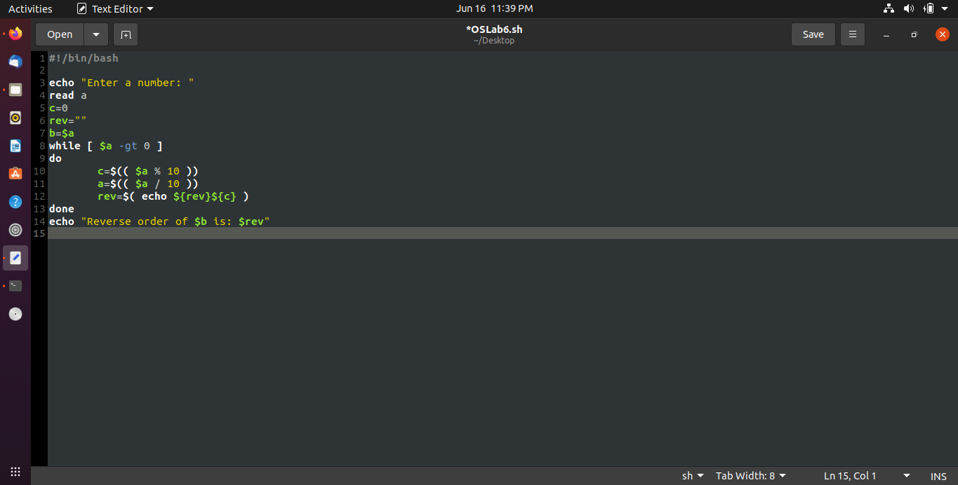**CODE:**

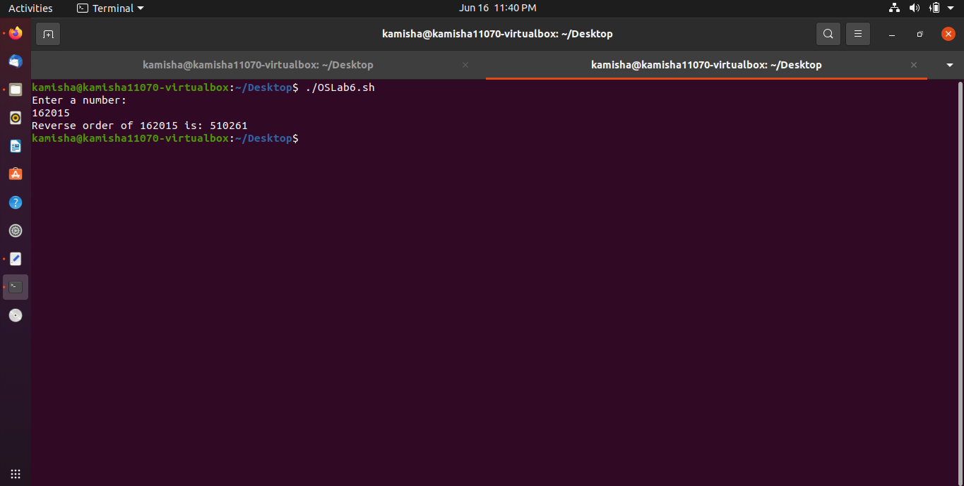**OUTPUT:**

**QUESTION – 2**

**CODE:**

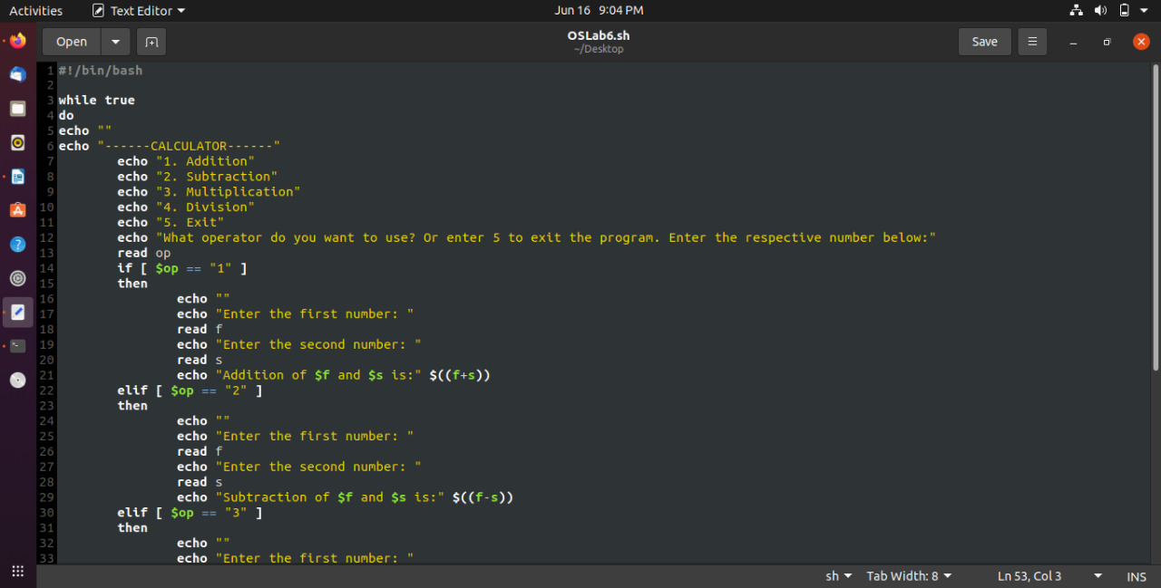

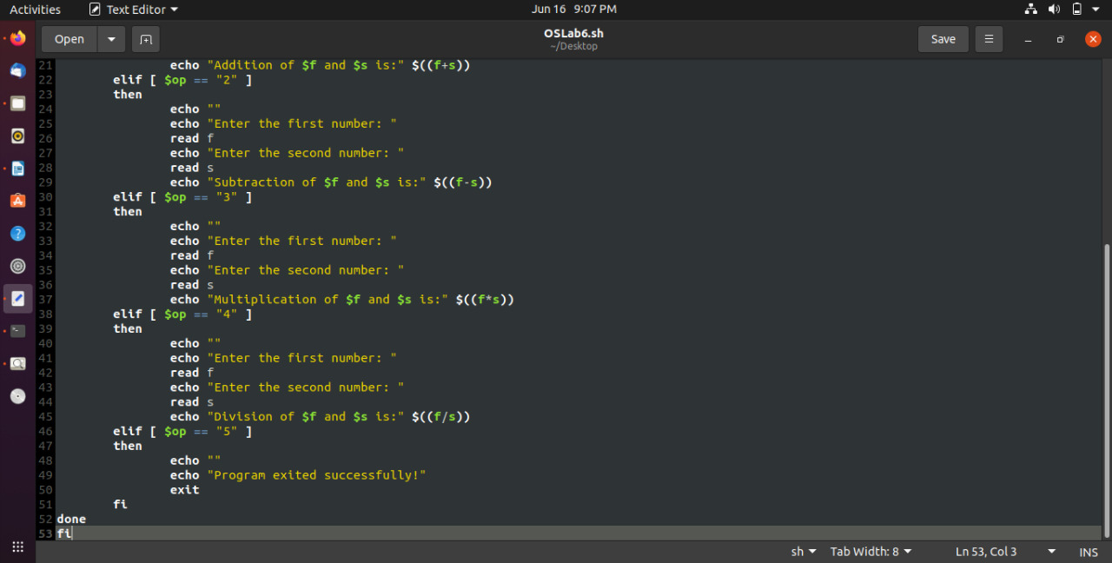

**OUTPUT:**

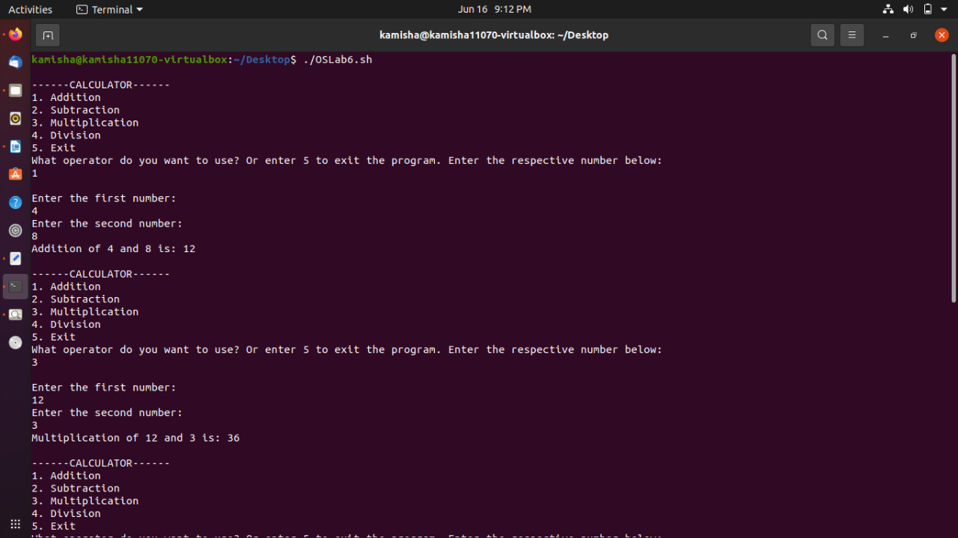

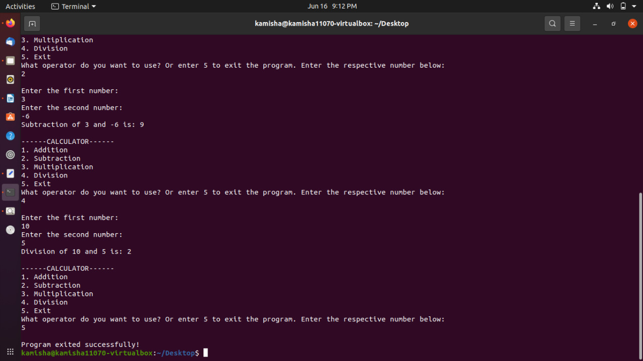

**QUESTION – 3**

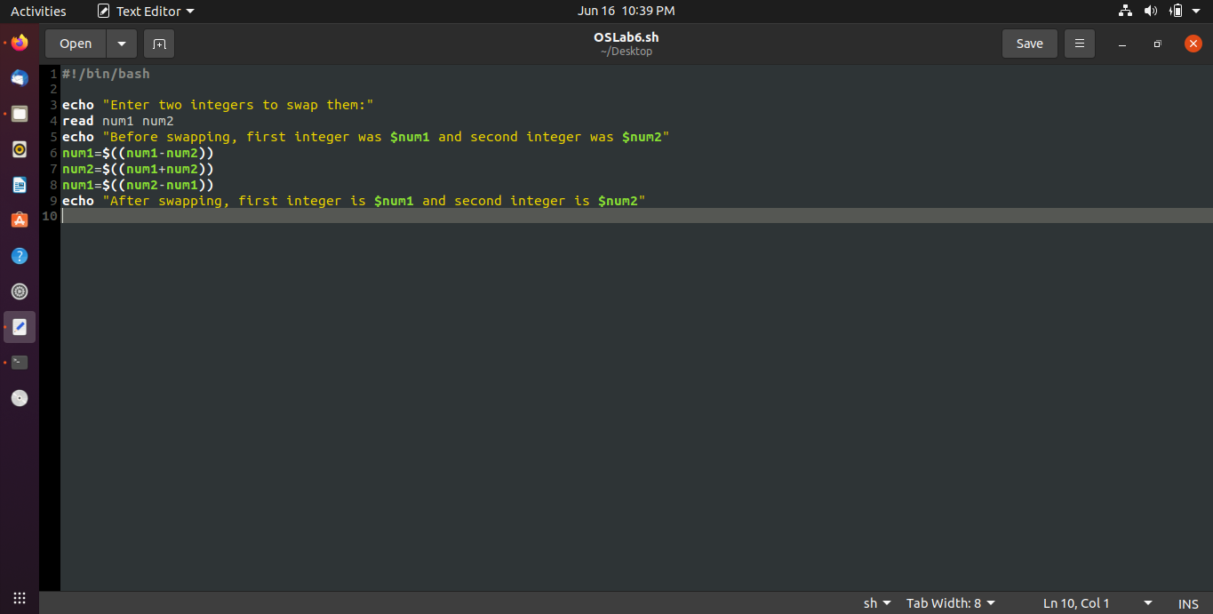**CODE:**

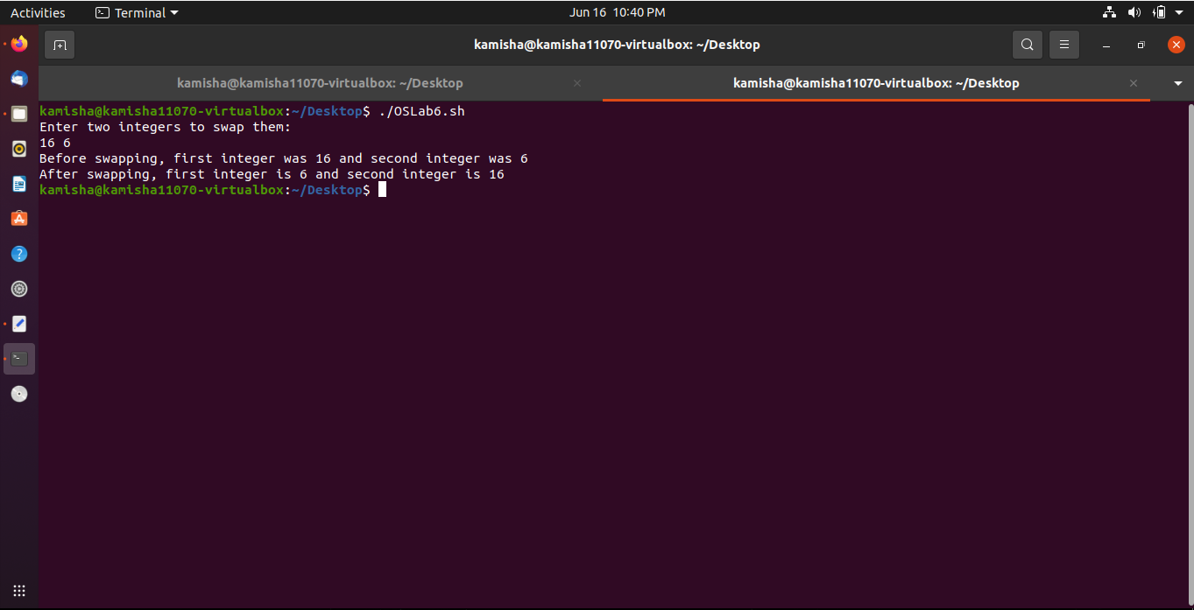**OUTPUT:**