**OPERATING SYSTEM**

**LAB TASK – 08**

**Name:** Kamisha Salim

**S.ID:** 11070

**QUESTION – 1**

**CODE:**

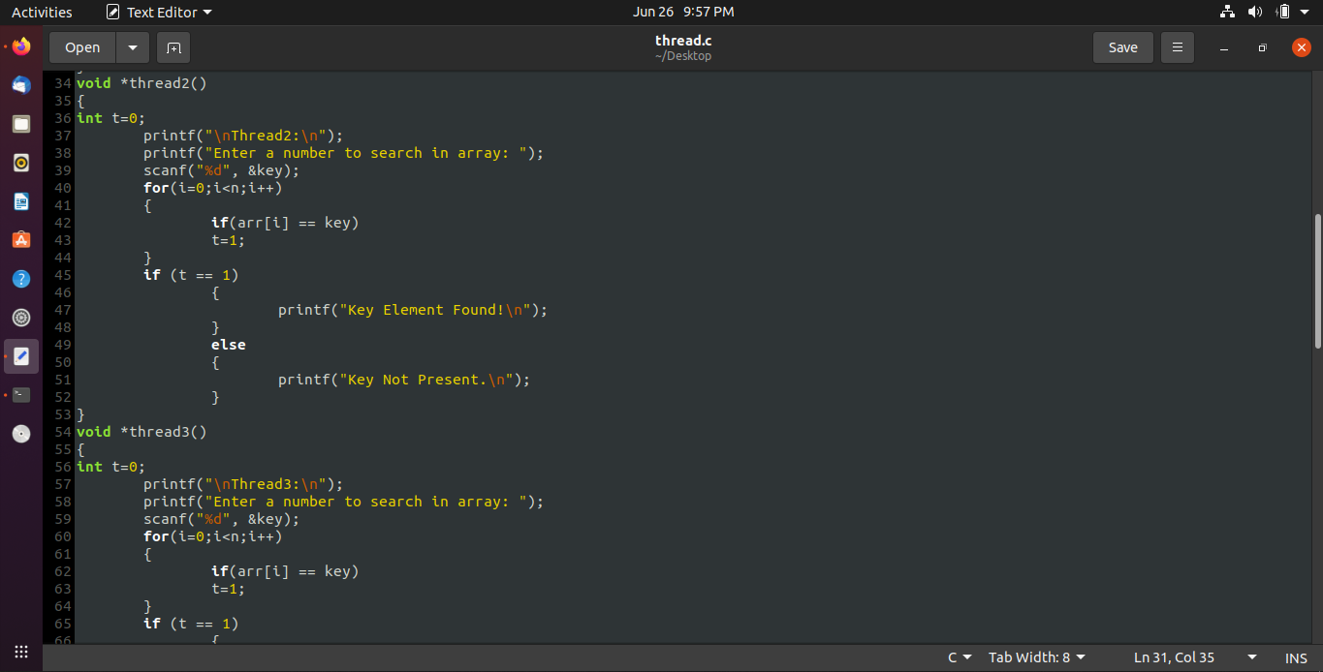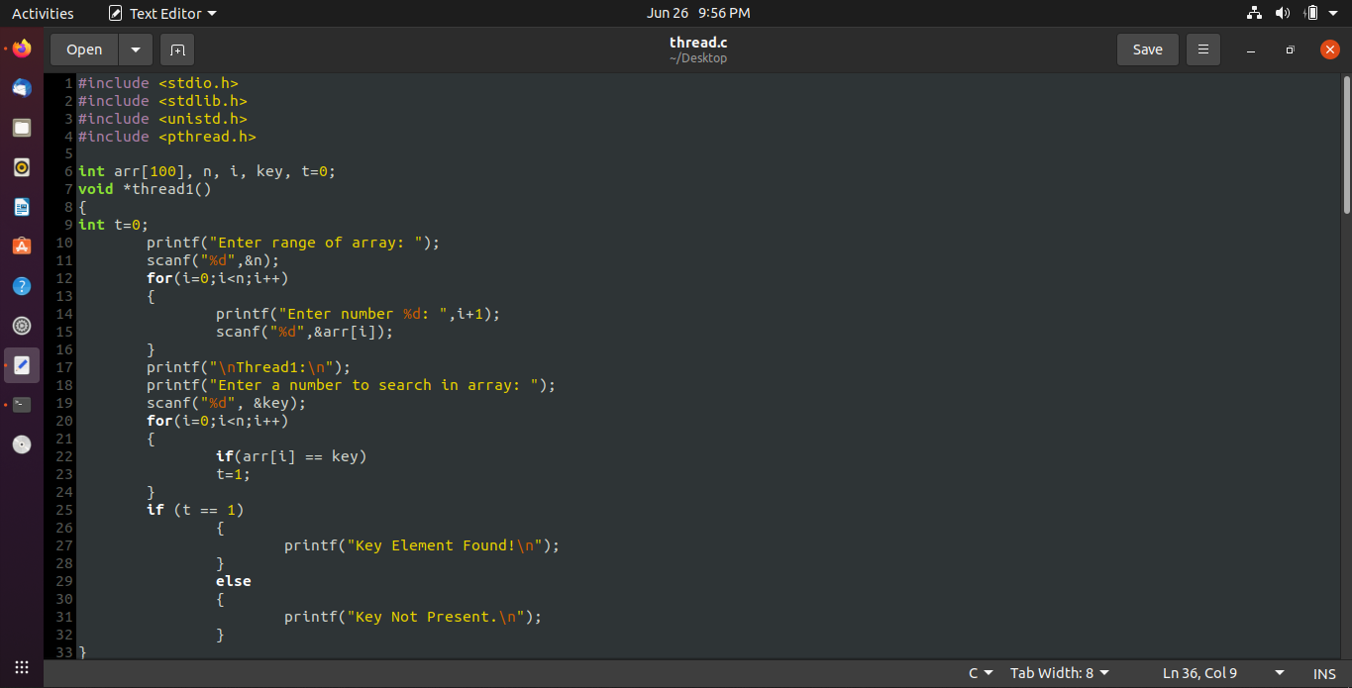

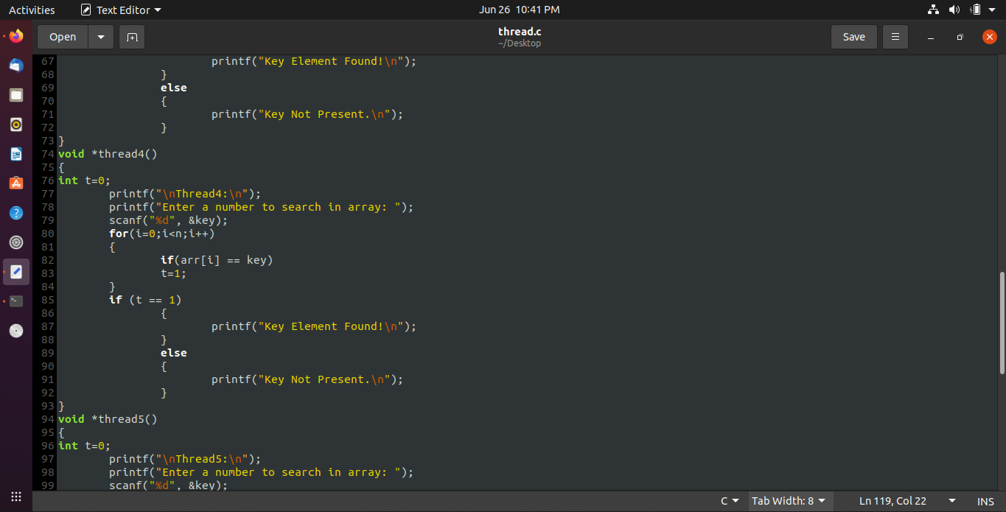

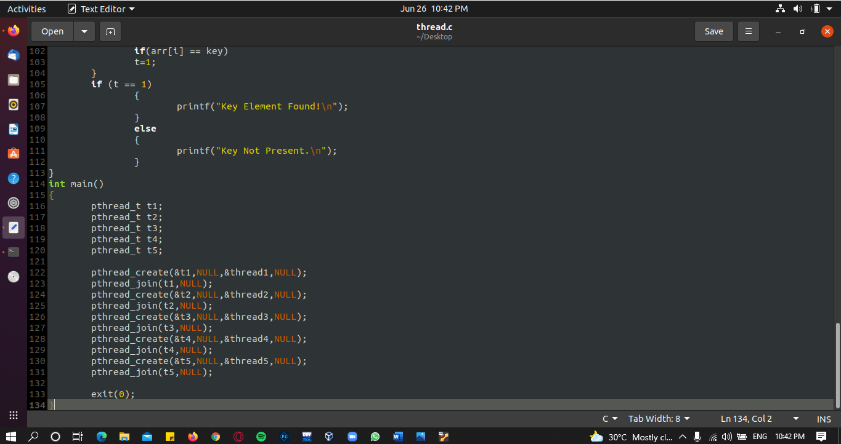

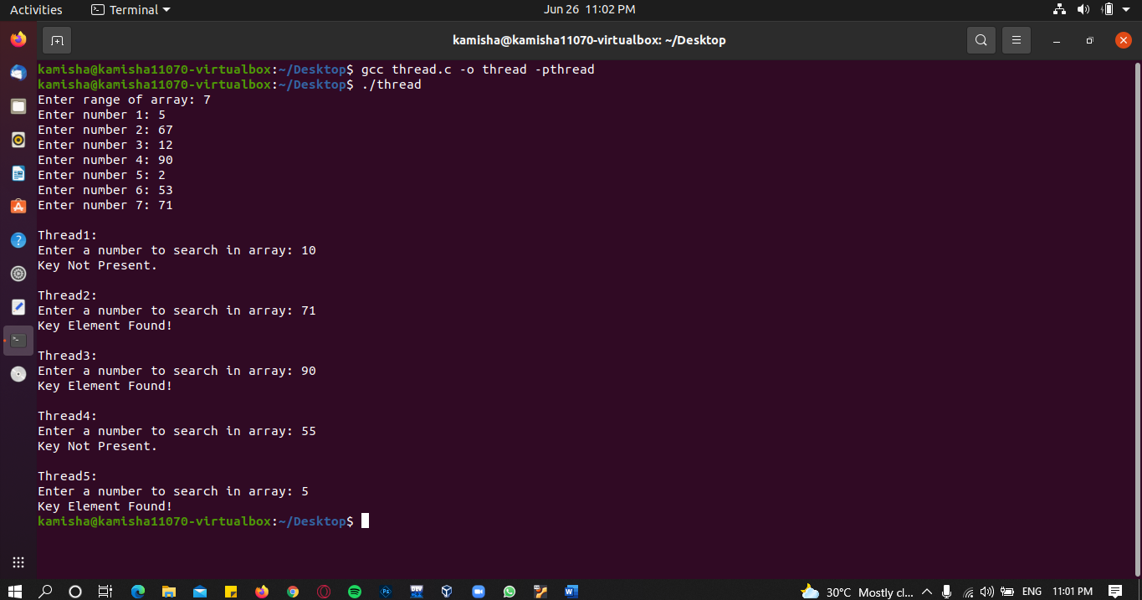**OUTPUT:**