**OPERATING SYSTEMS**

**LAB TASK – 10**

**Name:** Kamisha Salim

**S.ID:** 11070

**QUESTION – 1**

**CODE:**

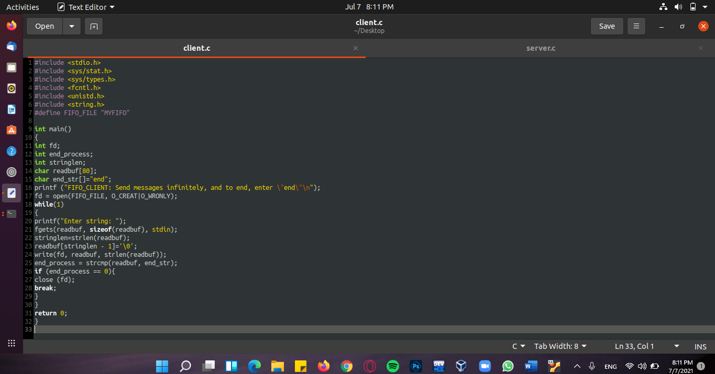**Client (Parent)**

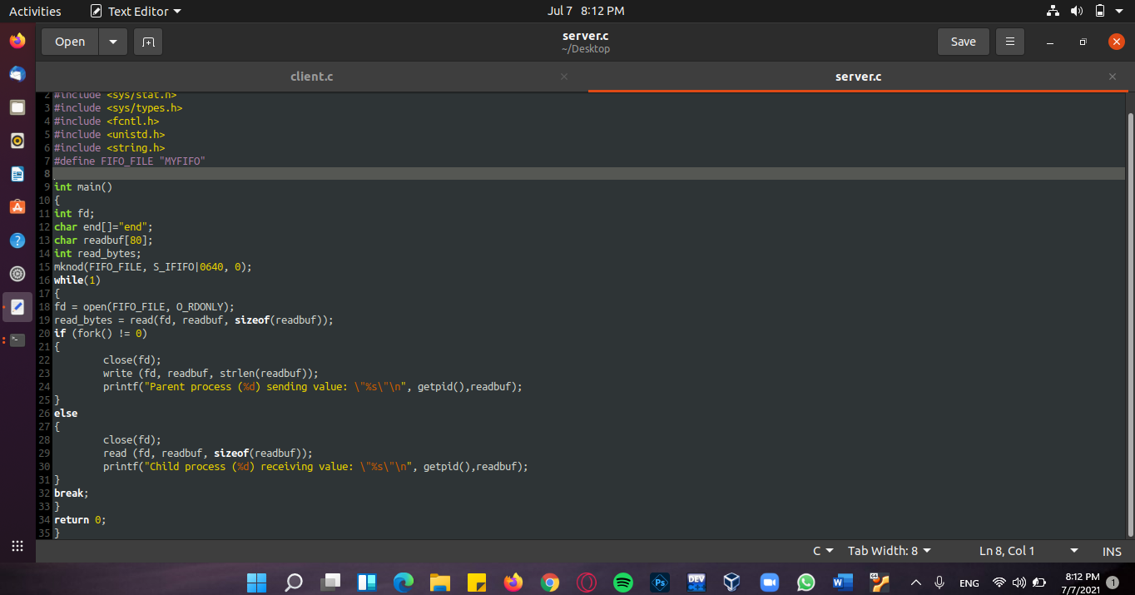**Server (Child)**

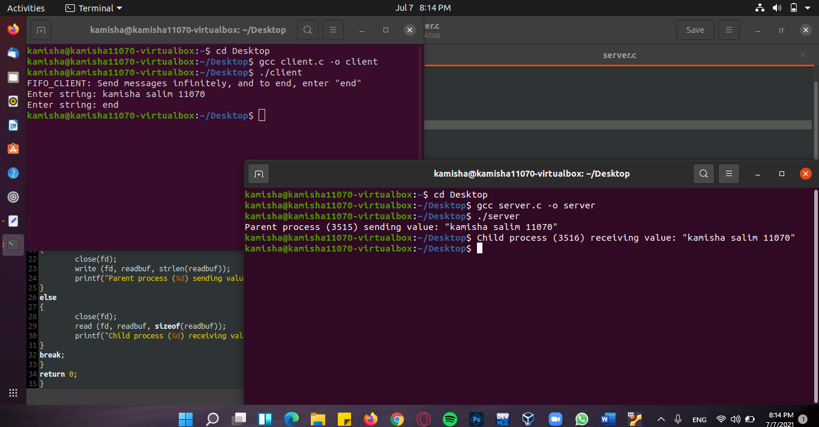**OUTPUT:**