**OPERATING SYSTEMS**

**LAB TASK – 11**

**Name:** Kamisha Salim

**S.ID:** 11070

**QUESTION – 1**

**CODE:**

**USING FIRST IN FIRST OUT (FIFO)**

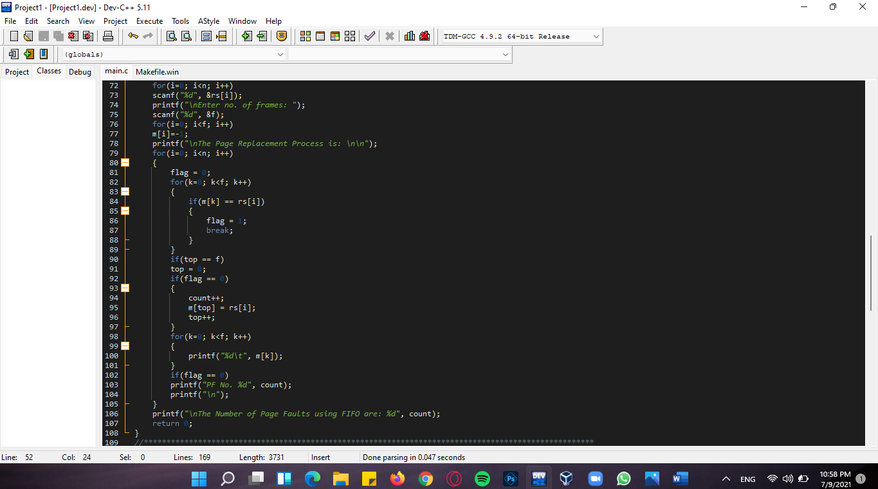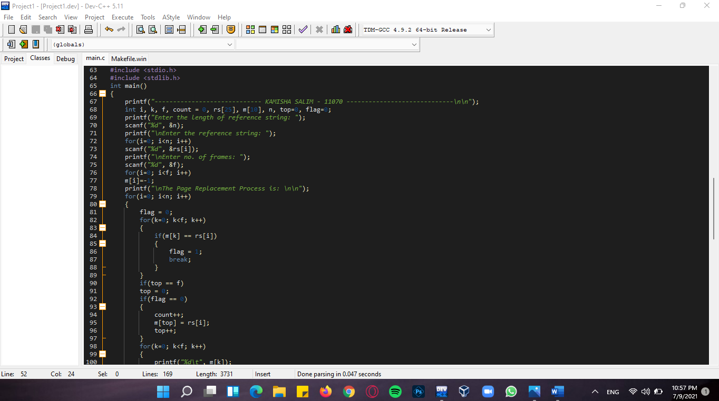

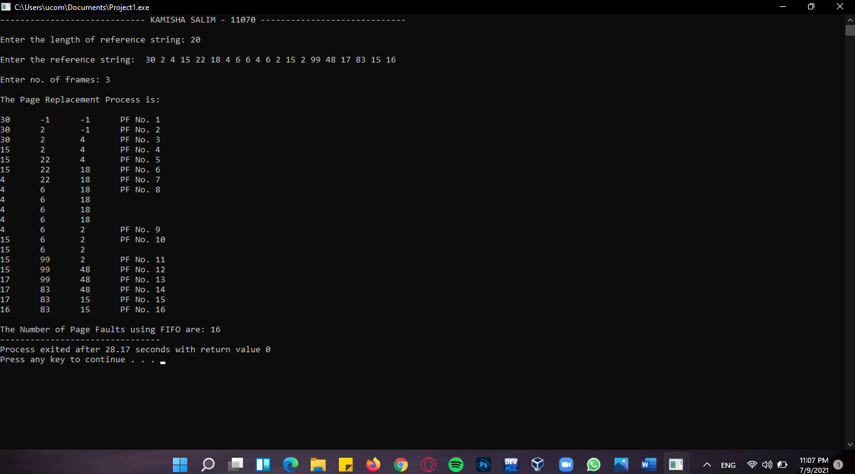**OUTPUT:**

**QUESTION – 2**

**CODE:**

**USING LEAST RECENTLY USED (LRU)**

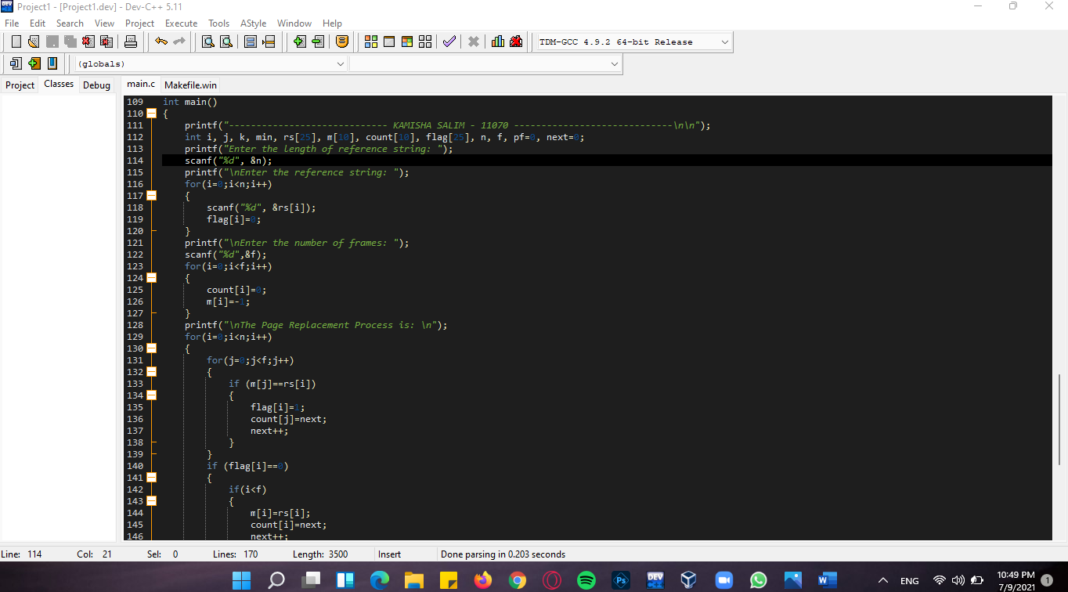

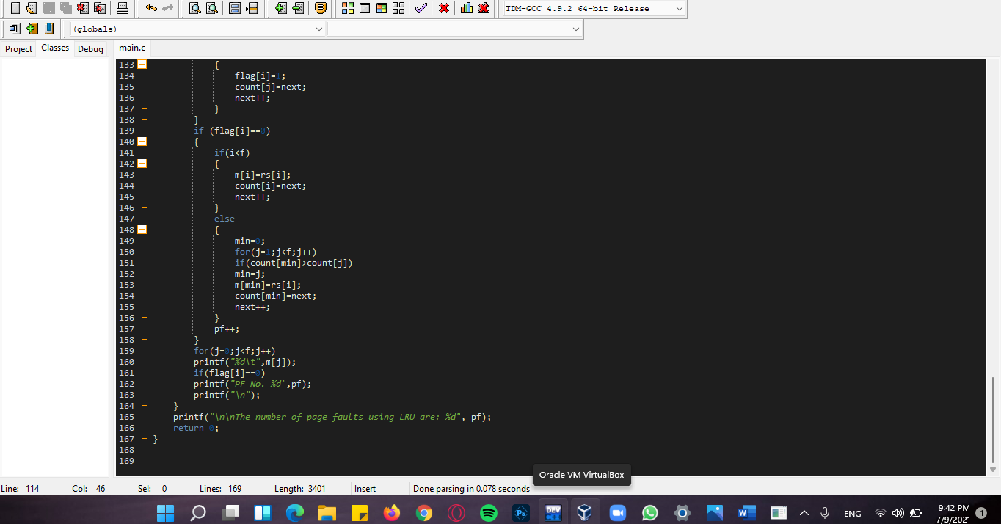

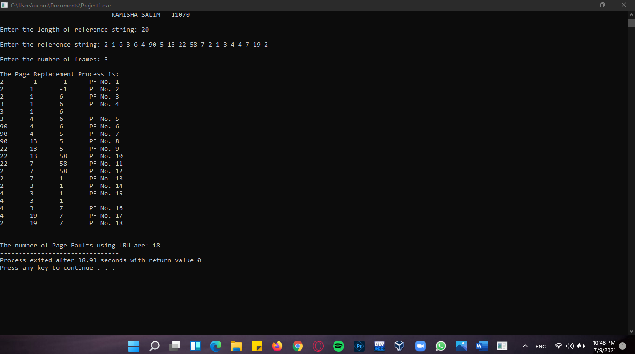**OUTPUT:**