**OPERATING SYSTEM**

**LAB TASK – 12**

**Name:** Kamisha Salim

**S.ID:** 11070

**QUESTION – 1**

**CODE:**

**USING OPTIMAL PAGE REPLACEMENT**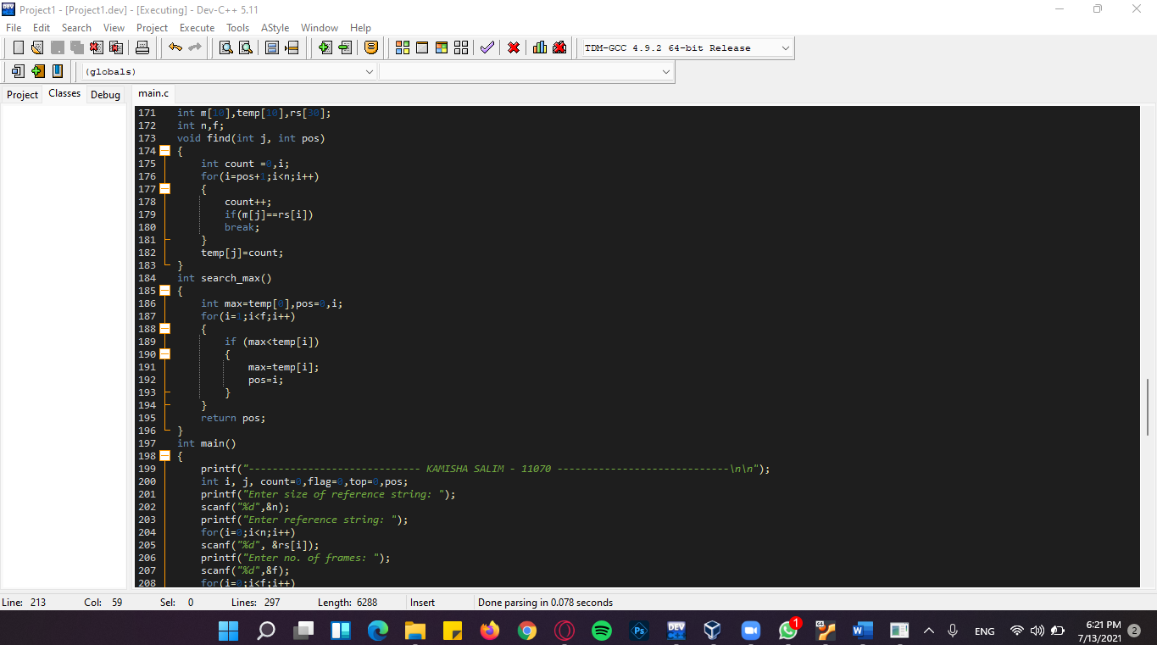

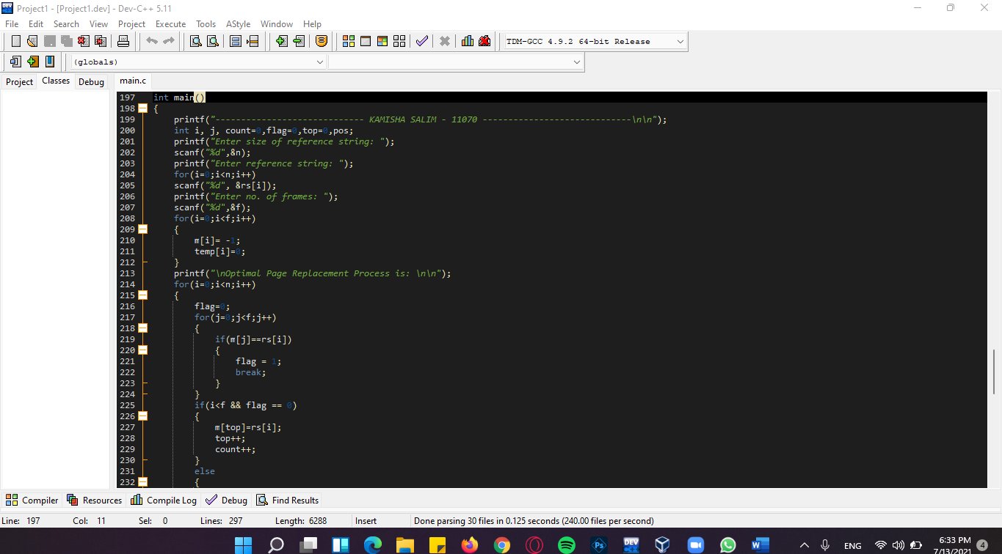

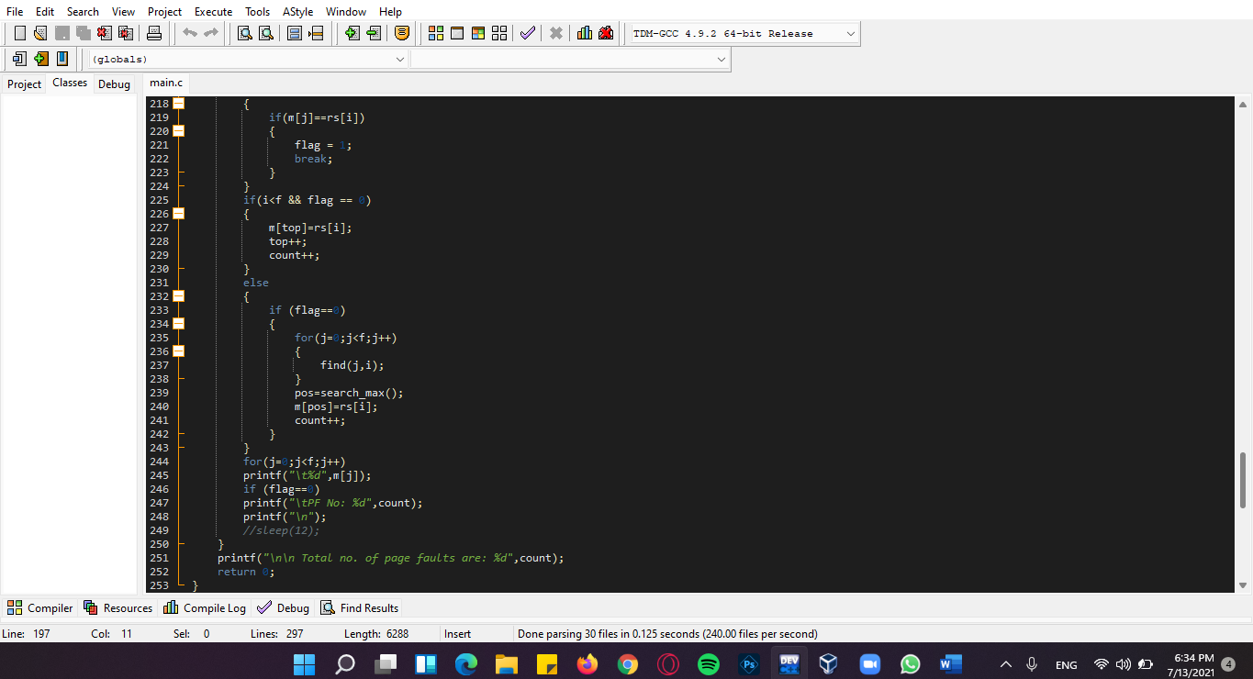

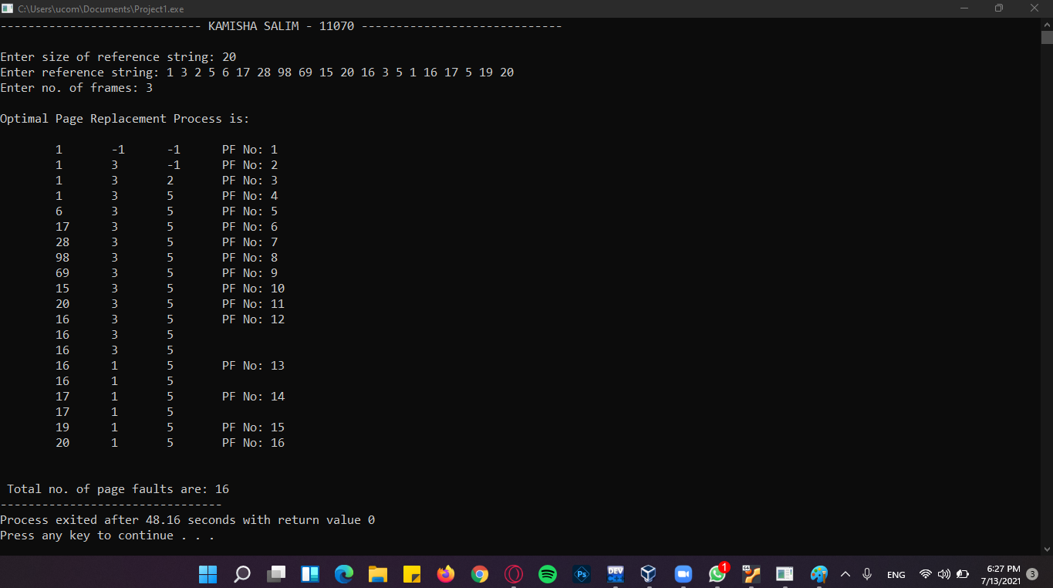**OUTPUT:**

**QUESTION – 2**

**CODE:**

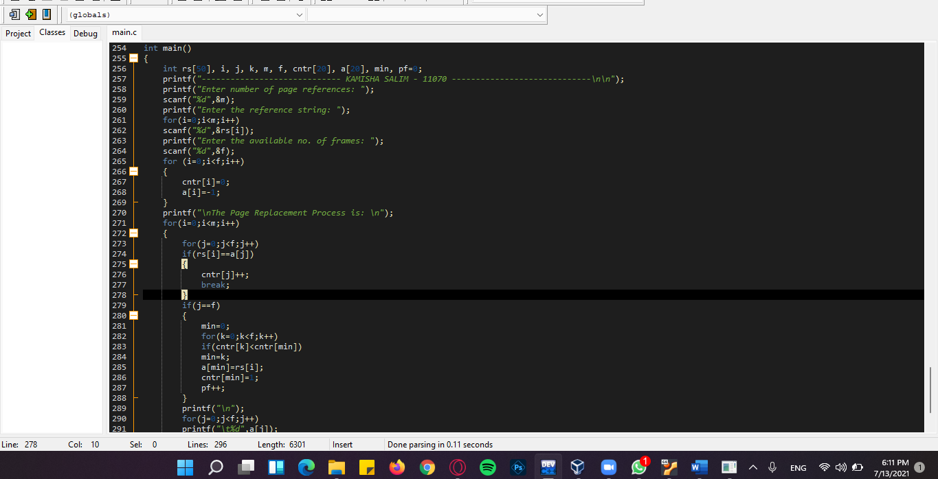**USING LFU**

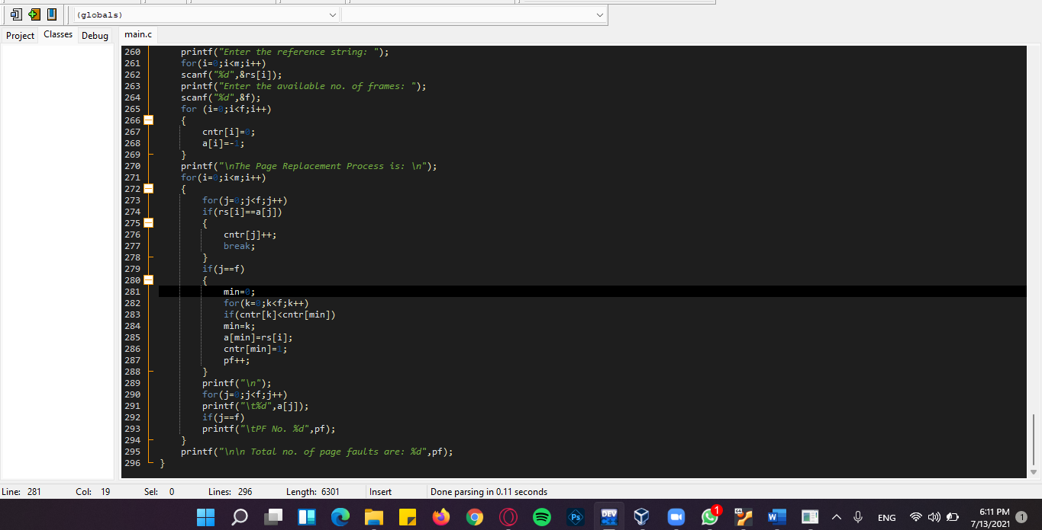

**OUTPUT:**

