Question 1:-

from numpy import array

def MatchingIntegers(integer,queries):

checker = array([0,0,0])

for i in range(3):

for j in range(3):

if(queries[i] == integer[j]):

checker[i] = checker[i] + 1

return checker

integer = array([1,1,2])

queries = array([1,2,3])

print("Result Array:",MatchingIntegers(integer,queries))

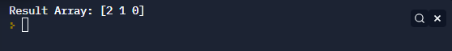

Question 2:-

from numpy import array

def BinarySearch(array, number,first,last):

index = -1

while(first <= last):

mid = int((first + last) / 2)

if (array[mid] == number):

index = mid

break

elif (number > array[mid]):

first = mid + 1

elif (number < array[mid]):

mid = first - 1

return index

array = array([i for i in range (1,10)])

index = BinarySearch(array, int(input("Enter Number: ")),0,len(array)-1)

if (index >= 0):

print("Your Guess is Right with Index:",index)

else:

print("Your Guess is Wrong")

