QUESTION#01:

CODE:

def SlopeOfSecantLine(x1,y1,x2,y2):  
 a = (y2 - y1) / (x2 - x1)  
 return a  
  
  
  
if __name__ == '__main__':  
  
 print("The slope of secant line is:")  
 print(SlopeOfSecantLine(-8,-5,-10,-9))

OUTPUT:

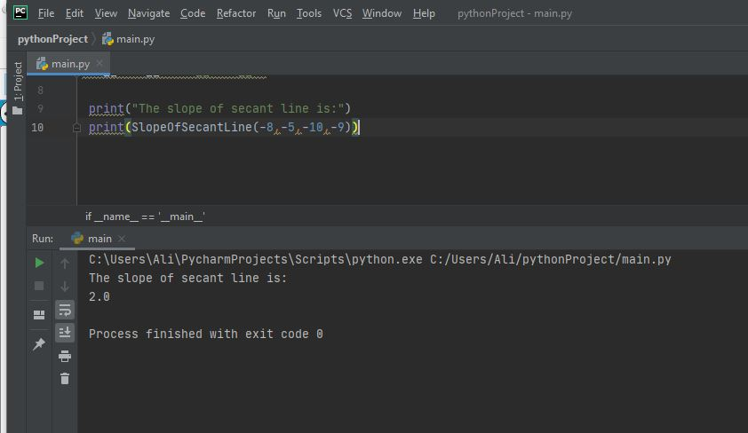

QUESTION#02:

CODE:

import matplotlib.pyplot as plt  
import numpy as np  
x = 7  
y = 55  
h = 0.01  
def f(x):  
 return 4*x**2  
def der(x):  
 print("Slope of the Tangent Line to the Curve Occurred at point: ")  
 print(((f(x + h) - f(x))/h))  
 return 0  
  
def plot(a):  
 x = np.linspace(1, 10)  
 y = der(a)*(x - a) + f(a)  
 plt.plot(x, f(x))  
 plt.plot(a, f(a), 'go')  
 plt.plot(x, y, 'y')  
 plt.show()  
  
plot(x)

OUTPUT:

