MUHAMMAD UMAR KHAN 10619

NC LAB#08

**LAB TASK 08**

**CODE**

1. = mat([[83,11,-4,95],[7,52,13,104],[3,8,29,71]])
2. = mat(([8,-3,2,45],[4,11,-1,71],[6,3,12,35]))
3. = mat(([3,2,1,10],[2,3,2,14],[1,2,3,14]))

# For A

A[1,:] = A[1,:]-A[0,:]*A[1,0]/A[0,0]

A[2,:] = A[2,:]-A[0,:]*A[2,0]/A[0,0] A[2,:] = A[2,:]-A[1,:]*A[2,1]/A[1,1]

z = A[2,3]/A[2,2] y = (A[1,3]-(A[1,2]*z)) / A[1,1] x = (A[0,3]-A[0,1]*y - A[0,2]*z)/A[0,0]

print('Function A',' ',' X ',' Y ',' Z ')

print(A,' ',x,' ',y,' ',z)

# For B

B[1,:] = B[1,:]-B[0,:]*B[1,0]/B[0,0]

B[2,:] = B[2,:]-B[0,:]*B[2,0]/B[0,0] B[2,:] = B[2,:]-B[1,:]*B[2,1]/B[1,1]

xx=B[2,3]/B[2,2] yy=(B[1,3]-B[1,2]*xx)/B[1,1] zz=(B[0,3]-B[0,1]*yy-B[0,2]*xx)/B[0,0]

print('\nFunction B',' ',' X ',' Y ',' Z ') print(B,' ',xx,' ',yy,' ',zz)

# For C

C[1,:] = C[1,:]-C[0,:]*C[1,0]/C[0,0]

C[2,:] = C[2,:]-C[0,:]*C[2,0]/C[0,0] C[2,:] = C[2,:]-C[1,:]*C[2,1]/C[1,1]

xxx=C[2,3]/C[2,2] yyy=(C[1,3]-C[1,2]*xxx)/C[1,1] zzz=(C[0,3]-C[0,1]*yyy-C[0,2]*xxx)/C[0,0]

print('\nFunction C',' ',' X ',' Y ',' Z ')

print(C,' ',xxx,' ',yyy,' ',zzz)

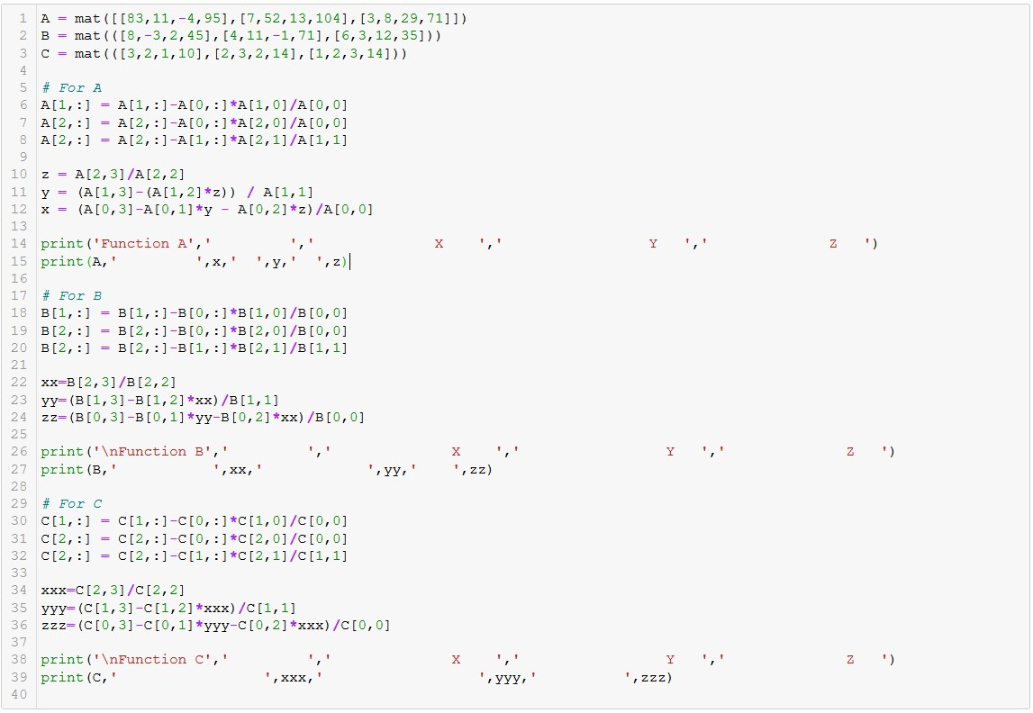

**OUTPUT:**

