**RESEARCH ARTICLE**

**TITLE:** A Progressive Testing Solution with Spiral Process Model to Develop ERP Software in Pakistan

**PUBLICATION**: Article*in* International Journal of Computer & Organization Trends · December 2017

Iqra Mahmood, Akmal Rehan, Sana Saeed

*Department of computer science university of Agriculture Faisalabad, Pakistan*

**FINDINGS:**

***Testing and implementation of ERP software projects facing product and project risks due to its initial stages:***

The ERP software being developed in Pakistan are facing project risks due to lack of concern in the initial stages of SDLC. All these risks must be tackled in the initial stage of SDLC until it’s too late and the project leads to failure. For that, better*r evaluation of ERP software required road map for Planning, identifying risks and testing activities. A Progressive testing technique* ***followed by spiral process*** *model was introduced to develop ERP software. This Progressive testing technique involved (TDD), (ATDD), (TFD), (TLD), (BDD), Pair Programming and grey box testing.*

**Problem Statement:**

**Business organizations are now facing market challenges as they compete in their day-to-day competitions:**

1. Every company wants to promote its products among its customers and manage its sales. This is why they are faced with a sudden change in the demands to successfully achieve their goals.
2. Due to the limited development time and resources the product becomes expensive and risky which leads the software towards failure.

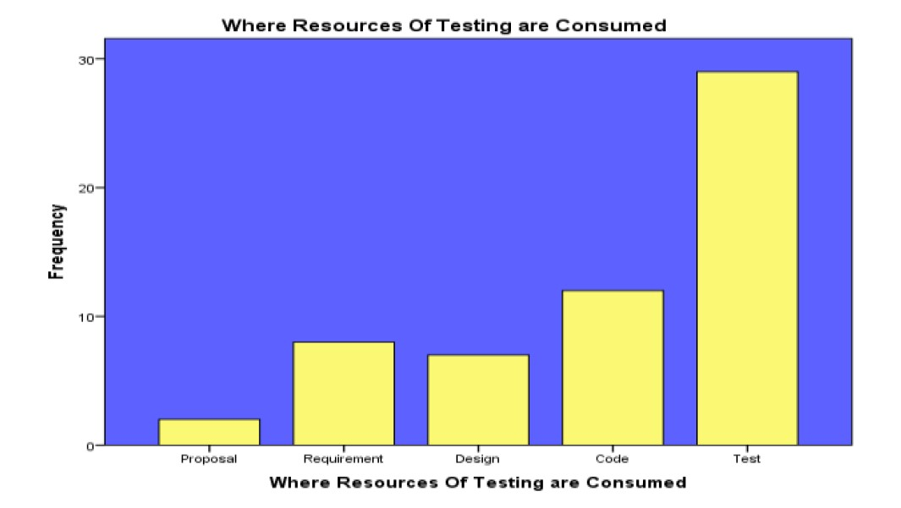

**Solution:**

Enterprise resource planning (ERP) is the integration and control of enterprise-wide information systems across the entire organization of all business processes. ERP is a "bundled business planning framework that allows organizations to provide a complete, integrated solution for the organization's information processing needs, efficient management and operational use of assets (materials, human resources, finance, etc). The development process and testing techniques required for ERP software effect overall cost of the product. Testing is the key attribute for the software success. It is a process to identify bugs, to mitigate bugs before they become monstrous and threat for cost consumption, and to check either the product fulfills its functional and technical requirements or not and either it does what the customer expects from the product to do or not. It is necessary to detect errors in the early stages of SDLC to produce defect free and Reliable software in defined time period. Because according to a rule:

**“A defect that is identified early in the development cycle can be significantly 100% time cheaper to rectify than those that are not found until much later in the production of the software”**

**CONS:**

* Testing becomes expensive and increases the risk/complications.
* Testing can take a lot of time and it can be a case where testing is not needed (depending of software scalability) it can delay project deployment time.
* There is not even a way to claim to fit all situations. Therefore, the software developers according to the requirements of the situation to choose a method are the biggest challenge. In this case, it was observed that there should be a hybrid approach with the latest testing techniques to produce defect-free, high-quality products over a specified time period and to save cost in the maintenance phase. Due to product risks and project risks, the product may fail and may disrupt the reputation of the Software houses. For this case we cannot just stick with one model of for product development.

**Area Of Benefit:**

* This paper brings awareness for the software houses in Pakistan through ERP which can benefit their business as it provides efficient tip for time/cost saving for product development.

**Improvements In Paper:**

* Some products would be too small or less costly to be tested. Therefore, testing could be costly than the project itself, the information to avoid testing under some circumstances should be provided.

**PROS:**

**Introduction:**

* Through spiral model, project manager can successfully develop the product with fewer defects for deployment
* Test artifacts generated at various stages of the development
* Execution testing and prototyping possible mitigating all possible risks involved in the project.
* Testing is beneficial because it delivers availability, efficiency, reliability, portability, integrity, security, maintainability, efficiency, and capacity.

**Area Of Benefit:**

* Initial testing of products in the early phase would save time and cost for future and will benefit the software house.

**Conclusion:**

Project can look good until there are some bugs which can get enormous with the time. Developing a great initial testing strategy can benefit the software house in terms of time and cost keeping spiral model together which works best for this concern.