Java HW3 Typing Tutor

一、原文說明

14.20 (Typing Tutor: Tuning a Crucial Skill in the Computer Age) Typing quickiy correctly is an essential skill for working effectively with cainputers and the Internet. In this exercise, you'll build a GUI application that can help users learn to "touch rype" (i.e., type correctly without look- ing ar the keyboard). The application should display a virtual keyboard (Fig. 14.50) and should al- low the user to watch what he or she is typing on the screen without looking at the actual kyboard. Use JButtons to represent the keys. As the user presses cach key, the application highlights the cor- responding JButton on the GUI and adds the character to a JTextArea that shows what the user has typed so far. [Hint: To highlight a 18utton, use its setBackground method to change its background color. When the key is released, reset its original background color. You can obtain the JButton's original background color with the getBackground method before you change its color.)

You can test your program by typing a pangram-a phrase contains every letter of the alphabet at least once-such as "The quick brown fox jumped over a lazy dog." You can find other pangrams on the web. To make the program more interesting you could monitor the user's accuracy. You could have the user type specific phrases that you've prestored in your program and that you display on the screen above the virtual keyboard. You could keep track of how many keystrokes the user types cor- rectly and how many are typed incorrectly. You could also keep track of which keys the user is hav- ing difficulty with and display a report showing those keys.

二、要求

1. 要有virtual keyboard ( Use JButtons)

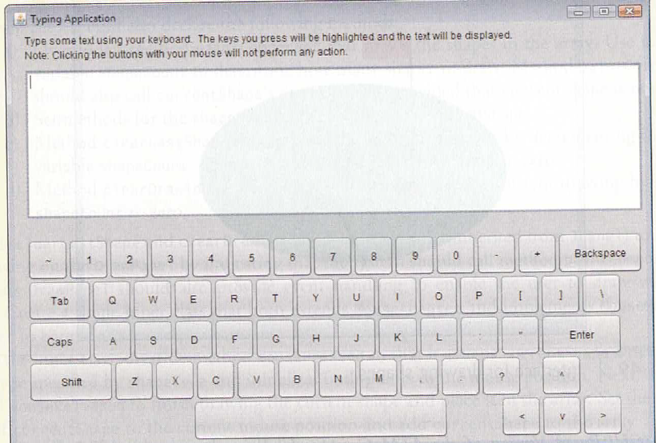

2.用戶打字用setBackground method 改變背景顏色 去highlight對應的JButton key，並加入 character to a JTextArea (顯示目前所有輸入)

(可寫一支程式測試 ，"The quick brown fox jumped over a lazy dog.")

3.顯示報告

(2)要有特定的短語讓用戶練習

(3)輸出用戶覺得較難的字(準確度低於50%的)

Java HW3 問題

1. 是否要跟模板一樣?否 可自由設計，也可插入GIF等等
2. 需要顯示用戶的準確度報告跟打錯的字嗎? 最後結束的時候顯示