**系統程式設計**

**Lab7 setjmp/longjmp**

**學號:406410114**

**姓名:郭晏誠**

1. **Where are the errors located?**

|  |  |  |
| --- | --- | --- |
| No | input | Error located |
| 1 | spta@embedded.cs.ccu.edu.tw | valid email address! |
| 2 | twetrewt.terthbbb.com.tw | error: at least one @ |
| 3 | spta@embed@ded.cs.cc@u.edu.tw | error: more than one @ |
| 4 | pv#pig@hot#mail.com | error: can't exist # |
| 5 | pvpig@hot*mail.com | error: can't exist * |
| 6 | aaawww@ccu.cs..edu.tw | error: can't exist .. |
| 7 | EA.EA@ccucsedutw | error: at least one . behind the @ |

1. **What is the error message format?  
   (you must not print any message after you print error message)**

|  |  |  |
| --- | --- | --- |
| No | input | Error format |
| 1 | spta@embedded.cs.ccu.edu.tw | valid email address! |
| 2 | twetrewt.terthbbb.com.tw | error: at least one @ |
| 3 | spta@embed@ded.cs.cc@u.edu.tw | error: more than one @ |
| 4 | pv#pig@hot#mail.com | error: can't exist # |
| 5 | pvpig@hot*mail.com | error: can't exist * |
| 6 | aaawww@ccu.cs..edu.tw | error: can't exist .. |
| 7 | EA.EA@ccucsedutw | error: at least one . behind the @ |

1. **How did you use the setjmp/longjmp function?**(1)main

(i) setjmp(jmpbuffer) == 0 → valid email address!

(ii) setjmp(jmpbuffer) == 1 → Email format error: at least one @

(iii)setjmp(jmpbuffer) == 2 → Email format error: more than one @

(iv) setjmp(jmpbuffer) == 3 → Email format error: can't exist #

(v) setjmp(jmpbuffer) == 4 → Email format error: can't exist *

(vi) setjmp(jmpbuffer) == 5 → Email format error: can't exist ..

(vii)setjmp(jmpbuffer) == 6 → Email format error: at least one . behind the @

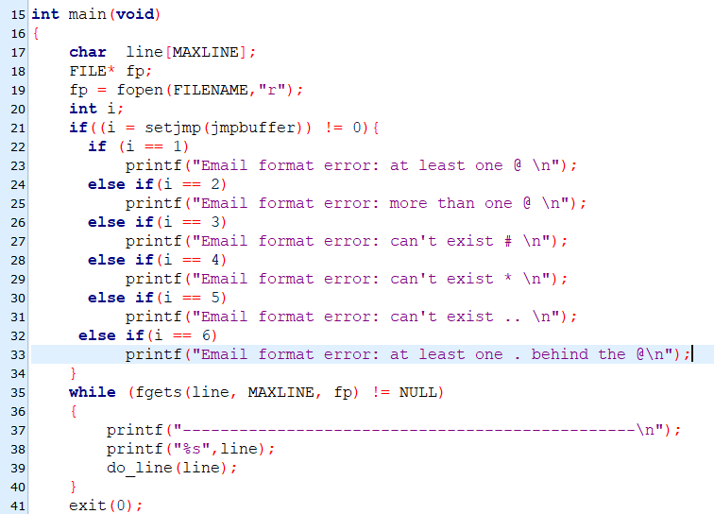

(2) void compare_at(char *str)

(i)採用cptr = strchr(str,'@') 檢查至少有一個

(ii)再用cptr = strchr(temp,'@') 檢查若有多個則longjmp(jmpbuffer, 2)

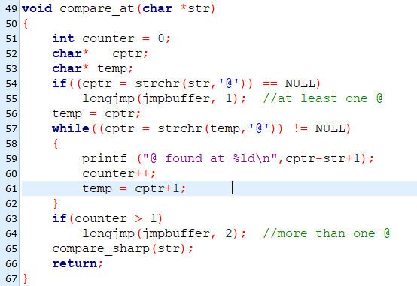

(3) void compare_sharp(char *str)

(i)採用(cptr = strchr(temp,'#') 檢查至少有一個則longjmp(jmpbuffer, 3)

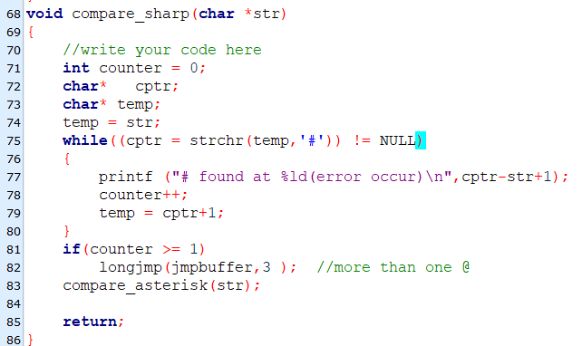

(4) void compare_asterisk(char *str)

(i)採用(cptr = strchr(temp,'*') 檢查至少有一個則longjmp(jmpbuffer, 4)

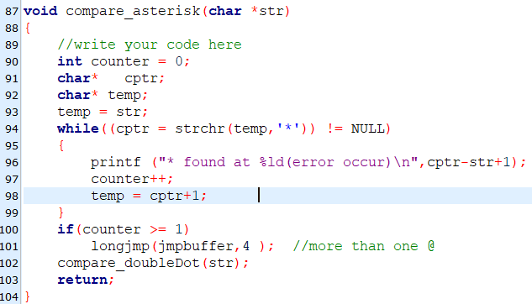

(5) void compare_doubleDot(char *str)

(i)採用(cptr = strstr(temp,"..") 檢查至少有一個則longjmp(jmpbuffer, 5)

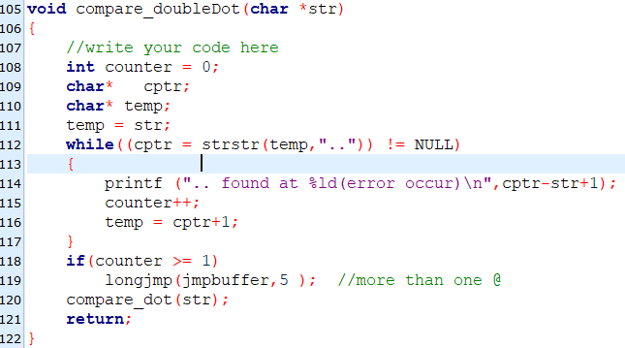

(6) void compare_at(char *str)

(i)採用cptr = strchr(str,'@') 檢查至少有一個

(ii)再用(cptr = strchr(temp,'.') 檢查若若無半個.則longjmp(jmpbuffer, 6)

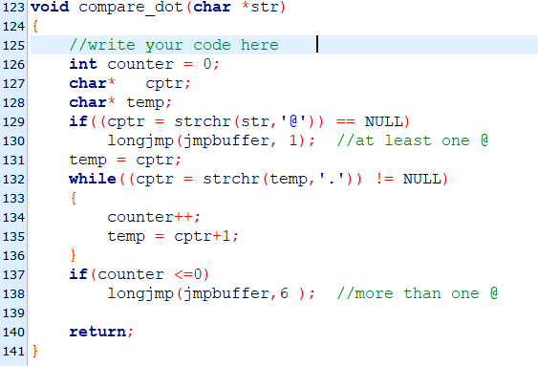

1. **Final result.  
   Please attach screenshot !**

