**Interactive Arts and Sciences: Web Media Production**

**IASC-STAC 1P02 D02 FW 20201**

**Assignment Four - Final Website**

Marcus Villena

Dec 8, 2021

# Wireframe Mock-up Images

## General Landscape Wireframe

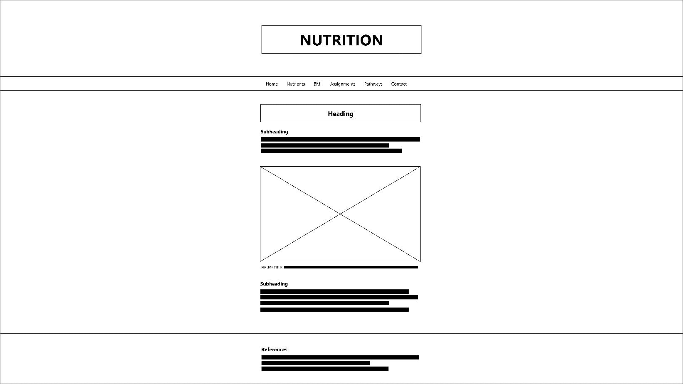

## General Mobile Wireframe

|  |  |
| --- | --- |
| **Navigation Collapsed** | **Navigation Expanded** |

# Rationale and Design

The objective or purpose of the website that was created is to serve as a central hub for a Nutrition class, including lecture content, useful class tools, assignments, and contact information. The website colours primarily utilized a monochromatic dark theme, to aid in giving a simplified, minimalist, and modern appearance that is easy for users to navigate. The dark theme makes use of white text atop different shades of grey for the background; with more background elements being darker, whereas more foreground elements (such as the navigation bar) being slightly lighter. To introduce contrast, two methods were utilized. Firstly, use of drop shadows helped in visually separating foreground and background elements. Secondly, use of various shades of green were implemented to highlight and bring attention to important elements (such as headers and interactive content). In aims of repetition and contrast, a similar approach to bringing contrast within the grey elements was used in the green elements: darker shades of green (such as in heading and navigation bar highlights) were utilized for background elements, whereas lighter shades of green (such as in heading text) were used in making elements appear closer to the foreground; in both cases, the shades of green utilized were brighter than the grey background, separating them and bringing more foreground attention to them.

Moreover, in further implementing repetition, the layout of the website, and the elements within the website, is consistent and repetitive across each of the pages making it easier for users to navigate. This layout had also made repetitive and consistent use of alignment and proximity across each of the pages. The header, placed at the top, is given a fair amount of space to separate it from other elements. The header also uses a background image, helping separate it from the other content. This is followed by a navigation bar, which being placed near the top, brings both importance and attention to it, while also helping users find and navigate across the webpage. The elements within the navigation bar are very proximal to each other, helping signify that they are all part of the navigation bar. The webpage also has an adaptive mobile navigation bar, which opts to remove the navigation links from the bar (aside from the current page) – replacing it with an icon. The icon opens a navigation pane, which has larger links to help with accessibility and clarity on more narrow devices.

This is followed by the content section, which like the header, is given further space between it and the navigation bar to signify that it is another main section of the site (separate from the header and navigation bar). The elements within the content section makes further repetitive use of the same alignment and proximity strategy: headers are given space between it and the previous element, to signify a new section of content; and text, placed closer with their appropriate header, indicate it is included or paired with that heading. Similarly, images are given space between it and the preceding element, with their subsequent captions being placed closer to indicate their connection. Moreover, interactive elements use a repetitive highlighted frame around themselves to both distinguish it from other content, and help users identify that it is a piece of interactive content. Lastly, following the content section, is a footer (references), which uses a similar format to both: the content section regarding text; alongside the header, regarding use of a background image to separate it from the content (signifying the end of the page). In targeting English-speaking users, the content is left-aligned to establish a familiar reading line, aiding in readability of the content. To introduce contrast, such as in the page header and content headings, center alignment was utilized. To further help in adaptability to wider screens, left and right margins were introduced to both help with consistent sizing and scaling of the content, while also aiding readability (users do not have to read from one end of the screen to the other). Moreover, a back-to-top button appears when scrolling, to further help users navigate the page.

Specific items, including interactive elements, within each page are intended to supplement and match the purpose of each page. The home page gives a brief overview of the course and site and directs the user to the navigation bar. The nutrients page describes lecture content, including both figures and an interactive quiz to help in studying the content. The BMI page both describes BMI, while also allowing users to interact and calculate their own BMI. The assignments page lists assignment details, with a deadline countdown clock to see how much time students have remaining for that assignment. The pathways page makes use of an interactive metabolic pathways map, which being a large image, interacts by hovering to zoom in. Lastly, contact information introduces the teaching team alongside providing their contact information (emails).