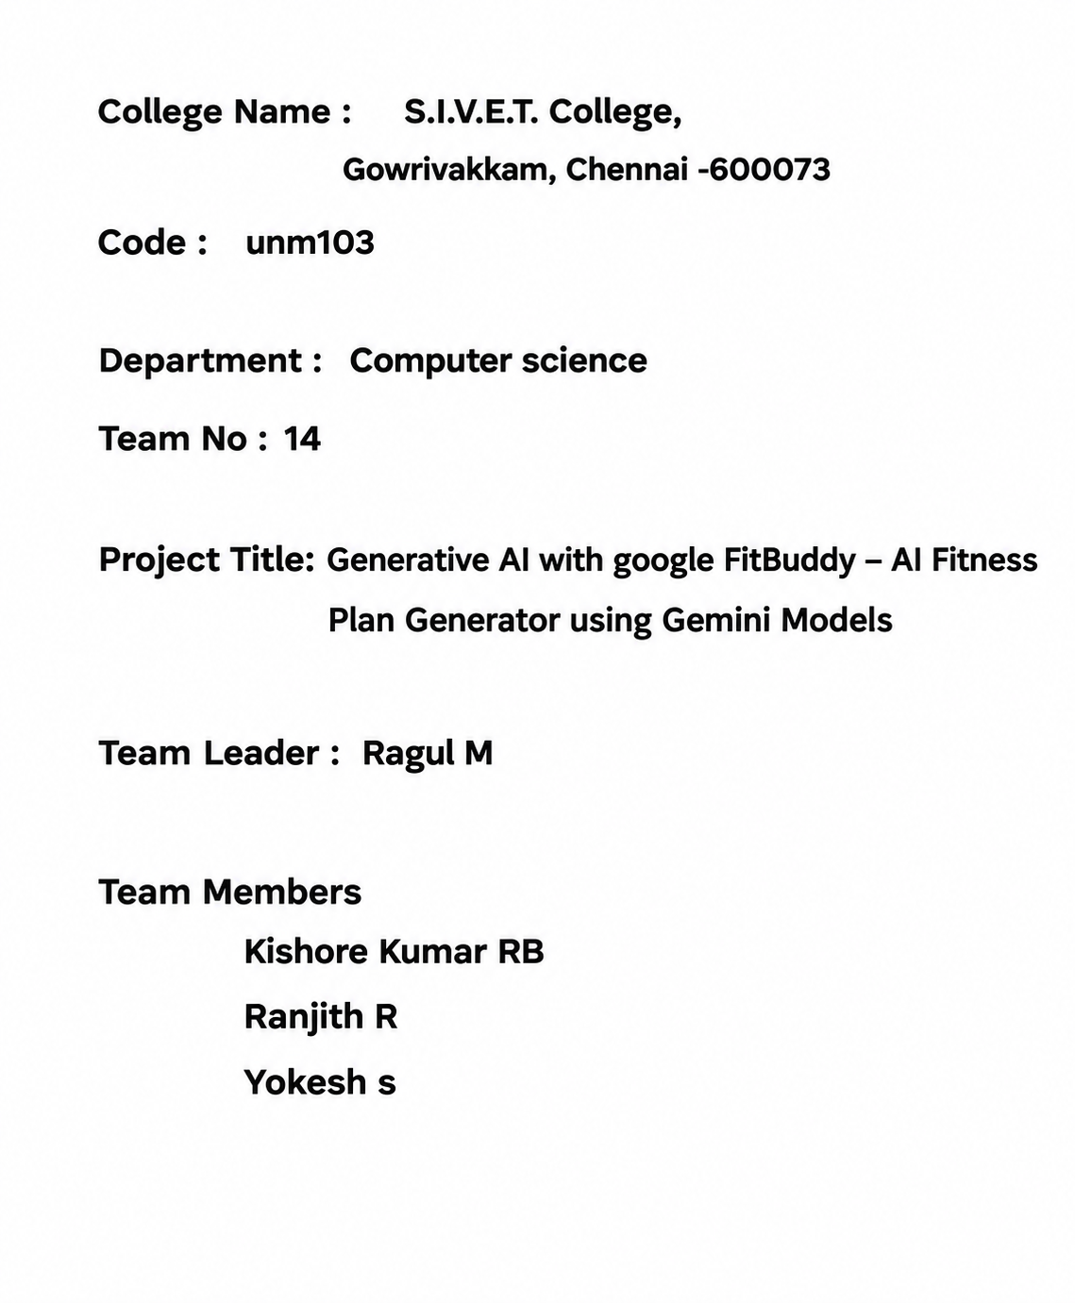

FitBuddy
AI Fitness Plan Generator using the Gemini API

Project Description
FitBuddy is a web-based application that uses Google's Gemini generative AI models to create a personalised workout and diet plan from a short questionnaire. The user enters basic profile details — age, gender, height, weight, fitness goal, activity level, workout days per week, diet preference and any health conditions — and the app returns a structured plan covering a day-by-day workout, a matching diet plan, and a short set of tips.
The application is built with Flask on the backend and vanilla HTML, CSS and JavaScript on the frontend. There is no database: each plan is generated on demand and, if the user chooses, saved to their browser's local storage so it can be revisited later without a server round-trip. The interface also supports light/dark theming and one-click export of the generated plan to PDF.

Scenarios

Scenario 1: Generate a personalised plan
A user fills in the form with their age, gender, height, weight, fitness goal, activity level, preferred workout days, diet preference and any health conditions or injuries, then selects “Generate My Plan.” The frontend posts this data as JSON to the /generate endpoint, which builds a prompt and sends it to a Gemini model. The response — a Workout Plan, a Diet Plan and three short Tips — is parsed and rendered on the page.

Scenario 2: Automatic model fallback
On startup, the backend queries the Gemini API for the list of available models and keeps only the “flash” models that support content generation (excluding image, TTS, live and audio variants), preferring “lite” variants first. When a plan is requested, the backend tries each candidate model in order until one succeeds, so a temporary quota or availability issue with one model does not stop the app from working.

Scenario 3: Save and revisit past plans
After a plan is generated, the user can select “Save to History.” The plan, its date and the selected goal are stored in the browser's local storage (capped at the last 10 entries). The History panel lists saved plans, and selecting “View” on any entry re-displays that plan without another API call.

Scenario 4: Export a plan as PDF
From the results view, the user can select “Download as PDF.” The client-side jsPDF library formats the current plan text into a downloadable PDF named fitbuddy-plan.pdf, so the user has an offline copy without any server-side file generation.

Scenario 5: Light / dark theme
A toggle in the top bar switches between light and dark themes. The chosen theme is written to local storage and re-applied automatically the next time the page loads.

Technical Architecture
FitBuddy follows a simple two-layer architecture:
- Frontend: a single HTML page (templates/index.html) with CSS variables for theming (static/style.css) and vanilla JavaScript (static/script.js) that handles form submission, rendering, history and PDF export.
- Backend: a Flask app (app.py) with two routes — “/” to serve the page and “/generate” to build the prompt, call the Gemini API and return JSON.
- AI layer: Google's Gemini API via the google-generativeai SDK, configured from a GEMINI_API_KEY environment variable loaded with python-dotenv.
- Persistence: none server-side; saved plans live only in the browser's localStorage under the current device/browser.

Backend responsibilities
- Load environment configuration and configure the Gemini client
- Discover usable Gemini “flash” models at startup (get_models)
- Build a structured prompt from the submitted form data (build_prompt)
- Call the Gemini API with automatic fallback across candidate models
- Return the generated plan as JSON, or a clear error (including a friendly message on quota exhaustion)

Frontend responsibilities
- Collect user input and submit it to /generate
- Render the returned plan, converting “## ” headings into styled section headers
- Persist and list plan history in localStorage
- Export the current plan to PDF via jsPDF
- Toggle and remember the light/dark theme

Project Structure
fitbuddy/
├── app.py # Flask app: routes, model selection, prompt building
├── .env # GEMINI_API_KEY (not committed)
├── .env.example
├── requirements.txt
├── templates/
│ └── index.html # Form, results card, history section
└── static/
├── style.css # Light/dark theme, layout, components
└── script.js # Form submit, rendering, history, PDF export, theme toggle

Pre-requisites
- Python programming basics
- Flask framework fundamentals (routes, templates, static files)
- Familiarity with the Gemini API (Google AI Studio, aistudio.google.com)
- HTML, CSS and Jinja2 templating basics
- JavaScript fetch/async basics
- Environment setup with pip and a virtual environment

Project Development Phases
In line with the phase-wise submission structure required for the course, the FitBuddy project is broken down into the following eight phases.

1. Brainstorming & Ideation Phase
The starting problem was that generic workout plans found online rarely account for an individual's age, weight, existing fitness level, diet preference, or injuries, and building a truly personalised plan usually requires a paid trainer. The idea behind FitBuddy was to use a generative AI model to instantly produce a workout and diet plan tailored to a person's own details, at zero ongoing cost, through a simple web form.
Several approaches were considered: a rule-based plan generator with hard-coded templates, a fine-tuned small language model, and an API-based generative model. The rule-based approach was rejected for being rigid and hard to extend; fine-tuning a model was rejected as unnecessary overhead for the scope of the project. Calling a hosted generative model (Google's Gemini) through its free-tier API was chosen because it needed no training data, understood structured formatting instructions out of the box, and could be integrated quickly behind a small Flask backend.

2. Requirement Analysis Phase

Functional requirements
- Accept user profile details: age, gender, height, weight, fitness goal, activity level, workout days per week, diet preference, and health conditions/injuries.
- Generate a structured plan containing a day-by-day Workout Plan, a matching Diet Plan, and three short Tips.
- Allow the user to download the generated plan as a PDF.
- Allow the user to save a generated plan to a local history and revisit it later.
- Allow the user to switch between light and dark themes.
- Handle API failures gracefully, including a clear message when the free daily quota is exhausted.

Non-functional requirements
- The app should respond within the model's normal latency (a few seconds) for a typical request.
- No sign-up or account should be required to use the app.
- The app should run entirely on a single developer machine for local testing, with no paid infrastructure.
- The interface should be usable on both desktop and mobile browser widths.

Technology decisions
Flask was chosen for the backend because the app needed only two simple routes and no heavy framework features. Vanilla HTML/CSS/JavaScript was chosen for the frontend to keep the project dependency-light and easy to run without a build step. Because the app has no multi-user accounts and only needs to remember a single browser's recent plans, the browser's own localStorage was chosen over a server-side database, which kept the whole project a single Flask service with no database setup or migrations.

3. Project Design Phase
High-level architecture:
- Frontend: templates/index.html (structure), static/style.css (light/dark theming, layout), static/script.js (form handling, rendering, history, PDF export).
- Backend: app.py, a single Flask application exposing “/” (serves the page) and “/generate” (builds the prompt, calls Gemini, returns JSON).
- AI layer: Google Gemini, accessed via the google-generativeai SDK, with the API key read from a .env file.
- Client storage: the browser's localStorage holds the theme preference and up to 10 recent plans; nothing is persisted on the server.
User interface flow:
- User lands on the form (index.html) and fills in their profile details.
- On submit, the page shows a loading spinner and posts the form data as JSON to /generate.
- The returned plan is parsed into headed sections and shown in the results card, with Download as PDF and Save to History actions.
- The History panel (also on the same page) lists previously saved plans and can redisplay any of them instantly.
This keeps the design intentionally simple: one page, one backend route for generation, and all “convenience” features (history, theme, PDF) implemented entirely on the client.

4. Project Planning Phase
The work was planned and delivered in the following order:
- Set up the Python environment, install dependencies, and confirm the Gemini API key works with a basic model call.
- Build the backend: model discovery/fallback logic, prompt construction, and the /generate route.
- Build the static frontend page and wire the form to the backend.
- Add the convenience features: plan history, PDF export, and the light/dark theme toggle.
- Test the app end-to-end and fix issues found (error handling, formatting edge cases).
- Write up the project documentation.
- Record the project demonstration video.
Each step depended on the one before it, so the plan followed a straightforward linear order rather than parallel workstreams, which suited a single-developer project of this size.

5. Project Development Phase
The build is organised into four milestones:
- Model selection and environment setup
- Backend development (Flask app and Gemini integration)
- Frontend development (form, results, history, theming)
- Local testing and running the app

Milestone 1: Model Selection and Environment Setup
Rather than hard-coding a single Gemini model name, FitBuddy queries genai.list_models() at startup and filters down to models that support content generation, contain “flash” in their name, and exclude image/TTS/live/audio variants. Remaining names are sorted so “lite” models are tried first, and a hard-coded fallback (models/gemini-3.6-flash) is used if the listing call fails.
def get_models():
names = []
try:
for m in genai.list_models():
name = m.name
if "generateContent" not in m.supported_generation_methods:
continue
if "flash" not in name:
continue
if any(x in name for x in ["image", "tts", "live", "audio"]):
continue
names.append(name)
except Exception as e:
print("Could not list models:", e)
if not names:
names = ["models/gemini-3.6-flash"]
names.sort(key=lambda n: 0 if "lite" in n else 1)
return names
Environment setup:
python -m venv fitbuddy-env
fitbuddy-env\Scripts\activate # Windows
pip install -r requirements.txt

# .env
GEMINI_API_KEY=your_real_key_here

Milestone 2: Backend Development

Prompt construction
build_prompt() assembles the user's answers into a single instruction to the model, fixing the exact output structure (Workout Plan / Diet Plan / Tips headings) and a 400-word limit so the response renders predictably on the page.
def build_prompt(d):
return f"""You are a friendly fitness coach. Create a simple, safe, personalised plan.

User details:
- Age: {d.get('age')}
- Gender: {d.get('gender')}
- Height: {d.get('height')} cm
- Weight: {d.get('weight')} kg
- Goal: {d.get('goal')}
- Activity level: {d.get('activity_level')}
- Workout days per week: {d.get('workout_days')}
- Diet preference: {d.get('diet') or 'No preference'}
- Health conditions / injuries: {d.get('conditions') or 'none'}

Give the answer using this exact structure with headings:

## Workout Plan
(day by day, one line per day)

## Diet Plan
(simple daily meals matching the diet preference)

## Tips
(three short tips)

Keep the whole answer under 400 words. Use plain text, no markdown tables."""

Generation route with model fallback
The /generate route walks the candidate model list, returning the first successful response. If every model fails and the last error mentions a 429 status, the route returns a friendly quota-exceeded message instead of a raw exception.
@app.route("/generate", methods=["POST"])
def generate():
data = request.get_json()
prompt = build_prompt(data)
last_error = "No model available"

for name in MODEL_NAMES:
try:
model = genai.GenerativeModel(name)
response = model.generate_content(
prompt,
request_options={"timeout": 120},
)
return jsonify({"plan": response.text})
except Exception as e:
last_error = str(e)
print(f"Model {name} failed:", last_error[:200])
continue

if "429" in last_error:
return jsonify({
"error": "Daily free quota finished for all models. Please try again later."
}), 429
return jsonify({"error": last_error}), 500

Milestone 3: Frontend Development

Form submission and rendering
script.js collects all form fields into a JSON payload, shows a spinner while waiting, and on success formats the returned plan text by turning “## ” lines into section headings and blank lines into spacing.
function formatPlan(text) {
return text
.split("\n")
.map(line => {
if (line.startsWith("## ")) {
return `<h3>${line.replace("## ", "")}</h3>`;
}
if (line.trim() === "") return "<br>";
return `<p>${line}</p>`;
})
.join("");
}

History (client-side only)
Saved plans are kept in localStorage under the key fitbuddy_history, capped at the 10 most recent entries. Each entry stores the date, the selected goal, and the full plan text so it can be redisplayed without contacting the server.
saveBtn.addEventListener("click", () => {
const items = JSON.parse(localStorage.getItem("fitbuddy_history") || "[]");
items.push({
date: new Date().toLocaleString(),
goal: document.getElementById("goal").value,
plan: currentPlanText
});
while (items.length > 10) items.shift();
localStorage.setItem("fitbuddy_history", JSON.stringify(items));
loadHistory();
});

PDF export
The Download as PDF button uses jsPDF (loaded from a CDN) to lay out the current plan text and save it as fitbuddy-plan.pdf:
downloadBtn.addEventListener("click", () => {
const { jsPDF } = window.jspdf;
const doc = new jsPDF();
const lines = doc.splitTextToSize(currentPlanText, 180);
doc.setFontSize(16);
doc.text("FitBuddy - My Fitness Plan", 10, 15);
doc.setFontSize(11);
doc.text(lines, 10, 25);
doc.save("fitbuddy-plan.pdf");
});

Theming
Colours are defined as CSS variables on :root and overridden under body.dark, so a single class toggle switches the whole palette. The chosen theme is remembered in localStorage under fitbuddy_theme.

Milestone 4: Running the App Locally
Run the app locally with:
python app.py
By default this starts the Flask development server (debug mode is on for auto-reload during development). The homepage form is available at the server's root URL; submitting it calls /generate and renders the returned plan, and the History and theme toggle are exercised entirely in the browser.

6. Project Testing Phase
Testing was carried out manually, covering the following cases:
- Form validation: submitting with required fields (age, height, weight, workout days) left empty is blocked by the browser's built-in required/min/max constraints on the inputs.
- Happy path: submitting a complete, realistic profile (e.g. age 24, goal “Weight Loss”, 4 workout days) returns a correctly structured plan with Workout Plan, Diet Plan and Tips sections.
- Model fallback: verified that if the first candidate model in MODEL_NAMES fails, the loop moves to the next model rather than failing the whole request.
- Quota handling: simulated a 429 response to confirm the route returns the friendly “Daily free quota finished for all models” message instead of a raw stack trace.
- History: saved several plans, confirmed the list is capped at 10 entries and the oldest is dropped first, and confirmed “View” correctly redisplays a past plan.
- PDF export: confirmed the Download as PDF button produces a readable fitbuddy-plan.pdf containing the full plan text.
- Theme toggle: confirmed the theme persists across a page reload via localStorage.
- Cross-browser/responsive check: verified the form and results card lay out correctly on both a desktop-width and a mobile-width viewport, using the CSS grid's single-column fallback.
No automated test suite was written for this project; all checks above were performed manually against the running local server.

7. Project Documentation Phase
This document is the project's documentation deliverable, covering the project description, usage scenarios, technical architecture, prerequisites, project structure, and a phase-by-phase account of how the project was built, including the key backend and frontend code. Alongside this document, the project also carries inline code comments in app.py and script.js, and a requirements.txt listing the exact Python dependencies needed to reproduce the environment.
- Repository contents: app.py, .env.example, requirements.txt, templates/index.html, static/script.js, static/style.css, and this documentation file.
- The .env file itself (containing the real API key) is kept out of version control; only .env.example, showing the expected variable name, is committed.

8. Project Demonstration Phase
The project demonstration video should be a screen recording with voice-over that walks through the working application end to end, covering:
- Project Name: FitBuddy — AI Fitness Plan Generator.
- Purpose of the Project: to generate a personalised workout and diet plan instantly from a short questionnaire, using a generative AI model instead of generic templates or a paid trainer.
- Use / Benefits: free to use, no sign-up, works for any fitness goal and diet preference, remembers past plans locally, and lets the user keep an offline PDF copy.
- Project Execution / Working Process: starting the Flask server, filling in the form, showing the request go to /generate, and narrating how the backend selects a Gemini model and builds the prompt before returning the plan.
- Final Output: the rendered Workout Plan, Diet Plan and Tips on screen, followed by saving the plan to history, reopening it from the History panel, downloading it as a PDF, and toggling the dark/light theme.

Conclusion
FitBuddy is a lightweight, single-service demonstration of an AI-assisted fitness planner: a Flask backend that turns a short questionnaire into a well-structured Gemini prompt, with automatic fallback across available models, paired with a dependency-light frontend that renders the plan, remembers past plans locally, exports to PDF, and supports light/dark themes. Because state lives in the browser rather than a database, the app stays simple to run and extend — a natural next step would be adding server-side storage (e.g. SQLite) if plans need to be shared across devices or reviewed by a coach.

