Introduction/motivations

The goal of this work was to experiment with embeddings, which are used nowadays in a wide variety of applications to represent and manipulate data, notably as inputs of neural networks. Out of personal interest, I chose to focus on the results of the professional men’s tennis tour (ATP). This work in composed of two main parts:
1) Data gathering from the parsing of Web pages, cleaning and preprocessing
2) Conception of a model to learn embeddings of data representing different elements (namely players and tournaments), and experiments to predict results from this representation.

Most of the ideas of this work are derived from a recent article on the prediction of transportation mode from data on users and geographic contexts [1]. I found the idea interesting, and wanted to apply it to another domain.

1) Data gathering

a) Source

The first step was to find a data source which would contain all the required data, that is:
- information about the players: nationality, dominant hand, etc.
- information about the tournaments: surface, level, etc.
- match results, dating back as much as possible (*)

(*): like many sports with a long history, tennis has gone through many changes over time, so the results from a century ago are not really comparable to those of today. As a cut-off point, we will focus on results from the “Open era”, i.e. after 1968; which marks the advent of the professional tour as it is known today.

The website of the ATP is remarkably exhaustive when it comes to historical data, as it contains all known results, players and tournaments, for our period of interest (and more). The presentation is also very clean and uniform, which would make the parsing easy.
Unfortunately, this site blocks attempts to scrap its data, and the resulting HTML pages do not contain any useful information for our purposes.

There exist many websites (usually related to betting) that aggregate sports results, including for tennis. However, these are not meant as historical archives, and as such do not date as far back as we would like. These also lack information about tournaments and players.

After consideration, the best option was to get the data from Wikipedia, as it includes everything we need from a single source. However, since it is a collaborative site, there are discrepancies in the way that pages are formatted, which makes parsing more challenging, as well as lack of data for some tournaments/players/years.

Note: this type of data may already have been gathered as part of other projects. However, doing it from scratch gave me better control and knowledge about the data, and the parsing process itself was quite interesting.

b) Overview of the parsing tool

We consider the following levels of tournaments from the ATP Tour: Grand Slam, ATP 1000, ATP 500, and ATP 250.
Other events are part of the tour (ATP Finals, Next Gen Finals, Davis Cup, etc.), but were excluded since these events’ formats were too different from the others (group stages, different scoring rules, etc.), so the parsing would have to be specific for each of these.

The parsing tool roughly works as follows:
- starting from the “ATP Tour” Wikipedia page, get the list of tournament levels
- for each tournament level, get the list of tournaments
- for each tournament, get the list of editions (i.e. years where the tournament was held)
- for each edition, find the page of the men’s singles results
- parse this page to extract the score results
- if previously unknown players participated in it, parse player info from his wiki page

The tool is built to be resilient to failures. Given that the full parsing process takes about one hour, that there are many irregularities in the format, and that we may need to rerun it (at least partly) to get new data as tournaments are held, it was also important to be able to stop it and resume it as easily as possible.
Therefore, the parsing tool first looks for the list of individual tournament editions (from the web pages), and only parses editions for which no data has been gathered (by looking at the data folder). This incurs a slight overhead for the first phase, but as a result the process can be launched, stopped and resumed at will, as it gathers the missing data.

c) Known data issues

Missing data occurs in different places:
- some editions do not have a dedicated page for the (men’s singles) results, and only mention the result of the final, or of the few final rounds. In this case, we do not get any results for this edition.
- some editions have unusual draw formats. The format depends on the number of rounds, number of entrants, number of seeds (top seeds get a bye into the second round). The main issue is that we need to know the draw format to be able to parse the match results from the HTML tables. The first version of this tool includes more than 20 possible formats, which captures most of the cases, but a few outliers still exist, especially for older editions (before 1990 or so).
- some players have missing information on their page. Again, this is more often the case for older or less-known players.

d) Stats on the data gathered

Below are some graphs about players, tournaments and results, based on the data gathered (around summer 2023).
The last one shows that most results are from 1990 onward, which translates the fact that lower-tier events (mostly ATP 250s) do not have the full results on Wikipedia before that. A shorter time frame such as this is actually fine for analysis purposes; we could even consider removing everything before 1990 to have a cleaner/more compact dataset (fewer players, more results per player).

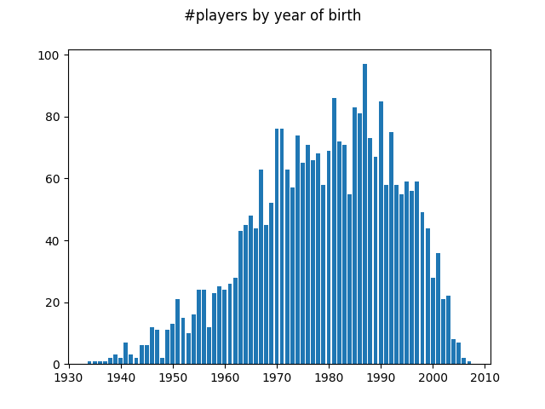
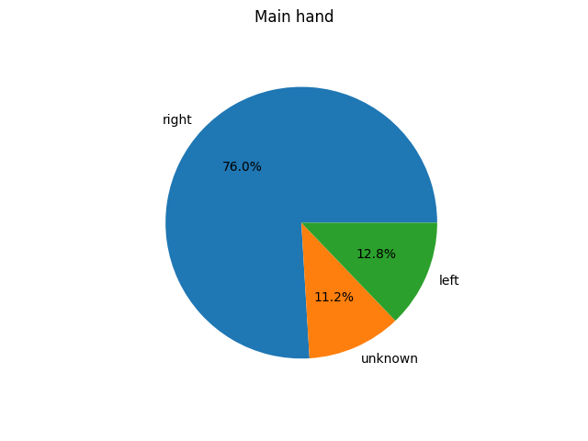

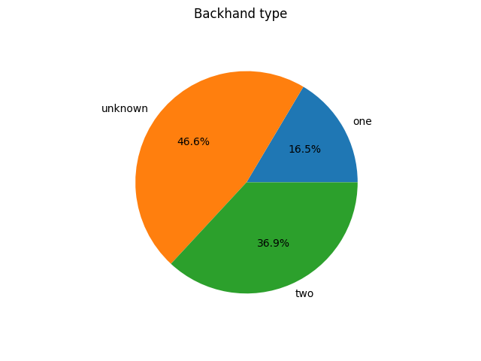
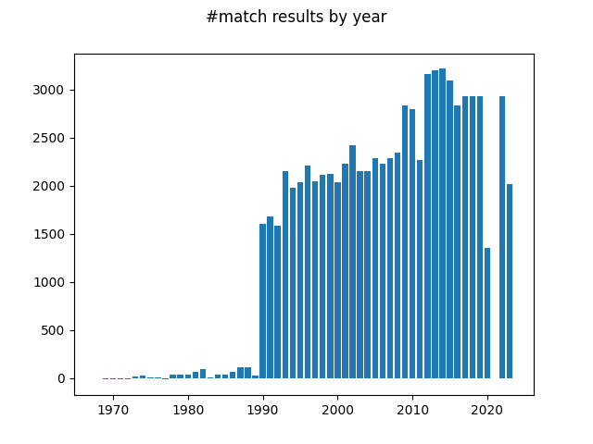

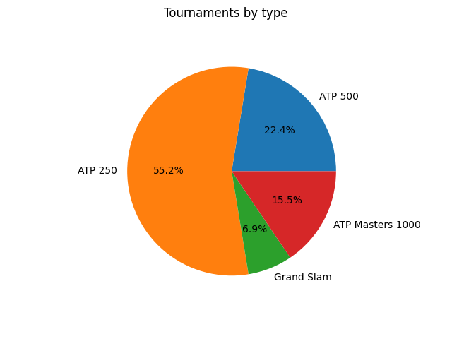

e) Preprocessing

The parsing process gathered both numerical and categorical features for players and tournaments. We apply some preprocessing to make these features more readily usable:
- the numerical features are normalized on [0,1]
- the countries (location country for tournaments, and country of birth for players) are mapped to their geographic sub-region (e.g. “Northern Europe”, “Southern Asia”), in order to reduce the number of possible values into meaningful groups.

At the end of the process, we have the following files:

A “tournaments” file with the features:
- surface (grass, clay, indoor hard, outdoor hard)
- draw size
- location sub-region
- last prize pool
- tournament type

A “players” file with the features:
- height
- year of birth
- sub-region of birth
- dominant hand
- backhand type

One “results” file per tournament edition (e.g. one file for Wimbledon 2001, etc.), where each row is the result of a match: player one, player two, round of match (e.g. first round, quarter-finals, etc.), scoreline.

2) Embeddings model

a) Model design

As mentioned in the introduction, the idea for this work came from a study on transportation mode recommendation [1]. Interestingly, the framework of the data representation they used can be translated to our context.

In the study, the authors use the concept of “joint representation”, i.e. concurrently representing different types of elements and their interconnections. More specifically, three types:
- user
- geographic context (called “origin-destination”)
- transportation mode

In this framework, a trip can be viewed as a tuple of [user, context, mode], and the problem of finding the most desirable mode, for example, can be written as “For user u and context c, find mode m that maximizes prob([u, c, m])”.

Coming back to our topic of interest, we can translate this idea with the following three types of elements:
- player
- tournament context
- result

Here, a match result can be viewed as a tuple of [player, context, result].
A potential issue with this representation is that it ignores the “confrontational” aspect of tennis: a match would be more accurately represented by [player_one, player_two, context, result], as the match-up between two players is an important part of the game and could be an important predictor of the result.
However, this would require significant changes to the learning algorithm, and I was not sure how to do it in a mathematical sound way. Therefore, we kept the first representation, with the assumption that a player’s result history alone would be enough to learn useful embeddings.

b) Anchor embeddings

The previous study uses fixed (“anchor”) embeddings for transportation modes, to provide a stable point from which the embeddings for the other types of elements can be learned. These anchor embeddings do not change during learning, and are based on mode-mode pairwise relevance, which is inferred from the data.

In our case, since we only have two possible results (win or loss) and they are direct opposites from each other, we chose to fix these two embeddings as far as possible in the vector space, i.e.:
- x_{loss} = [-1/2d, …, -1/2d]
- x_{win} = [1/2d, …, 1/2d]
where d is the number of dimensions.

c) Learning algorithm

The learning algorithm is inspired by the one in [1], but modified to take into account the different data. In the pseudo-code below, the third inner foreach loop is the main modification.

For parameters, we take values in the same range as those in the original paper:
- α = 0.4
- β₁ = 0.1
- β₂ = 0.3
- ε = 0.01 (not used; we use a fixed number of iterations instead to avoid overfitting)
- γ = 0.5
- #dimensions = 32 (64 works fine as well)

We didn’t really try to optimize these parameters, since no rigorous testing/tuning was designed.
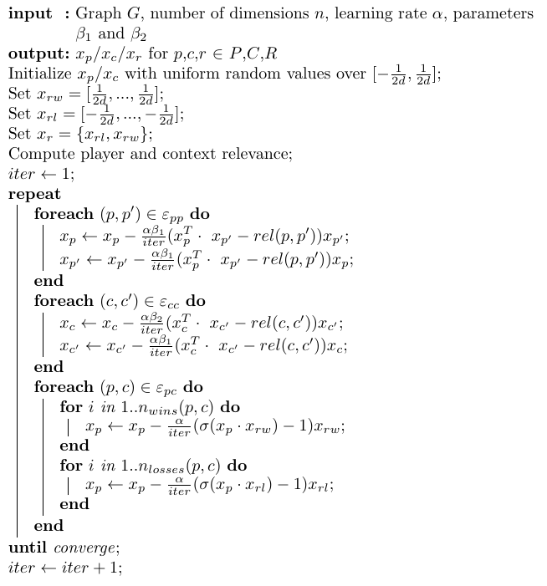

d) Results

A straightforward way to get an idea of the predictive power of the embeddings learned, is to keep a separate “test” set of matches, and try to predict the results. We tried holding the full year of 2021 as “test”, and got the following predictions stats:

Correctly predicted = 1541
Incorrectly predicted = 1026

for an accuracy on the test set of a = 60%, which is decent for a first approach, and at least significantly better than random guessing.
[1]: Liu, Hao, et al. "Joint representation learning for multi-modal transportation recommendation." Proceedings of the AAAI Conference on Artificial Intelligence. Vol. 33. No. 01. 2019.

