Started by reading the question thoughroughly this time. The main question was how to create a maze. Also there was a sentence which was making some sort of confusion *"This means you'll need algorithms to create random mazes with walls, corridors, and open spaces.*

Making a maze apparently didn’t sound difficult as I also had a rough sketch in mind that a grid is to be made using nested loops with some random function inside that’ll remove some part from the grid in order to make a path to follow.

Now I asked the question regarding the confusion in discord and started to search on maze creation. I had to see multiple resources few stated below:  
<https://www.youtube.com/watch?v=D8UgRyRnvXU>

<https://cantwell-tom.medium.com/prims-algorithm-as-a-maze-in-javascript-aec7415ad2cd>

https://stackoverflow.com/questions/29739751/implementing-a-randomly-generated-maze-using-prims-algorithm  
https://professor-l.github.io/mazes/  
<https://medium.com/swlh/how-to-create-a-maze-with-javascript-36f3ad8eebc1>

These are some of them that were still open in my browser yet there were a lot more but I closed those tabs.

I initially had the statement in my mind that the maze generation has to be done by using an algorithm but I wasn’t 100% certain as I wasn’t answered yet. When I started my search on it I realized it is quite difficult, after exploring quite a lot and failing to achieve an output I asked chatgpt for maze creation, I didn’t just straight away pasted the whole question rather I just explicitly asked about maze generation.

Following was the output and it was exactly the same as the picture in my mind of making a netsted loop followed by a random function. Now this was the point where I thought no algorithm as such is required. Because apparently this logic below is an algorithm too. All of this was supported by my thinking as I had a misconception that all of these algorithms BFS,DFS (including prims and kruskals etc) are used for traversals and path finding and there’s no such need of traversals since we are the ones to navigate the object, and till now I wasn’t replied in the group.

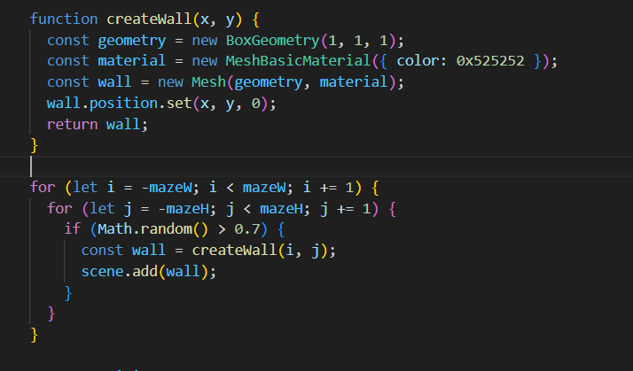 Even though my research was algorithm oriented at first but this misconception in my mind and the output by chatgpt made me think that probably this is the right way and no algorithm is as such required.

Now I was done doing the maze part and an object character, In the meanwhile when I was constantly playing with the output of the regular approach attached above. As I tried to manually follow the maze and I was thinking that since the random function is being used blindly this’d definitely cause a dead end (could be at the very start or in the middle of the path making the goal state totally unreachable) at some point which actually occurred at various instances forcing me to think that this definitely has to be done using an algorithm.

And then I finally got a reply that I have to use an algorithm. Now after the whole procedure and the confirmation message it all made sense because the point of the maze was not to create solemnly a maze but to rather make sure that there exists a path that enables to reach the goal state.

Now I was back to square one once again since creating a maze using algorithms was quite challenging, now once again I started searching and these are few of the links.

<https://cantwell-tom.medium.com/prims-algorithm-as-a-maze-in-javascript-aec7415ad2cd>

https://www.baeldung.com/cs/maze-generation

<https://www.youtube.com/watch?v=zbXKcDVV4G0>

https://joeiddon.github.io/projects/javascript/maze_generation.html

Now All of this didn’t help much, so I asked chatgpt to make a maze using these algorithms but none of them was working. One of them apparently worked(like all of the results would not even generate a maze like structure but this one made an apparent maze) but it had the same problem which I faced with the regular code and it was that I could see the maze but it didn’t give a solution every time, like I could see not reaching the goal state.

Once again I started to search as chatgpt was also useless and I finally came across a blog that seemed quite helpful ([Tutorial - Random Maze Generation Algorithm in Javascript - dstromberg](https://www.dstromberg.com/2013/07/tutorial-random-maze-generation-algorithm-in-javascript/)), the code made sense as everything was well explained. I with some modifications and help of chatgpt incorporated this code snippet into my threejs file. it ran in the first try and a maze was created.

I tried following the maze path to see if it reached the goal state and I saw multiple times that it didn’t fail and there was a definite path till the end everytime.I created the goal state at the bottom right and the player character(a cube) on the top left. Now it was the time to add keyboard controls and implement collision detection.

A handlekey function was created and inside the same function there was the functionality to check whether the move is valid or not like there must be no movement if there is a wall in the direction of player movement. This had some issue at the start like it wouldn’t move to certain areas I don’t know that whether this was due to some size misconfiguration or something else, I asked chatgpt, and the solution it gave worked fine I don’t know what exactly was changed but the functionality was working fine. Additionally at some point I faced another weird issue that pressing the ‘d’ key specifically or I guess pressing any of the key(w,a,s,d) would make the maze reload again and again this was also solved by chatgpt.