# golang

The Steps for this assignment is as described below with the screen shot

Creating 3 instance

App1:- applicaton node for GO Code Section

App2:-Application node for Go COde section

LB:- this is the for showing the "Hi there, I'm served from "server name"" in round robin fashion.

Screenshot for the same

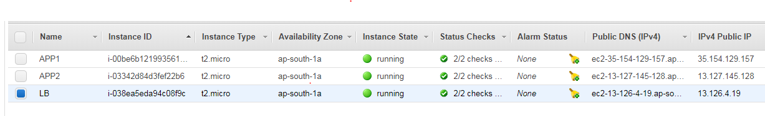

Nginx configuration file at lb

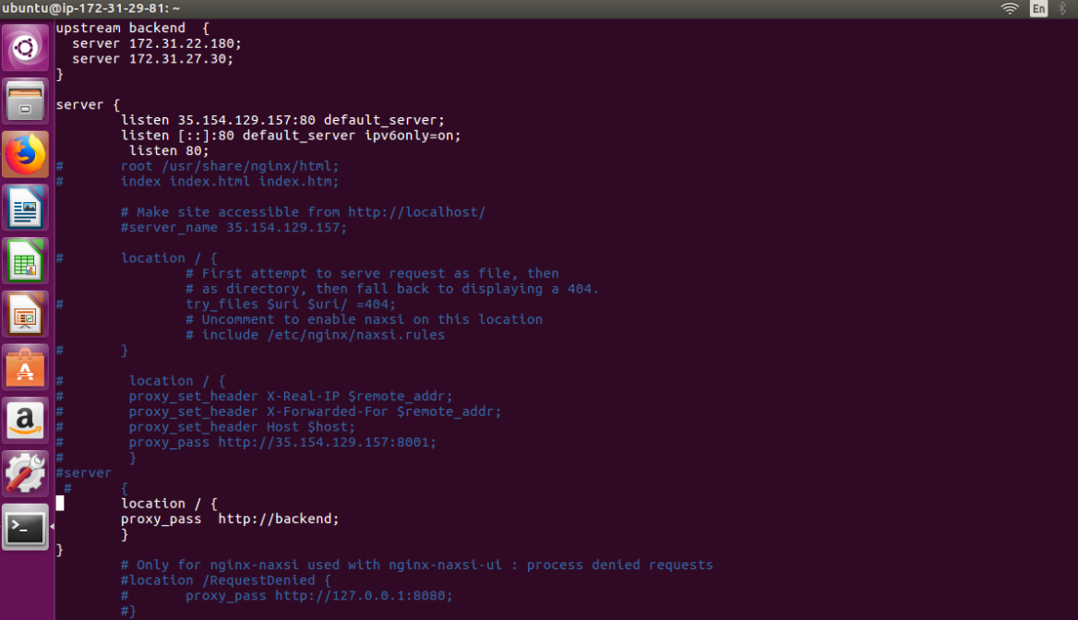

Links to test the application

: App 1 :- ec2-35-154-129-157.ap-south-1.compute.amazonaws.com

App2:- ec2-13-127-145-128.ap-south-1.compute.amazonaws.com

LB:- ec2-13-126-4-19.ap-south-1.compute.amazonaws.com