MLA0101-Artificial Intelligence and Expert Systems
CO1-Assessesment Tool2
Scenario Based Research Assessment

Name: M. Vaishnavi
Register No:192525051

Artificial Intelligence in Healthcare: AI-Assisted Medical Diagnosis Using Med-Gemini

1. Title of AI Application
AI-Assisted Medical Diagnosis Using Med-Gemini
Domain: Healthcare

2. Domain Selection
The selected domain is Healthcare. Artificial Intelligence is transforming healthcare by improving disease diagnosis, supporting doctors in clinical decision-making, reducing medical errors, and enhancing patient care. Med-Gemini is one of the latest AI applications designed to understand medical text, images, and patient records for accurate diagnosis.

3. Introduction and Background
Artificial Intelligence is revolutionizing modern healthcare by assisting medical professionals in diagnosing diseases quickly and accurately. Med-Gemini is an advanced multimodal AI model developed to analyze medical images, laboratory reports, patient history, and clinical notes. It supports doctors by providing intelligent suggestions and reducing diagnosis time. This technology improves healthcare quality while ensuring better patient outcomes.

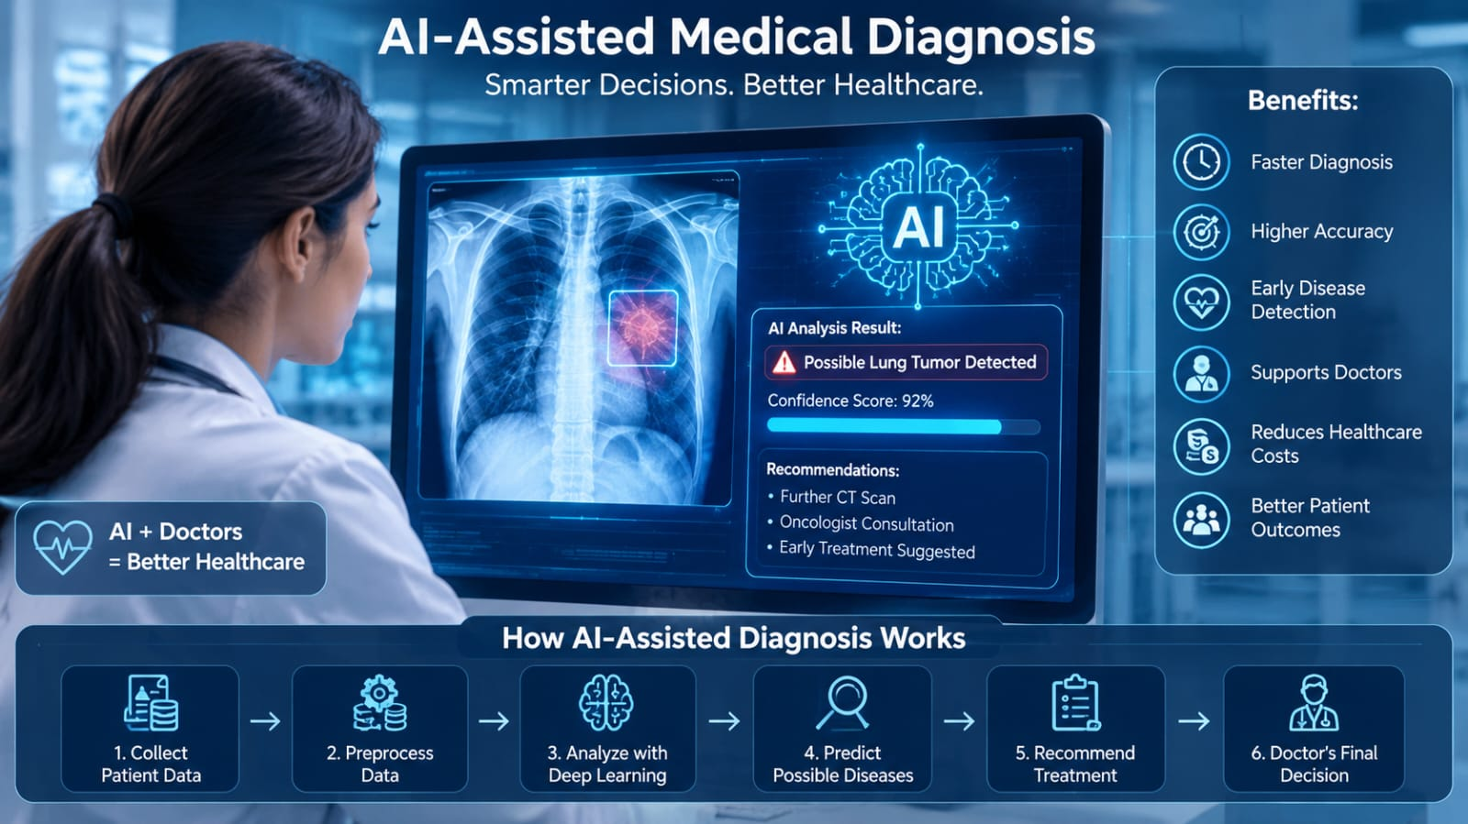

4. Problem Identification
Healthcare professionals often face challenges such as:
- Large numbers of patients.
- Complex medical records.
- Delayed diagnosis.
- Human errors.
- Limited specialist availability in rural areas.
These challenges can delay treatment and reduce healthcare quality.

5. Need for AI Solution
AI is required because it:
- Processes huge medical datasets rapidly.
- Detects diseases with high accuracy.
- Supports doctors in decision-making.
- Reduces diagnostic errors.
- Saves time and healthcare costs.
- Provides healthcare assistance even in remote areas.
Compared to traditional diagnosis, AI delivers faster and more consistent results.

6. AI Technologies Used
The system uses:
- Machine Learning (ML)
- Deep Learning (DL)
- Computer Vision
- Natural Language Processing (NLP)
- Generative AI
- Large Language Models (LLMs)
- Medical Image Analysis
- Neural Networks
These technologies enable the system to understand medical reports, X-rays, MRI scans, CT scans, and patient history.

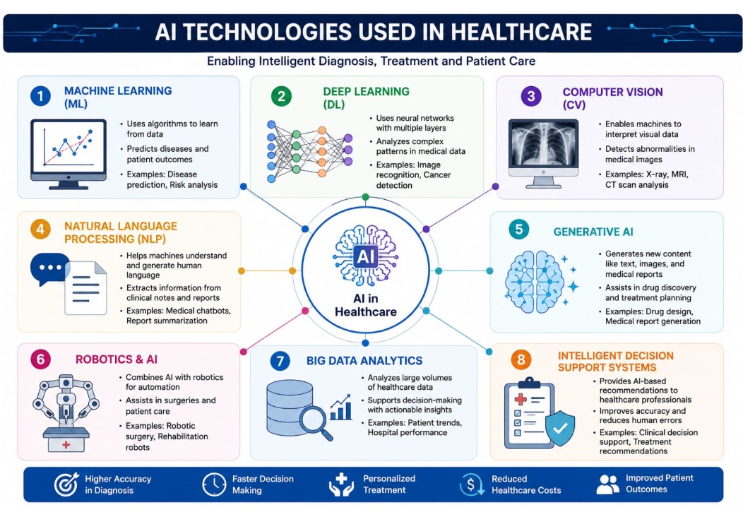

7. Working Mechanism

Step 1: Collect patient information, symptoms, medical history, laboratory reports, and medical images.
Step 2: Preprocess the data by removing noise and standardizing the information.
Step 3: Deep learning algorithms analyze medical images while NLP processes clinical text.
Step 4: AI compares the information with millions of medical records and trained models.
Step 5: The system predicts possible diseases and recommends suitable treatments.
Step 6: Doctors review the AI recommendations and make the final clinical decision.
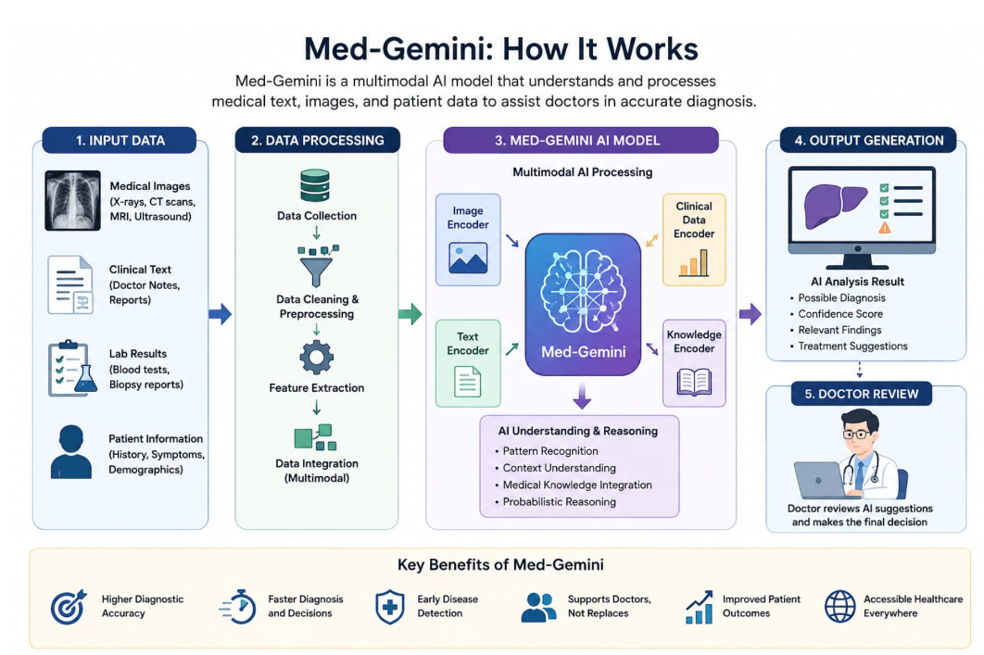

8. Data Sources and Processing
The AI system uses:
- Electronic Health Records (EHR)
- X-ray images
- MRI scans
- CT scans
- Blood test reports
- Clinical notes
- Medical research databases
The collected data is cleaned, normalized, labeled, and processed using machine learning models before prediction.

9. Real-World Implementation
AI-assisted diagnosis is currently used by:
- Google DeepMind
- Mayo Clinic
- Cleveland Clinic
- Apollo Hospitals
- NHS (United Kingdom)
Applications include:
- Cancer detection
- Diabetic retinopathy diagnosis
- Brain tumour detection
- Heart disease prediction
- Lung disease analysis

10. Impact and Benefits
Benefits include:
- Faster diagnosis
- Higher accuracy
- Early disease detection
- Reduced healthcare costs
- Better patient monitoring
- Reduced workload for doctors
- Improved healthcare accessibility
- Better patient satisfaction

11. Challenges and Limitations
Challenges include:
- Patient data privacy
- Cybersecurity risks
- High implementation cost
- Requirement for quality medical datasets
- Ethical concerns
- AI bias
- Need for human supervision
- Regulatory compliance

12. Future Scope and Emerging Trends
Future developments include:
- Personalized AI treatment plans.
- Wearable AI health monitoring.
- AI-assisted robotic surgery.
- Digital twins for patients.
- Remote healthcare through AI.
- Improved multimodal AI systems.
- Faster disease prediction with advanced deep learning.
AI is expected to become an essential assistant for doctors rather than replacing them.

13. Conclusion
Artificial Intelligence is transforming healthcare by improving diagnosis, treatment planning, and patient care. Med-Gemini demonstrates how advanced AI technologies can support healthcare professionals with faster and more accurate clinical decisions. Although challenges such as privacy, ethics, and implementation costs remain, continuous research and technological advancements will make AI an indispensable tool in future healthcare systems.

14. References
- Google DeepMind. Med-Gemini: Advancing Multimodal Medical AI.
- World Health Organization (WHO). Ethics and Governance of AI for Health.
- IEEE Xplore Digital Library – AI in Healthcare.
- Nature Medicine – Artificial Intelligence in Clinical Practice.
- National Institutes of Health (NIH) – Artificial Intelligence in Medicine.
- Journal of Artificial Intelligence in Medicine.
- The Lancet Digital Health.
- Google Research – Healthcare AI.

