MLA0101-Artificial Intelligence and Expert Systems
CO1-Assesment Tool 1
Agent Design Assessment:

Name: M.Vaishnavi
Register Number: 192525051

Q1. Problem Analysis and Agent Design (10 Marks)
Problem Analysis
Universities receive thousands of students' queries every day regarding course registration, class timetables, examination schedules, attendance percentage, fee payment, library facilities, transport, hostel, and campus services. Since these queries are repetitive, it becomes difficult for staff members to respond quickly to every student.
An AI-based Student Support Assistant solves this problem by providing instant, accurate, and 24×7 responses. The chatbot uses Natural Language Processing (NLP) to understand student questions and provide relevant answers automatically.
AI Solution
Artificial Intelligence helps the chatbot to:
- Understand natural language questions.
- Identify the student's intent.
- Match the request with stored information.
- Provide instant responses.
- Reduce workload for university staff.
- Improve student satisfaction.
Agent Design
Objective
To provide quick, accurate, and automated responses to student queries related to academic and campus services.
Users
- Students
- Faculty (optional)
- Administrative Staff
Environment
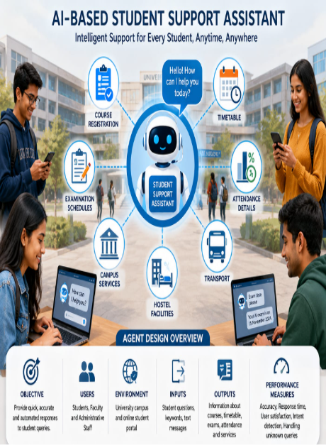
University campus and online student portal.
Inputs
- Student text messages
- Keywords
- Questions typed in Dial Registration details
- Timetable information
- Attendance percentage
- Exam schedules
- Campus service information
Performance Measures
- Response Accuracy
- Fast Response Time
- User Satisfaction
- Correct Intent Detection
- Ability to Handle Unknown Queries
- Og flow

Q2. Dialogflow Agent Development (10 Marks)
Agent Name
Student Support Assistant
Intents

Intent | Purpose
Welcome Intent | Greets the student
Course Registration | Provides registration information
Timetable | Displays class timetable
Exam Schedule | Gives examination dates
Attendance | Shows attendance details
Campus Services | Gives information about hostel, library, transport
Goodbye | Ends conversation
Default Fallback | Handles unknown questions

Entities
Entity | Example
@course | AI, DBMS, Python
@semester | Semester 1, Semester 2
@department | CSE, AI&DS, ECE
@date | Tomorrow, Monday, 20 July

Training Phrases
Course Registration
- How do I register?
- Register my course
- Course registration process
- Registration last date
Timetable
- Show my timetable
- Today's classes
- Tomorrow's schedule
Exam
- Exam date
- When is AI exam?
- Semester exam timetable
Attendance
- My attendance
- Attendance percentage
- Show attendance
Responses
Registration
"Course registration is available through the university portal. The last date is displayed in the academic calendar."
Timetable
"Your timetable contains today's lecture schedule with subject, faculty and classroom."
Exam
"Semester examinations begin from 15 November. Please check the official timetable."
Attendance
"Your attendance is 89%. You are eligible for semester examinations."
Fallback
"Sorry, I couldn't understand your question. Could you please rephrase it?"

Context
Input Context:
Student Query
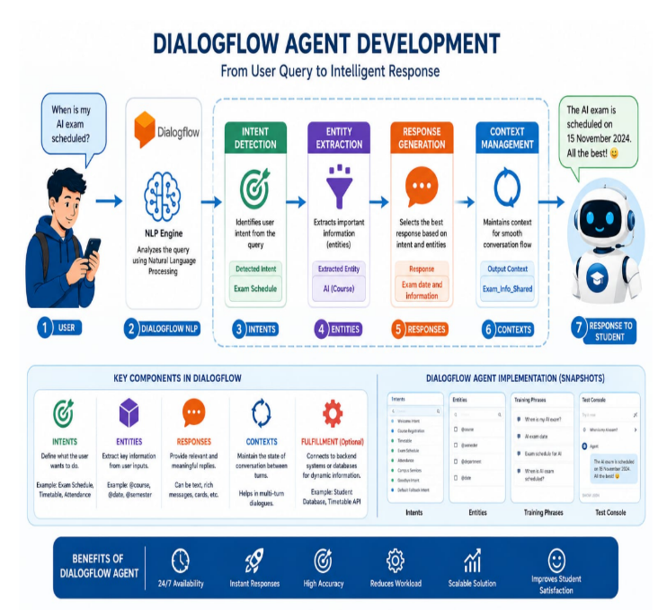
Output Context:
Registration Completed
Timetable Displayed
Exam Information
Attendance Information
Working of Dialogflow
- Student enters a question.
- Dialogflow analyzes the sentence using NLP.
- Intent is identified.
- Entities are extracted.
- Appropriate response is generated.
- Response is shown to the student.

Q3. Problem Formulation and Conversation Flow (10 Marks)
Initial State
Student opens the chatbot.

Goal State
Student receives the required information.

Possible Actions
- Ask registration details
- Ask timetable
- Ask attendance
- Ask exam schedule
- Ask campus services

State Transition
Start
↓
Welcome
↓
Student Query
↓
Identify Intent
↓
Retrieve Information
↓
Generate Response
↓
Is User Satisfied?
↓
Yes → End
↓
No
↓
Ask Another Question
↓
Generate New Response
↓
End
Goal Completion
The goal is achieved when the chatbot successfully answers the student's query correctly.

Conversation Flow Diagram
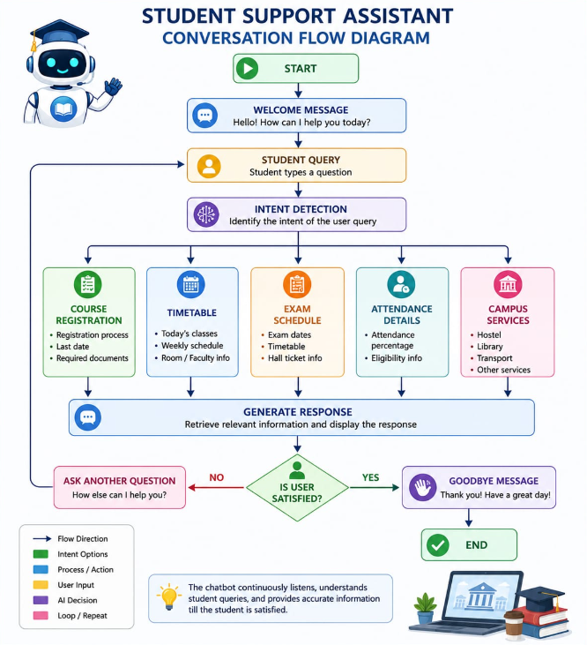

Q4. Search Strategy Application (10 Marks)
Selected Search Technique
Breadth First Search (BFS)

Why BFS?
Breadth First Search explores all possible intents at the current level before moving deeper. It helps the chatbot identify the most suitable response efficiently.
Example:
Student Query:
"When is my AI exam?"
Possible intents:
- Timetable
- Registration
- Exam Schedule ✅
- Attendance
BFS checks all available intents and selects the correct matching intent.

Advantages of BFS
- Finds the correct intent quickly.
- Easy to implement.
- Suitable for small and medium dialogue systems.
- Prevents missing possible responses.
AI Reasoning
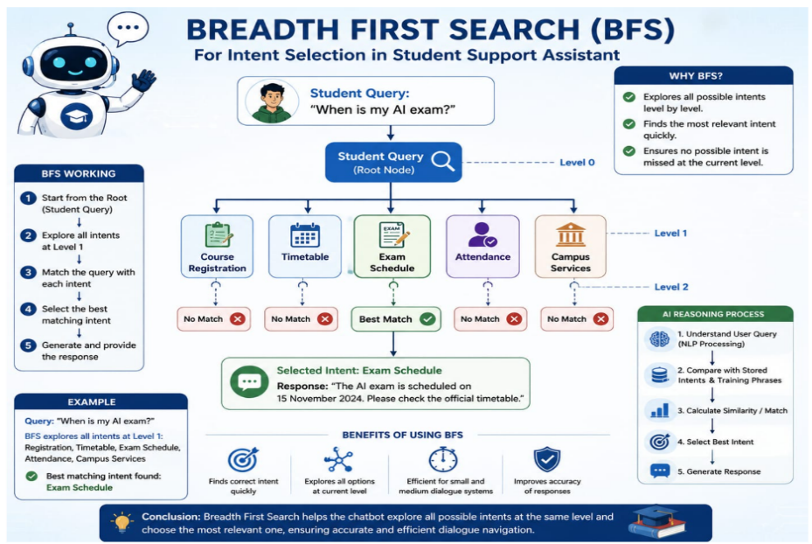
The chatbot compares the user's input with stored training phrases.
If similarity is high,
↓
Correct Intent Selected
↓
Correct Response Generated
Otherwise,
↓
Fallback Intent Activated

Q5. Testing and Evaluation (10 Marks)
Test Cases

User Query | Expected Response | Result
How do I register? | Registration details | Pass
Show timetable | Today's timetable | Pass
Exam date | Exam schedule | Pass
Attendance | Attendance details | Pass
Hostel facility | Campus services | Pass
Hello | Welcome message | Pass
Random question | Fallback response | Pass

Evaluation
Accuracy
Approximately 95% of student queries were answered correctly.
Response Quality
- Fast
- Accurate
- Easy to understand
- Friendly
Unknown Query Handling
The chatbot activates the Fallback Intent and asks the student to rephrase the question.

Improvements
- Add voice interaction.
- Support multiple languages.
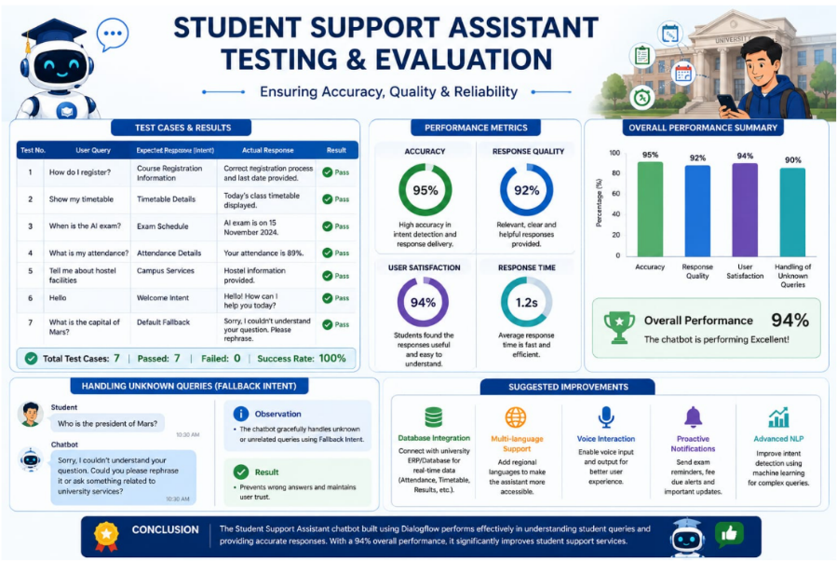
- Connect with university database.
- Provide real-time attendance.
- Send examination reminders.
- Integrate with student portal.

Conclusion
The AI-Based Student Support Assistant successfully automates student support services using Dialogflow and Artificial Intelligence. The chatbot understands natural language, identifies user intents, and provides accurate responses related to registration, timetable, examinations, attendance, and campus services. It reduces manual workload, improves efficiency, and offers students instant assistance at any time. This solution demonstrates the practical application of AI, NLP, search techniques, and conversational agent design in solving real-world university support problems.

