**Prompt**

*You are a Junior UX Designer for the Firefox product at Mozilla. Your boss, Chad, has asked your team to re-design the user experience for the product’s* ***Bookmark*** *feature. You believe this is a waste of time and suggest the team should focus on improving the* ***Tab*** *experience instead. To support your case, you request a data pull from BI to explore bookmark and tab usage from a sample week of surveyed users. Link to raw data found here 🡪* Firefox public usage data.

* **WHO - Describe the users represented in the data (2-3 sentence narrative)**
* Distribution by Age *– Bar Charts w/ Manual Sorting*
* Distribution by Technical Skill *– Bar Charts w/ Field Sorting*
* Distribution by Time on Web, etc. *– Bar Charts w/ Manual Sorting*
* Distribution by Time with Firefox *– Bar Charts w/ Manual Sorting*
* *BONUS: Distribution by Operating System – Bar Charts w/ Manual Sorting*
* **WHAT - Describe the activity of the users represented in the data (2-3 sentence narrative)**
* What of % of users launched a bookmark? - *Calculated Fields IF statement*
* What of % of users used more than 1 tab? - *Calculated Fields IF*
* *BONUS: What % of users created a bookmark? – Calculated Fields IF Statement*
  + **HOW - Describe how often these activities occur in the data (2-3 sentence narrative)**
* What is the distribution of # bookmarks launched? What was the median and avg?
* What is the distribution of # of tabs launched? What was the median and avg?
* BONUS: What is the distribution of # of bookmarks created? What was the median/avg?

**LEGEND**

INSTRUCTOR GUIDED

GROUP PRACTICE

BONUS PRACTICE

**Firefox Usage - Metadata**



Hello Chad,

I suggested doing a deep dive into the engagement with our tab vs. bookmark feature before investing any further resources into either of them. I obtained a sample week of data of 1.8K users from BI. I’ve described who these users are, what they are doing and my recommendation below. Let me know if you have any questions. Link to my Tableau dashboard for your own analysis can be found [here](http://www.michaelvaleri.com).

**Who Are These Users**

The user base from the sample week was comprised of 1,819 users. The users can be best described as:

* Young: 71% of users are under the age of 35, with a majority between 18-25 years old
* Engaged: 65% of users spend more than 4 hours on web per day
* Tech Savvy: 66% of users believe their technical skills are at least 8 out 10
* Loyal: 70% of users have been using Firefox for 5+ Years

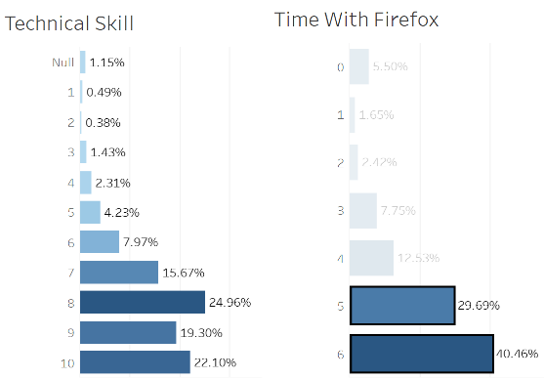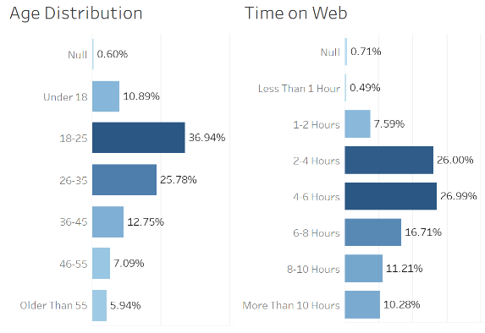

**What are they doing related to Tab and Bookmark usage?**

These users launched a bookmark 40% **more often** than they launched more than 1 tab during browsing.

* *53% launched at least one bookmark (Median = 5 bookmarks)*
* *37% used more than 1 tab during browsing (Median = 2 tabs)*

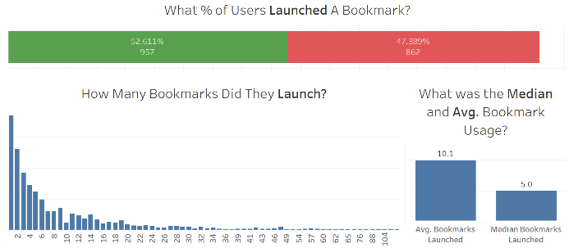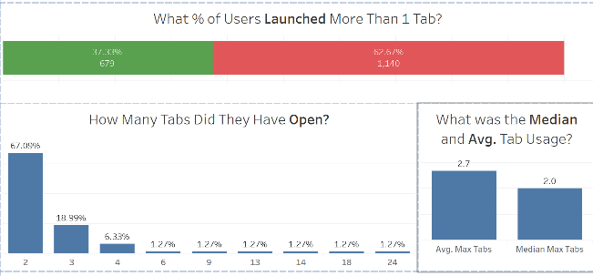

**Summary**

Our young, engaged, tech-savvy and loyal user base is engaging less with our tab feature than they are with our bookmark feature. Based on this finding I believe we should direct our efforts to towards further investigation into the tab UX experience before investing any resources into other features. Some additional questions include

* How does the usage compare between browsing habits?
* How does usage compare between OS (Mac vs. Windows)?