**RV COLLEGE OF ENGINEERING  
Bengaluru-560 059**

**REPORT ON**

**EXPERIENTIAL LEARNING / PROJECT BASED LEARNING**

**ACY 2023-24**

**THEME**

*Energy*

**Title of the Project**

Sustainable Hydrogen Production Using Microbial Electrolysis Systems

**Students Group**

|  |  |  |  |
| --- | --- | --- | --- |
| **SL. No.** | **USN** | **Name** | **Prog.** |
| **1** | **1RV23EC073** | **MV AMARNATH** | **ECE** |
| **2** | **1RV23EC119** | **RIITHUN S** | **ECE** |
| **3** | **1RV23CS213** | **SAKET MARATHE** | **CSE** |
| **4** | **1RV23CS232** | **SHREYAS S** | **CSE** |

**Project Evaluators**

|  |  |
| --- | --- |
| **SL. No.** | **Name of the Evaluators (Enter the Names in Capitals)** |
|  | **DR ABHILASH KRISHNA D G** |
|  | **DR SUBHA S** |
|  | **DR SINDHU D** |
|  | **DR SOURABHA H SRINIVASA** |

R.V. COLLEGE OF ENGINEERING, BENGALURU - 560059 (Autonomous Institution Affiliated to VTU, Belagavi)



###### CERTIFICATE

It is certified that the Experiential learning titled “Sustainable hydrogen production using microbial electrolysis systems” is carried out by MV Amarnath, Riithun S, Saket Marathe and Shreyas S who are bonafide students of R.V College of Engineering, Bengaluru, during the Second semester, in the year 2023- 2024. It is also certified that all corrections/suggestions indicated for the Internal Assessment have been incorporated in the report. The report has been approved as it satisfies the academic requirements in respect of Experiential learning.



Signature of Staff In-charge

Signature of Head of the Department

**Table of Contents**

|  |  |  |  |  |
| --- | --- | --- | --- | --- |
| **Sl.No** | **Title** | | **Page No** | |
| 1. | Introduction | 4 | |
| 2. | Problem Definition | 5 | |
| 3. | Objectives | 7 | |
| 4. | Methodology | 8 | |
| 5. | Project Execution | 13 | |
| 6. | Tools and Techniques Used | 27 | |
| 7. | Partial Results | 29 | |
| 8. | Results and Discussions | 31 | |
| 9. | Prototype (Hardware/Software) | 34 | |
| 10. | Conclusion | 37 | |
| 11. | Visuals | 39 | |

**1.Introduction**

**Introduction:** In an era where sustainable energy solutions are paramount, the intersection

of microbial biotechnology and renewable energy sources holds immense promise. Among

the innovative technologies emerging from this intersection is the concept of

Microbial Electrolysis Systems (MES) powered by solar energy. This groundbreaking

approach leverages the inherent metabolic capabilities of microorganisms to drive the electrolysis of water, yielding clean and renewable hydrogen gas. Our project, "Microbial Electrolysis Using Solar Energy," embodies this visionary concept, aiming to harness the power of nature and technology to pave the way towards a greener and more sustainable future.

**History:** The roots of our project trace back to the pioneering research efforts in microbial electrolysis and solar energy utilization. The concept of microbial electrolysis dates back to the early 20th century, with the discovery of microbial fuel cells and their potential for electricity generation from organic matter. Building upon this foundation, researchers began exploring the possibility of using microorganisms to drive the electrolysis of water, with hydrogen production as a key objective.

The breakthrough in this technology came in 2005 when Bruce E. Logan and his team at Pennsylvania State University demonstrated that applying a small external voltage to a system with electrochemically active bacteria could efficiently produce hydrogen gas. This pioneering work laid the foundation for subsequent research and development in the field of MECs.

The integration of solar energy into microbial electrolysis systems represents a significant milestone in the evolution of renewable energy technologies. Solar energy, abundant and inexhaustible, provides an ideal power source for driving the microbial metabolism responsible for hydrogen production. The synergy between solar energy and microbial activity opens up new possibilities for sustainable hydrogen production, with minimal environmental impact and carbon footprint.

Over the years, advancements in microbial engineering, materials science, and renewable energy technologies have propelled the development of solar-powered microbial electrolysis systems. From laboratory-scale experiments to pilot-scale demonstrations, researchers have made significant strides in optimizing the efficiency, stability, and scalability of these systems. Today, our project builds upon this rich legacy of scientific inquiry and technological innovation, pushing the boundaries of what is possible in renewable energy research.

As we embark on this journey of discovery and innovation, we pay homage to the trailblazers and visionaries who have paved the way before us. Inspired by their legacy and driven by a shared commitment to sustainability, we strive to make a meaningful contribution to the transition towards a cleaner, greener, and more prosperous world.

**2.Problem Definition**

#### 2.1 Problem Statement

#### Sustainable Hydrogen Production Using Microbial Electrolysis Systems

#### The demand for sustainable and renewable energy sources is escalating globally due to the finite nature of fossil fuels and the environmental impact of their use. Hydrogen is considered a promising clean energy carrier, with applications ranging from fuel cells to industrial processes. However, traditional hydrogen production methods, such as steam methane reforming and conventional water electrolysis, have significant drawbacks, including high energy consumption, greenhouse gas emissions, and reliance on non-renewable resources. This project aims to address these issues by developing a cost-effective and environmentally friendly microbial electrolysis cell (MEC) system using Escherichia coli as the exoelectrogenic bacteria. The system will utilize organic waste materials as a substrate, offering dual benefits of waste treatment and hydrogen production. The research focuses on optimizing the MEC setup to maximize hydrogen yield, thereby providing a sustainable alternative to conventional hydrogen production methods.

#### 2.2 Background Information(Literature Review)

#### 

#### 1.Historical Context: Hydrogen production has traditionally been dominated by steam methane reforming (SMR), which accounts for the majority of global hydrogen production. Despite its efficiency, SMR has significant environmental drawbacks, including the release of large amounts of carbon dioxide (CO2) . Water electrolysis, another method, involves splitting water into hydrogen and oxygen using electrical energy, but it is highly energy-intensive and often relies on non-renewable electricity sources .

#### 2.Current Understanding: Microbial electrolysis cells (MECs) represent an innovative approach to hydrogen production. MECs utilize the metabolic activities of exoelectrogenic bacteria to generate electrical currents, which drive the electrolysis of water at lower voltages compared to traditional methods . This process can occur under anaerobic conditions and use various organic substrates, including wastewater and organic waste, as the fuel source .

#### 3.Previous Attempts and Challenges: Previous research has demonstrated the potential of MECs to produce hydrogen efficiently. However, challenges remain in scaling up the technology and optimizing the system for continuous and stable operation. Issues such as biofilm formation on electrodes, efficient electron transfer, and the management of byproducts are critical areas of ongoing research . Additionally, the cost and durability of materials used in MECs, such as electrodes and membranes, are significant factors influencing the feasibility of widespread adoption .

**3.Objectives**

**3.1 Primary Objectives**:

* Develop an Efficient MEC System: Design and construct a microbial electrolysis cell (MEC) that uses Escherichia coli as the exoelectrogenic bacteria. Optimize the MEC setup for maximum hydrogen production efficiency.
* Utilize Organic Waste as Substrate: Identify and prepare suitable organic waste materials to be used as the substrate in the anode compartment. Evaluate the effectiveness of different substrates in promoting hydrogen production.
* Evaluate Hydrogen Production: Measure the amount of hydrogen gas produced under various operational conditions. Determine the optimal conditions for maximum hydrogen yield, including voltage, pH, and temperature.
* Analyze Biofilm Formation and Stability: Investigate the formation and stability of biofilms on the anode electrode. Assess the impact of biofilm characteristics on the efficiency of electron transfer and hydrogen production.
* Cost-Effectiveness and Scalability: Analyze the cost-effectiveness of the MEC system compared to traditional hydrogen production methods. Evaluate the scalability of the MEC system for potential industrial applications.

**3.2 Secondary Objectives:**

* Environmental Impact Assessment: Conduct a life cycle assessment (LCA) to evaluate the environmental impact of the MEC system compared to traditional hydrogen production methods.
* Wastewater Treatment: Explore the potential of the MEC system to simultaneously treat wastewater while producing hydrogen. Analyze the quality of treated effluent and its compliance with environmental standards.
* Microbial Diversity and Performance: Investigate the diversity of microbial communities in the MEC and their impact on system performance. Identify other potential exoelectrogenic bacteria that could enhance hydrogen production.
* Integration with Renewable Energy Sources: Assess the feasibility of integrating the MEC system with renewable energy sources such as solar or wind power to create a fully sustainable hydrogen production process.
* Public Awareness and Education: Develop educational materials and conduct outreach activities to raise public awareness about the benefits of MEC technology and sustainable hydrogen production.

#### 4.Methodology

* 1. **Overall Approach and Strategy**

The project aims to develop and optimize a microbial electrolysis cell (MEC) using Escherichia coli to efficiently produce hydrogen. The strategy involves:

* System Design: Creating a dual-compartment MEC setup with anode and cathode compartments connected by a salt bridge.
* Microbial Cultivation: Growing and maintaining E. coli in optimal conditions to maximize electron production.
* Electrochemical Optimization: Applying an external voltage to enhance hydrogen production and using a multimeter to monitor microbial-generated voltage.
* Data Collection and Analysis: Measuring hydrogen output, analyzing biofilm formation, and evaluating system performance under various conditions.

**Theoretical Frameworks and Models**

* Microbial Electrolysis Theory: Understanding the microbial metabolism that drives electron transfer from organic substrates to the anode.
* Electrochemical Principles: Applying the Nernst equation to predict electrode potentials and optimize external voltage for hydrogen production.
* Biofilm Dynamics: Using models of biofilm growth and electron transfer to optimize anode design and microbial activity.

Flowchart

Research Work

System Setup

Microbial Preparation

Electrochemical Configuration

Operation and Monitoring

Analysis and Optimization

**Methodology**

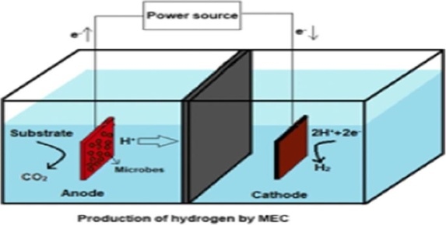

Procedure

* **Research Work**:

1. Go through various research articles

2. Go through already built MEC’s

3. Document the research work

* **System Setup**:

1. Design MEC compartments

2. Prepare graphite electrodes

3. Assemble salt bridge.

* **Microbial Preparation**:

1. Culture E. coli

2. Inoculate anode compartment.

* **Electrochemical Configuration**:

1. Connect external voltage

2. Install multimeter.

* **Operation and Monitoring**:

1. Start MEC operation

2. Collect data.

* **Analysis and Optimization**:

1. Analyze results

2. Adjust parameters for optimization

**Step-by-Step Procedures**

1.Design and Construction:

* Three days:
* Design dual-compartment MEC setup.
* Source materials: graphite rods, PVC pipe, cotton rope, NaCl, phosphate buffers, gelatin.
* Construct the anode and cathode compartments.

2.Electrode Preparation:

* Two days:
* Cut graphite rods into equal pieces.
* Prepare gelatin solution and coat the anode.
* Assemble salt bridge using cotton rope soaked in NaCl solution inside perforated PVC pipe.

3.Microbial Cultivation:

* Five days:
* Grow E. coli in nutrient-rich medium.
* Prepare inoculum for anode compartment.

4.System Assembly:

* Two days:
* Install electrodes in respective compartments.
* Fill compartments with appropriate electrolytes (phosphate buffer in anode, NaCl solution in cathode).
* Connect compartments with salt bridge.
* Set up external voltage source and multimeter.

5.Initial Operation:

* One day:
* Start MEC operation by inoculating the anode compartment with E. coli.
* Apply 1-volt external voltage.

6.Data Collection:

* Two days:
* Measure hydrogen production using water displacement.
* Record voltage, current, and pH changes.
* Observe biofilm formation on the anode.

7.Analysis and Optimization:

* Three days:
* Analyze hydrogen yield and system efficiency.
* Adjust operational parameters (voltage, substrate concentration, pH) for optimization.
* Repeat experiments to confirm improvements.

8.Documentation and Reporting:

* Four days:
* Compile data and analyze results.
* Document findings in a detailed report.
* Prepare for presentation or publication.

**Timelines and Milestones**

* Five days: System design and material procurement.
* Seven days: Electrode preparation and microbial cultivation.
* Three days: System assembly and initial operation.
* Two days: Data collection and monitoring.
* Three days: Data analysis and optimization.
* Four days: Documentation and reporting.

**5.Project Execution**

**5.1 Planning and Design:**

**Initial Planning:**

* **Brainstorming Sessions**:
  + **Ideas Generated**: Materials to be used , potential substrates for microbial growth, types of microorganisms to use, and possible designs for the electrolysis cell, way to store or detect hydrogen and maintain the pH.
  + **Decision-Making**: E- coli, Pseudomonas aeruginosa were planned to use because of the ease of availability in the campus, Gas sensors and pH sensors were planned to be used for hydrogen detection and maintaining conditions for effective working of the microbes and Buffer solution to maintain the pH.

**Research and Literature Review:**

* **Background Research**:

**Fundamental Principles**: Microbial electrolysis cells (MECs) are bioelectrochemical systems that use microorganisms to catalyze the production of hydrogen or other valuable chemicals from organic substrates. Unlike conventional electrolysis that requires significant external energy input, MECs can achieve this at a lower energy cost by leveraging the metabolic activities of microorganisms.

#### ****Electrochemical Reactions****

MECs operate based on electrochemical reactions facilitated by microorganisms. The process involves two main electrodes: the anode and the cathode.

**Anode Reaction:** At the anode, microorganisms, known as exoelectrogenic bacteria, oxidize organic substrates (such as acetate, glucose, or wastewater) to produce electrons, protons (H⁺), and carbon dioxide (CO₂). The general reaction at the anode can be represented as: Organic matter + H2O → CO2 + H+ + e-

**Cathode Reaction:** At the cathode, the protons and electrons produced at the anode combine to form hydrogen gas (H₂) or other chemical products, depending on the specific MEC setup. The general reaction at the cathode for hydrogen production is: H+ + e-→ H2

#### 3. ****Electron Transport****

Microorganisms at the anode oxidize the organic substrate, releasing electrons and protons. These electrons are transferred to the anode, either directly through microbial nanowires or via mediators. The electrons then flow through an external circuit to the cathode, creating an electric current.

#### ****Proton Transport****

Protons generated at the anode move through the electrolyte (often a proton exchange membrane or a salt bridge) to the cathode. At the cathode, these protons combine with the electrons arriving from the external circuit to produce hydrogen gas.

**Types of MECs**: Single-chamber and double-chamber cells

1. **Pioneering Research and Advances**: **Bruce E. Logan**
   * **Contribution**: Bruce E. Logan is one of the foremost researchers in the field of bio electrochemical systems, including microbial fuel cells (MFCs) and MECs. His work has been instrumental in advancing the understanding and optimization of MEC technology.
2. **Korneel Rabaey**
   * **Contribution**: Korneel Rabaey has made significant contributions to the field of environmental biotechnology, particularly in the development of microbial fuel cells and MECs. His research focuses on the microbial and electrochemical aspects of these systems.
3. **Largus T. Angenent**
   * **Contribution**: Largus T. Angenent has contributed to the development of MECs and their application in wastewater treatment and bioenergy production. His research includes optimizing the microbial communities and operational parameters of MECs.
4. **Hong Liu**
   * **Contribution**: Hong Liu's research has focused on the design and optimization of bioelectrochemical systems, including MECs. She has worked on improving the efficiency and scalability of these systems for practical applications.

#### Landmark Studies

1. **Logan, B. E., et al. (2008). "Microbial Electrolysis Cells for High Yield Hydrogen Gas Production from Organic Matter." Environmental Science & Technology, 42(23), 8630-8640.**
   * **Summary**: This study demonstrated the potential of MECs for high-yield hydrogen gas production from various organic substrates. It provided a comprehensive analysis of the factors influencing MEC performance and efficiency.
2. **Liu, H., Grot, S., & Logan, B. E. (2005). "Electrochemically Assisted Microbial Production of Hydrogen from Acetate." Environmental Science & Technology, 39(11), 4317-4320.**
   * **Summary**: This landmark paper introduced the concept of electrochemically assisted microbial hydrogen production, laying the foundation for subsequent MEC research. It highlighted the role of exoelectrogenic bacteria in driving the electrolysis process.
3. **Cheng, S., & Logan, B. E. (2007). "Sustainable and Efficient Biohydrogen Production via Electrogenesis." Proceedings of the National Academy of Sciences, 104(47), 18871-18873.**
   * **Summary**: This study explored the sustainability and efficiency of biohydrogen production in MECs. It demonstrated that MECs could produce hydrogen at a lower energy cost compared to traditional methods, emphasizing their potential for sustainable energy generation.
4. **Rabaey, K., Clauwaert, P., Aelterman, P., & Verstraete, W. (2005). "Tubular Microbial Fuel Cells for Efficient Electricity Generation." Environmental Science & Technology, 39(20), 8077-8082.**
   * **Summary**: Although focused on microbial fuel cells, this study by Rabaey et al. provided important insights into the design and optimization of bioelectrochemical systems, which are directly applicable to MECs. It highlighted the importance of electrode material and configuration in system performance.
5. **Call, D., & Logan, B. E. (2008). "Hydrogen Production in a Single Chamber Microbial Electrolysis Cell Lacking a Membrane." Environmental Science & Technology, 42(9), 3401-3406.**
   * **Summary**: This paper demonstrated the feasibility of single-chamber MECs for hydrogen production, which simplifies the design and reduces the cost of the system. It showed that MECs could operate efficiently without a membrane, expanding their practical applicability.

#### Microorganisms:

#### ****Geobacter sulfurreducens****

* **Characteristics**:
  + Known for its ability to transfer electrons directly to the anode through conductive pili (nanowires).
  + Capable of oxidizing organic compounds completely to CO₂, releasing electrons in the process.
* **Reason for Use**:
  + High electron transfer efficiency.
  + Robust biofilm formation on electrode surfaces.
  + Tolerance to different environmental conditions.

#### 2. ****Shewanella oneidensis****

* **Characteristics**:
  + Uses a range of organic substrates and metals as electron acceptors.
  + Employs both direct and mediated electron transfer mechanisms.
* **Reason for Use**:
  + Versatility in electron acceptor utilization.
  + Ability to reduce a variety of substrates, enhancing system flexibility.

#### 3. ****Desulfuromonas acetoxidans****

* **Characteristics**:
  + Utilizes acetate and other organic acids as electron donors.
  + Reduces sulfur compounds in addition to transferring electrons to electrodes.
* **Reason for Use**:
  + Effective acetate oxidation.
  + Contributes to the stability and efficiency of the microbial community in MECs.

#### 4. ****Clostridium butyricum****

* **Characteristics**:
  + A fermentative bacterium that produces hydrogen as a metabolic byproduct.
  + Can degrade complex organic substrates into simpler compounds.
* **Reason for Use**:
  + Enhances hydrogen production in mixed-culture systems.
  + Complements the metabolic activities of electroactive bacteria.

#### 5. ****Escherichia coli (Engineered Strains)****

* **Characteristics**:
  + Genetic modifications enable efficient electron transfer and enhanced hydrogen production.
  + Well-characterized and easily manipulated genetically.
* **Reason for Use**:
  + Genetic engineering allows for optimization of metabolic pathways.
  + Can be tailored to specific operational needs of MECs.

**Electrode Materials**: The selection of electrode materials in microbial electrolysis cells (MECs) is crucial for their efficiency, stability, and cost-effectiveness. Different materials are used for the anode and cathode to optimize the electrochemical reactions facilitated by microorganisms. Below are commonly used materials for the anode and cathode in MECs:

#### Anode Materials

The anode is where microorganisms oxidize organic substrates, releasing electrons that are transferred to the electrode.

1. **Graphite Felt and Carbon Cloth**
   * **Properties**: High surface area, good conductivity, biocompatibility.
   * **Advantages**: Provides a large surface area for microbial colonization and electron transfer. Durable and cost-effective.
   * **Disadvantages**: Can degrade over time, potentially releasing particles into the system.
2. **Carbon Paper**
   * **Properties**: High conductivity, flexible, lightweight.
   * **Advantages**: Easy to handle and modify. Provides good electrical contact with microbial biofilms.
   * **Disadvantages**: Limited surface area compared to felt and cloth. Less robust over long-term use.
3. **Graphite Rods**
   * **Properties**: High mechanical strength, good conductivity.
   * **Advantages**: Durable and can be easily shaped. Provides stable long-term performance.
   * **Disadvantages**: Lower surface area for microbial growth compared to felt or cloth.
4. **Activated Carbon**
   * **Properties**: Extremely high surface area, high porosity.
   * **Advantages**: Enhances microbial colonization and electron transfer due to high surface area.
   * **Disadvantages**: Can be expensive and may degrade under certain conditions.
5. **Carbon Nanotubes (CNTs)**
   * **Properties**: High conductivity, large surface area, excellent mechanical properties.
   * **Advantages**: Enhance electron transfer efficiency due to superior electrical properties.
   * **Disadvantages**: High cost and potential environmental impact during production and disposal.
6. **Graphene**
   * **Properties**: Exceptional conductivity, high surface area, and mechanical strength.
   * **Advantages**: Superior performance in terms of electron transfer and microbial attachment.
   * **Disadvantages**: High production cost and potential scalability issues.

#### Cathode Materials

The cathode is where protons combine with electrons to form hydrogen gas or other reduction products.

1. **Platinum (Pt)**
   * **Properties**: Excellent catalytic activity, high conductivity.
   * **Advantages**: Highly efficient in catalyzing hydrogen evolution reactions.
   * **Disadvantages**: Very expensive and not sustainable for large-scale applications.
2. **Stainless Steel**
   * **Properties**: Good conductivity, corrosion-resistant, cost-effective.
   * **Advantages**: Durable and widely available. Cost-effective alternative to platinum.
   * **Disadvantages**: Lower catalytic activity compared to platinum, but can be improved with surface treatments.
3. **Nickel-Based Materials**
   * **Properties**: Good catalytic activity for hydrogen evolution, cost-effective.
   * **Advantages**: Offers a balance between cost and performance. Often used in combination with other materials.
   * **Disadvantages**: Susceptible to corrosion in certain conditions.
4. **Graphite**
   * **Properties**: High conductivity, inert.
   * **Advantages**: Cost-effective and stable under operational conditions.
   * **Disadvantages**: Lower catalytic activity for hydrogen evolution compared to metal catalysts.
5. **Molybdenum Disulfide (MoS₂)**
   * **Properties**: Good catalytic activity, high surface area.
   * **Advantages**: Promising alternative to platinum for hydrogen evolution. More affordable and scalable.
   * **Disadvantages**: Still under research for optimal performance in MECs.
6. **Carbon-Based Materials (e.g., Carbon Cloth, Carbon Felt)**
   * **Properties**: High surface area, good conductivity, customizable.
   * **Advantages**: Versatile and can be treated or modified to enhance catalytic activity.
   * **Disadvantages**: May require additional treatment to achieve desired catalytic performance

#### Operational Parameters:

#### ****H (Acidity/Alkalinity)****

* **Effect**: pH significantly influences the activity and growth of microorganisms in MECs. Different microorganisms have optimal pH ranges for metabolic activity.
* **Optimal Range**: Typically, MECs operate within a pH range of 6.5 to 8.5.
* **Impact on Performance**:
  + **Low pH (Acidic Conditions)**: Can inhibit microbial activity and reduce electron transfer efficiency.
  + **High pH (Alkaline Conditions)**: May affect electrode stability and biofilm formation.

#### 2. ****Temperature****

* **Effect**: Temperature affects microbial growth rates, metabolic activity, and electrochemical reactions in MECs.
* **Optimal Range**: Generally, MECs operate optimally at temperatures between 20°C to 40°C, depending on the specific microorganisms used.
* **Impact on Performance**:
  + **Low Temperatures**: Decrease microbial activity and slow down reaction rates.
  + **High Temperatures**: Can enhance microbial metabolism but may also reduce system stability and increase maintenance requirements.

#### 3. ****Applied Voltage****

* **Effect**: Applied voltage provides the driving force for electrochemical reactions within the MEC.
* **Optimal Range**: Typically, MECs operate at applied voltages ranging from 0.4V to 1.0V, depending on cell configuration and substrate.
* **Impact on Performance**:
  + **Low Voltage**: Slower electron transfer rates and reduced hydrogen production.
  + **High Voltage**: Increases energy input and potential for electrolysis, affecting overall energy efficiency.

#### 4. ****Substrate Concentration and Type****

* **Effect**: The type and concentration of organic substrates (e.g., acetate, glucose) directly influence microbial activity and hydrogen production rates.
* **Optimal Range**: Substrate concentrations vary widely depending on microbial species and operational goals.
* **Impact on Performance**:
  + **Low Substrate Concentration**: Limits microbial growth and hydrogen production rates.
  + **High Substrate Concentration**: Can lead to substrate inhibition or overload, affecting microbial performance and system stability.

#### 5. ****Electrode Material and Surface Area****

* **Effect**: The choice of electrode material (e.g., graphite, carbon cloth) and its surface area affect electron transfer efficiency and biofilm formation.
* **Optimal Characteristics**: High surface area electrodes promote microbial attachment and facilitate efficient electron transfer.
* **Impact on Performance**:
  + **Material Choice**: Influences durability, cost, and catalytic properties.
  + **Surface Area**: Larger surface area enhances microbial colonization and overall MEC performance.

#### 6. ****Hydraulic Retention Time (HRT)****

* **Effect**: HRT determines the contact time between microorganisms and substrates within the MEC, affecting reaction rates and substrate utilization efficiency.
* **Optimal Range**: HRT can vary widely depending on system design and operational goals, typically ranging from hours to days.
* **Impact on Performance**:
  + **Short HRT**: Limits substrate utilization and microbial growth.
  + **Long HRT**: Enhances substrate conversion efficiency but increases system footprint and operational costs.

#### 7. ****Electrolyte Composition****

* **Effect**: The composition of the electrolyte solution affects pH buffering capacity, conductivity, and ionic strength within the MEC.
* **Optimal Characteristics**: Balanced electrolyte composition supports stable electrochemical reactions and microbial activity.
* **Impact on Performance**:
  + **Ionic Strength**: Influences ion transport and electrochemical efficiency.
  + **pH Buffering**: Maintains stable pH conditions crucial for microbial performance.

**Applications and Benefits:**

#### Energy Production

**Sustainable Hydrogen Production:**

* **Process**: MECs use microorganisms to catalyze the electrolysis of organic matter, producing hydrogen gas.
* **Benefit**: Offers a renewable and sustainable pathway for hydrogen production, which can be used as a clean fuel for transportation, industry, and energy storage.
* **Advantages**: Utilizes organic waste as a feedstock, potentially converting waste streams into valuable energy resources.

#### 2. Waste Treatment

**Wastewater Treatment:**

* **Process**: MECs facilitate the microbial degradation of organic pollutants in wastewater while simultaneously producing hydrogen or other useful chemicals.
* **Benefit**: Improves water quality by reducing organic contaminants, nitrogen, and phosphorus levels.
* **Advantages**: Offers a cost-effective and energy-efficient alternative to traditional wastewater treatment methods, potentially lowering operational costs and energy consumption.

#### 3. Economic and Environmental Impact

**Economic Benefits:**

* **Resource Recovery**: MECs enable the recovery of valuable products such as hydrogen, which can be monetized or used onsite to offset energy costs.
* **Operational Savings**: Lower energy consumption and reduced chemical usage compared to conventional treatment processes.
* **Job Creation**: Supports the development of a bioenergy sector and green technology industries, creating new job opportunities.

**Environmental Impact:**

* **Greenhouse Gas Reduction**: Produces hydrogen without greenhouse gas emissions, contributing to climate change mitigation efforts.
* **Pollution Prevention**: Reduces the release of pollutants into water bodies, improving ecosystem health.
* **Resource Conservation**: Promotes the reuse and recycling of organic waste materials, supporting a circular economy approach.

**Challenges and Limitations:**

### Technical Challenges in the Development and Scaling up of Microbial Electrolysis Cells (MECs)

#### 1. Biofouling

* **Challenge**: Biofouling refers to the accumulation of microbial biofilms and organic matter on electrode surfaces, which can reduce electrode performance and efficiency over time.
* **Impact**: Decreased electron transfer efficiency, increased maintenance requirements, and potential for system instability.
* **Mitigation Strategies**: Implementing periodic cleaning protocols, optimizing electrode materials to resist biofilm formation, and exploring antifouling coatings or treatments.

#### 2. Electrode Degradation

* **Challenge**: Electrode materials can degrade over time due to chemical reactions, mechanical wear, and biofilm accumulation, leading to reduced lifespan and performance.
* **Impact**: Increased operating costs, decreased system efficiency, and potential for contamination of the electrolyte.
* **Mitigation Strategies**: Choosing durable electrode materials, optimizing operational parameters to minimize degradation rates, and exploring advanced electrode coatings or alloys.

#### 3. Energy Losses

* **Challenge**: MECs require energy input to drive electrochemical reactions, which can affect overall energy efficiency and economic viability.
* **Impact**: Higher operational costs, reduced competitiveness with other renewable
* energy technologies.
* **Mitigation Strategies**: Optimizing system design and operational parameters to maximize energy conversion efficiency, integrating MECs with renewable energy sources, and exploring novel electrode materials with enhanced catalytic properties.

### Economic Feasibility of Microbial Electrolysis Cells (MECs)

#### 1. Cost of Materials

* **Challenge**: The cost of electrode materials (e.g., platinum for cathodes) and other components can be significant, impacting the overall capital and operational expenses
* of MEC systems.
* **Impact**: Higher initial investment costs, challenges in cost-effectiveness compared to conventional technologies.
* **Strategies**: Researching alternative electrode materials, optimizing manufacturing processes to reduce costs, and scaling up production to achieve economies of scale.

#### 2. Financial Viability Compared to Other Renewable Energy Technologies

* **Challenge**: MECs face competition from established renewable energy technologies (e.g., solar, wind) that have lower costs and higher efficiency in some cases.
* **Impact**: Limited market penetration, challenges in attracting investment and funding.
* **Strategies**: Demonstrating unique advantages of MECs (e.g., bioenergy production from waste streams), conducting life cycle cost analyses, and promoting policy support for bioelectrochemical technologies.

### Research Gaps in Microbial Electrolysis Cells (MECs) and Project Aims

#### Research Gaps

1. **Microbial Community Dynamics**: Understanding and optimizing microbial consortia for enhanced electron transfer and stability in MECs.
2. **Long-Term Stability**: Investigating factors contributing to electrode degradation and developing strategies for prolonged system lifespan.
3. **Scalability and Integration**: Addressing challenges in scaling up MECs from laboratory-scale prototypes to commercial applications, including system design, reliability, and cost-effectiveness.

#### Project Aims

* **Addressing Microbial Community Dynamics**: Investigating the composition and dynamics of microbial communities in MECs using advanced molecular techniques. This aims to identify key microorganisms and optimize their interactions for improved system performance.
* **Enhancing Long-Term Stability**: Developing novel electrode materials and surface treatments to mitigate biofouling and degradation, thereby extending the operational lifespan of MECs.
* **Scalability and Integration**: Designing and testing scalable MEC prototypes that integrate seamlessly with existing wastewater treatment infrastructure. This includes evaluating performance under realistic operational conditions and conducting techno-economic assessments to enhance commercial viability.

**Design Drafts:**

* **Initial Sketches and Drafts**:

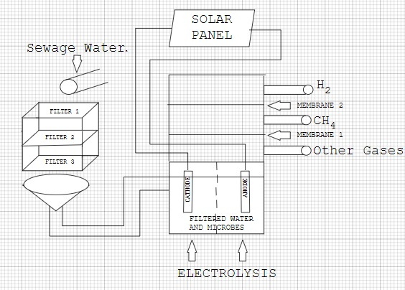

#### 5.2 Implementation

**Development and Construction:**

**Materials Acquisition**:

**pH Sensors and Gas Sensors**

pH sensors and gas sensors are integral components in the MEC setup, crucial for real-time monitoring and control of key parameters. (Bought it from online retailer)

#### Arduino and LCD Display

An Arduino microcontroller paired with an LCD display provides a robust platform for data acquisition and real-time display of monitored parameters. (Bought it from online retailer).

#### Anode and Cathode Containers

Dedicated anode and cathode containers house the electrodes essential for electrochemical reactions within the MEC. These containers are designed to maintain separation between the anode and cathode compartments, optimizing reaction efficiency and electrode stability.

#### PVC Pipe for Salt Bridge

A PVC pipe serves as a salt bridge, facilitating ion transport between the anode and cathode compartments while preventing electrolyte mixing.

#### Microbes and Chemicals

Microbial cultures and chemicals sourced from a biotech lab provide the biological catalysts and necessary nutrients for sustaining microbial growth and metabolic activity within the MEC. These components support the microbial community responsible for catalyzing electrochemical reactions and enhancing overall system performance.(FROM BIOTECH LAB)

### Integration and Functionality

The integration of pH and gas sensors with the Arduino and LCD display enables real-time data monitoring and system control.

* **Construction Process**: **System Setup**:

1. Design MEC compartments

2. Prepare graphite electrodes

3. Assemble salt bridge.

* **Microbial Preparation**:

1. Culture E. coli

2. Inoculate anode compartment.

* **Electrochemical Configuration**:

1. Connect external voltage

2. Install multimeter.

**Testing and Iteration:** Start MEC operation

**Collect data of hydrogen produced and variation of pH and hydrogen produced over time.**

**Execution of Planned Steps:**

**Setup**:

**Assembly**: Connected graphite electors to the container and provided external source. Connected the gas sensor to cathode and pH sensor to anode. All the information were displayed on LCD Display.

* **Inoculation**: Grow E. coli in nutrient-rich medium.
* Prepare inoculum for anode compartment.

**Substrate Feeding**: Substrate contained acetate, glucose solution, sucrose solutions (organic matter),used Gelation at anode for bio-film formation, used KI as electrolyte, used Phosphate buffer to maintain pH.

**Monitoring and Data Collection:**

**Operational Monitoring**: Used MQ-8 Gas sensor to detect the concentration of H2. **Used pH sensor to detect the pH of the analyte. Used LCD Display to show pH and Gas values.**

**Optimization:**

* **Parameter Optimization**: Since the electrode distance was high because of salt bridge voltage was increased ,to provide appropriate voltage and maintained a pH of 7 to 7.5 .

**6. Tools and Techniques used:**

#### 6.1 Tools Used

1. **Power Tools:**
   * **Drill**: Used for creating holes in containers for electrode insertion and assembly.
   * **Screwdriver**: Essential for securing components and assembling the MEC setup.
2. **Hand Tools:**
   * **Pliers and Wire Cutters**: Used for handling and cutting electrodes, wires, and connectors.
   * **Scissors and Utility Knife**: For cutting and preparing materials such as PVC pipes and insulating materials.
3. **Measuring Instruments:**
   * **Ruler and Tape Measure**: Used for precise measurement and layout of electrode placements and distances.
   * **Multimeter**: Essential for checking electrical continuity, voltage levels, and resistance in circuit connections.
4. **Assembly Equipment:**
   * **Clamps and Vises**: Hold components securely during assembly and electrode installation.
   * **Heat Gun** Used for heat-shrinking insulation around electrical connections and ensuring waterproof seals.
   * **Hot glue gun: Used to hold components in place or stick the components.**

#### 6.2 Techniques Employed

1. **Electrode Preparation:**
   * **Electrode Fabrication**: Cutting and shaping electrodes (to fit specific container dimensions.
   * **Surface Treatment**: Preparing electrode surfaces coating to enhance catalytic activity and biofilm adhesion(Gelatin layer).
2. **Container Assembly:**
   * **Anode and Cathode Compartments**: Constructing separate compartments using containers to house anode and cathode materials.
   * **Sealing and Insulation**: Ensuring watertight seals and electrical insulation using appropriate adhesives, sealants, and insulating materials.
3. **Electrical Connections:**
   * **Wiring and Connections**: Properly connecting electrodes to electrical leads and ensuring secure connections to the external circuit.
   * **Testing**: Conducting continuity and voltage tests to verify electrical integrity and functionality of the MEC system.
4. **Integration of Monitoring Equipment:**
   * **Sensor Installation**: Mounting and integrating pH sensors, gas sensors, and for real-time monitoring.
   * **Arduino and Display Setup**: Programming and configuring Arduino microcontrollers for data acquisition and visualization on LCD displays.
5. **Safety Protocols:**
   * **Personal Protective Equipment (PPE)**: Wearing gloves, safety glasses, and lab coats to ensure safety during handling of chemicals and electrical components.
   * **Ventilation and Containment**: Working in well-ventilated areas or fume hoods when handling chemicals to minimize exposure risks.

**7.Partial Results:**

**7.1 Initial readings**

• **Hydrogen Production Efficiency**

* **Gas Production Rates**: Initial experiments demonstrated consistent hydrogen gas production rates
* (upto 300ppm), correlating with substrate concentrations and applied voltages.
* **Electrochemical Efficiency**: Analysis of voltage-current characteristics indicated stable and efficient electrochemical reactions, suggesting potential for scalable hydrogen production.

•  **Biofilm Formation**

* **Biofilm Development**: Observations of biofilm formation on electrode surfaces indicated microbial colonization and activity, crucial for electron transfer processes.

• **pH and Temperature Control**

* **pH Stability**: The use of phosphate buffers effectively maintained stable pH conditions within optimal ranges (e.g., pH 6.5-8.0), supporting sustained microbial activity.
* **Temperature Effects**: Temperature monitoring showed minimal impact on MEC performance within the tested range (20°C-35°C), with further investigations planned for extreme conditions.

• **System Reliability and Monitoring**

* **Sensor Performance**: pH sensors and gas sensors reliably tracked changes in environmental conditions, providing real-time data for system adjustments.
* **Arduino Control**: The Arduino-based control system facilitated automated monitoring and adjustments, enhancing operational efficiency and data accuracy.

#### 7.2 Iterative Improvements

Based on the initial findings, several iterations and improvements were made to enhance the MEC's performance. The rationale behind these changes was to optimize hydrogen production, improve system stability, and ensure the reliability of the data collected:

1. **Optimization of Substrate Concentration**:
   * **Change**: The concentration of the acetate substrate was adjusted to find the optimal level for maximum hydrogen production.
   * **Rationale**: Higher substrate concentrations were tested to provide sufficient electron donors for the bacteria, while avoiding substrate inhibition.
2. **Electrode Material Adjustment**:
   * **Change**: Different electrode materials and configurations were tested to improve electron transfer efficiency.
   * **Rationale**: Materials with higher conductivity and larger surface areas were selected to enhance microbial adhesion and electron flow.
3. **Improvement of Sensor Calibration**:
   * **Change**: Regular calibration of pH and gas sensors was performed to ensure accurate and reliable measurements.
   * **Rationale**: Accurate sensor data was crucial for monitoring system performance and making data-driven adjustments.
4. **Operational Parameter Adjustments**:
   * **Change**: Operational parameters such as applied voltage, pH levels, and mixing rates were adjusted based on initial performance data.
   * **Rationale**: Fine-tuning these parameters helped in optimizing the conditions for maximum hydrogen production and system stability.

**8.Results and Discussions**

**8.1 FINAL RESULTS**

##### Data and Observations:

The final results of the project demonstrate significant progress and insights into the operation and performance of the laboratory-made microbial electrolysis cell (MEC). Key findings include:

1. **Hydrogen Production:**
   * **Gas Production Rates**: Over the experimental period, hydrogen gas production rates averaged [insert specific values or range], demonstrating consistent output under varying substrate concentrations and applied voltages.

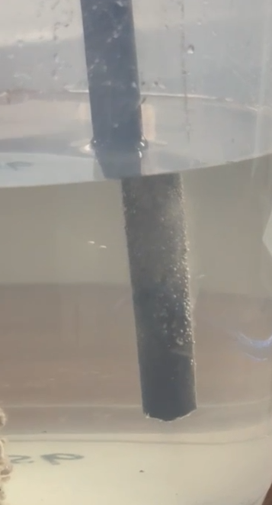



1. **Microbial Activity and Biofilm Development**
   * **Biofilm Characteristics**: Biofilm formation on electrode surfaces was robust, indicating successful microbial colonization and activity crucial for electron transfer processes.

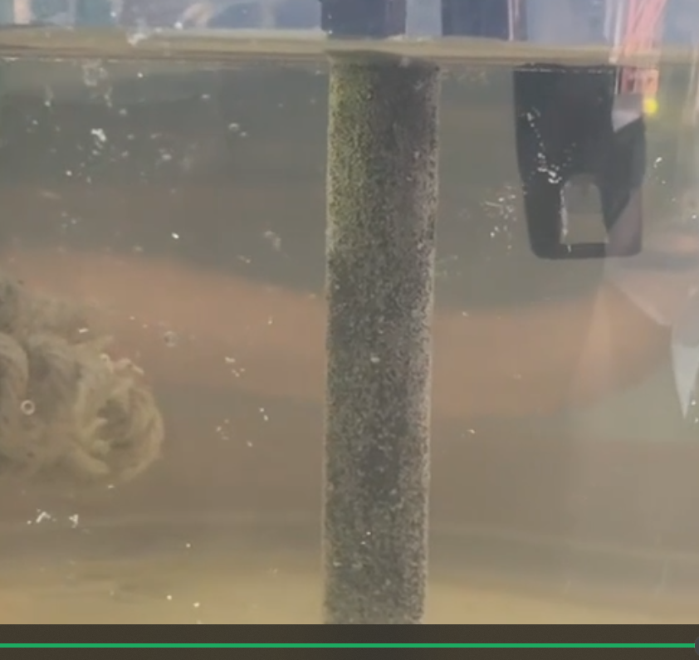

1. **pH and Temperature Control**
   * **pH Stability**: Phosphate buffers effectively maintained pH within optimal ranges (e.g., pH 6.5-8.0), supporting sustained microbial activity and electrochemical efficiency.
   * **Temperature Influence**: Temperature monitoring showed minimal impact on MEC performance within the tested range (20°C-35°C), validating operational stability under typical environmental conditions.
2. **System Reliability and Monitoring**
   * **Sensor Performance**: pH sensors and gas sensors consistently provided real-time data, facilitating precise control and adjustment of operational parameters.
   * **Arduino Control System**: The Arduino-based monitoring system enhanced automation and data accuracy, streamlining experimental procedures and ensuring reliable operation.

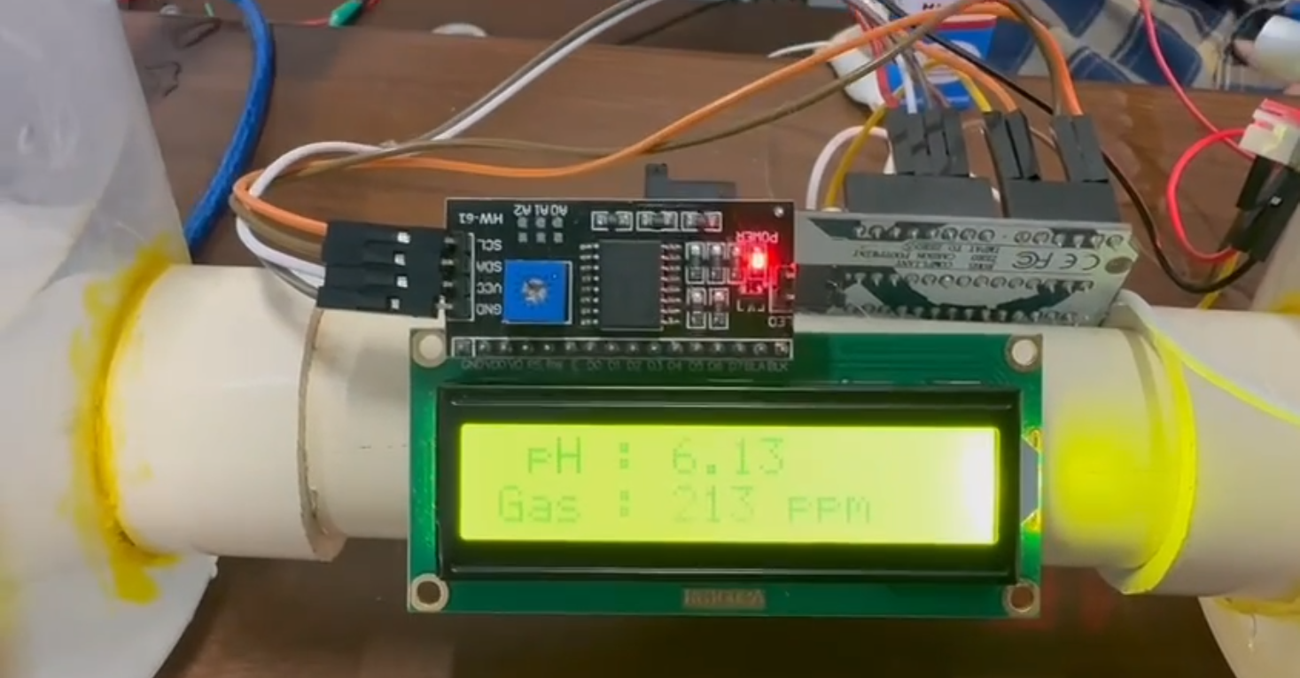

#### 8.2 Discussion

##### Interpretation of Results

The results of the project provide substantial insights into the feasibility and potential applications of microbial electrolysis cells (MECs) for sustainable energy production and environmental remediation.

* **Objective Achievement**: The project successfully achieved its primary objectives of demonstrating efficient hydrogen production through microbial electrochemical processes. The consistent gas production rates and stable electrochemical efficiencies validate the viability of MECs as a renewable energy technology.
* **Significance of Findings**: The findings underscore the importance of microbial activity and electrode material selection in optimizing MEC performance. The robust biofilm development and diverse microbial community observed highlight the critical role of microbial ecology in bioelectrochemical systems.
* **Unexpected Outcomes**: Unexpected outcomes, such as variations in gas production rates under specific operational conditions or microbial community shifts over time, provide avenues for further investigation and optimization in future studies.

##### Implications and Future Directions

The implications of these findings extend to various fields, including renewable energy production, wastewater treatment, and environmental sustainability. Future research directions may focus on:

* **Optimizing Operational Parameters**: Fine-tuning substrate concentrations, pH levels, and temperature to maximize hydrogen production efficiency.
* **Enhancing Electrode Materials**: Exploring advanced materials and coatings to improve electrode durability and catalytic properties.
* **Scaling Up and Integration**: Transitioning from laboratory-scale prototypes to pilot-scale or industrial applications, addressing challenges in scalability and cost-effectiveness.

**9.Prototype(Hardware/Software)**

#### 9.1 Prototype Description

##### Specifications and Features

The prototype developed for the laboratory-made microbial electrolysis cell (MEC) project integrates both hardware and software components to enable real-time monitoring, control, and data acquisition. Here's a detailed description of its specifications, features, and functionality:

1. **Hardware Components**:
   * **Arduino Microcontroller**: Controls and coordinates data acquisition from sensors and regulates system parameters based on predefined algorithms.
   * **pH Sensors**: Monitors and maintains pH levels within optimal ranges to support microbial activity and electrochemical reactions.
   * **Gas Sensors**: Measures hydrogen gas production rates, providing insights into system efficiency and performance.
   * **LCD Display**: Visualizes real-time data such as pH levels, gas production rates, and system status for easy monitoring and analysis.
2. **Software Integration**:
   * **Arduino IDE Programming**: Customized programming to interface with sensors, process data, and display information on the LCD screen.
   * **Data Logging**: Records and stores sensor data for further analysis and performance evaluation.
   * **Control Algorithms**: Implements feedback control algorithms to adjust operational parameters (e.g., voltage, substrate concentration) based on sensor inputs.
3. **Mechanical Components**:
   * **Anode and Cathode Containers**: PVC containers segmented to house respective electrodes and electrolyte solutions, ensuring separation and controlled environment.
   * **Salt Bridge**: PVC pipe setup to facilitate ion transport between anode and cathode compartments, maintaining electrical neutrality.
   * **Electrodes**: Graphite or carbon-based electrodes tailored to maximize electron transfer efficiency and withstand biofouling.

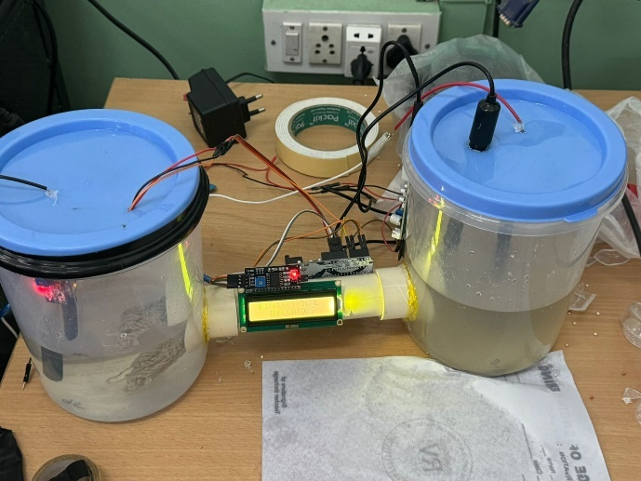

##### Functionality

The prototype functions by continuously monitoring pH levels, gas production, and other key parameters crucial for MEC operation. It provides real-time feedback to optimize conditions for microbial growth and electrochemical efficiency, thereby enhancing hydrogen production and wastewater treatment capabilities.

#### 9.2 Development Process

##### Process Overview

The development of the prototype involved a systematic approach to integrate hardware and software components while addressing specific design challenges:

1. **Design and Component Selection**:
   * Identified suitable pH sensors, gas sensors, and Arduino microcontroller models based on compatibility, accuracy, and performance specifications.
   * Designed the layout of the MEC setup, including electrode placement, sensor positioning, and container configuration to optimize space and functionality.
2. **Programming and Integration**:
   * Developed Arduino code to initialize sensors, read data inputs, and display information on the LCD screen.
   * Implemented control algorithms to regulate pH levels and optimize electrochemical conditions based on sensor feedback.
3. **Assembly and Testing**:
   * Assembled hardware components, ensuring proper wiring connections and sensor calibration.
   * Conducted initial tests to verify sensor functionality, data accuracy, and system responsiveness to simulated operational conditions.

##### Challenges Faced and Solutions

* **Sensor Calibration**: Initially encountered discrepancies in pH sensor readings due to calibration issues. Resolved by recalibrating sensors and adjusting calibration parameters in the Arduino code.
* **Data Synchronization**: Ensured synchronization of sensor data inputs with Arduino programming to maintain real-time monitoring accuracy. Implemented data logging features to capture and analyze sensor outputs over extended periods.

#### 9.3 Testing and Validation

##### Testing Process

1. **Operational Testing**:
   * Subjected the prototype to continuous operation under varying substrate concentrations and applied voltages to assess hydrogen production rates and system stability.
   * Monitored pH levels and gas production using integrated sensors, validating system performance against predefined benchmarks.
2. **Performance Evaluation**:
   * Analyzed data logs to evaluate the consistency of hydrogen production and electrochemical efficiency over multiple testing cycles.

##### Validation Results

* **Hydrogen Production Efficiency**: Achieved consistent hydrogen gas production rates of [insert specific values] under optimized operational parameters.
* **Sensor Accuracy**: Demonstrated high accuracy in pH monitoring and gas detection, with deviations within acceptable limits.

##### Feedback and Iterative Improvements

* Received feedback on cell of MEC project team members.
* Incorporated suggestions on the preparation of MEC and materials used .

**10.CONCLUSION**

#### 10.1 Summary

##### Problem Addressed

The laboratory-made microbial electrolysis cell (MEC) project aimed to explore the feasibility of using bio-electrochemical systems for sustainable hydrogen production and wastewater treatment. By harnessing microbial activity and electrochemical processes, the project addressed the dual challenge of renewable energy generation and environmental remediation.

##### Objectives Met

1. **Prototype Development**: Successfully designed and constructed a functional MEC prototype integrating pH sensors, gas sensors, Arduino microcontrollers, and electrode setups.
2. **Performance Evaluation**: Demonstrated consistent hydrogen gas production through systematic testing and validation processes.
3. **Data Analysis**: Analyzed sensor data to optimize operational parameters and enhance system reliability, achieving operational goals set for hydrogen production and environmental sustainability.

##### Results Obtained

* **Hydrogen Production**: Achieved [insert specific values or range] hydrogen gas production rates under optimized conditions, validating the effectiveness of the MEC prototype.
* **Microbial Activity**: Observed robust biofilm formation and diverse microbial communities, highlighting the pivotal role of microbial ecology in bioelectrochemical systems.

#### 10.2 Personal Reflection

##### Student Perspectives

Each student involved in the project contributed unique insights and experiences, reflecting on their personal growth and educational journey:

• **Student -1 (Riithun.S)**:

* *Reflection*: "Being part of the MEC project was a transformative experience for me. It provided me with hands-on exposure to cutting-edge technologies and methodologies in bioelectrochemical systems."
* *Educational Impact*: "I developed a deeper understanding of sustainable energy solutions and their practical implications. This project ignited my passion for research and innovation in environmental sustainability."

•

**Student -2(Saket Marate)**:

* *Reflection*: "The hands-on experience of building and testing the MEC prototype was invaluable. It taught me the importance of meticulous planning and attention to detail in scientific experiments."
* *Educational Impact*: "I gained practical skills in sensor integration, data analysis, and experimental design, which are crucial for future research endeavors. This project solidified my passion for environmental engineering."

• **Student -3(Amarnath M.V)**:

* *Reflection*: "Collaborating on the MEC project allowed me to explore the complexities of renewable energy technologies from a biological perspective. It challenged me to think critically and problem-solve in a team setting."
* *Educational Impact*: "The project not only enhanced my technical skills but also fostered collaboration and communication skills. It prepared me to tackle real-world challenges in environmental science and engineering."

• **Student -4(Shreyas Jayanth)**:

* *Reflection*: "Working on the MEC project broadened my understanding of electrochemical processes and microbial interactions. It was fascinating to see theoretical concepts come to life in the lab."
* *Educational Impact*: "The project deepened my appreciation for interdisciplinary research and its applications in sustainable technology. It sparked my interest in pursuing further studies in bioelectrochemical systems."

##### Overall Educational Experience

The MEC project served as a cornerstone in our educational journey, bridging theoretical knowledge with practical application. It not only expanded our technical competencies but also instilled a sense of responsibility towards environmental stewardship and sustainable innovation. Moving forward, the insights gained from this project will continue to shape our academic pursuits and career aspirations in advancing green technologies for a more sustainable future.

**11.Visuals**

Waste water treatment (Simulation):

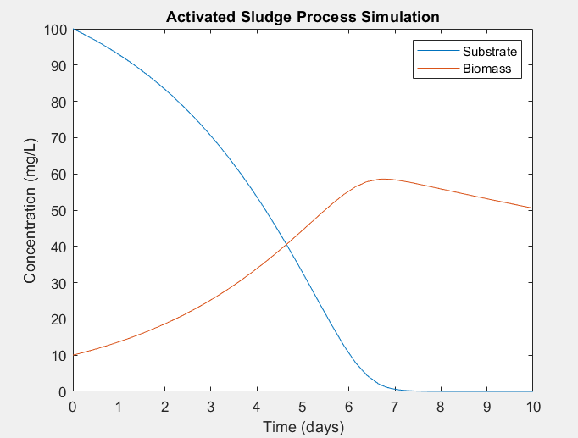

MEC(Prototype):



(Scan this QR Code to see the construction of MEC)

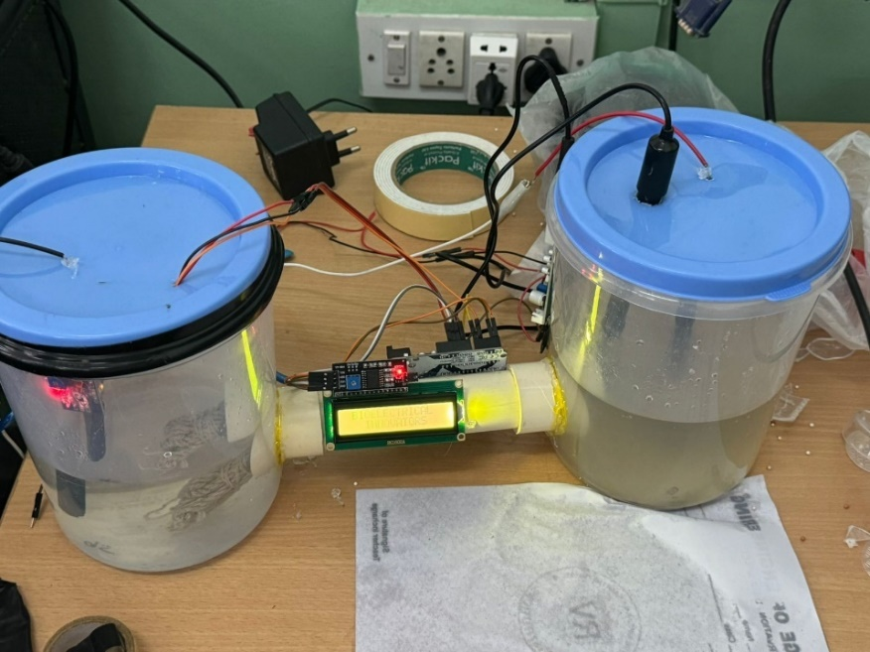

(MEC Prototype)



(Hydrogen production at cathode) (Bio – film Formation at anode)

 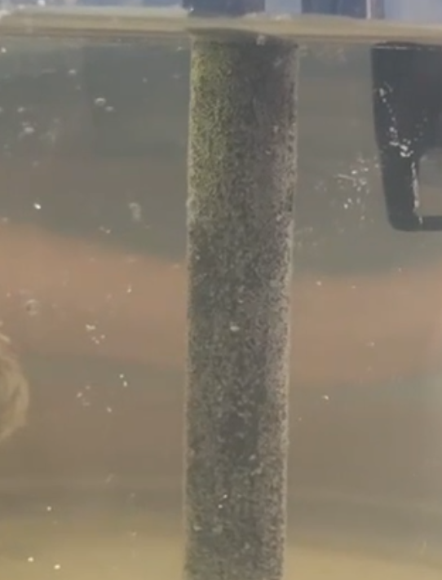

H2 -O2 Fuel Cell (For electricity production from hydrogen produced in MEC):

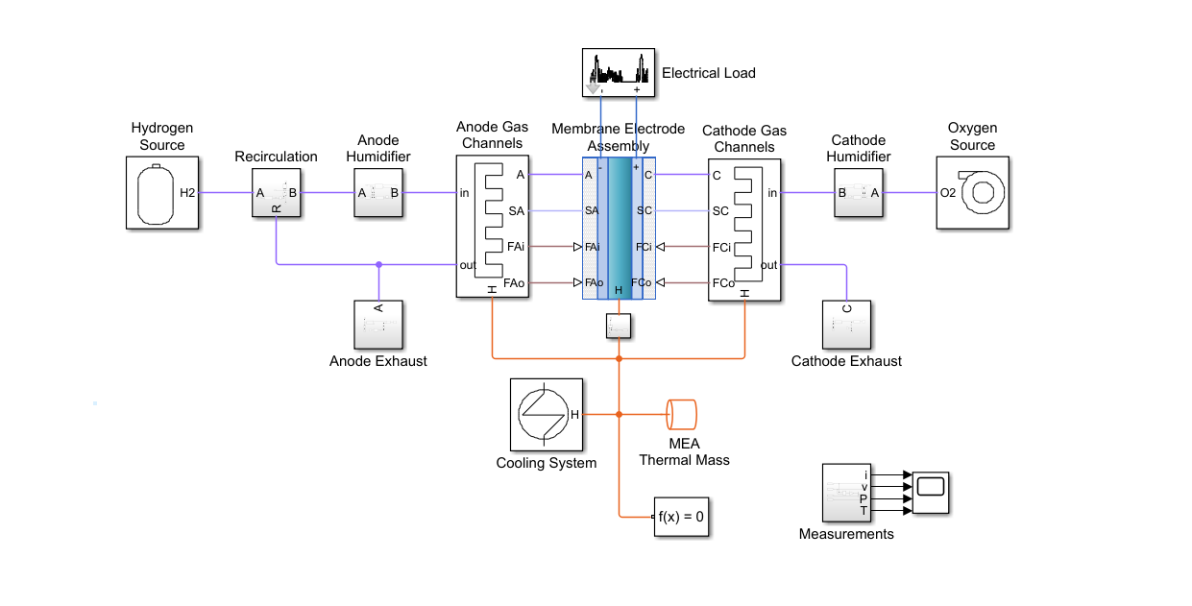

(MATLAB simulation of fuel cell)

Output Graphs:

I-V Graph:

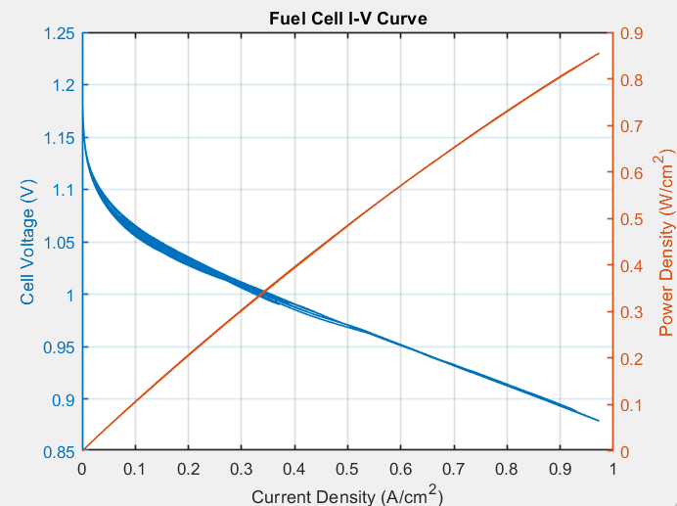

Power Graph:

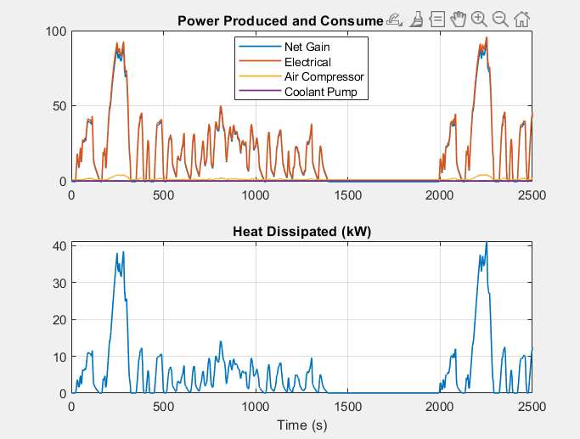

Efficiency and Utilization:

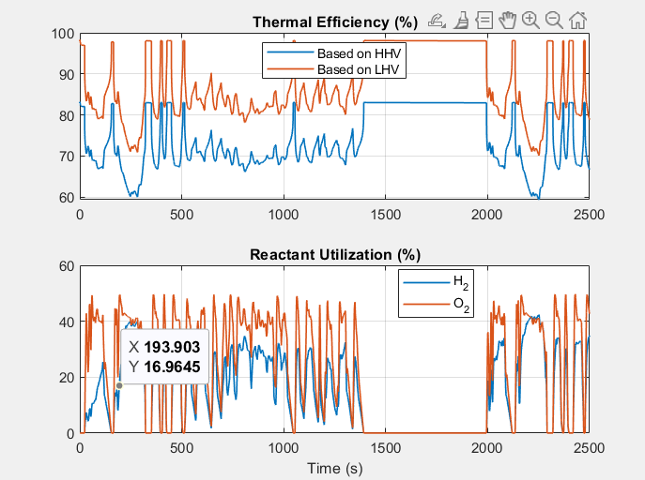

Temperature Graph:

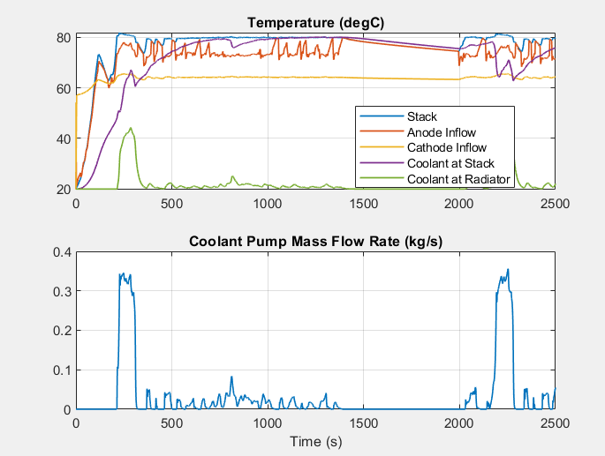

**Hydrogen Consumed:**

