- Go to: https://mvanaman.shinyapps.io/sample_z_teaching/
- The very important and legitimate rough collie coalition known as FCRCA (pronounced “Fur-kuh”, short for Florida Coalition for Healthy and Floofy Rough Collie Tails Association) recently measured all the tail lengths of all Florida rough collies. They had two goals:
  - To ensure all Florida rough collie tails were healthy and floofy enough according to the latest standards of rough collie tail healthiness and floofiness (they all were – yay!); and more importantly,
  - to provide a population from which infinite samples could be taken to construct a sampling distribution for all sample sizes (from n = 2 to n = 50) for use as an example in today’s Behavioral Statistics class.
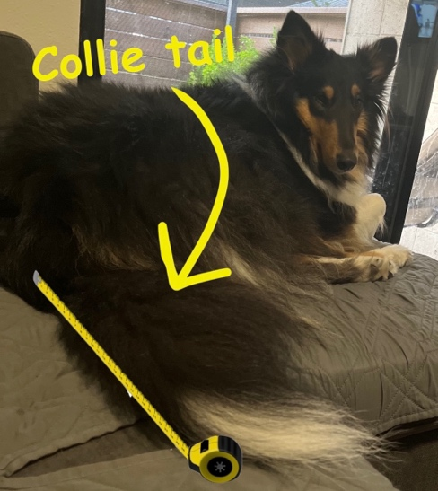
- Choose a confidence level and sample size, then draw a sample of rough collie tail lengths.
  - What was your confidence level? ________
  - What was your sample size? _________
- The dotted line dotted line shows the mean ($\overline{x}$) of the sample you just drew. The shading shows the confidence interval around $\overline{x}$. Answer these questions:
  - Based on your confidence level, how many confidence will capture the population mean ($\overline{μ}$)? ___________
  - Calculate these statistics for your sample:
    - $\overline{x}$: ___________
    - s (sample standard deviation):____________
    - The Standard Error (SE)of the sampling distribution is shown at the top of the distribution. But we never get to know the true SE because we can’t actually take infinite samples. Estimate the SE from your sample data.
      - What was the SE? ___________
      - What was the difference between your SE and the true SE of the sampling distribution?
    - Using the true SE of the sampling distribution, express $\overline{x}$ as a Z-score i.e., the number of SE units away from the population mean ($\overline{μ}$) our sample was: ___________
  - Calculate the confidence interval around $\overline{x}$:
    - First, find $z_{crit}$ in the web application (right-hand panel): _____________
    - Use this to calculate the confidence interval. What is the lower and upper bound?
      - Lower bound: ________ Upper bound: ________
  - Did the confidence interval from your sample capture the population mean ($\overline{μ}$)? ________________
    - How can you tell? Don’t overthink it: ________________

