User Manual

And

Documentation

Team J

Camosun Innovates Nursing Survey

Contributors:

Mike Vandendorpel

Meron Meresa

Aleks Janzen

# Introduction

This document is made up of 3 separate documents created at the request of the project sponsor. The first part is the user directions from the website, converted into a document. The second part is the instructions on the reports that the API currently exports based on user data. The third document is the readme for the GitHub page related to this project, for assistance is passing off the project.

These documents will attempt to explain the operation of this web application for 3 different groups: users, researchers, and the developers who will continue to work on this project.

The first part will be from the user’s point-of-view of navigating through the web application. These instructions will guide the user through setting up their Fitbit device, registering for the website, and completing their first surveys.

The second section will layout and provide examples of the data being exported. This data is currently exported to Excel spreadsheets and come in three different formats.

The final part will give an overview of the different parts of this web application, and the major modules used in Node.JS to develop, as well as brief instructions on how to run the separate parts when downloaded.

Contents

1.0 User Manual 4

1.1 Fitbit Signup 4

1.2 Web App Signup 4

1.3 Dashboard 5

5

1.4 User Profile 5

5

1.4.1 My Steps 5

1.4.2 My Stats 6

1.5 User Surveys 6

1.5.1 Daily Surveys 6

1.5.2 Weekly Surveys 6

2.0 Research Tool 7

2.1 Sleep Report 7

2.1 Daily Activity Report 7

2.2 Weekly Report 7

3.0 Software Documentation 8

3.1 Overview 8

3.2 Front End 8

3.2.1 Major Modules 8

3.2.2 Pages 8

3.2.3 Usage 8

3.3 Back End 9

3.3.1 Database Model 9

3.3.2 Data Encryption 9

3.3.3 Usage 10

3.4 API 10

3.4.1 Major Modules 10

3.4.2 Endpoints 10

3.4.2 Usage 11

3.5 Future Development 11

3.5.1 Oauth2 Login 11

3.5.2 Expansion of Research Tool 11

3.5.3 Front End 11

3.5.4 API 11

4.0 Conclusion 11

# 1.0 User Manual

This guide will take you through the process of setting up your account, as well as include a brief tour of the site’s functionality. Use of the site is very simple, but there are a few steps for initial setup.

## 1.1 Fitbit Signup

Before diving into the web app, users should first set up their Fitbit account.

1. Download the Fitbit App on either [iPhone](https://apps.apple.com/us/app/fitbit-activity-calorie-tracker/id462638897?ign-mpt=uo%3D4) or [Android](https://play.google.com/store/apps/details?id=com.fitbit.FitbitMobile).
2. Create a Fitbit account.
3. Tap the button on your Fitbit device to wake it up.
4. Follow the directions on screen to sync your device with your Fitbit account.

Once you have set up your Fitbit account and synced your account and device together, the next step is to register your account on the web app.

## 1.2 Web App Signup

The signup form for the web app is very simple. Simply enter your name, e-mail, username, and password.

Figure Signup Page

Other information will be pulled from your Fitbit profile when you complete your first survey.

Once you have completed your registration on the web app, you can then sign in using your e-mail and password.

After signing in, you will be taken to the dashboard.

## 1.3 Dashboard

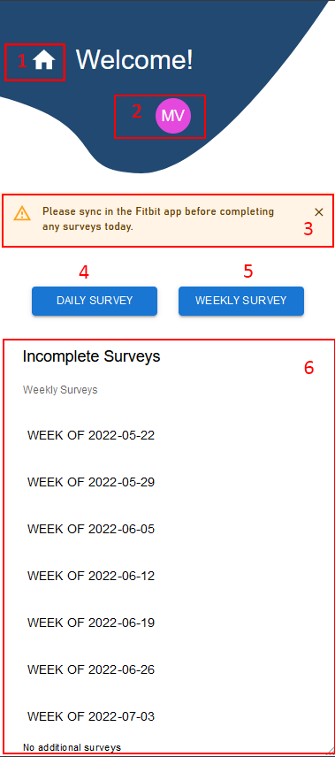The dashboard is the main page after signing in.

1. Home Button – Use this to return to the dashboard at any time
2. User Profile button – Brings up a menu for the user to review their biometric data
3. Reminder to sync your Fitbit device – Please be sure to sync your device before completing a survey
4. Daily Survey – Will allow you to complete today’s daily survey
5. Weekly Survey – Will allow you to complete this week’s weekly survey
6. List of incomplete survey – Missed a day? Doesn’t matter, we will keep track and let you know which ones you still have to complete.

Figure 2 Dashboard

## 1.4 User Profile

The user profile can display data pulled from Fitbit devices when the user completes daily surveys

### 1.4.1 My Steps

The steps page will pull all step data found in completed daily surveys. The total amount of steps taken during the survey period are listed are **Cumulative Steps**.

**Average Steps Today** will display the average number of steps taken daily over the survey period.

**Steps Today** displays the step data from the most recently found daily data. If you completed yesterday’s survey, but not today’s, the number of steps shown will be from yesterday.

Figure 3 My Steps page

### Chart Description automatically generated1.4.2 My Stats

The My Steps page will give an overview of data pulled from Fitbit devices and your survey answers for the given study period.

**Sleep** data is pulled from the Fitbit API and displays the amount of sleep at each stage your device has recorded within the study period.

The resting heart rate for the previous 7 days will be displayed in the **Base Heart Rate** chart.

The **Fatigue Levels** chart will display the frequency of your choices made regarding morning fatigue during the daily survey.

Figure 4 My Stats page

## 1.5 User Surveys

User surveys are divided into two formats: daily and weekly.

### 1.5.1 Daily Surveys

The daily survey will ask you questions about your sleep, fatigue, and work that day. Completing the daily survey should take about 5-10 minutes.

After completing the daily survey, the web app will then pull your biometric data for the day from Fitbit’s API. The first time this happens, you will be asked to authorize the web app to collect this data. Details on how we protect this information can be found in our About page.

## 1.5.2 Weekly Surveys

The weekly survey will focus on reflecting over trends you noticed in the previous week, and how you feel certain factors such as stress or work may have contributed to these trends. Completing this survey should take between 10-20 minutes.

Please remember to be honest and thorough when answering these questions.

Figure 5 Example of survey questions

# 2.0 Research Tool

This section will describe the functionality of the research tool. This tool is intended to be used to extrapolate data collected from the web app and export this data into Excel format for review by researchers.

This tool is designed to build 3 reports currently:

1. Sleep Report
2. Daily Report
3. Weekly Report

All these reports are generated for an individual user based on a given date range.

## 2.1 Sleep Report

The sleep report will gather data based on the user’s sleep over a given period. This includes time to bed/wake, efficiency of sleep, as well as activity from that day and the shift worked that day. This report currently outputs a single sheet with all data.



Figure 6 Excerpt of Sleep Report

## 2.1 Daily Activity Report

The daily activity report will gather data based on daily activity over a given period. The number of sheets generated will depend on the date range. There is first is an overview sheet with user’s shift data, sleep schedule, and average heart rate and steps. Second is a sheet with the user’s answers for each given question. For each day, the tool will generate sheets for both heart rate and steps for:

* The user’s shift it one was worked that day
* A 2-hour period before and after



Figure 7 Excerpt of Daily Report

## 2.2 Weekly Report

The weekly report will be a higher-level view of data compared to the daily activity report. The overview sheet will give averages and totals for activity, steps, heart rate and shift. A second sheet will give the user’s answers to the weekly survey questions, and a final sheet will give a daily breakdown of the totals from the overview sheet

## 

Figure 8 Excerpt of Weekly Report

# 3.0 Software Documentation

## 3.1 Overview

This web app is designed to be a user survey to collect data based on the user’s fatigue and sleep. Data collected from the users is combined with data collected from the user’s Fitbit device to generate reports in Excel spreadsheet format. The project was developed in Node.js, with MySQL, Express.JS, and React.

This project was commissioned by Camosun Innovates for use in a study of perioperative nurses.

This project was built by students at Camosun College for the 2022 Capstone Program.

## Front End

The front end is used by survey subjects to complete daily and weekly surveys, as well as review some of the data collected through the surveys and collected by the Fitbit device.

### Major Modules

[React](https://www.npmjs.com/package/react-scripts) – User Interface module for building front end applications

[React-Scripts](https://www.npmjs.com/package/react-scripts) – Configuration files for Create React App

[Axios](https://www.npmjs.com/package/axios) – Connecting and retrieving data from the API

[Recharts](https://www.npmjs.com/package/recharts) – Displaying data in user stats page

[Jwt-decode](https://www.npmjs.com/package/jwt-decode) – Allows decoding of security token to send data to/from API

### Pages

Login/Signup – Pages for registering on site and logging in.

Dashboard – Main index page, shows all incomplete surveys for the current survey period

User Stats – displays biometric data related to user’s heart rate and sleep

Daily Survey – Contains a list of questions including a calendar to input user’s shift. Redirects to the API after completion to gather data from Fitbit

Weekly Survey – List of questions. Does not gather Fitbit data so remains on website after submission

### Usage

Server is run with the command:

**HTTPS=true npm start**

HTTPS is needed as the front-end and API use SSL certificates. Because this was developed behind a VPN, the site uses a self-signed certificate.

## Back End

The database is built with MySQL, and currently runs on the same server as the API. All personal information, including survey answers and Fitbit data, is stored in an encrypted state.

### Database Model

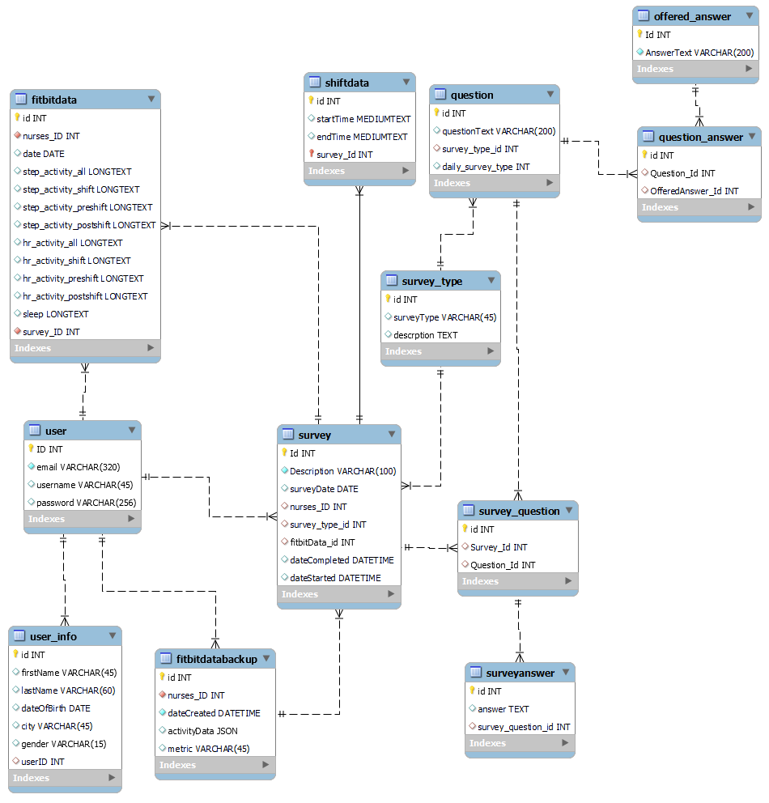

Figure 9 Database Model

### Data Encryption

After decryption, all entries in **fitbitdata** are stored in JSON format. The tables **user, user_info, surveyanswer,** and **shiftdata** will also contain encrypted entries.

### Usage

Command to run the MySQL server will vary by setup. The script containing all tables is found inside the Documentation folder.

## API

### Major Modules

[Express](https://www.npmjs.com/package/express) – Middleware to run the API

[Sequelize](https://www.npmjs.com/package/sequelize) – Database modelling and querying

[Passport](https://www.npmjs.com/package/passport-jwt) – User Authentication with JSON Web Tokens

[Fitbit-Node](https://www.npmjs.com/package/fitbit-node) – Oauth2 integration with Fitbit API

[Crypto-es](https://www.npmjs.com/package/crypto-es) – Handles database encryption

[XLSX](https://www.npmjs.com/package/xlsx) – Exports data from API

### Endpoints

/authorize – Redirects to Fitbit API for oauth2 authentication

/fb – landing page after Fitbit redirect – gathers data from Fitbit API and stores in DB

/login

/users – register and update user information

/stepcount – retrieve data for steps page on front end

/allsurveys – returns user’s survey data

/lastsubmission – returns Fitbit and survey information for last survey submitted

/userstats – returns heart rate, sleep and fatigue info

/dashboard – returns surveys not yet completed

/weeklysurvey – post user survey answers or get survey questions

**Research Endpoints**

/sleepresearch – generates Excel spreadsheet on user’s sleep

/dailyreport – generates Excel spreadsheet on user’s daily biometric data and surveys

/weeklyreport – generates Excel spreadsheet on user’s weekly survey’s and totals and averages of biometric data

See documentation on Research Tool for more information on these reports

### 3.4.2 Usage

Usage of the API will require an SSL certificate. The application is currently using a self-signed certificate.

The API can be run with the command:

**npm run dev**

## Future Development

### Oauth2 Login

Fitbit’s API supports Oauth2 authentication through the web app. The project could be modified to use Fitbit’s own account data, rather than creating a separate login for this web app.

### Expansion of Research Tool

1. Allow modification of survey questions stored within the database
2. Examine ways to further secure the endpoints
3. Allow reports on multiple users to be generated at once
4. Allow the researcher to select which data appears on each report

### Front End

1. The weekly surveys could be modified to allow users to determine which dates start and end the week.
2. The site could redirect users to login page after signup.
3. Landing page after daily survey completion could be created.

### API

1. A method of exported nested JSON to Excel would simplify the spreadsheets exported.
2. Many sections of code could be refactored
3. Remove non-REST endpoint
4. Create a model for an entire survey: Fitbit data, survey info, survey questions, and answers.

# 4.0 Conclusion

This concludes the documentation for the web application. Although there were plenty of obstacles with the development, many of these challenges led to opportunities to learn new skills or reinforce those learned in class over the last two years.

Contributors:

[mvandendorpel](https://github.com/mvandendorpel)

[Mer0n](https://github.com/Mer0n)

[ajanzenn](https://github.com/ajanzenn)