HW00 — STAT/CS 287

NAME: Michael Arnold

DATE: 2018-09-04

# P1

Yes.

# P2

Yes.

# P3

I had to install the websockets-client package to get the script to run without error.

# P4

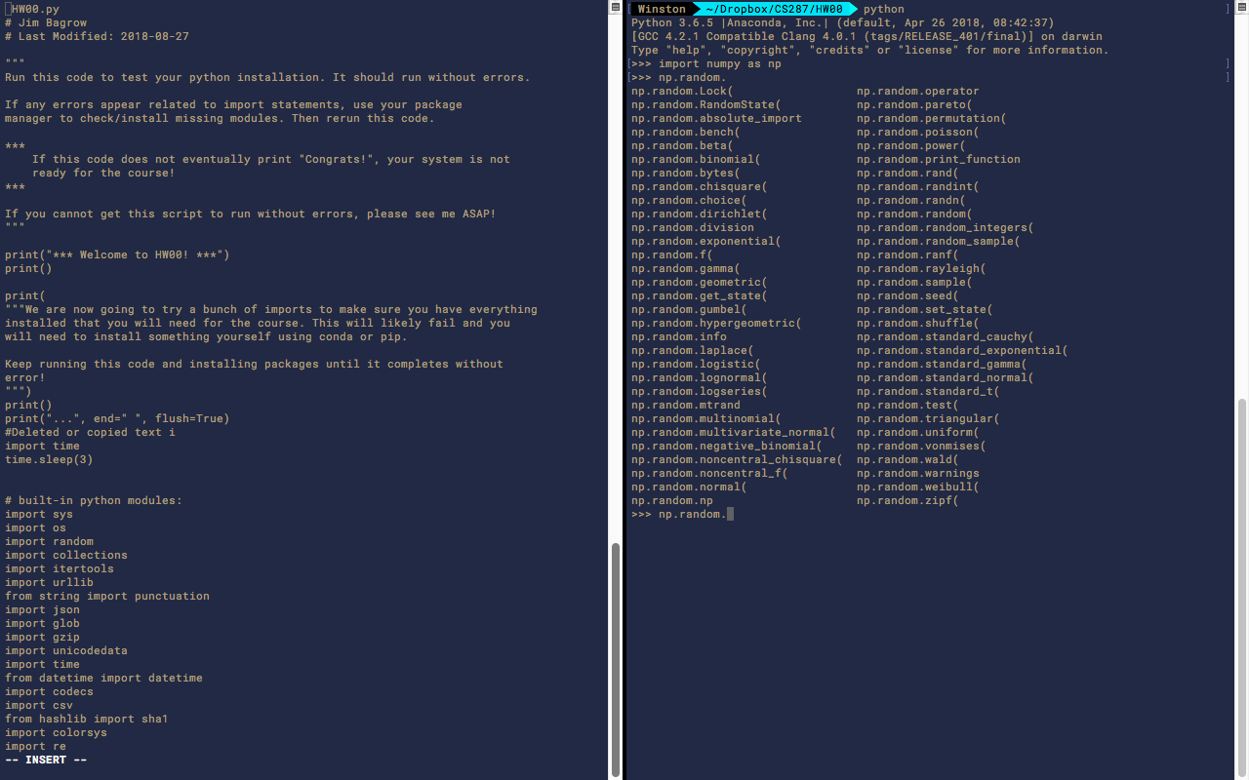

# P5a

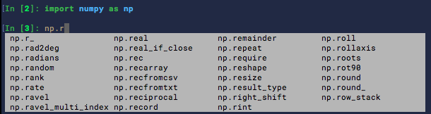

# P5b

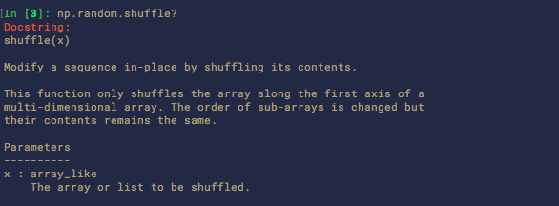

# P5c

It appears that the major difference is that the python built-in “random.shuffle” has the optional ability to substitute your own random number generator for random.random, if random.random isn’t sufficiently random for your purposes. The numpy.random.shuffle function doesn’t have this feature.