Name : M VARSHALAKSHMI
Reg No : 411625104074
Department : CSE
Subject : PYTHON
Batch : 1

Project : Dice Game (Player vs Computer) using Python
1. Project Title
Dice Game (Player vs Computer) using Python
2. Problem Statement
To develop a Python program that simulates a dice game between a player and the computer using random number generation.
- Objective
Start the program
Initialize scores
Set number of rounds
For each round:
· Generate random number for player
· Generate random number for computer
· Compare values
· Update scores
Display final result
Stop
4. Tools Used
- Python 3
- VS Code
5. Description
This project simulates a dice game where the player competes against the computer. Both roll a virtual dice, and the higher number wins the round. Scores are tracked and displayed at the end.
- Algorithm
● Start program
● Initialize scores
● Set rounds
● Generate random numbers
● Compare values
● Update scores
● Repeat for all rounds
● Display winner
- Program (Python Code)
import random
player_score = 0
computer_score = 0
rounds = 5

for i in range(rounds):
input("\nPress Enter to roll dice...")
player = random.randint(1, 6)
computer = random.randint(1, 6)
print("You rolled:", player)
print("Computer rolled:", computer)

if player > computer:
player_score += 1
print("You win this round!")
elif computer > player:
computer_score += 1
print("Computer wins this round!")
else:
print("Draw!")

print("\nFinal Score:")
print("You:", player_score)
print("Computer:", computer_score)

if player_score > computer_score:
print("You are the winner!")
else:
print("Computer wins!")
8. Conclusion
This project demonstrates the use of random numbers and conditional logic to simulate a real-world game.
9.Sample Output
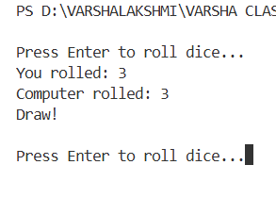
10. Result
The Dice Game successfully simulates gameplay and determines the winner based on scores.

