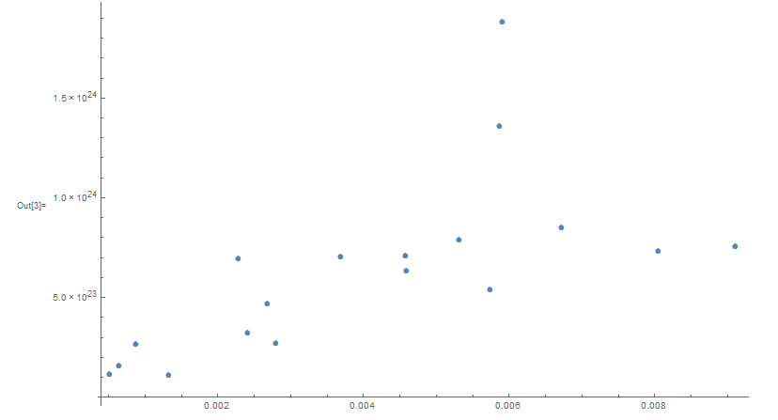

Equation of least squares:

y = 1.7397232\*10^23+1.114027\*10^26x

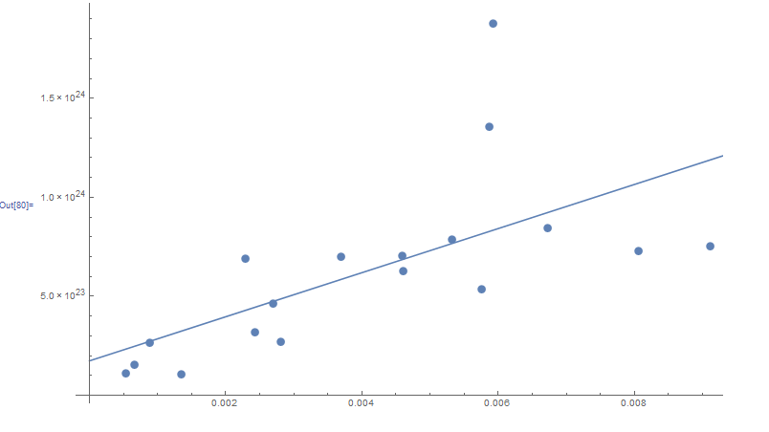

1.7397232\*10^23+1.114027\*10^26 (0.00460652)

1.7397232\*10^23+1.114027\*10^26 (0.009112971)

1.7397232\*10^23+1.114027\*10^26 (0.00228825)

1.7397232\*10^23+1.114027\*10^26 (0.005750645)

1.7397232\*10^23+1.114027\*10^26 (0.006727988)

1.7397232\*10^23+1.114027\*10^26 (0.004586506)

1.7397232\*10^23+1.114027\*10^26 (0.001344263)

1.7397232\*10^23+1.114027\*10^26 (0.002425011)

1.7397232\*10^23+1.114027\*10^26 (0.008058909)

1.7397232\*10^23+1.114027\*10^26 (0.002691862)

1.7397232\*10^23+1.114027\*10^26 (0.000660457)

1.7397232\*10^23+1.114027\*10^26 (0.000530367)

1.7397232\*10^23+1.114027\*10^26 (0.005874064)

1.7397232\*10^23+1.114027\*10^26 (0.00369589)

1.7397232\*10^23+1.114027\*10^26 (0.005323683)

1.7397232\*10^23+1.114027\*10^26 (0.005924098)

1.7397232\*10^23+1.114027\*10^26 (0.002805274)

1.7397232\*10^23+1.114027\*10^26 (0.000890616)

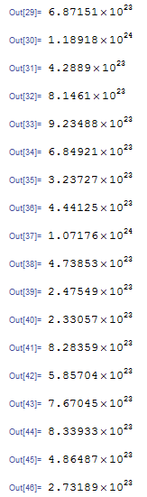

(1.7397232\*10^23+1.114027\*10^26 (0.00460652)) -6.29395\*10^23

(1.7397232\*10^23+1.114027\*10^26 (0.009112971))-7.5299\*10^23

(1.7397232\*10^23+1.114027\*10^26 (0.00228825)) - 6.91269\*10^23

(1.7397232\*10^23+1.114027\*10^26 (0.005750645)) - 5.35425\*10^23

(1.7397232\*10^23+1.114027\*10^26 (0.006727988))- 8.45571\*10^23

(1.7397232\*10^23+1.114027\*10^26 (0.004586506))-7.067\*10^23

(1.7397232\*10^23+1.114027\*10^26 (0.001344263))-1.07575\*10^23

(1.7397232\*10^23+1.114027\*10^26 (0.002425011))-3.20584\*10^23

(1.7397232\*10^23+1.114027\*10^26 (0.008058909)) -7.2933\*10^23

(1.7397232\*10^23+1.114027\*10^26 (0.002691862))-4.62904\*10^23

(1.7397232\*10^23+1.114027\*10^26 (0.000660457)) -1.54301\*10^23

(1.7397232\*10^23+1.114027\*10^26 (0.000530367))-1.112\*10^23

(1.7397232\*10^23+1.114027\*10^26 (0.005874064))-1.35476\*10^24

(1.7397232\*10^23+1.114027\*10^26 (0.00369589))-7.00065\*^23

(1.7397232\*10^23+1.114027\*10^26 (0.005323683))-7.86936\*10^23

(1.7397232\*10^23+1.114027\*10^26 (0.005924098))-1.8763\*10^24

(1.7397232\*10^23+1.114027\*10^26 (0.002805274))-2.68793\*10^23

(1.7397232\*10^23+1.114027\*10^26 (0.000890616))-2.62929\*10^23

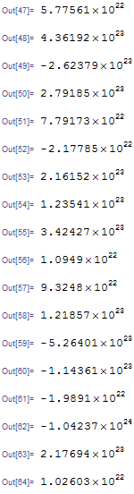

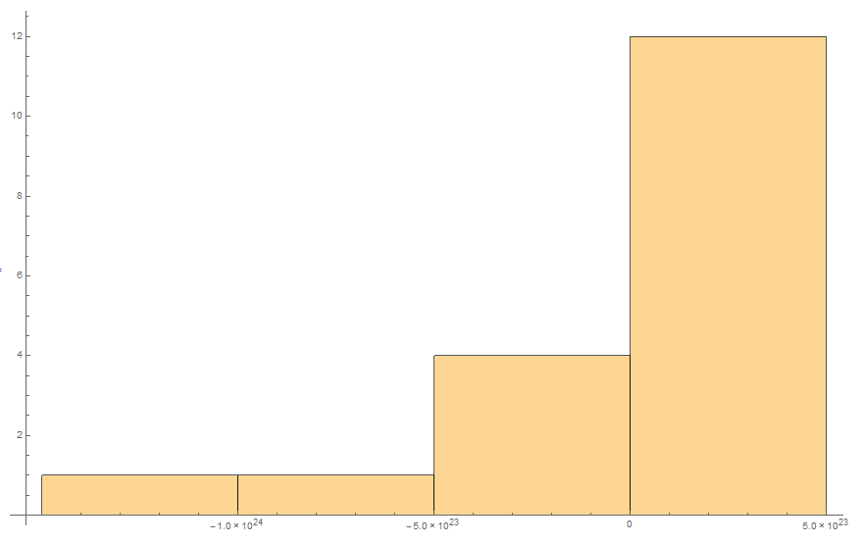

Standard deviation of residual errors: 3.408

R^2= .412

R = .642