Manoj Vasa

12/8/2016

MTH 3210-001

Stat Project 2

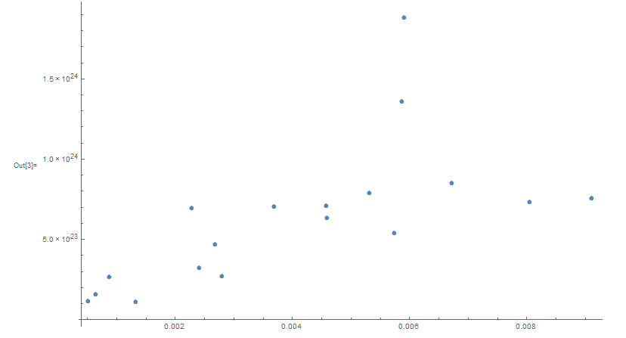15)

16) Visually this data seems to show a strong linear trend when excluding the two outliers above the rest of the data. The data doesn’t provide any strong evidence for a nonlinear relationship.

17) Least square regression equation:

y = 1.7397232\*10^23+1.114027\*10^26x

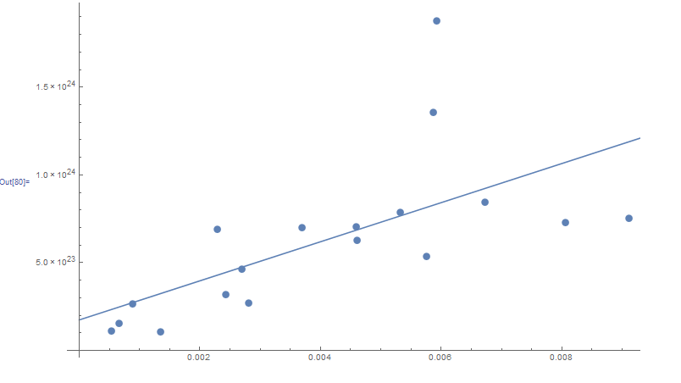

The slope shows an increasing positive trend, but it isn’t too high of an increase rate since the slope isn’t too steep. This positive slope does signify that the further away a galaxy the higher the redshift. This indicates that galaxies that are farther away tend to be moving away at a faster rate.

18) Calculations for the residual errors:

(1.7397232\*10^23+1.114027\*10^26 (0.00460652)) -6.29395\*10^23

(1.7397232\*10^23+1.114027\*10^26 (0.009112971))-7.5299\*10^23

(1.7397232\*10^23+1.114027\*10^26 (0.00228825)) - 6.91269\*10^23

(1.7397232\*10^23+1.114027\*10^26 (0.005750645)) - 5.35425\*10^23

(1.7397232\*10^23+1.114027\*10^26 (0.006727988))- 8.45571\*10^23

(1.7397232\*10^23+1.114027\*10^26 (0.004586506))-7.067\*10^23

(1.7397232\*10^23+1.114027\*10^26 (0.001344263))-1.07575\*10^23

(1.7397232\*10^23+1.114027\*10^26 (0.002425011))-3.20584\*10^23

(1.7397232\*10^23+1.114027\*10^26 (0.008058909)) -7.2933\*10^23

(1.7397232\*10^23+1.114027\*10^26 (0.002691862))-4.62904\*10^23

(1.7397232\*10^23+1.114027\*10^26 (0.000660457)) -1.54301\*10^23

(1.7397232\*10^23+1.114027\*10^26 (0.000530367))-1.112\*10^23

(1.7397232\*10^23+1.114027\*10^26 (0.005874064))-1.35476\*10^24

(1.7397232\*10^23+1.114027\*10^26 (0.00369589))-7.00065\*^23

(1.7397232\*10^23+1.114027\*10^26 (0.005323683))-7.86936\*10^23

(1.7397232\*10^23+1.114027\*10^26 (0.005924098))-1.8763\*10^24

(1.7397232\*10^23+1.114027\*10^26 (0.002805274))-2.68793\*10^23

(1.7397232\*10^23+1.114027\*10^26 (0.000890616))-2.62929\*10^23

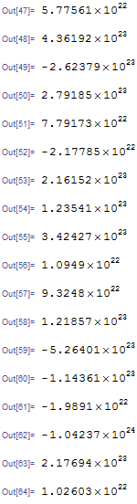Residual Errors

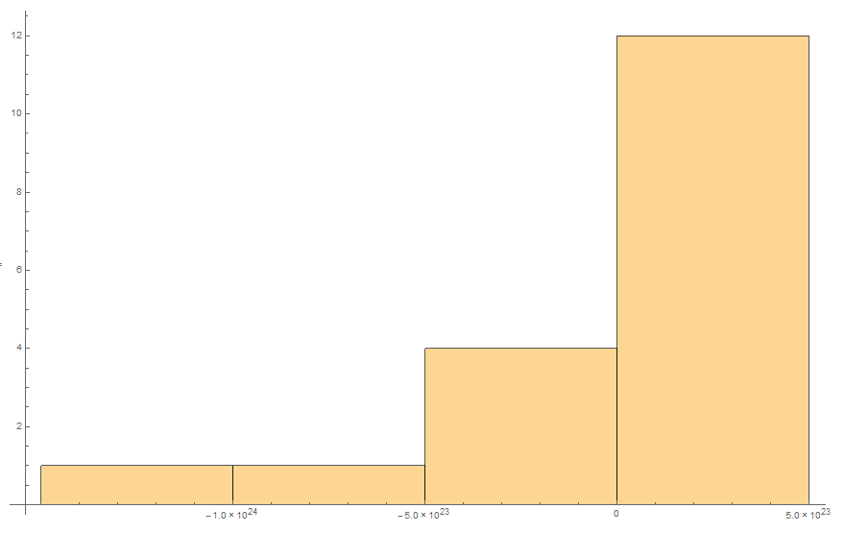19)

The histogram doesn’t appear to be normally distributed. The data seems to be skewed left and the mean doesn’t appear to be zero.

20) Standard deviation of residual errors: 3.408

21) Coefficient of determination:

R^2= .412

Correlation Coefficient

R = .642

The r value implies that the variables aren’t strongly linearly related.