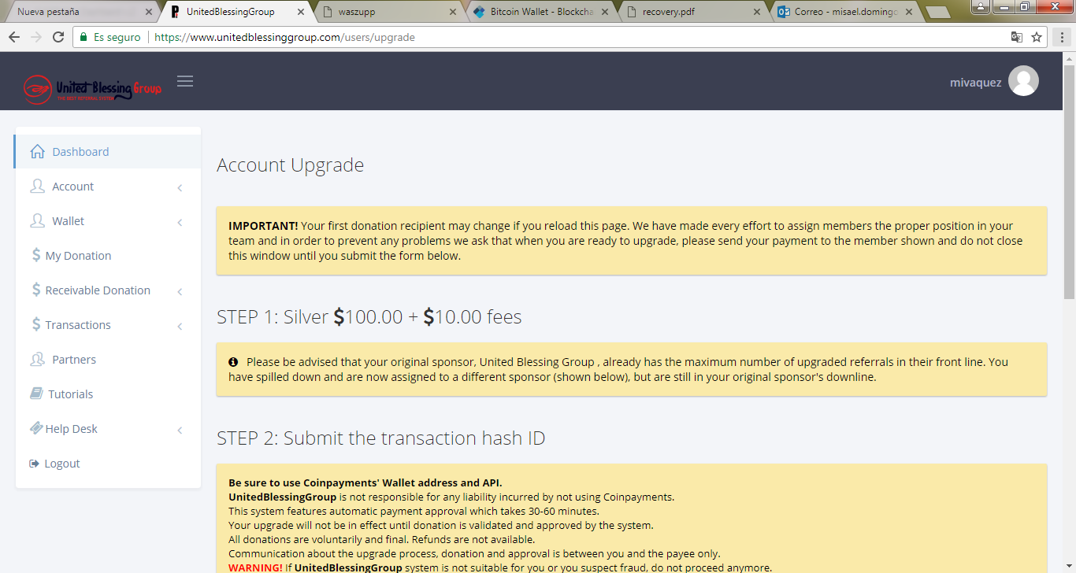

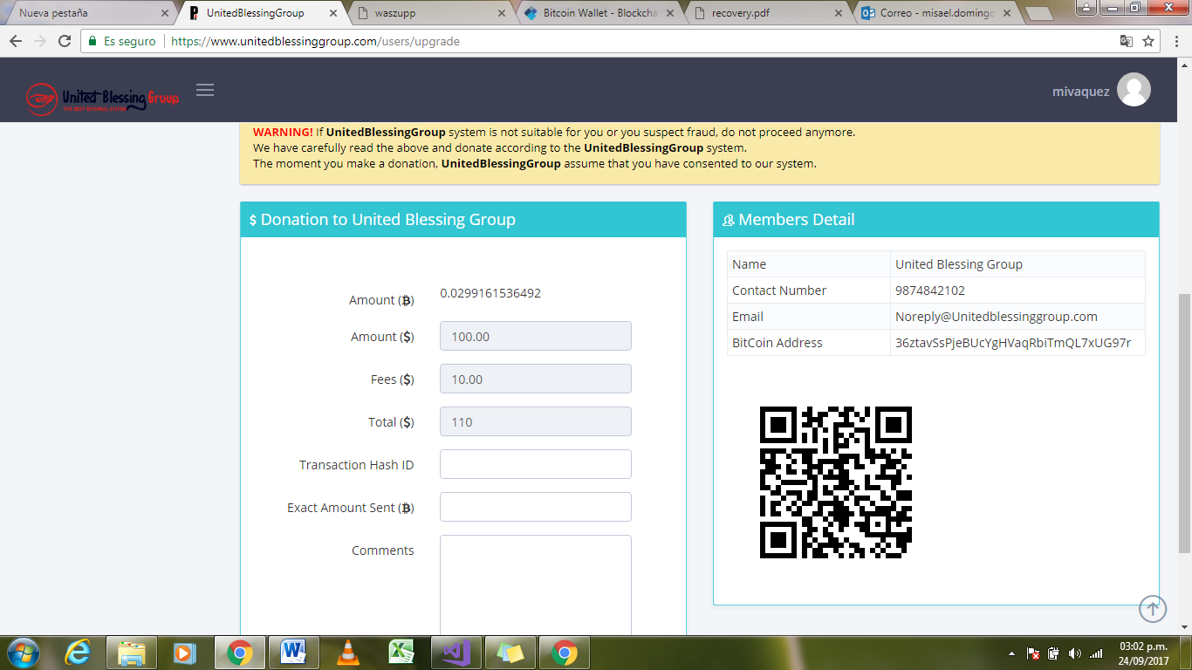

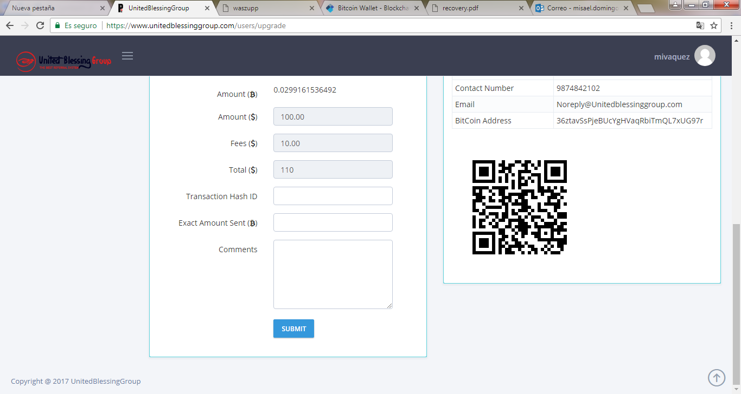

**IMPORTANT!** Your first donation recipient may change if you reload this page. We have made every effort to assign members the proper position in your team and in order to prevent any problems we ask that when you are ready to upgrade, please send your payment to the member shown and do not close this window until you submit the form below.

STEP 1: Silver 100.00 + 10.00 fees

   Please be advised that your original sponsor, United Blessing Group , already has the maximum number of upgraded referrals in their front line. You have spilled down and are now assigned to a different sponsor (shown below), but are still in your original sponsor's downline.

STEP 2: Submit the transaction hash ID

**Be sure to use Coinpayments' Wallet address and API.**

**UnitedBlessingGroup** is not responsible for any liability incurred by not using Coinpayments.

This system features automatic payment approval which takes 30-60 minutes.

Your upgrade will not be in effect until donation is validated and approved by the system.

All donations are voluntarily and final. Refunds are not available.

Communication about the upgrade process, donation and approval is between you and the payee only.

**WARNING!** If **UnitedBlessingGroup** system is not suitable for you or you suspect fraud, do not proceed anymore.

We have carefully read the above and donate according to the **UnitedBlessingGroup** system.

The moment you make a donation, **UnitedBlessingGroup** assume that you have consented to our system.